**OTFT**

**DEVICE**

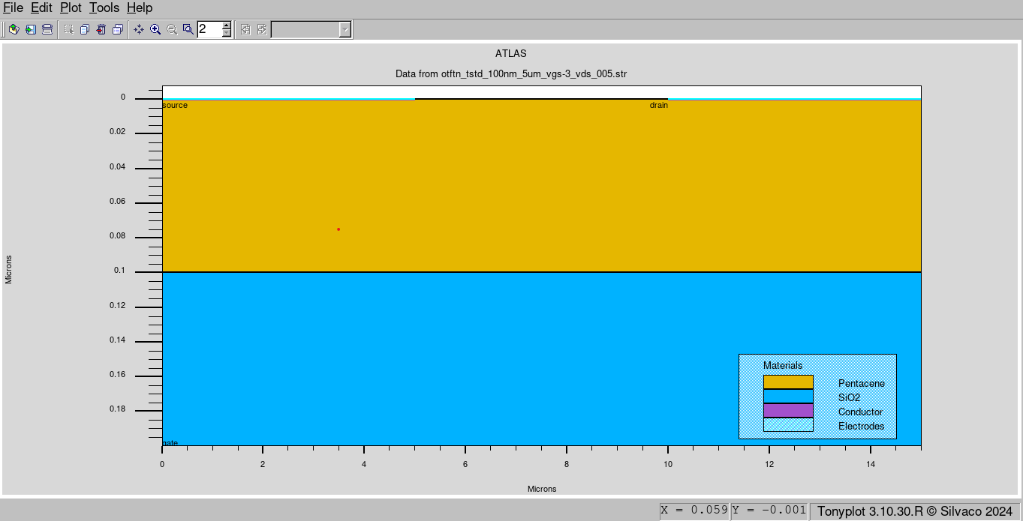

**Id vs Vgs plot sweeping Vgs from 1 to -5V**

(When values of Ids are taken as it is)

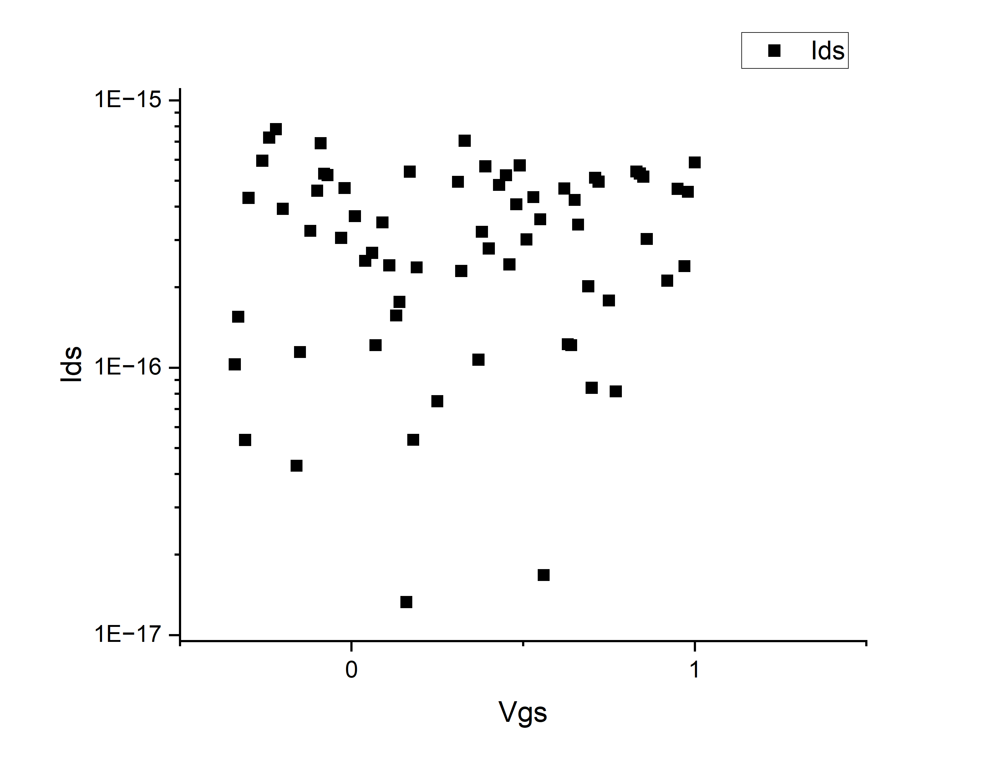

(When absolute values of Ids are taken)

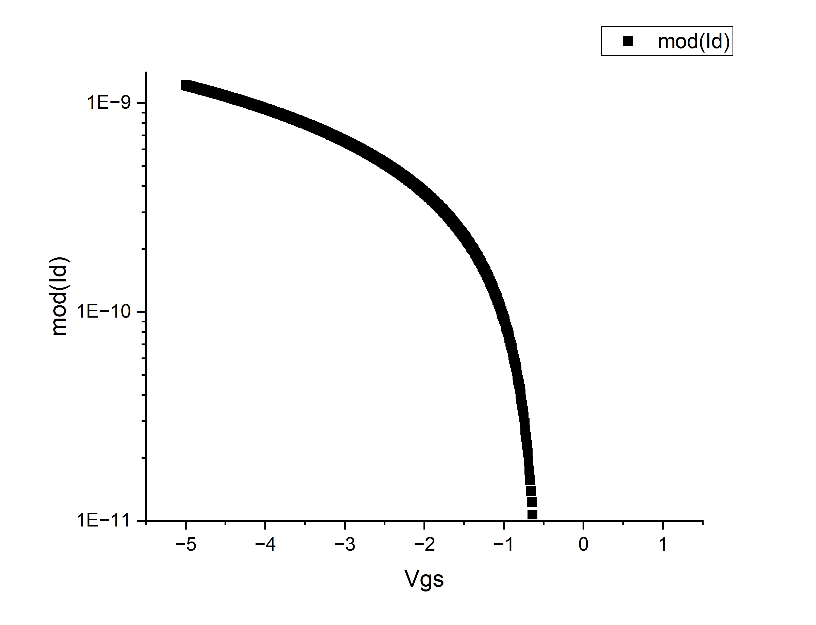

**AC Analysis sweeping Vgs from 1 to -5V**

(TONYPLOT)

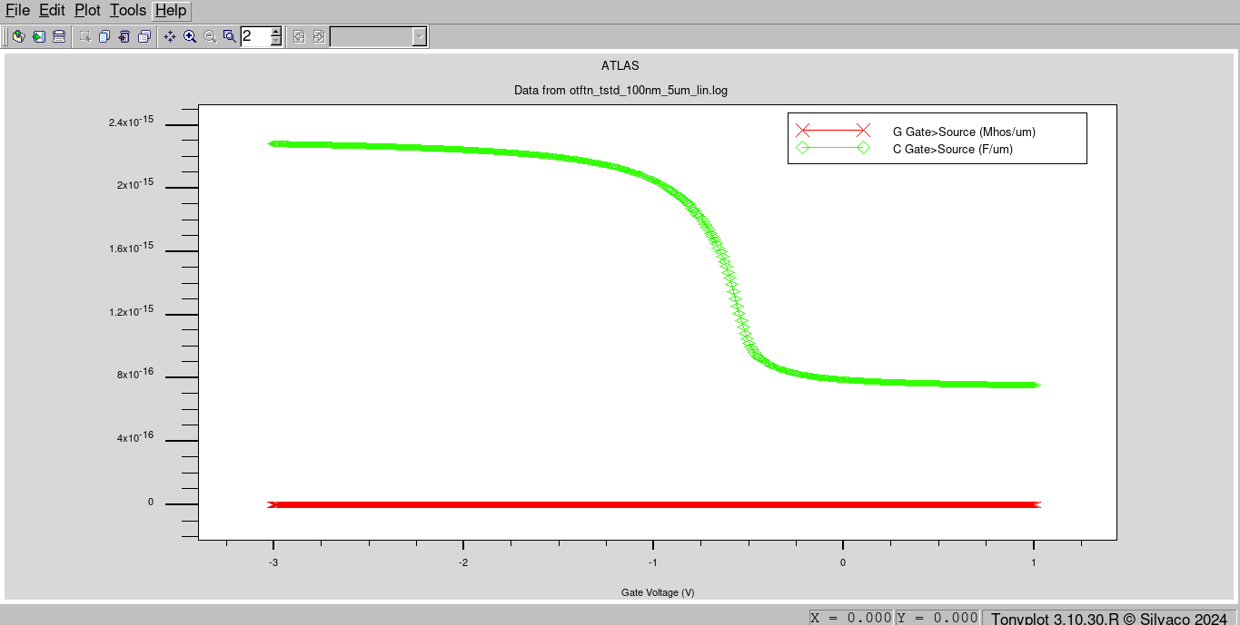

ORIGIN SOFTWARE

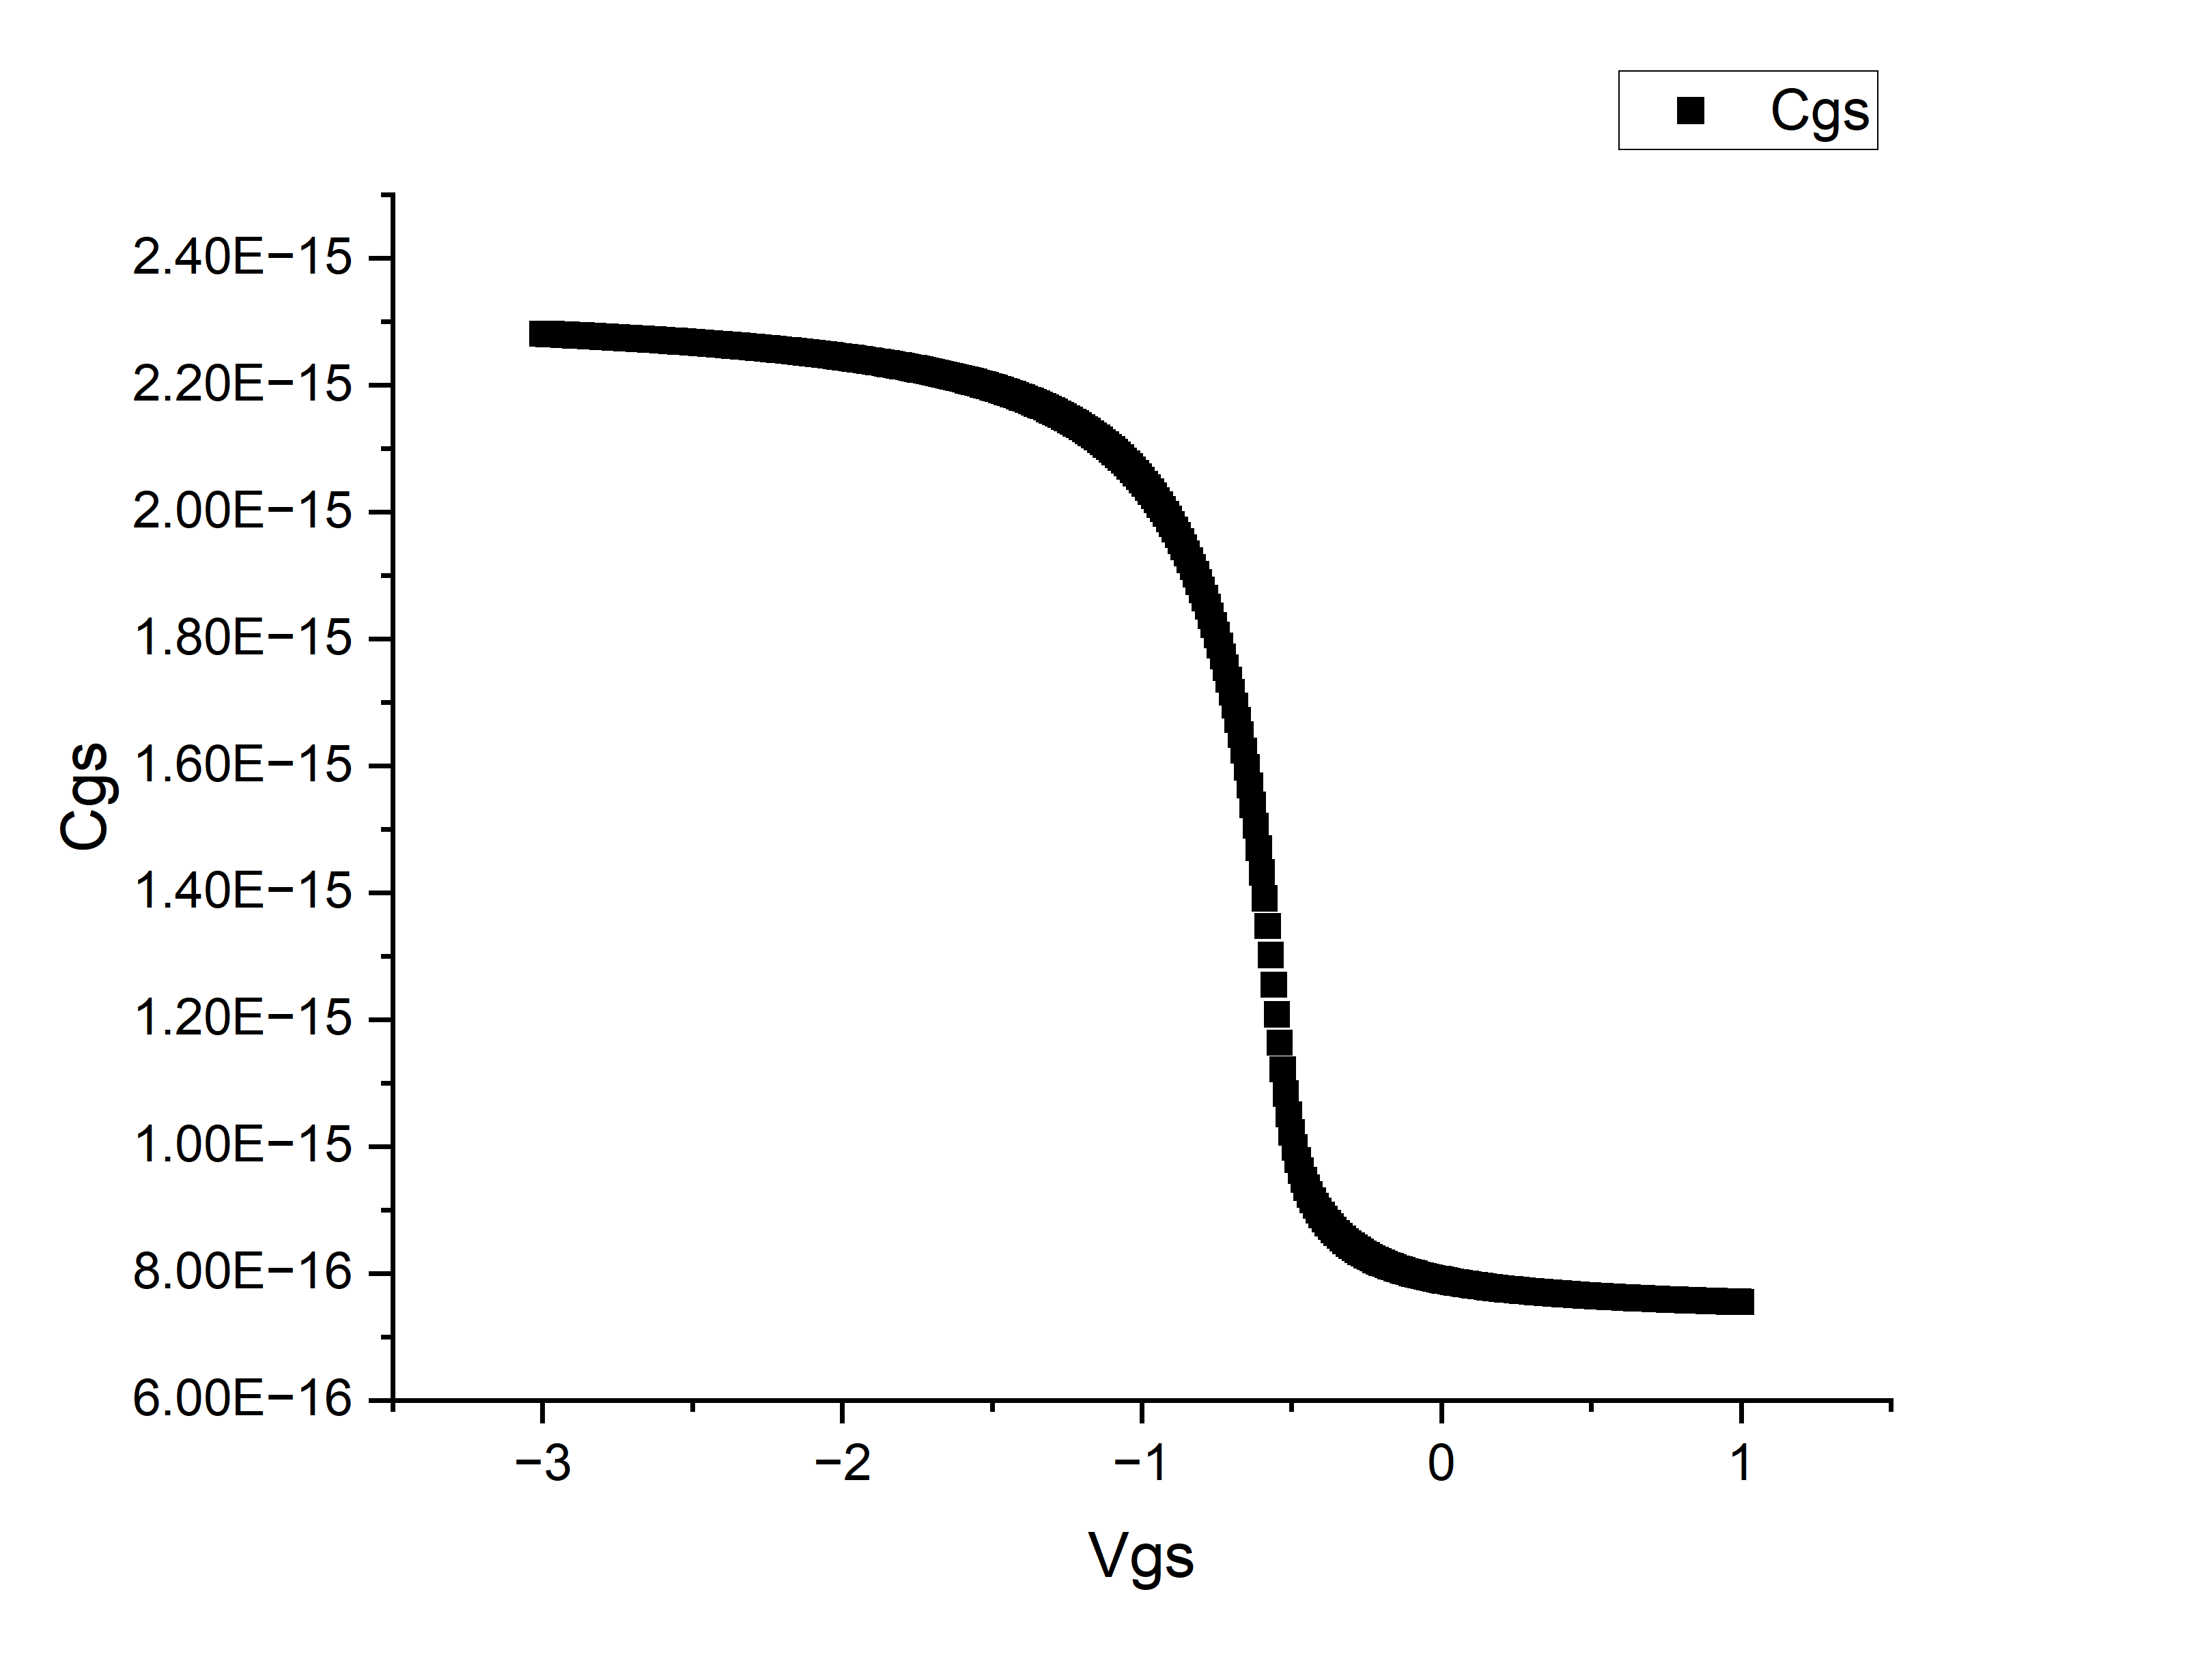

Id vs Vgs

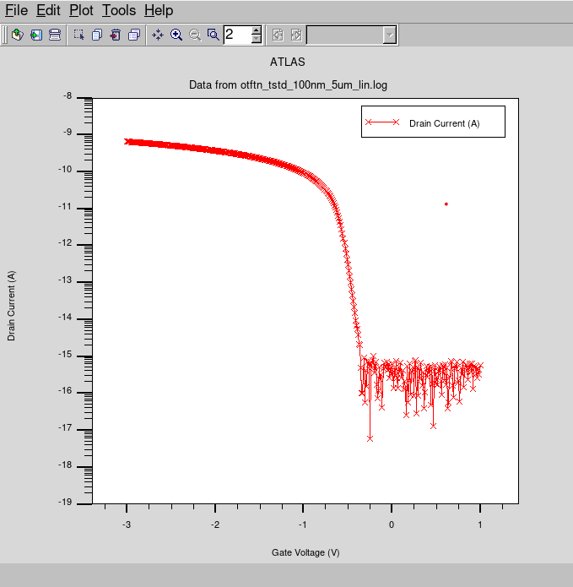

**Id vs Vds**

**(Code)**

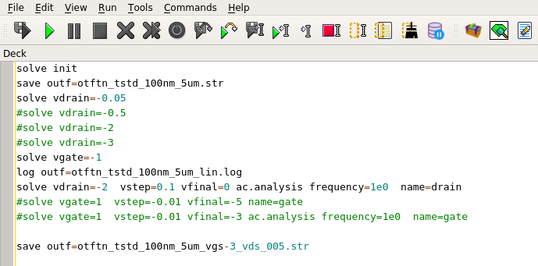

(Tonyplot)

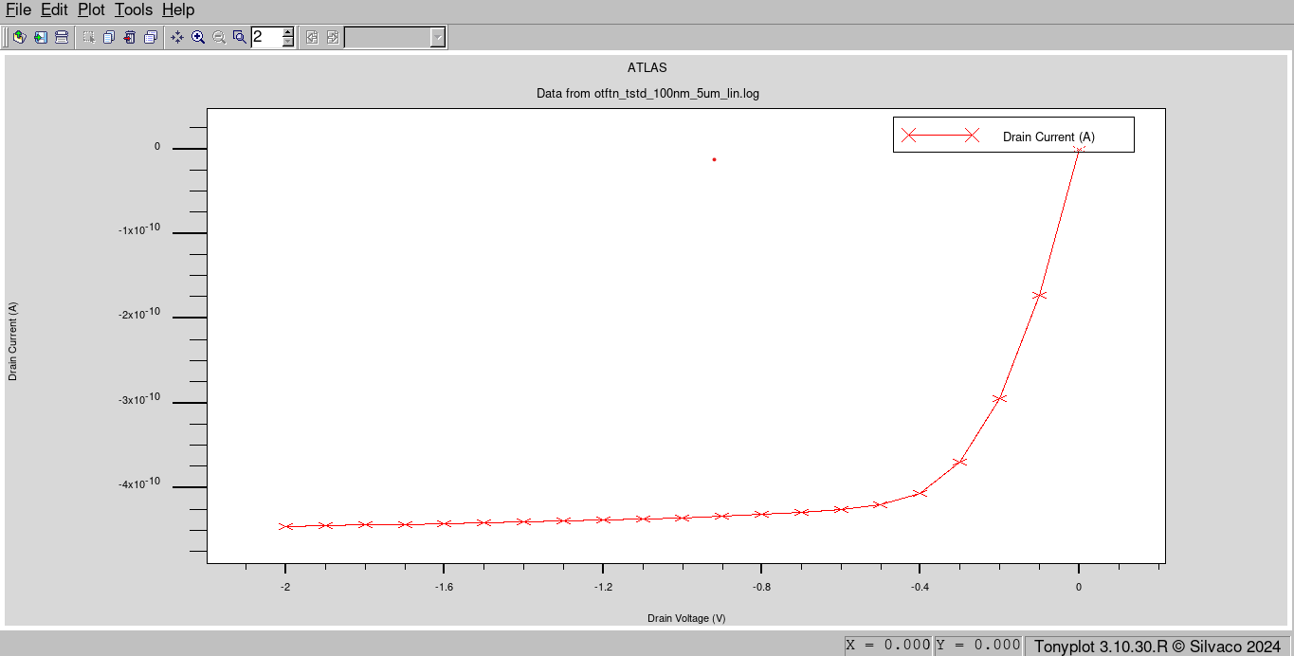

(Origin)

