For microservices: 2 EC2 instance, 1 for wordpress and 1 for MYSQL

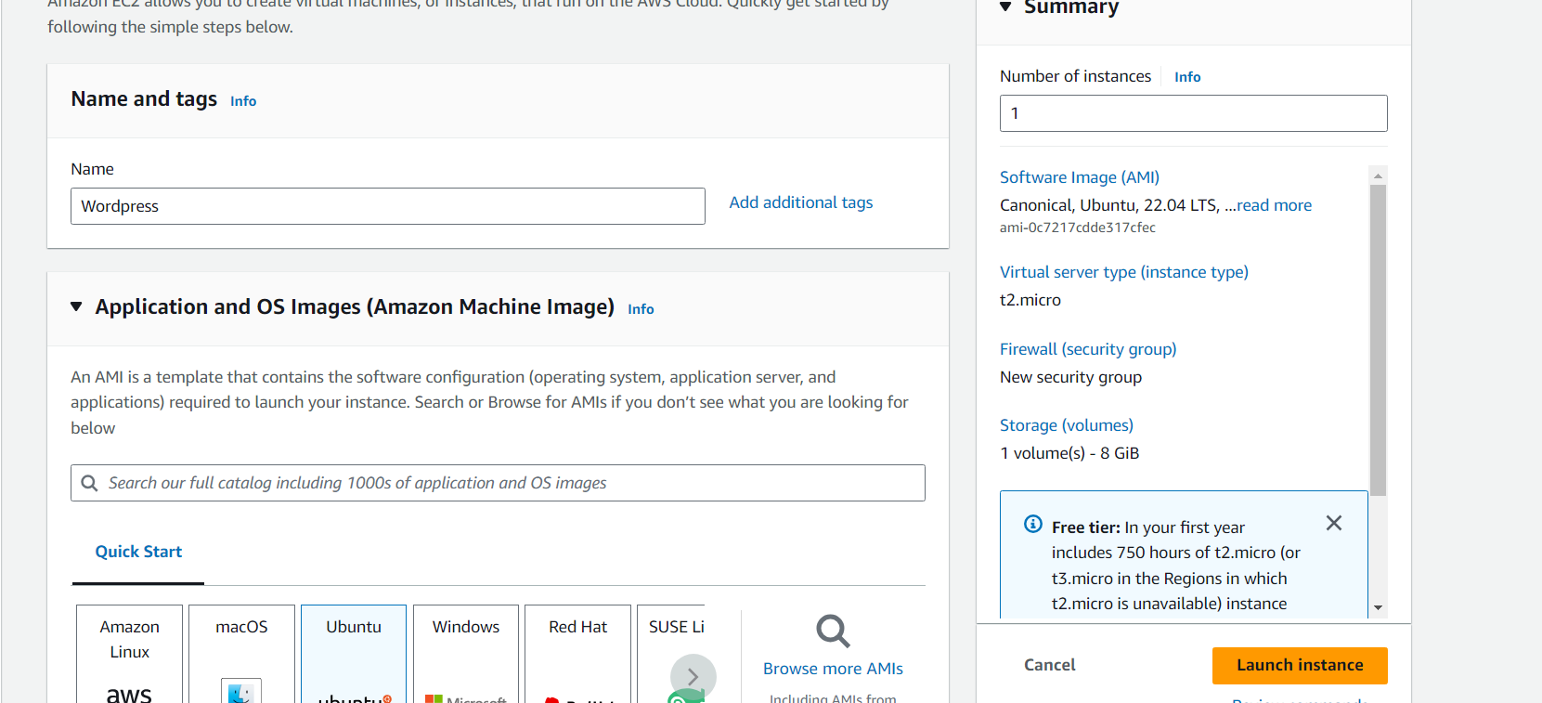

## Allow the Required Port to Access

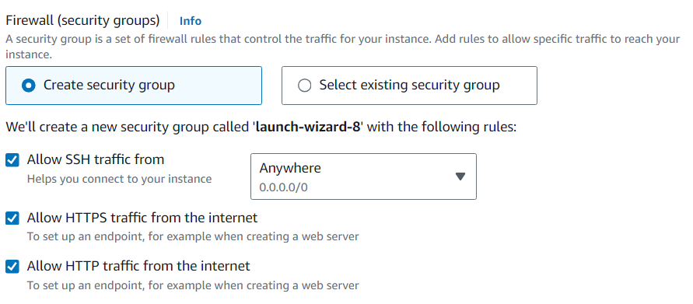

After connect the terminal and Install Dependencies

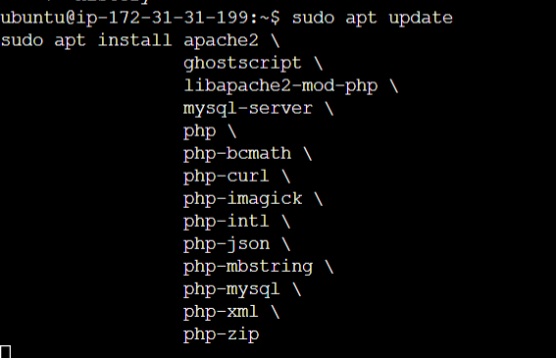

## Install WordPress

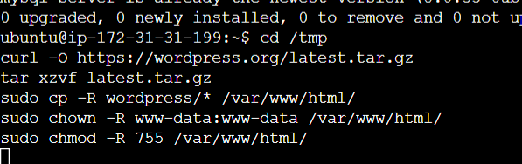

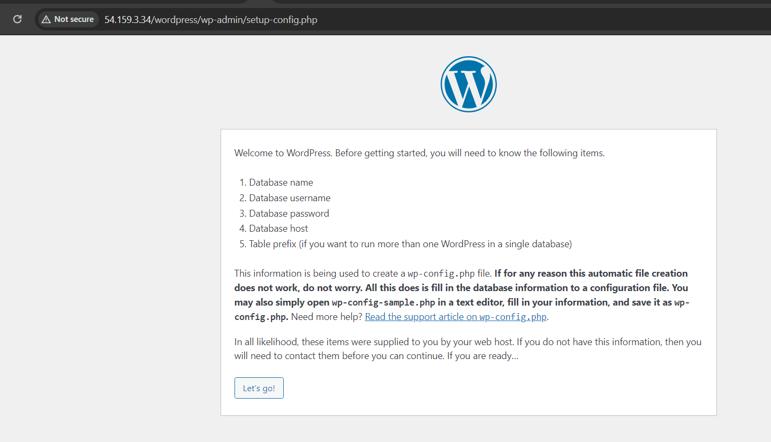

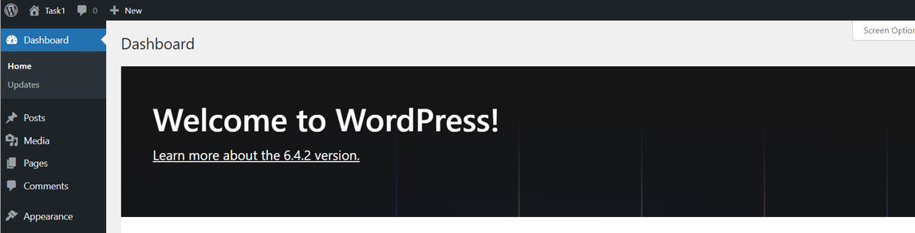

Create the Instance for My SQL/For microservices:

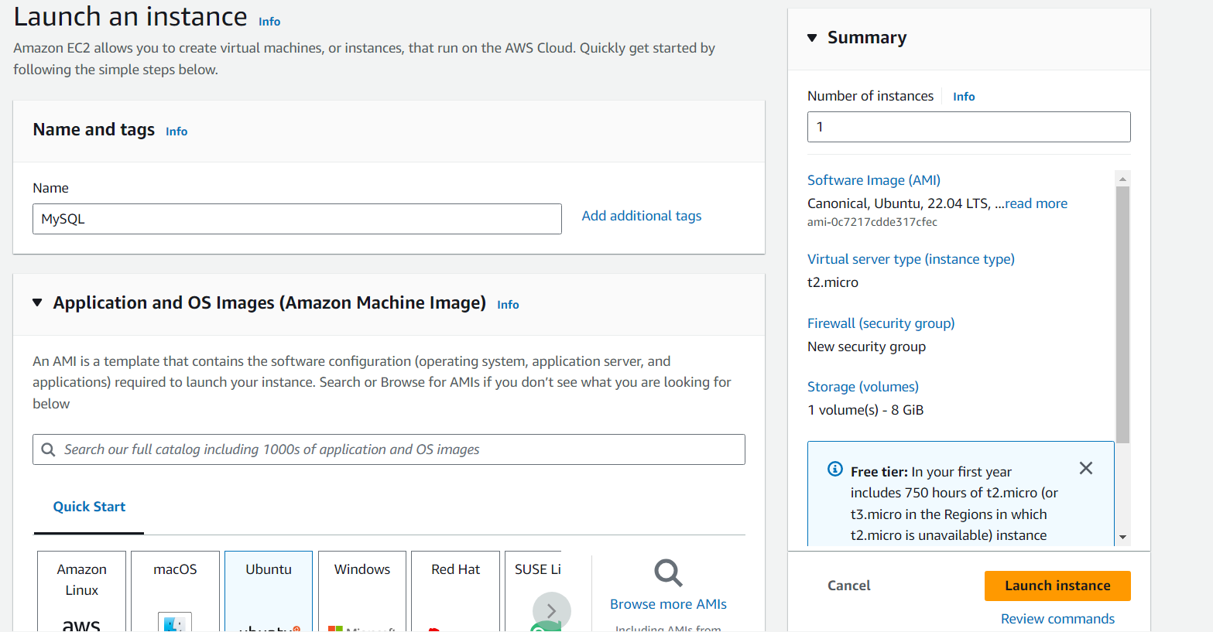

Connect the Ec2 machine 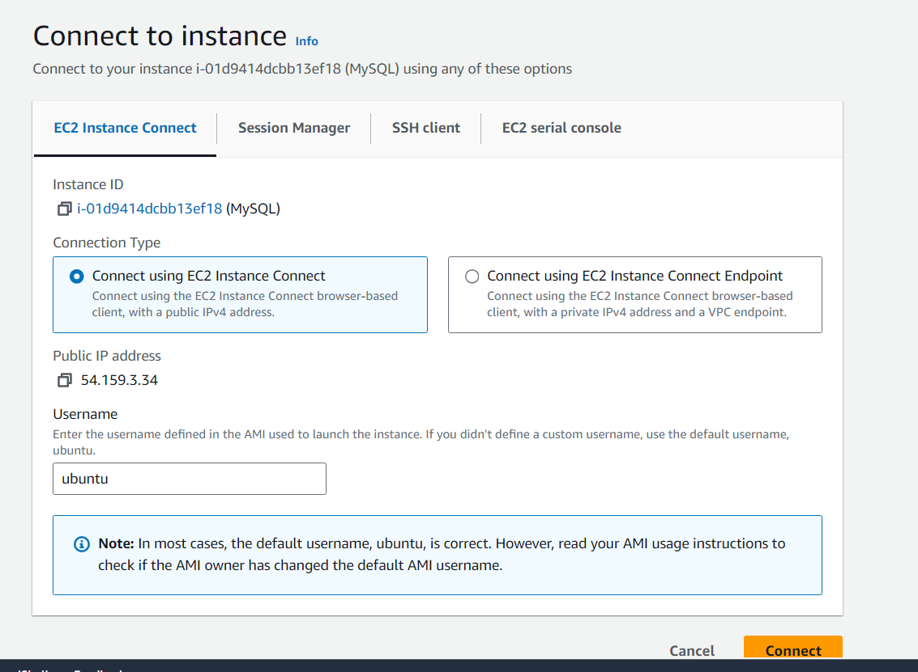

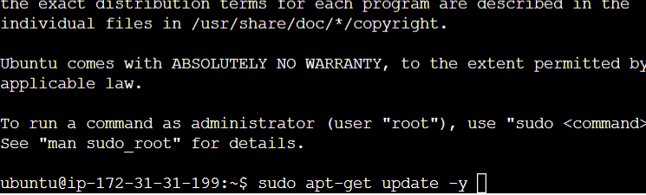

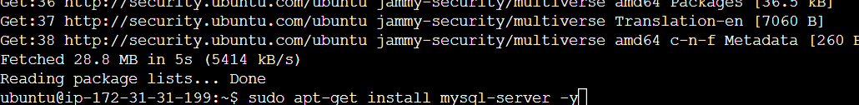

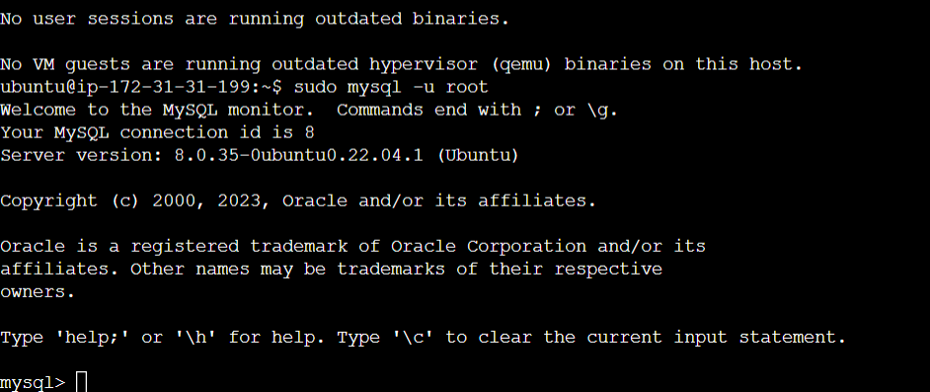

Task 2 completed