Eureka Service registry URI shows registered services. It is running in port 8761

UI: <http://localhost:8761>

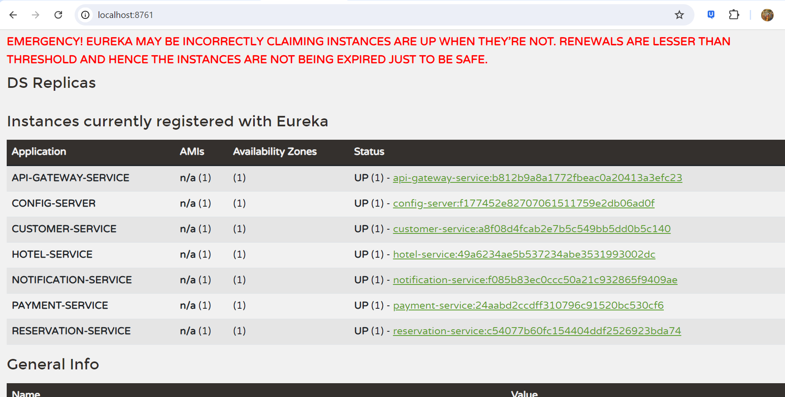

API Gateway Server testing which is running in 8072

All 5 services have been configured in API Gateway

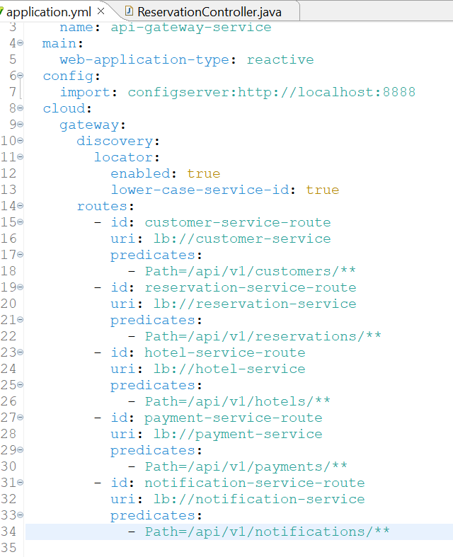

API Gateway is routing request to customer-service

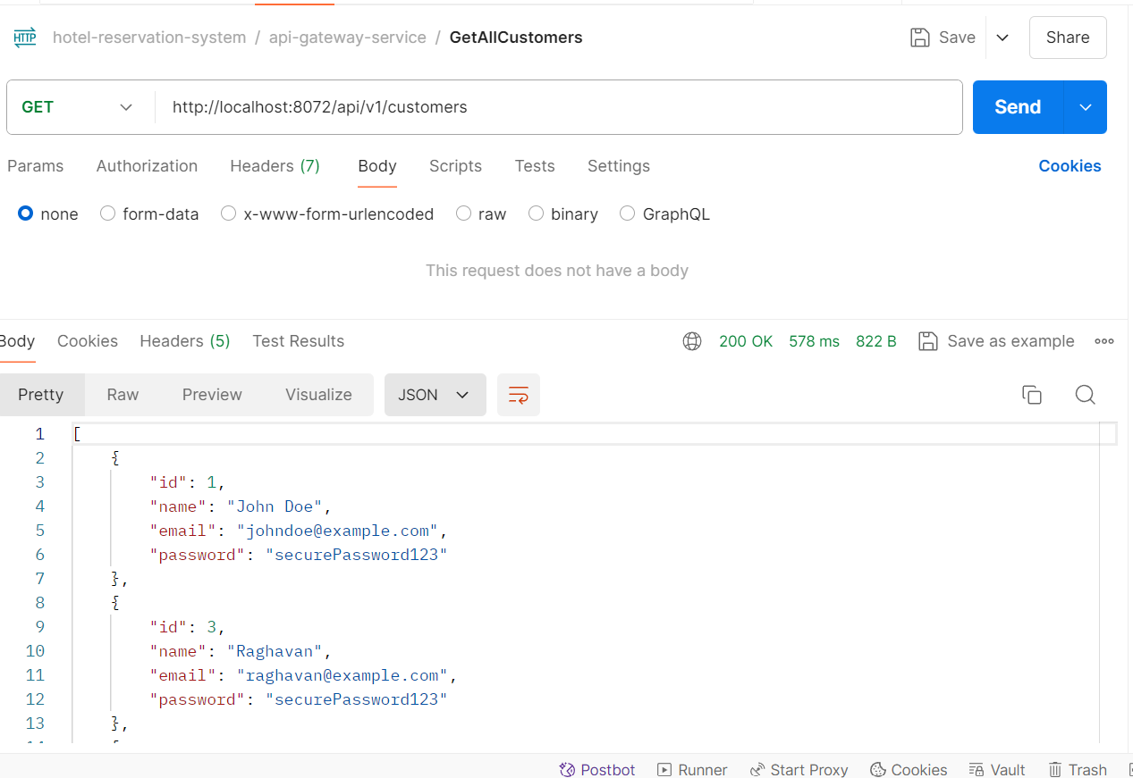

Zipkin Tracing

We can see TraceId and SpanId is added in logs

