Nexus vs. Hub
Does splitting one AI agent into five actually help?
A plain-English comparison of two post-hospital recovery co-pilots · June 2026

The one-line takeaway
I built the same product two ways — Nexus, with five specialist agents, and Hub, with a single agent doing the same work — and measured both on identical inputs. Result: the two cost and perform almost exactly the same, but Hub is built with far less plumbing. For this kind of step-by-step task, splitting the work into five agents did not make it cheaper, faster, or smarter — it mainly added wiring.

What each system does
Both are the same product: you upload a hospital discharge summary, and the system builds a 30-day recovery plan, runs a daily symptom check-in, and raises an alarm if something looks dangerous. They use the same tools, the same instructions to the AI, and the same AI model. The ONLY difference is how the work is organized internally.
Nexus — the team of five specialists
- Intake Agent — Reads the discharge PDF and pulls out the key facts.
- Care Plan Agent — Turns those facts into a plain-language recovery plan and checks the medicines.
- Monitoring Agent — Reviews each daily check-in and rates it green, yellow, or red.
- Escalation Agent — Decides how urgently to act on a red flag (up to a 911 screen).
- Admin Agent — Sends reminders and weekly summaries.
Hub — the single capable generalist (plus one specialist)
- One Recovery Agent does intake, care plan, monitoring, and admin — the same four jobs, just inside one component instead of four.
- The Escalation step is kept separate on purpose — it is the only step that can take a real-world action (send an SMS, show a 911 screen), so it deserves its own clear gate.

The two designs, side by side
Nexus splits the job into five boxes wired across two separate flowcharts:
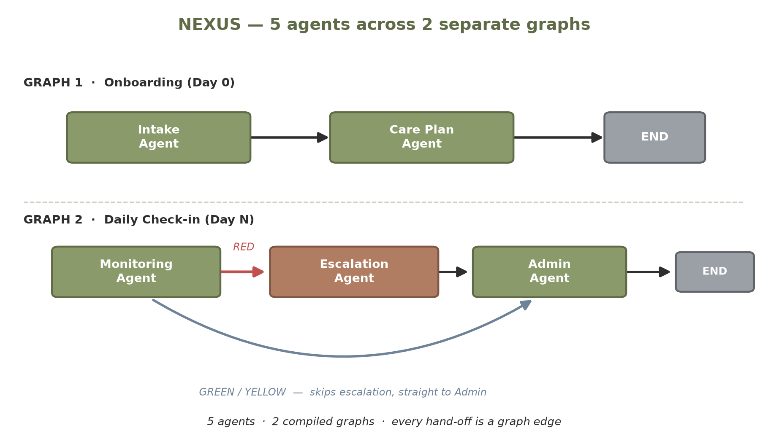

Hub folds the four routine steps into one box and keeps a single real connection — the hand-off to Escalation:
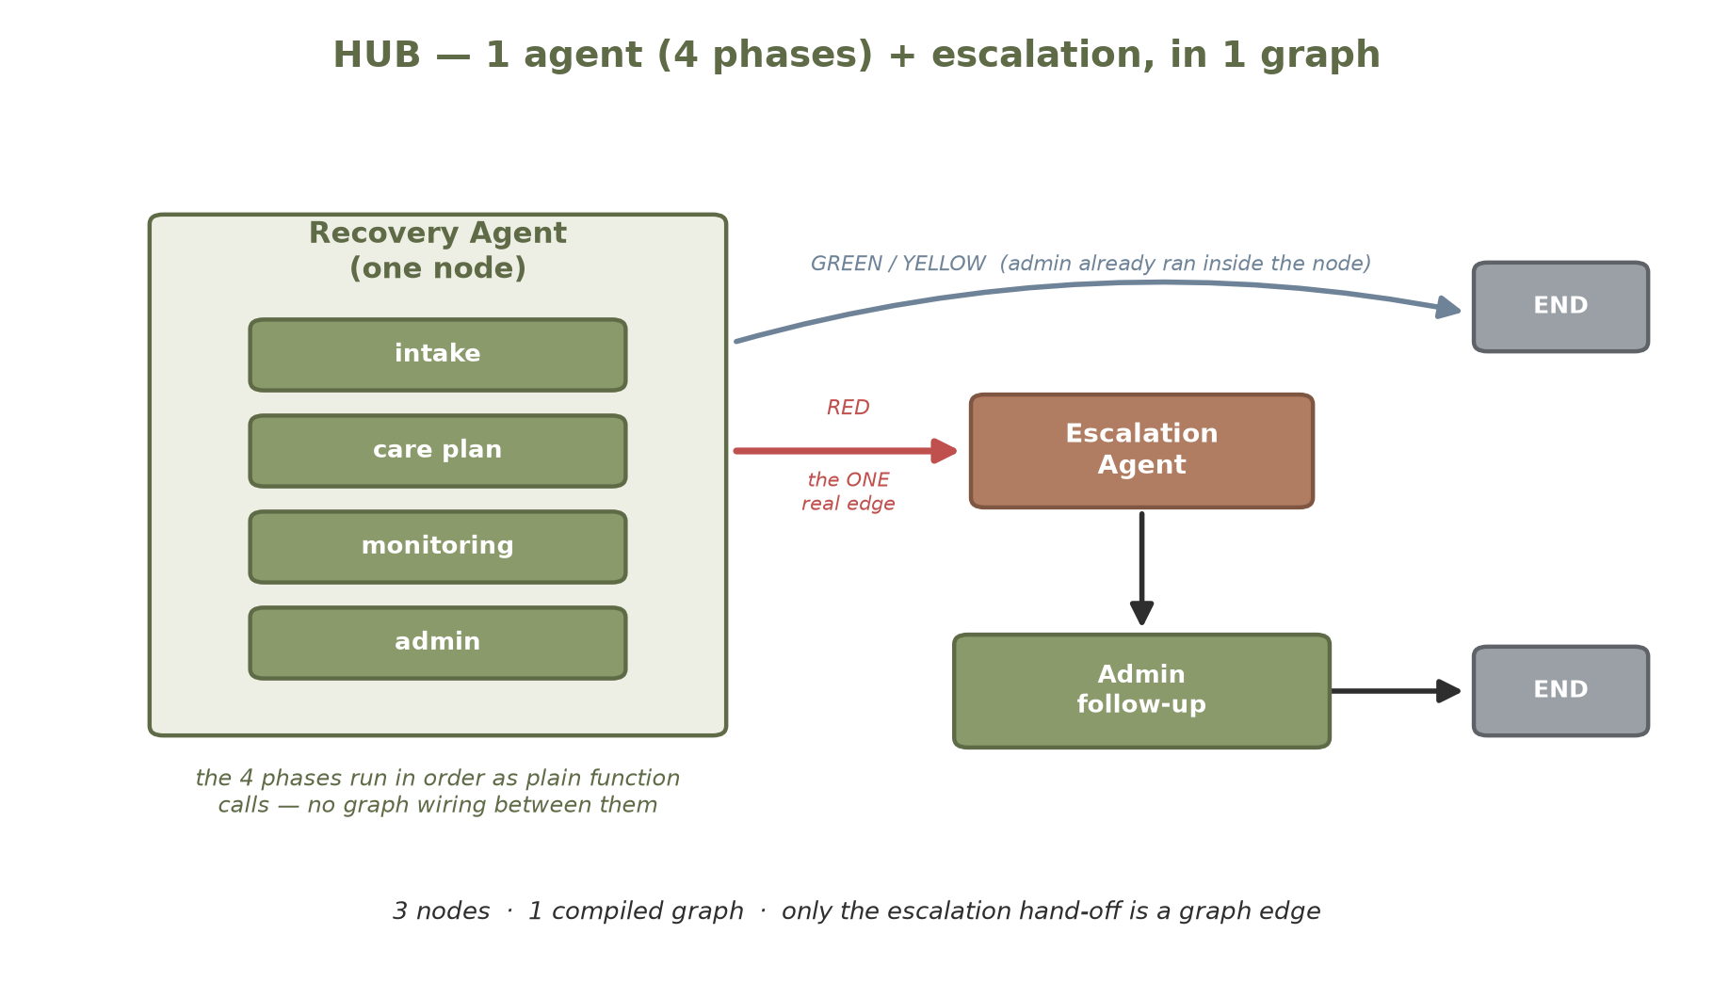
The plain-English difference: in Nexus, the work passes between five separate boxes, and every hand-off is a wired connection that has to be built and maintained. In Hub, the routine steps simply happen one after another inside a single box (ordinary code, no wiring), and only the decision that can trigger a real-world action — escalation — is kept as its own box with a real connection.

How I tested it
To compare fairly, both systems ran the exact same inputs: the same patient discharge summary (a heart-failure case), then a daily check-in. I did this twice — once with a normal 'all good' (GREEN) check-in, and once with a 'chest pain' (RED) check-in that triggers the emergency path. Every call to the AI was measured for word count, cost, and time.

The numbers
Run 1 — normal 'all good' (GREEN) check-in
Metric | Nexus (5 agents) | Hub (1 agent)
Claude (AI) calls | 3 | 3
Words in (input tokens) | 2,456 | 2,454
Words out (output tokens) | 3,078 | 2,761
Cost (USD) | $0.0535 | $0.0488
Time taken | 45.8 s | 42.4 s

Run 2 — 'chest pain' (RED) check-in that triggers the 911 path
Metric | Nexus (5 agents) | Hub (1 agent)
Claude (AI) calls | 3 | 3
Words in (input tokens) | 2,473 | 2,470
Words out (output tokens) | 3,004 | 2,986
Cost (USD) | $0.0525 | $0.0522
Time taken | 48.5 s | 48.5 s

How the systems are built (this is where they really differ)
Build complexity | Nexus | Hub
Agents / nodes | 5 | 3
Compiled graphs | 2 | 1
Graph edges (fixed) | 3 | 2
Graph edges (conditional) | 2 | 1
Orchestration code (lines) | 56 | 41

What I found
- Cost and speed are basically the same. Across both runs, total cost differed by less than half a cent and time by seconds. Splitting into five agents bought no measurable cost or speed advantage.
- The AI did the same amount of work. The amount of information sent to the AI — the part the design actually controls — was identical to within 2 words out of ~2,450. The small differences in cost come from the AI writing a slightly longer or shorter care plan on a given run (normal variation), not from the architecture.
- Hub is simpler to build. Hub uses 3 building blocks instead of 5, one flowchart instead of two, and about 15 fewer lines of wiring code. Less to build, less to break.
- The one boundary that matters still works. A red 'chest pain' check-in produced the same outcome in both — a 911 screen — using the exact same emergency logic. Keeping that one step separate is the part of the multi-agent design that genuinely earns its place.
- The trade-off: Nexus's five separate boxes make it a little easier to see which step a problem came from (each prints its own label). That is the main thing you give up by consolidating.

Bottom line
For a task like this — a fixed sequence of steps all working on one patient's data — the five agents were really a pipeline, not five independent experts. Collapsing them into one agent kept the cost, speed, and results the same while cutting the plumbing roughly in half. The lesson is not 'never use multiple agents' — it is 'add an agent boundary only where it earns its keep.' Here, exactly one did: the escalation gate that can take a real-world action. Hub keeps that one and drops the rest.

A note on one quirk I deliberately kept
In Nexus, the Admin step (appointment reminders and weekly summaries) runs at the end of every daily check-in — including right after a red 'call 911' alert. That happens because Admin is the shared 'end of the day' step that every check-in passes through; on a red day the system simply inserts the Escalation step in front of it. It is harmless (Admin makes no AI call and usually has nothing to do), but on a genuine 911 it is a little tone-deaf to follow an emergency screen with a routine appointment reminder.
I kept this behaviour in Hub on purpose, so the two systems behave identically and the comparison stays fair. It is also a neat illustration of the project's whole point: a fixed multi-step pipeline can carry a step into a moment where it does not really belong, simply because that is how the flow is wired. A real product would gate Admin so it is skipped during a true emergency.

Questions you might have
Q. Why keep the Escalation step as its own separate piece, but merge the other four?
A. Escalation is the only step that can take a real-world action — send a text message or show a 911 screen. Every other step just has the AI reason about the patient and hand the result to the next step. A clear, separate gate in front of the one step that acts in the real world is worth the extra structure; splitting the purely-internal steps apart is not. Hub keeps that one boundary and drops the rest.
Q. How does the system decide green / yellow / red — and why does a red check-in still cost only one AI call?
A. A single AI call reads the day's answers and labels them green (all good), yellow (worth noting), or red (urgent). Only that one call uses the AI. Everything that follows a red — deciding the urgency level, showing the 911 screen, drafting a message — is plain rules and templates, with no AI. So a dramatic red day costs the same single AI call as a calm green one.
Q. Why doesn't a yellow flag trigger an alert?
A. Yellow means 'a little off' — a missed dose, a mild symptom — something to note and watch, not to act on. It is recorded and shown, but it deliberately does not page anyone. Only red, which means an emergency warning sign, triggers the escalation path. (Several yellows in a row are designed to be raised to red by the monitoring step.)
Q. The emergency level keys off words like 'chest pain'. What if someone describes an emergency differently?
A. The urgency levels (up to the 911 screen) are decided by matching the patient's words against a list of keywords. This is simple and predictable, but it is a known limitation: if a serious symptom is described in unusual wording that is not on the list, it can be under-rated. This is identical in both systems (the emergency code is copied byte-for-byte), and it is the clearest place a real product would replace keyword-matching with something smarter.
Q. There is a second AI (a Llama model) that runs but its result is not shown — why?
A. My project brief had a requirement: use at least one AI model that isn't Claude. To satisfy that, the care-plan step also asks a second model (Llama) to draft a plan — but the app ignores Llama's version and always shows Claude's. Llama's draft is just printed to the logs and thrown away. It runs off to the side (in the background) so it never makes you wait, and if its access key isn't set up it simply skips. It is left out of the cost comparison on purpose: the comparison is about the Claude pipeline, and the Llama call is only there to tick the requirement box.
Q. Why does my data disappear when I restart the app?
A. These are demos. The current patient's information lives in the app's memory only for the session, so restarting clears it and you begin again from onboarding. Every sample patient is synthetic — there is no real patient data anywhere.
Q. Why aren't the text messages and emails actually sending?
A. Real sending needs phone (Twilio) and email (Gmail) accounts configured. Without them — or on a free trial — those steps simply log 'skipped' and carry on, by design, so a missing account never crashes a check-in. The on-screen guidance, including the 911 screen, still appears.
Q. Are the dollar figures exact?
A. They are calculated from the AI's word counts using standard published rates, so treat them as close estimates, not a bill. The most reliable signal in the comparison is not the dollar amount (which wobbles a little because the AI writes a slightly different-length plan each run) — it is the amount of information sent in, which the design controls and which came out essentially identical.
Q. Why doesn't the long-term 'memory' feel smart about recalling past details?
A. The memory store uses a simplified, placeholder method for indexing text rather than true meaning-based search. It reliably stores and looks up a patient's records, but it will not do clever 'find anything similar' matching. This was carried over from Nexus unchanged on purpose — improving it is a separate exercise from the single-versus-multi-agent question this project is about.

Appendix — per-step detail
GREEN run, broken down by step (input / output words, cost, time):
Step | Nexus in/out | Nexus cost | Hub in/out | Hub cost
Intake | 799 / 775 | $0.0140 | 798 / 794 | $0.0143
Care plan | 1005 / 2188 | $0.0358 | 1005 / 1860 | $0.0309
Monitoring | 652 / 115 | $0.0037 | 651 / 107 | $0.0036

Note: 'words in/out' are the AI's tokens; care-plan output varies run-to-run, which is the main source of the tiny cost gap. Escalation and Admin make no AI calls, so a red check-in still costs just one AI call — the emergency routing is free.

