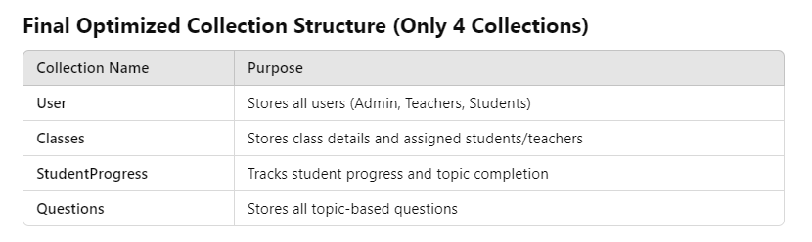

### ****User Collection (Stores All Users: Admin, Teachers, Students)****

**Purpose**: Stores authentication details and user roles (Admin, Teacher, Student).

{

"_id": "<Auto-generated MongoDB ID>",

"name": "<Full Name>",

"email": "<User Email>",

"password": "<Hashed Password>",

"type": "<student | teacher | admin>",

"grade": "<Grade Level (only for students)>",

"gender": "<Male | Female | Other (only for students)>",

"school_name": "<School Name (only for students)>",

"assigned_classes": ["<Class ID 1>", "<Class ID 2>"] (only for teachers),

"creation_timestamp": "<Timestamp>"

}

### ****Classes Collection****

**Purpose**: Stores class details, student enrollments, and teacher assignments.

{

"_id": "",

"class_id": "",

"class_name": "",

"grade_level": "",

"academic_year": "",

"subject": "",

"teacher_id": "",

"students": ["", ""],

"status": "",

"created_at": "",

"updated_at": "",

"schedule": {

"day": "",

"start_time": "",

"end_time": ""

},

"max_capacity": "",

"description": ""

}

### ****StudentProgress Collection****

**Purpose**: Tracks student progress, including assigned topics, difficulty levels, and performance.

{

"_id": "",

"student_id": "",

"class_id": "",

"topic": "",

"sub_topic": "",

"difficulty": "",

// Enhanced tracking fields

"session_data": [

{

"session_id": "",

"start_time": "",

"end_time": "",

"questions_attempted": [

{

"question_id": "",

"difficulty": "",

"response_time": "",

"is_correct": "",

"attempt_timestamp": ""

}

],

"duration": ""

}

],

// Aggregated metrics

"performance_metrics": {

"total_questions_displayed": "",

"total_questions_correct": "",

"accuracy_percentage": "",

"average_response_time": "",

"difficulty_distribution": {

"easy": {

"attempted": "",

"correct": ""

},

"medium": {

"attempted": "",

"correct": ""

},

"hard": {

"attempted": "",

"correct": ""

}

},

"total_time_spent": "",

"last_activity": ""

},

// Progress tracking

"completion_status": "",

"completion_timestamp": "",

"mastery_level": ""

}

**Questions Collection**

**Purpose**: Stores questions, including multiple-choice answers, solutions, and difficulty levels.

{

"_id": "<Auto-generated MongoDB ID>",

"description": "Find the vector equation...",

"type": "SCQ",

"options": [

{"option_id": 1, "text": "<Option 1>", "is_correct": false},

{"option_id": 2, "text": "<Option 2>", "is_correct": true},

{"option_id": 3, "text": "<Option 3>", "is_correct": false},

{"option_id": 4, "text": "<Option 4>", "is_correct": false}

],

"solution": "Vector equation of the line...",

"difficulty": "UNMARKED",

"topic": null,

"sub_topic": "Section2",

"tags": [],

"topic_id": "test-data"

}

**Assignments Collection Schema**

Purpose: This collection would:

1. Track both student-wise and class-wise assignments
2. Link to both the StudentProgress and User collections
3. Allow tracking of individual student completions within class assignments
4. Support the teacher dashboard requirements for assignment management

{

"_id": "<Auto-generated MongoDB ID>",

"teacher_id": "<Teacher User ID>",

"assignment_type": "<student | class>",

// If student-wise assignment

"student_id": "<Student User ID>",

// If class-wise assignment

"class_id": "<Class ID>",

"subject": "<Subject Name>",

"topic": "<Topic Name>",

"sub_topic": "<Sub-topic Name>",

"status": "<pending | completed>",

"assigned_date": "<Timestamp>",

"completion_date": "<Timestamp>",

// For tracking which students have completed in class-wise assignments

"student_completions": [

{

"student_id": "<Student User ID>",

"completion_date": "<Timestamp>",

"progress_id": "<Reference to StudentProgress Collection>"

}

],

// Optional fields for assignment management

"due_date": "<Timestamp>",

"instructions": "<Assignment Instructions>",

"difficulty_level": "<easy | medium | hard>",

"is_active": "<boolean>"

}