Permission
Code
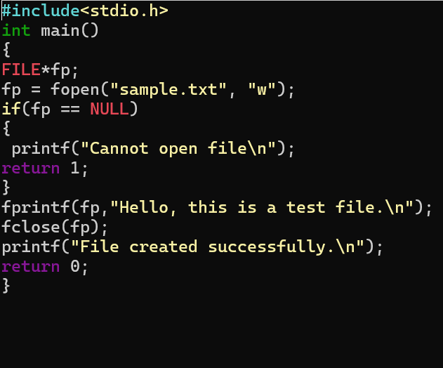
Output
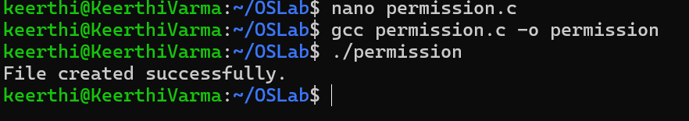

Task of the day
Task-1(Give Read and Write only to the owner)
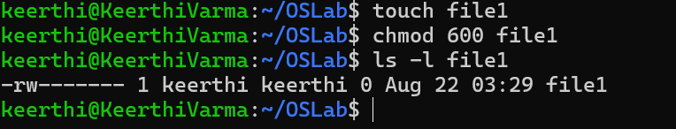
Task-2(Give Read and Write to the owner and group)
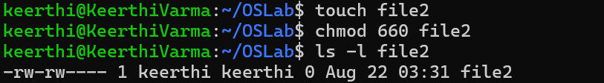

Task-3(Only owner can read and write)
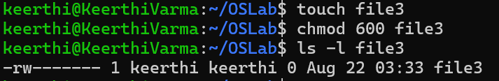

Task-4(Owner read/write, everyone else read-only)
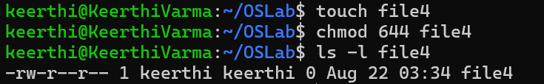

Task-5(Owner can do everything, others can only read and execute)
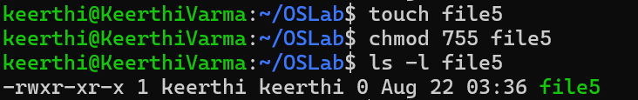

Task-6(Owner and group can read/write)
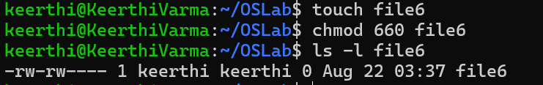

Task -7(Only owner can execute)
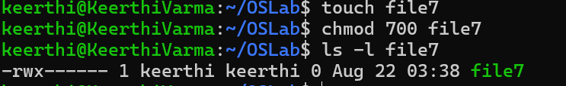

Fill in the permission numbers for the following:
8) Owner: read + write; Group: nothing; Others: nothing → chmod 600
9) Owner: read + write; Group: read; Others: read → chmod 644
10) Owner: read + write + execute; Group: read + execute; Others: read + execute → chmod 755
11) Owner: read + write; Group: read + write; Others: nothing → chmod 660
12) Everyone: read only →chmod 660

