1. Confirm the jre path by checking the tomcat status

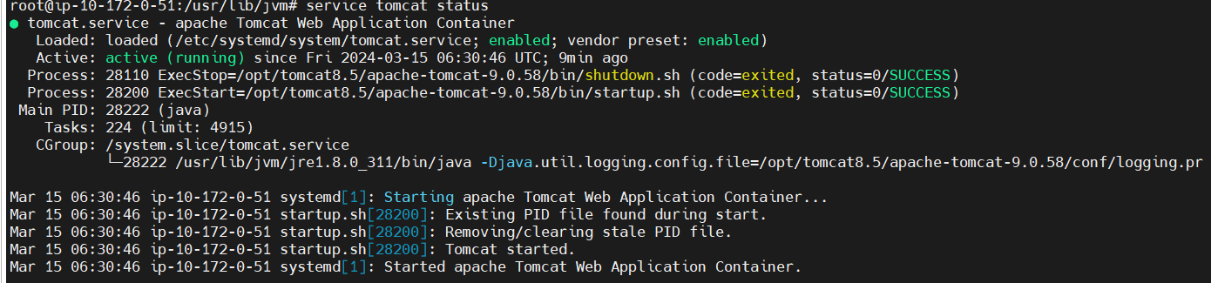

/usr/lib/jvm/jre1.8.0_311/bin/

1. Go to this path /usr/lib/jvm/jre1.8.0_311/lib/security
2. Run the below command to import the certificate
3. keytool -import -file "/home/ubuntu/FidoTrail.crt" -alias "fido2cert" -keystore "/usr/lib/jvm/jre1.8.0_311/lib/security/cacerts" -storepass "changeit"

