**Steps and Prerequisites:**

1. Components/Services Names which we want to restart (Apache2, tomcat, schedular tomcat etc.)

2. Server IP’s and login Usernames with root access. (By default, root)

3. Password less login (SSH) connectivity between the servers and local server itself (where we run the script)

4. Once, we established the SSH connectivity, Run the script from any node.

Ex: CI node

**Script flow,**

1. Define all the required variables.
2. Define Hazelcast node variables.
3. Check whether the hazelcast service is running or not, if running stop, the service and wait for 10seconds
4. Start the hazelcast service.
5. Login into each server with SSH command “username@Host IP” and check all the components individually and restart the service if it is present in the server.

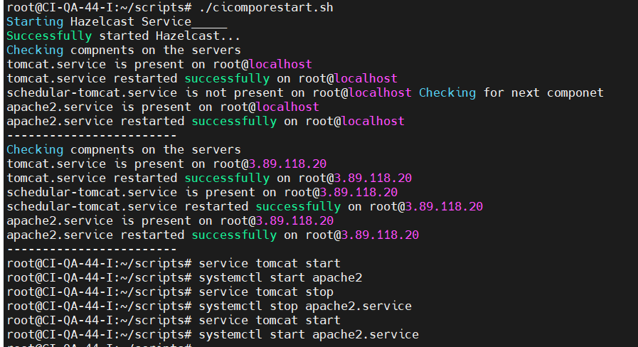

**NOTE:** While we are starting Hazelcast from Remote server, The service is starting with the help of hazelcast CLASSPATH (You can find it in /hazelcast-3.12.8/bin/start.sh file)

* **Hence it will take default group name as “dev”.** We need to change the **hazelcast-default.xml** configuration file from the below file path.

**CLASSPATH="$HAZELCAST_HOME/lib/hazelcast-all-3.12.8.jar:$HAZELCAST_HOME/user-lib:$HAZELCAST_HOME/user-lib/*"**

**"$HAZELCAST_HOME/lib/hazelcast-all-3.12.8.jar**

**To change the default group name,**

1. Extract the **hazelcast-all-3.12.8.jar** file into temporary directory

unzip **hazelcast-all-3.12.8.jar** -d temp_directory

1. Find the filename **hazelcast-default.xm**l file and change the group name as your environment save the file and exit.

vim **hazelcast-default.xm**l

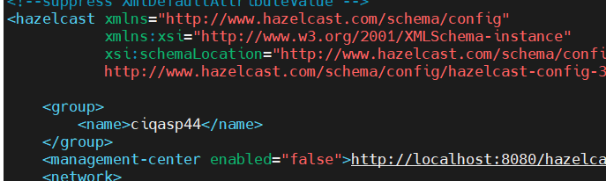

1. Zip the file after modification.

cd /temp_directory

Zip -r ../**hazelcast-all-3.12.8.jar \***

1. Replace the updated jar file to the actual classpath

**"$HAZELCAST_HOME/lib/hazelcast-all-3.12.8.jar/**

1. Now the script will start the hazelcast with the actual GroupName successfully.