**Bank Credit Risk Prediction**

Wireframe Document

Home Page

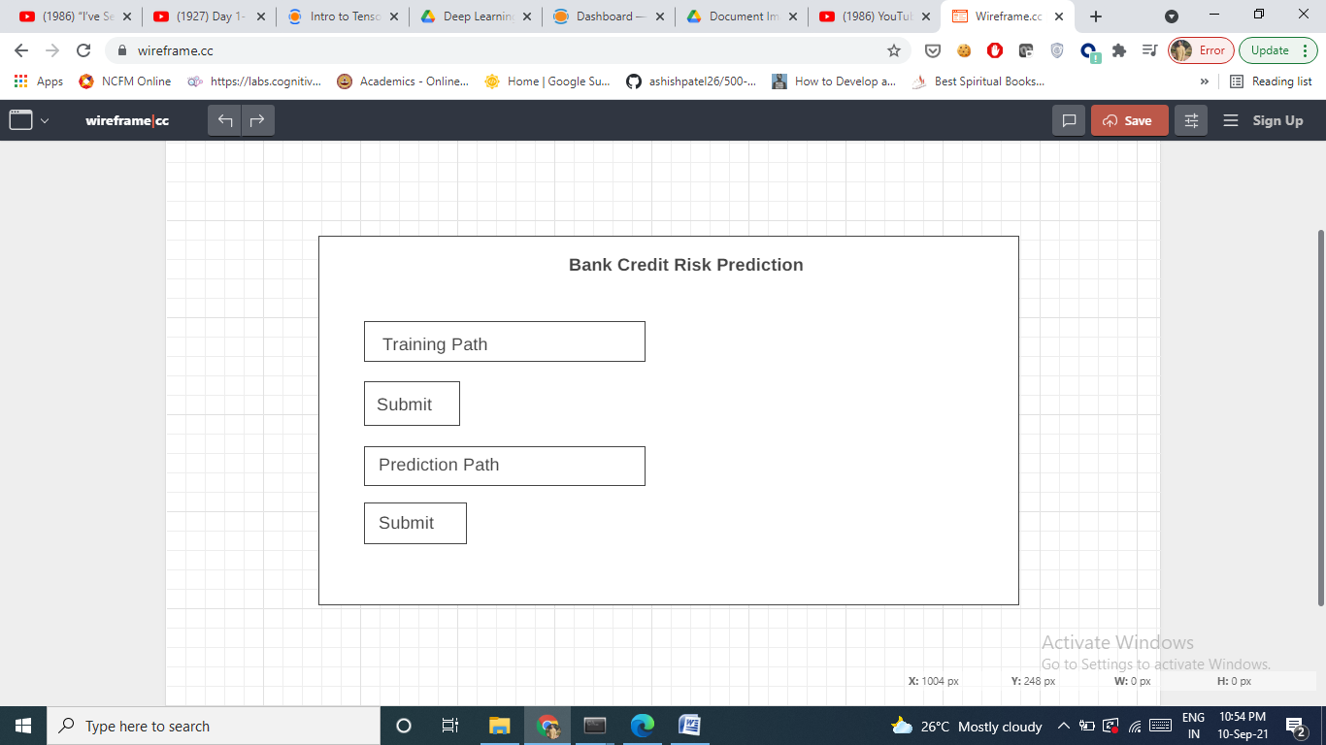

Here we will put the training path and click on submit. This will train our model. After that we will put the prediction file path and click submit button. The result will be calculated and will be saved in a folder.