ECE 270 (Spring 2022)

Homework 3

Due on 02/04/2022 (Friday) by 11:59 pm sharp on BrightSpace.

Note: Only legibly handwritten or typed submissions in PDF format are allowed.

You should work alone (no discussion)

1. Prove the consensus theorem and its dual by using other switching algebra theorems.
2. A mechanical wheel consists of 3-bit binary-coded numbers. List all possible values that can be detected by the encoder if the contact falls at the boundary between 001 and 010 as shown in the figure. How can we reduce this error?

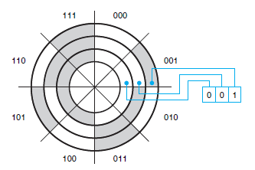

1. Show that an n-input OR gate can be replaced by (n−1) 2-input OR gates.
2. F is called a self-dual logic function when F = FD, where FD  is the dual form of F. State with proof if the following function is self-dual or not.

F = (A + B) . (B + C) . (C + A)

1. Use DeMorgan’s theorem to find F’ where F = (X’ . Y ) + (X + Y’).
2. Show that ( W . (X’ + Y’) + X’ . (X’ + Y’) ) . (W’ + X . Z) = W . X . Y’ . Z + W’ . X’ using axioms and theorems.
3. How many logic functions can be formed using 3 variables?
4. Draw the truth table for the function F(P,T,Z) = P.T’.(P + Z).
5. Write Canonical Sum and Product equations for the function ‘F’ described in question 8.
6. Write Canonical Product equation for F(A,B,C,D) = ∑ (0,1,4,5,7,9,12).