Initial Project Proposal

Year: 2024 Semester: Spring Project Name: KayO

Creation Date: October 20, 2023 Last Modified:

Team Members (#1 is Team Leader):

Member 1: Raghav Kumar Sudharshan Kumar Email: rsudhars@purdue.edu

Member 2: Yolanda Chen Email: chen3633@purdue.edu

Member 3: Jessica Wong Email: wongjt@purdue.edu

Member 4: Minh Nguyen Email: nguye599@purdue.edu

1. Description of Problem:

People are trying to make game controllers feel like the old arcade days---comfortable and fun, especially for fighting games. [1] The objective of fighting game controllers is to make the experience of playing fighting games even more exhilarating and reminiscent of those thrilling moments spent in arcades. This evolution significantly affects a community of people known as the Fight Game Community (FGC), a passionate group of players that regularly meet for tournaments and various events. Beyond the direct circle of players, game developers are also influenced by these advancements. With the introduction of Arcade controllers, they are inclined towards creating games that complement these retro controllers. One of the big reasons for the rise in this type of controller is the comfort that it provides. The Xbox and PlayStation controllers that are so prevalent now can cause tremendous stress to the wrists while playing these games thanks to their button placement. This drives passionate players to make a switch to the more ergonomic arcade controllers but thanks to patents and the small number of sellers for this type of controller the prices can be exorbitant as shown later in this document. Therefore, our project proposal includes an ergonomic fighting game controller that aims to bring back the retro design of classic arcade setups, catering to the needs of the FGC at a reasonable cost, and ensuring compatibility for future games.

2.0 Proposed Solution:

Our vision is to make a fighting game controller with the classic feel of the arcade with modern connectivity capabilities. In addition to the necessary input devices, like buttons and a joystick, we will also have an LED display panel on the surface of the controller for displaying any pixel animations, battery percentage or some other media of the user’s choice. The LED panel is customizable, allowing user personalization. By offering both USB and Bluetooth options, this controller ensures seamless integration with your personal computer. More than just a nod to nostalgia, it’s designed to provide comfort and convenience wherever possible while ensuring high performance, ensuring that players can fully immerse themselves in their games. With this, we aim to provide both a trip down memory lane and a reliable tool for the avid gamer.

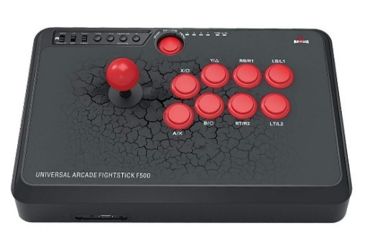

Fig 1. Initial project sketch Fig 2. Mayflash F500 fightstick [2]

3.0 ECE 47700 Course Requirements Satisfaction

The controller being proposed plans to incorporate and achieve the below requirements.

1. Handle multiple power sources. The controller should be capable of switching from built-in battery to USB power, if the USB cable is connected to a PC.

2. I2C/Serial communication protocol between the STM32 and Bluetooth module.

3. Use Timer-based interrupts to read input from controller keys and fight-stick.

4. Convert 5V power to 3.3V

5. Read from SD card and display status image on an OLED/LCD screen

3.1 Expected Microcontroller Responsibilities

The controller being proposed plans to use STM32 Microcontroller to achieve the following functionalities:

1. Process timer-based interrupts to interface controller keys and fight stick
2. Communicate with Bluetooth module via serial communication
3. Communicate with adaptive screen to display modes or battery percentages via serial communication
4. Communicate with USB-Serial module if USB cable is used on controller

Additional functionalities may be added to the list to accommodate for future features.

3.2 Expected Printed Circuit Responsibilities

The controller being proposed plans to integrate a PCB design that will house the following parts:

1. STM32 Microcontroller
2. Flash Memory
3. Connector to keys and stick of controller
4. Adaptive display (OLED or LCD screen)
5. USB-to-Serial (UART) bridge controller (FTDI)
6. Bluetooth Module
7. USB female ports for power input and data transfer
8. Battery monitor IC
9. Linear Voltage Regulator to convert 5V to 3.3V

Additional parts will be added to the list to accommodate for future features.

4.0 Market Analysis:

The fighting controller marketplace is quite niche, but within the actual gaming community (specifically fighter-style games), this product is sought after and quite popular with the new wave of ‘arcade’, ‘retro’, feel controllers. As of 2023, there are several new ergonomic designs like the hitbox controller designs [8]. Dependent on functionality and features, these controllers go for around $200-$300 each, with some more affordable and commercial ones in the $150 range. [9]. For this new design, the team is looking at making a more ergonomic console, allowing for better playing efficiency. It allows players to get a better feel and immersive experience. From this, the target market would be the gaming community, but also any individual looking to reconnect with arcade style gaming. Within the gaming community, it is applicable for both consumers, game sellers, and manufacturers. Game publishers would be looking for ways to make more money, and an easy way to do it would be to sell themed controllers along with their games. Manufacturers and designers would also be looking at this product to meet the needs of customers and to keep up with the supplier competition in this market, especially with the slight rise in fighter games and more retro consoles [10]. Regular consumers would also be interested in buying these controllers to play their fighting games while being more comfortable. There are also people that like modifying their controllers with different colored buttons and artwork, making a big community of modders that would be our customers as well.

5.0 Competitive Analysis:

In the thriving ecosystem of fighting games controllers, our concept might seem familiar to avid enthusiasts, but our controller has the interest of the user’s posture and budget in mind. We plan all the necessary components needed for top-tier performances. In addition to that, we offer an adaptive screen for user personalization, which as mentioned earlier is a draw for a big part of the consumer base. Though this community is small compared to shooter and MOBA games, we still have numerous competitors in this niche community. Some fight sticks have a quality joystick and action buttons with an easy hot swappable cover so that users can modify the controller to their likings. Others offer different compatibility with PlayStation, Nintendo Switch, Xbox and PC. Some tournament-grade fight sticks have incredible build quality with high-end Sanwa components make for buttons that are impressively responsive and the joystick is perfectly precise. We will need to navigate existing patented designs that might resemble our intended project. Yet, if we do achieve our end goal, our controller should offer enhanced ergonomics in an affordable budget with an adaptive, customizable LED screen.

5.1 Preliminary Patent Analysis:

While there are quite a few patents on fight sticks, they don’t concern the major design parts of our design. Most of them are either on the functionality of certain parts like the joystick or the buttons themselves, or they are based on the layout of the buttons on the device. Some of the patents can be seen below:

5.1.1 WIPO Patent Application WO 2020081943 A1:

Patent title: Ergonomic Game controller and system

Patent holder: Hitbox LLC

Patent Filing date: Oct 18th, 2019

Figure 3. Ergonomic controller design

This patent [5] details an ergonomic controller with 23 buttons on the top and 2 switches on the side. This was intended for games that were played on the gamecube and other Nintendo products. It is mainly intended to protect the layout of the controller.

5.1.2 US Patent Application US20220387884A1:

Patent Title: Ergonomically correct game controller

Patent Holder: Hitbox LLC.

Patent Filing date: June 20th, 2022

Figure 4. Ergonomically correct game controller design

This patent [6] is for an ergonomic design of a game controller. Multiple push buttons are arranged in the way that hands would naturally rest. As the buttons are pressed, the inputs are sent to the computer through the wiring. The design is specifically for a few different layouts of buttons on this type of controller

5.1.3 US patent Application US10569162B2:

Patent Title: Detachable Joystick for video game controller

Patent Holder: Performance Designed Products LLC.

Patent Filing date: Sept 17th, 2019

Figure 5. Detachable joystick design

This patent [7] is for a removable joystick design that comes attached to a base shaft so that the end of the base shaft extends into the housing of the controller. The top shaft of the controller that has the lever and the ball are removable and can be cleaned easily or swapped out for other parts. The patent is specifically for the design of the joystick itself.

5.2 Commercial Product Analysis:

Since the late 1990s there have been people in the fighting game community making their own fight sticks at home, and when the big game developers noticed this, they started making their own as well. Sega released their arcade stick with the Dreamcast in 1999 [11], and Nintendo made their NES advantage with the NES in 1987. Fight sticks slowly started getting more popular with the rise of tournaments and fighting games in general with the return of Street Fighter in 2008. In recent years fight sticks are expensive thanks to patents holding back the cheaper versions, with the most affordable coming in at around $125. Some of the more recent fight sticks that would be our competition are shown below.

5.2.1 Qanba N3 Drone 2:

Price: $124.99

Fig 6. Qanba N3 Drone 2

The Quanba N3 Drone 2 is a lightweight and affordable fightstick for people getting serious about their gaming. It is designed to work specifically with the PS4, PS5 and PC. It features a touch pad, control panel, action buttons, and a switch joystick. [3] The buttons provide snappy auditory feedback and the light case has a gap on the right side for the cable to fit into snugly. It is easy to switch out the buttons and the joystick on the controller to fit your preference [4].

5.2.2 The PS4/PC Hit Box Fightsick:

Price: $249.99

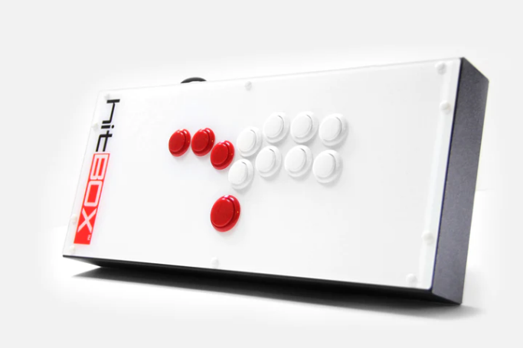

Fig 7. The PS4/PC Hit Box Fightsick

The PS4/PC Hit Box Fightsick is a fancy and innovative game controller from Hit Box for normal gamer enthusiasts as well as professional competitive gamers. It features 3 highlighted features: slim yet effective physical design, wide compatibility, and innovative control system. Specifically, it features a slim box-like steel case with buttons that are specially made from Sanwa-Denshi arcade buttons [14]. One big thing that is noticed immediately, is the lack of a joystick. Finally, it integrates SOCD cleaning for both Standard and Alternative functions to comply with tournament regulations [14]. It is also compatible with PlayStation 4, PC, and Nintendo Switch [14]. Their patents have enabled the company to charge a very high price of $250.

5.2.3 HORI PlayStation 5 – Fighting Stick:

Price: $199.99

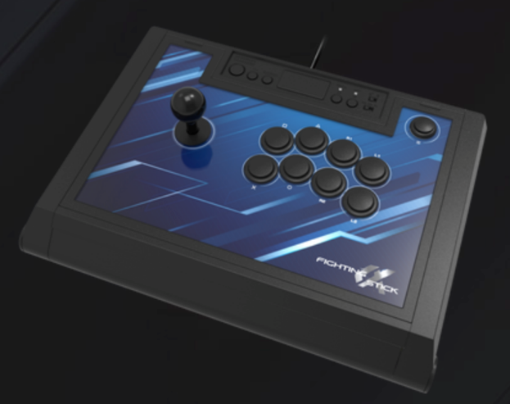

Fig 8. HORI PlaySation 5 – Fighting Stick

The HORI PlayStation 5 – Fighting Stick console is a PS5 compatible device for any of their fighting games. This console has many of the same standard features that other fighting sticks would have, with the addition of a companion app. This functionality has several profile buttons that allow you to switch between different profiles easily. This device also has on-board audio and mic controls [15].

5.3 Open-Source Project Analysis:

As mentioned in a previous section, a large part of the fighting game community that has a fondness for fight sticks also tend to modify their fight sticks. In fact, some of the first fight sticks in America were made by one person, Thao Nguyen, in his home, the MAS sticks. In this same spirit many open-source projects have made their way onto the internet. Some of them have been mentioned below:

5.3.1 Arcade Stick Custom Build DIY:

Fig 9. Arcade Stick Custom Build DIY

An arcade stick that uses a store-bought USB encoder that is made specifically for fight sticks, and simply teaches new FGC enthusiasts how to make their first controller. It’s nothing special and straightforward. The level of customizability is low but that is understandable since it is meant for newcomers to the field. [13]

5.3.2 PicoFightingBoard:

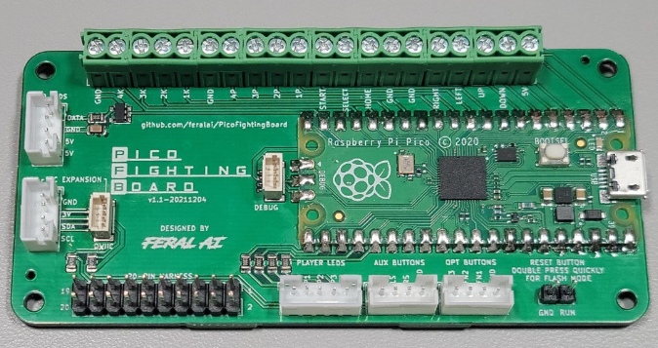

Fig 10. PicoFightingBoard PCB

The Pico Fighting Board is created by FeralAI on github.com [16]. It's a GPIO breakout board fashioned in the style of a standard arcade board, utilizing the Raspberry Pi Pico and the GP2040 gamepad firmware. This firmware comes pre-configured for immediate use and is compatible with PC, Nintendo Switch, and PS3. Additionally, the Pico Fighting Board allows users to modify the PCB layout using the free KiCAD software. While the software and pin layout were initially shared on FeralAI’s Github, a later updated version, which simplifies the installation process, is available in a new repository [17]. This is just the microcontroller that goes in the board, but it’s one of the only open source projects we found that actually discussed the code in the device.

5.3.3 Not Rocket Science Arcade Fight Stick:

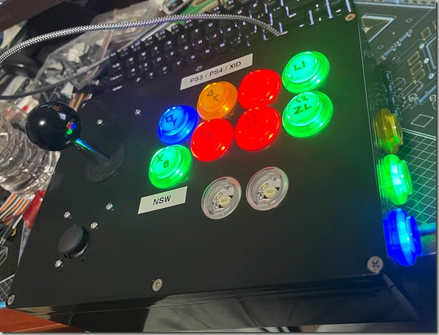

Fig 11. Not Rocket Science Arcade Fight Stick

The Not Rocket Science’s Arcade Fight Stick [18] is an open-source project about designing and building a controller with multiple sticks and buttons with market-available products and interface modules. The project is demonstrated through a website where assemble instructions, wiring instruction, and part lists are included. It contains components that can be bought from Amazon including a controller module, connector cables, LEDs, buttons, and joystick. Specifically, the project features electronically the Brook PS4 + Fighting Board with Audio module as the main microcontroller of the whole controller system that can read multiple data inputs.

6.0 Sources Cited:

1. “Why do many competitive fighting game players use fight sticks instead of traditional controllers?”, Quora. Available: <https://www.quora.com/Why-do-many-competitive-fighting-game-players-use-fight-sticks-instead-of-traditional-controllers>
2. *Mayflash F500*, Fightsticks fandom. Available: <https://fightsticks.fandom.com/wiki/Mayflash_F500>
3. *Qanba Drone 2*, QanbaUSA. Available: <https://qanbausa.com/drone-2/>
4. *Qanba Drone 2 review*, The Arcade Stick. Available: <https://thearcadestick.com/qanba-drone-2/>
5. Hitbox LLC. , *Ergonomic Game controller and system.* Available:<https://patentimages.storage.googleapis.com/3c/0d/5b/4a4b86ba038525/WO2020081943A1.pdf>
6. Hitbox LLC, *Ergonomically correct Game Controller*. Available: <https://portal.unifiedpatents.com/patents/patent/US-20220387884-A1>
7. Performance Designed Products LLC. *Detachable joystick for video game controller.* Available: <https://patents.google.com/patent/US10272327B2/en?oq=10%2c272%2c327>
8. “Top PC hitboxes 2023”, The Arcade Stick. Available: <https://thearcadestick.com/top-pc-hitboxes/>
9. HitBOX. Available: <https://www.hitboxarcade.com/>
10. “Fighting Games Market 2023-2030 | Trends and Business Growth Prospects”, Industry Research Co. Available: <https://www.linkedin.com/pulse/fighting-games-market-2023-2030-trends-business-growth>
11. *NES Advantage,* Wikipedia. Available: <https://en.wikipedia.org/wiki/NES_Advantage>
12. *Dreamcast Arcade Stick,* SEGA Retro. Available: <https://segaretro.org/Dreamcast_Arcade_Stick>
13. f1racer, *Arcade Stick Custom Build Simple DIY*, Instructables. Available: <https://www.instructables.com/Arcade-Stick-Custom-Build-Simple-DIY/>
14. “PRE-ORDER-PS4/PC hit box,” Hit Box Arcade. Available: <https://www.hitboxarcade.com/products/hit-box>.
15. “Fighting Stick a for PlayStation 5”, HORI. Available: <https://stores.horiusa.com/fighting-stick-for-playstation-5/>
16. FeralAI, “Feralai/picofightingboard: Open source PCB for arcade sticks using Raspberry Pi Pico.,” GitHub, <https://github.com/FeralAI/PicoFightingBoard> (accessed Oct. 24, 2023).
17. OpenStickCommunity, “OpenStickCommunity/GP2040-CE,” GitHub, <https://github.com/OpenStickCommunity/GP2040-CE> (accessed Oct. 24, 2023).
18. “Not rocket sciencerandom thoughts of neat disorder,” Not Rocket Science RSS. Available: <https://www.stum.de/2021/10/03/building-an-arcade-fight-stick/>

Appendix 1: Concept Sketch

All buttons are either 24mm or 30mm in diameter as these are the standard buttons used in all fight sticks. The power button will glow with LED backlight when the controller is on, and the display should display battery level, and either inputted combos, or a configurable media (undecided as of this moment)

Figure 12. Stick-style concept sketch

Figure 13. Hitbox style concept sketch