**Exercise No: 13**

**Date: 20.11.2020**

**Aim:** An apparel shop wants to manage the items which it sells.25 min  
Write a python program to implement the class diagram given below.

**Class Description:  
Apparel class:**

1. Initialize static variable counter to 100
2. In the constructor, auto-generate item_id starting from 101 prefixed by "C" for cotton apparels and "S" for silk apparels. Example – C101, S102, S103, C104 etc.
3. **calculate_price():** Add 5% service tax on the price of the apparel and update attribute, price with the new value

**Cotton class:**

1. While invoking parent constructor from child constructor, pass "Cotton" as item_type
2. **calculate_price():** Update attribute, price of Apparel class based on rules given below
   1. Add service tax on price by invoking appropriate method of Apparel class
   2. Apply discount on price
   3. Add 5% VAT on final price

Initialize **Silk class:**

1. While invoking parent constructor from child constructor, pass "Silk" as item_type
2. **calculate_price():** Update attribute, price of Apparel class based on rules given below
   1. Add service tax on price by invoking appropriate method of Apparel class
   2. Identify points earned based on rules given below:

Silk apparels with price more than Rs. 10000, earn 10 points and anything less than or equal to that earn 3 points

* 1. attribute, points with the identified points
  2. Add 10% VAT on price

**Note:**Perform case sensitive string comparison   
  
**For testing:**

* Create objects of Cotton class and Silk class
* Invoke **calculate_price()** on Cotton objects and Silk objects
* Display their details

**Program:**

class Apparel:

counter=100

def __init__(self,price,item_type):

Apparel.counter+=1

self.__item_id=item_type[0]+str(Apparel.counter)

self.__price=price

self.__item_type=item_type

def calculate_price(self):

self.__price+=self.__price*0.05

def get_item_id(self):

return self.__item_id

def get_price(self):

return self.__price

def get_item_type(self):

return self.__item_type

def set_price(self,price):

self.__price=price

return self.__price

class Cotton(Apparel):

def __init__(self,price,discount):

super().__init__(price,'Cotton')

self.__discount=discount

def calculate_price(self):

super().calculate_price()

price=self.get_price()

price-=price*(self.__discount/100)

price+=price*0.05

self.set_price(price)

return price

def get_discount(self):

return self.__discount

class Silk(Apparel):

def __init__(self,price):

super().__init__(price,'Silk')

self.__points=None

def calculate_price(self):

super().calculate_price()

if(self.get_price()>10000):

self.__points=10

else:

self.__points=3

return self.set_price(self.get_price()+(self.get_price()*0.1))

def get_points(self):

return self.__points

silk=int(input())

cotton=int(input())

discount=int(input())

a=Silk(silk)

print(a.calculate_price())

b=Cotton(cotton,discount)

print(b.calculate_price())

**Link:**

<http://103.53.53.18/mod/vpl/forms/submissionview.php?id=328&userid=1644>

**Output:**

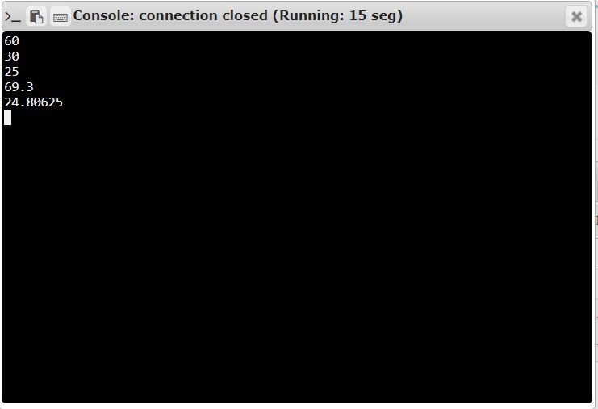

**Result:** Program to has been successfully verified.