Exercise No: 2

Date: 11/10/2020

**Aim:**

To write a python program to count the number of occurrence of a number in a list.

**Program:**

def countX(lst1,x1):

count=0

for i in range(0,len(lst1)):

if(x1==lst1[i]):

count=count+1

return count

lst=[]

n=int(input("Enter number of elements in the list:"))

for i in range(0,n):

inp=int(input())

lst.append(inp)

print(lst)

x=int(input("Enter the number(x) that to be searched in the list:"))

y=countX(lst,x)

print(y)

**Link:**

<http://103.53.53.18/mod/vpl/forms/edit.php?id=230&userid=1644>

**Output:**

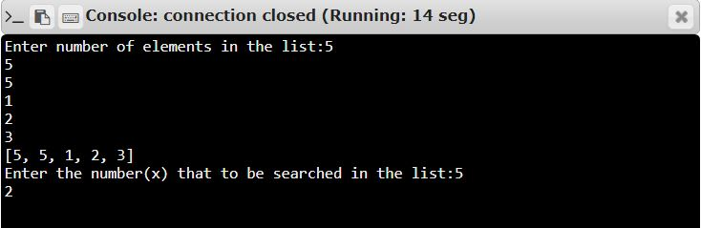

**Result:**

Thus, the program is executed and output of occurrence count Is obtained.