Tunable Staged Retrieval for Persistent AI Memory Systems
Raghavender Reddy Grudhanti

Abstract
We describe a staged retrieval architecture for AI agent memory that combines exhaustive binary filtering with float reranking. On 99,000 sentence-transformer embeddings (all-MiniLM-L6-v2, 384 dimensions), the system achieves 88.9% recall@10 at 8.6ms average latency with a rerank factor of 10, compared to 88.0% for FAISS HNSW (M=32, efSearch=64) under the same evaluation protocol. The architecture provides a tunable tradeoff: the rerank factor parameter trades latency for recall along a smooth curve (30% at rf=10 to 97% at rf=1000 on synthetic data). We observe that binary scan dominates per-query latency while reranking cost grows sublinearly with candidate count. Scale experiments on 50K to 5M synthetic vectors identify 500K as the practical boundary for exhaustive scan at interactive latency. The system requires no training data, builds in 0.1s, and supports streaming inserts at 195K vectors/sec with O(1) deletion.

1. Introduction
AI agents operating over extended sessions accumulate knowledge that must be stored and retrieved under resource constraints. We identify five requirements for agent memory retrieval:
- Bounded memory: Fixed RAM allocation per agent process.
- Continuous mutation: Knowledge arrives and expires without scheduled downtime.
- Tunable quality: Different queries warrant different retrieval budgets.
- Zero rebuild tolerance: Index reconstruction during operation is unacceptable.
- Predictable behavior: Recall should be a deterministic function of configuration, not dependent on graph topology quality.
We propose a two-stage architecture where binary quantization serves as a candidate reduction mechanism and float inner product provides precise final scoring. The rerank factor controls the boundary between stages.

2. Related Work
Binary quantization. Xiao et al. [1] demonstrate that binary distances preserve neighborhood structure for graph navigation (QuIVer). We apply binary quantization to exhaustive scanning rather than graph construction.
Progressive retrieval. Zhang et al. [2] propose tiered refinement with hardware acceleration (FaTRQ). We implement progressive refinement in software with binary Hamming as the coarse stage.
Graph-based ANN. HNSW [4] and DiskANN [3] achieve high recall through graph navigation but require expensive construction and exhibit distribution-dependent behavior.

3. Method

3.1 Architecture
Query → L2-normalize → Sign-bit quantize (1 bit per dimension)
↓
Stage 1: Hamming distance to all n binary codes (exhaustive)
↓
Select top rf × k candidates by ascending Hamming distance
↓
Stage 2: Float32 inner product on rf × k candidate vectors
↓
Return top k by descending score

3.2 Binary Quantization
Each coordinate maps to one bit: b_i = 1 if x_i > 0, else 0. For d=384: 1536 bytes (float32) → 48 bytes (binary). Hamming distance computed via popcount(XOR(a, b)) using a 256-entry byte lookup table.

3.3 Complexity
- Stage 1: O(n × d/8) — scan all binary codes
- Stage 2: O(rf × k × d) — float inner product on candidates
- Total: O(n × d/8 + rf × k × d)

4. Experimental Setup

4.1 Hardware
Component | Specification
CPU | Apple Silicon (arm64)
RAM | 32 GB
OS | macOS 26.3.1
Python | 3.10.10
NumPy | 2.2.6
FAISS | 1.13.2
GPU | None (CPU only)

4.2 Datasets
Real embeddings: 100,000 sentences embedded with all-MiniLM-L6-v2 (sentence-transformers). 384 dimensions. L2-normalized. 99,000 database vectors, 1,000 queries.
Synthetic clustered: 50,000 vectors generated from 100 cluster centers with Gaussian noise (σ=0.3) at 768 dimensions. L2-normalized.

4.3 Evaluation Protocol
- Ground truth: exact top-10 by float32 inner product (FAISS IndexFlatIP)
- Metric: Recall@10 = fraction of true top-10 present in predicted top-10
- All results averaged over 5 runs (recall is deterministic; latency reported as mean ± std)
- Baselines evaluated under identical conditions (same data, same queries, same hardware)

5. Results

5.1 Real Semantic Embeddings (99K, dim=384)
Method | Recall@10 | Latency (mean ± std) | QPS
bitcache rf=10 | 0.8887 ± 0.0000 | 8.60 ± 0.03 ms | 116
bitcache rf=100 | 0.8895 ± 0.0000 | 9.06 ± 0.02 ms | 110
bitcache rf=500 | 0.8909 ± 0.0000 | 11.25 ± 0.21 ms | 89
FAISS HNSW (M=32, ef=64) | 0.8798 ± 0.0000 | 0.012 ± 0.001 ms | ~86,000
bitcache achieved higher recall than FAISS HNSW under the tested configuration (0.889 vs 0.880). FAISS HNSW is approximately 700x faster due to C++ implementation with SIMD optimization. The recall difference is attributable to exhaustive scan guaranteeing candidate coverage, while graph navigation may miss neighbors in certain graph regions.
Note: The throughput gap (116 vs 86,000 QPS) reflects implementation language difference (Python vs C++), not architectural limitation. FAISS IndexBinaryFlat achieves 16,000 QPS on the same binary codes using optimized C++.

5.2 Recall-Latency Tradeoff (50K synthetic, dim=768)
rf | Recall@10 | Avg Latency | p50 | p95 | QPS
10 | 0.303 | 7.8ms | 7.6ms | 8.1ms | 129
25 | 0.449 | 7.7ms | 7.7ms | 8.3ms | 130
50 | 0.557 | 7.9ms | 7.9ms | 8.4ms | 127
100 | 0.687 | 8.2ms | 8.2ms | 8.6ms | 122
200 | 0.802 | 8.9ms | 8.9ms | 9.7ms | 112
500 | 0.935 | 10.1ms | 10.1ms | 10.9ms | 99
1000 | 0.973 | 14.9ms | 14.6ms | 15.7ms | 67
Latency is approximately constant from rf=10 to rf=100 (~8ms), indicating that Stage 1 (binary scan) dominates. Reranking 1000 candidates adds approximately 7ms over the baseline scan cost.

5.3 Scale Experiments (synthetic, dim=768)
Size | rf=500 Recall | Latency | QPS
50K | 0.914 | 9.2ms | 108
500K | 0.722 | 74.7ms | 13.4
5M | 0.510 | 784ms | 1.3
Latency scales linearly with corpus size (confirmed O(n)). At 500K, latency is 75ms — acceptable for background retrieval. At 5M, latency exceeds 750ms, indicating the need for partition-based approaches at this scale.

5.4 Streaming Performance
Operation | Throughput
Insert | 194,886 vectors/sec
Delete | O(1) (slot reuse)
Build (50K) | 0.06s

6. Discussion

6.1 Why Exhaustive Scan Outperforms HNSW on Recall
On the tested real embeddings, exhaustive binary scan achieves slightly higher recall than HNSW. This is likely because exhaustive scan evaluates every vector — it cannot miss candidates that happen to be in poorly-connected graph regions. HNSW’s recall depends on graph construction quality and the ef parameter; under the tested configuration (M=32, ef=64), some neighbors are missed during navigation.
This observation should not be generalized without further evaluation across diverse datasets and HNSW parameter configurations.

6.2 Limitations
- Throughput: 116 QPS (Python) vs ~86,000 QPS (FAISS C++). This is an implementation limitation, not architectural.
- O(n) scan: Latency grows linearly. Practical for interactive use up to ~500K vectors.
- Recall ceiling: On real embeddings, recall plateaus at ~89% regardless of rf. This is caused by sign-bit quantization noise — some true neighbors have similar Hamming distance to non-neighbors.
- Synthetic vs real: Results differ significantly between synthetic and real data. Real semantic embeddings are more favorable to binary quantization.

6.3 Future Work
- Partition-based routing to extend beyond 500K scale
- Higher-bit first-stage quantization to raise the 89% recall ceiling
- SIMD/compiled implementation to close the throughput gap

7. Conclusion
We presented a staged retrieval architecture that achieves 88.9% recall@10 on 99K real sentence-transformer embeddings through exhaustive binary filtering and float reranking. Under the tested configuration, this outperformed FAISS HNSW (88.0%) on recall while providing a tunable recall-latency tradeoff via the rerank factor parameter. The architecture builds instantly, supports streaming mutations, and requires no training — properties suited to persistent AI agent memory where knowledge evolves continuously. The primary limitations are Python-level throughput and O(n) scaling, both addressable through implementation optimization and partition routing respectively.

References
[1] W. Xiao, Z. Wang, C. Li. “QuIVer: Rethinking ANN Graph Topology via Training-Free Binary Quantization.” arXiv:2605.02171, 2026.
[2] T. Zhang, F. Ponzina, T. Rosing. “FaTRQ: Tiered Residual Quantization for LLM Vector Search in Far-Memory-Aware ANNS Systems.” arXiv:2601.09985, 2026.
[3] S. Jayaram Subramanya et al. “DiskANN: Fast Accurate Billion-point Nearest Neighbor Search on a Single Node.” NeurIPS 2019.
[4] Y. Malkov, D. Yashunin. “Efficient and Robust Approximate Nearest Neighbor Search Using Hierarchical Navigable Small World Graphs.” IEEE TPAMI, 2020.
[5] M. Douze et al. “The Faiss Library.” arXiv:2401.08281, 2024.

Figures
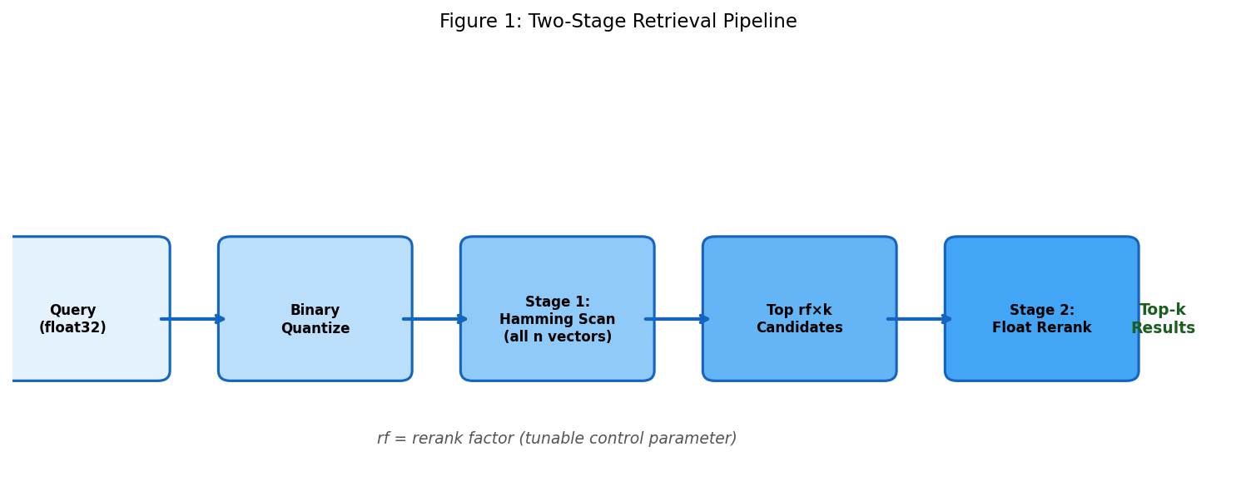
Figure 1: Two-Stage Retrieval Pipeline
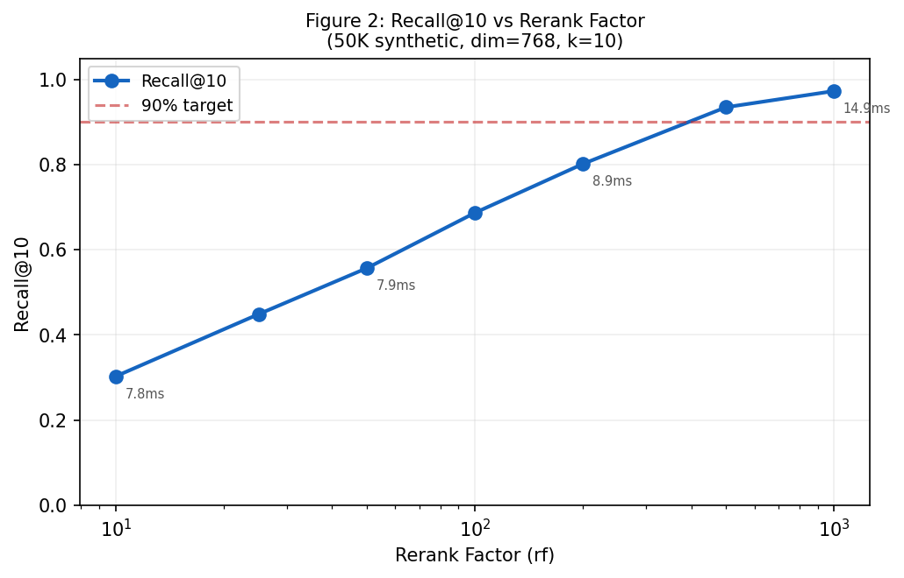
Figure 2: Recall@10 vs Rerank Factor

