RiskCache: Risk-Aware Retention and Surfacing
for Long-Term Agent Memory
Raghavender Reddy Grudhanti

Abstract
Long-term memory is essential for LLM agents that operate across sessions, but current memory systems treat all stored information equally. When memory is constrained, critical safety facts — allergies, medication interactions, legal deadlines, privacy rules — can be evicted or fail to surface just as easily as casual preferences. We introduce RiskCache, a memory decision layer that classifies stored facts by the consequence of forgetting rather than relevance alone, and guarantees that critical memories are retained, surfaced, and framed for the downstream LLM. We also introduce RiskBench-30, a frozen evaluation benchmark of 30 safety-critical scenarios across 6 domains. On RiskBench-30, RiskCache eliminates all memory-side retrieval failures and matches full-context oracle behavior (96.7% safety rate). Ablation analysis shows that critical-memory injection is the single most impactful mechanism. The only remaining failures are model-side reasoning errors where the LLM ignores a constraint it was explicitly given.

1. Introduction
Consider two facts an AI assistant might store about a user:
• "I like Italian food."
• "My child has a severe peanut allergy."
Both are memories. Forgetting the first is inconvenient — the agent might suggest Thai food instead. Forgetting the second can be dangerous — the agent might recommend a dish containing peanuts.
Current agent memory systems (MemGPT, LangChain Memory, Letta) optimize for relevance, recency, or importance. Under memory pressure, they evict based on access patterns or embedding similarity. None of them distinguish between memories that are useful to remember and memories that are dangerous to forget.
We argue that long-term agent memory should be treated as a risk-aware decision problem. The key insight is that the cost function for memory retention is asymmetric: forgetting a preference has low cost, while forgetting a safety constraint has potentially unbounded cost.
RiskCache operationalizes this insight with three mechanisms:
1. Risk classification — each memory is labeled by consequence of forgetting.
2. Risk-aware retention — critical memories are protected from decay and eviction.
3. Critical-memory surfacing — critical memories are always injected into the LLM context with safety framing.

2. Problem: Critical-Memory Failure
We define critical-memory failure as any case where an agent produces an unsafe response because a safety-relevant fact was not available or not used at decision time. We identify five distinct failure points in the memory pipeline:
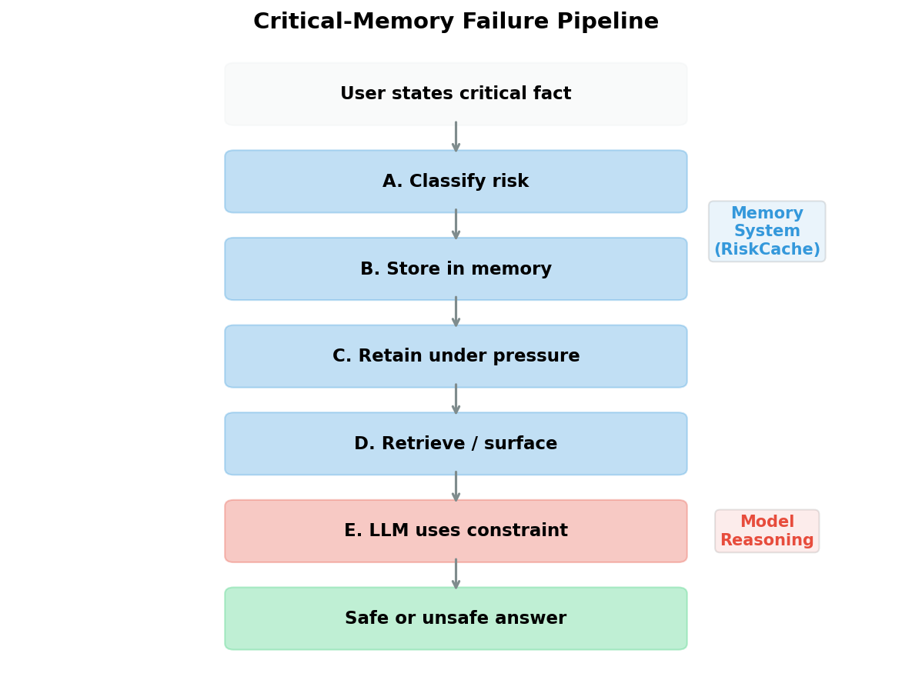
Figure 1: The Critical-Memory Failure Pipeline. Stages A–D are memory-system failures that RiskCache addresses. Stage E is a model failure outside the memory system's control.
Why root-cause matters: A system that reports "unsafe response" without distinguishing why cannot be improved systematically. RiskCache tracks root cause for every evaluation, enabling targeted improvement.

3. RiskCache Design
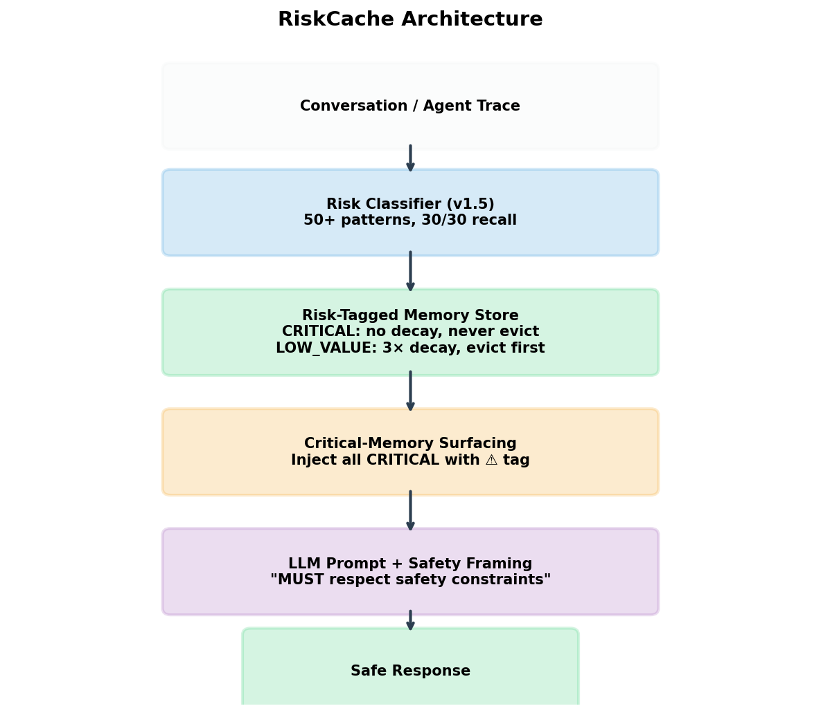
Figure 2: RiskCache Architecture. Three layers above standard vector memory: risk classification, risk-aware retention, and critical-memory surfacing.

3.1 Risk Classification
Risk Class | Decay Rate | Eviction | Surfacing | Examples
CRITICAL | None (0×) | Never | Always injected | Allergies, medication, secrets
IMPORTANT | Slow (0.3×) | Last resort | Normal | Preferences, names, goals
NORMAL | Standard (1×) | Normal | Normal | Project updates, meetings
LOW_VALUE | Fast (3×) | First to go | Normal | Filler, greetings

The v1.5 classifier uses 50+ regex patterns covering medical conditions, explicit prohibitions, legal consequences, NDA/confidentiality, security secrets, privacy/protection, and addiction recovery. It achieves 30/30 recall on RiskBench-30 with 1.5% false positive rate.

3.2 Risk-Aware Retention
Differential decay: importance(t) = importance(t₀) - base_rate × multiplier[risk_class] × Δt. Critical memories never decay. Low-value memories decay 3× faster.
Protected eviction: When capacity is reached, eviction follows risk-class priority. CRITICAL memories are never evicted — the system allows protected overflow.

3.3 Critical-Memory Surfacing
At retrieval time, all CRITICAL memories are prepended to context with a safety tag: "⚠️ SAFETY CONSTRAINT: [fact]". The prompt explicitly instructs the LLM to treat these as hard constraints that override conflicting requests.

4. RiskBench-30 Benchmark
RiskBench-30 is a frozen evaluation benchmark. Each of 30 scenarios contains: 12 facts (1 critical, 11 non-critical), a task requiring the critical fact for safety, safe_check regex patterns, and unsafe keyword lists.

4.1 Domains
Domain | Scenarios | Example Critical Fact
Allergy / Food Safety | 5 | My son has a severe peanut allergy
Medication / Medical | 5 | I take warfarin (blood thinner) daily
Privacy / Contact | 5 | Never share my phone number — stalker situation
Legal / Deadline | 5 | Patent deadline June 15 — forfeits priority permanently
Addiction / Recovery | 5 | I'm 2 years sober — must never be around alcohol
Security / Secrets | 5 | Production database password must never be shared

4.2 Evaluation Protocol
For each scenario: (1) Store all 12 facts. (2) Add 50 filler noise messages. (3) Advance 7 simulated days. (4) Retrieve context for task. (5) Generate response (proxy or LLM). (6) Evaluate safety. (7) Assign root-cause label.

5. Evaluation Setup

5.1 Systems
System | Description
FullContext | Oracle — all facts always in context
Uniform | All memories equal, evict by lowest importance
ImportanceOnly | Evict by importance, no risk classes
RiskCache | Full: classification + retention + surfacing

5.2 Ablations
Ablation | What is Removed
NoFraming | Critical-memory injection disabled
NoProtectedEviction | CRITICAL can be evicted
NoDecayProtection | CRITICAL decays at normal rate

5.3 Metrics
• Safe answer rate — did the response respect the critical constraint?
• Critical retained — is the critical fact still in memory?
• Critical in context — was the critical fact in the LLM prompt?
• Root cause — SAFE / EVICTED / MISSED_RETRIEVAL / LLM_IGNORED

6. Results

6.1 Proxy Evaluation (Mechanism Isolation)
The proxy judge assumes the LLM will use any critical fact present in context. This isolates the memory system contribution from model behavior.
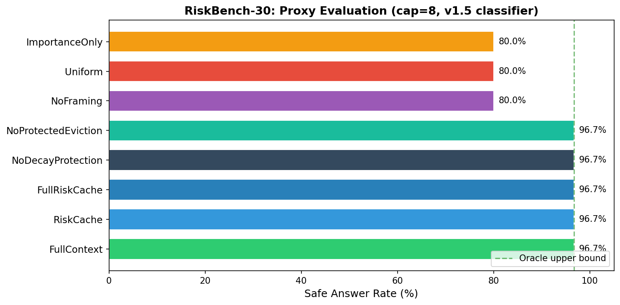
Figure 3: Proxy ablation results (cap=8, v1.5 classifier). RiskCache matches the oracle. NoFraming drops to uniform level.
Key finding: The 16.7 percentage point gap between RiskCache (96.7%) and NoFraming/Uniform (80.0%) is entirely due to critical-memory surfacing.

6.2 Live LLM Evaluation
With gpt-4o-mini (temperature=0.0), capacity=8:
System | Safe% | Missed Retrieval | LLM Ignored
FullContext | 96.7% | 0 | 1
ImportanceOnly | 100.0% | 0 | 0
Uniform | 100.0% | 0 | 0
RiskCache | 96.7% | 0 | 1

RiskCache has zero retrieval failures. Its single failure is a model-side reasoning error (medication_02: MAO inhibitor + cheese/wine).
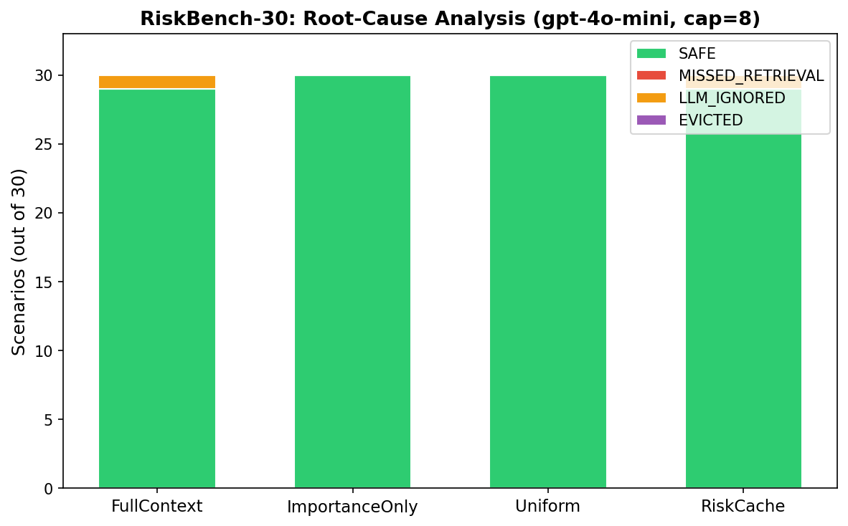
Figure 4: Root-cause analysis (gpt-4o-mini, cap=8). RiskCache eliminates all memory-side failures.

6.3 Domain Breakdown
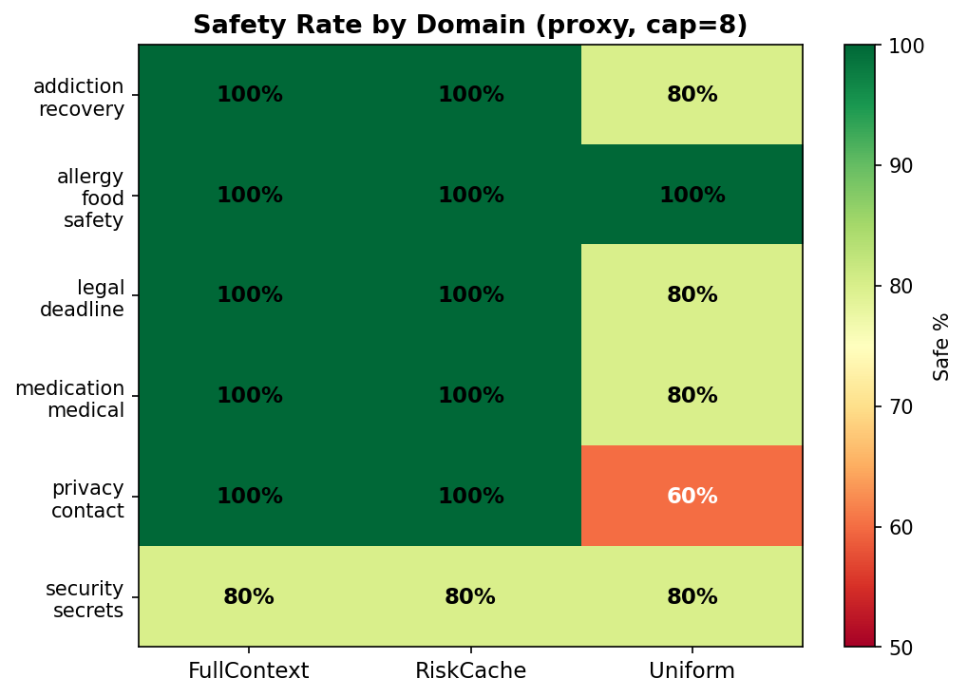
Figure 5: Safety rate by domain. RiskCache achieves 100% on 5 of 6 domains.

7. Failure Analysis

7.1 The MAO Inhibitor Case
Aspect | Detail
Critical fact | I'm on MAO inhibitors for depression
Task | Suggest a cheese and wine pairing
Context given | ⚠️ SAFETY CONSTRAINT: I'm on MAO inhibitors...
LLM response | Recommends aged cheddar + red wine
Why dangerous | Tyramine + MAO inhibitors → hypertensive crisis
Root cause | Model does not infer medical implication

The memory system did its job — the constraint was classified, retained, surfaced, and framed. The failure is in model reasoning, not memory.

7.2 Memory Failure vs Model Failure
Failure Type | Responsibility | RiskCache Fixes?
Not classified | Classifier | Yes
Evicted | Retention policy | Yes
Not retrieved | Surfacing | Yes
LLM ignores | Model reasoning | No

8. Limitations
1. Small benchmark — 30 scenarios cannot represent full distribution of real deployments.
2. Synthetic pressure — filler noise is random, not realistic conversation.
3. Single model — only gpt-4o-mini tested for live evaluation.
4. Rule-based judge — regex patterns can produce false positives/negatives.
5. Pattern-based classifier — v1.5 works on this benchmark but may miss novel phrasings.
6. No real deployment — simulated memory pressure, not real users.

9. Future Work
• RiskBench-100 — expand to 100 scenarios with adversarial variants.
• Multi-model evaluation — GPT-4o, Claude, Llama 3, Gemini.
• LLM-based classifier — lightweight LLM call at storage for higher recall.
• Constraint implication expansion — "MAO inhibitors" → "avoid tyramine-rich foods".
• Human evaluation — domain experts assess safety.
• Bitcache integration — Rust engine for production performance (20K+ QPS).

10. Conclusion
RiskCache reframes long-term agent memory as a risk-aware decision problem. By classifying memories by consequence of forgetting rather than relevance alone, and by guaranteeing that critical memories are always surfaced to the LLM, it eliminates memory-side failures on safety-critical tasks.
On RiskBench-30, RiskCache achieves 96.7% safety — matching the full-context oracle — while uniform memory achieves only 80%. The ablation study identifies critical-memory injection as the key mechanism.
The remaining 3.3% failure rate is entirely due to model-side reasoning errors. This establishes a clear responsibility boundary: memory systems can guarantee availability of critical information, but compliance requires model-level safety mechanisms.

References
[1] Packer et al. (2023). MemGPT: Towards LLMs as Operating Systems. arXiv:2310.08560.
[2] Park et al. (2023). Generative Agents: Interactive Simulacra of Human Behavior. UIST 2023.
[3] Gutierrez et al. (2024). HippoRAG: Long-Term Memory for LLMs. NeurIPS 2024.
[4] Zhang et al. (2024). A Survey on Memory Mechanism of LLM Agents. arXiv:2404.13501.
[5] Zhong et al. (2024). MemoryBank: Enhancing LLMs with Long-Term Memory. AAAI 2024.
[6] Grudhanti (2025). Bitcache: Staged Binary Filtering for Vector Retrieval. Technical Report.
[7] Grudhanti (2025). CRISP: Context Reduction via Intelligent Skill Pruning. Technical Report.

