Three ways of configuring a form:
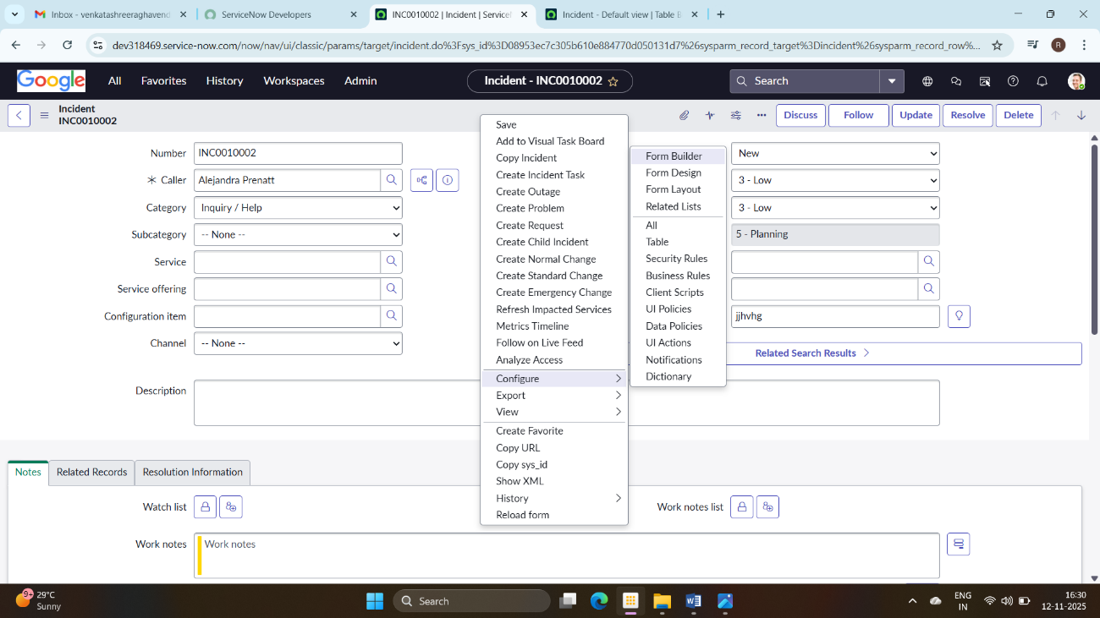

1.Form Builder (Advanced)
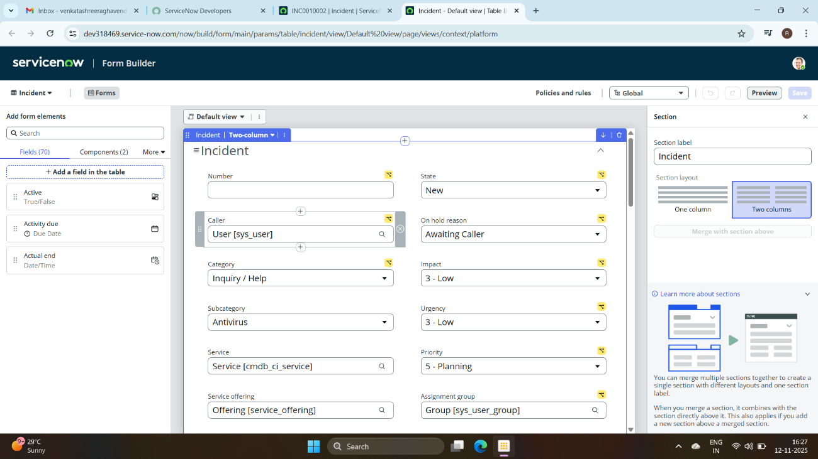

2.Form Layout (auto-refresh)
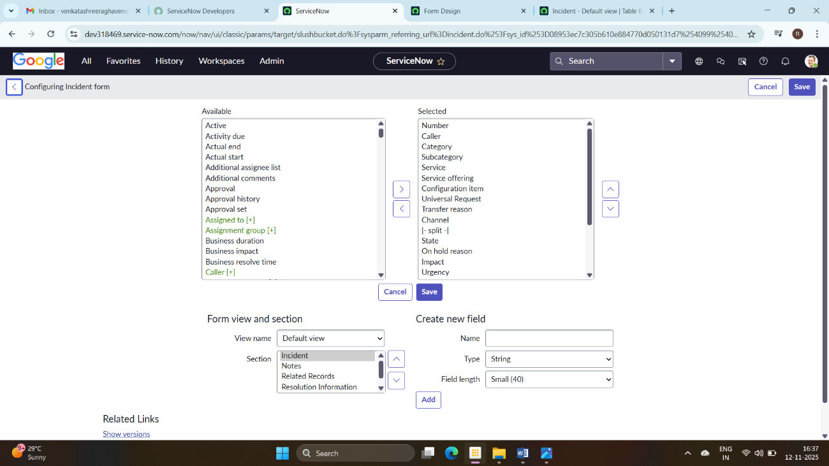

3.Form Design

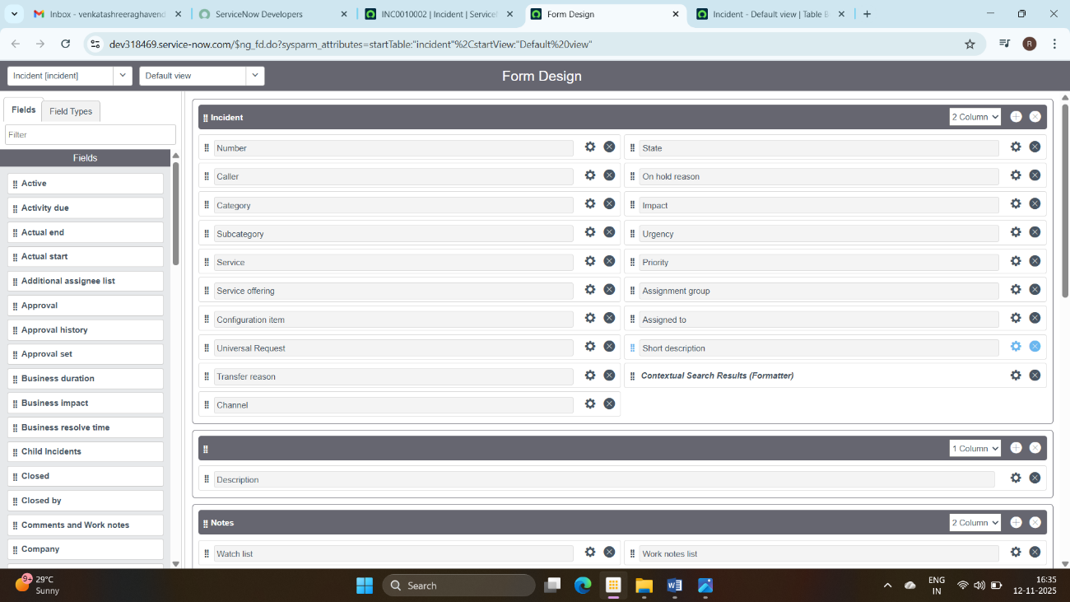
Making the form single column using Form design
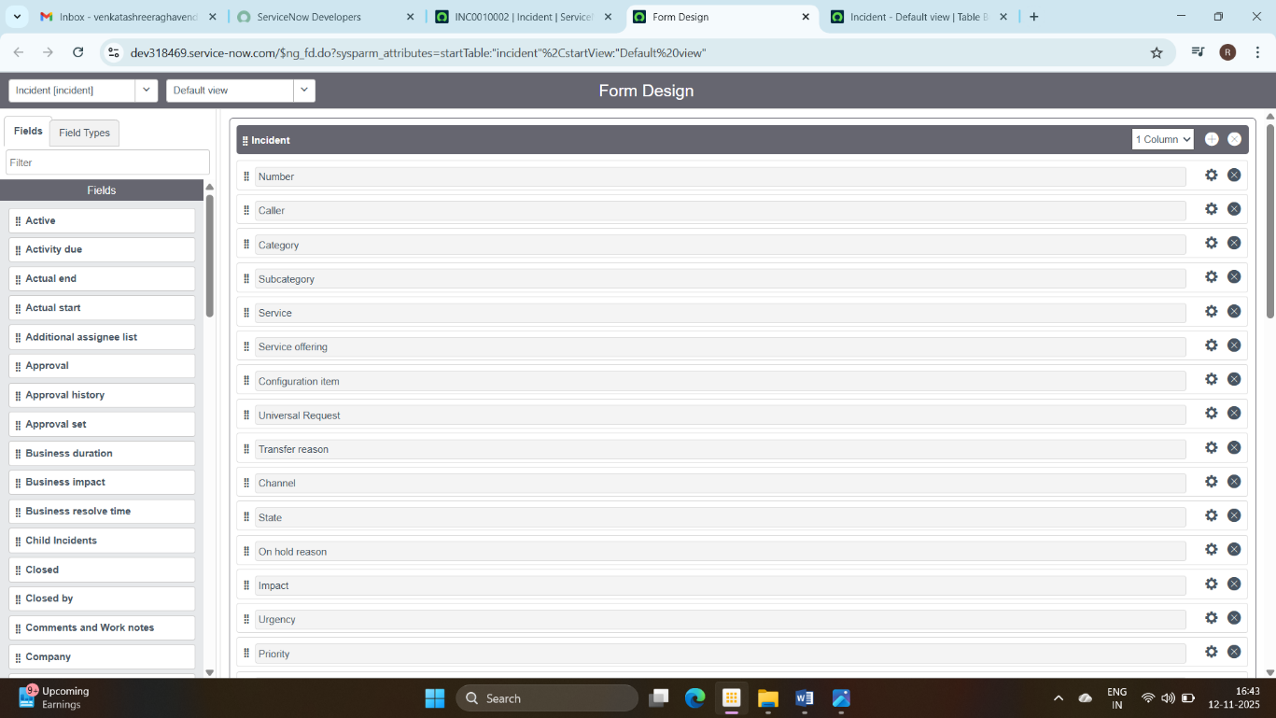
Reloading the form
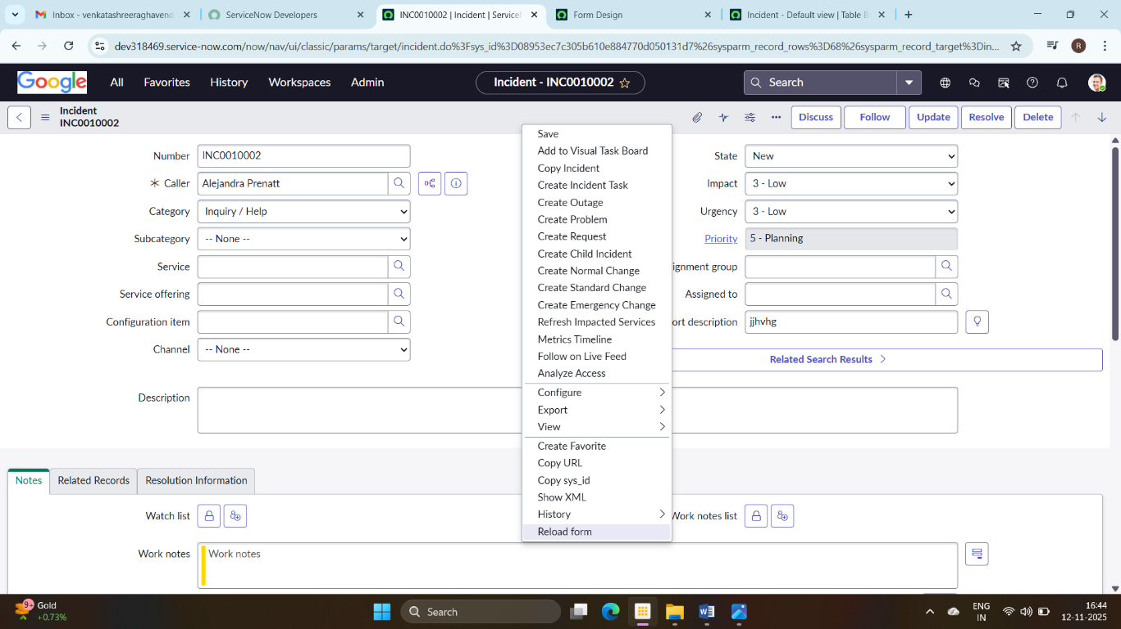

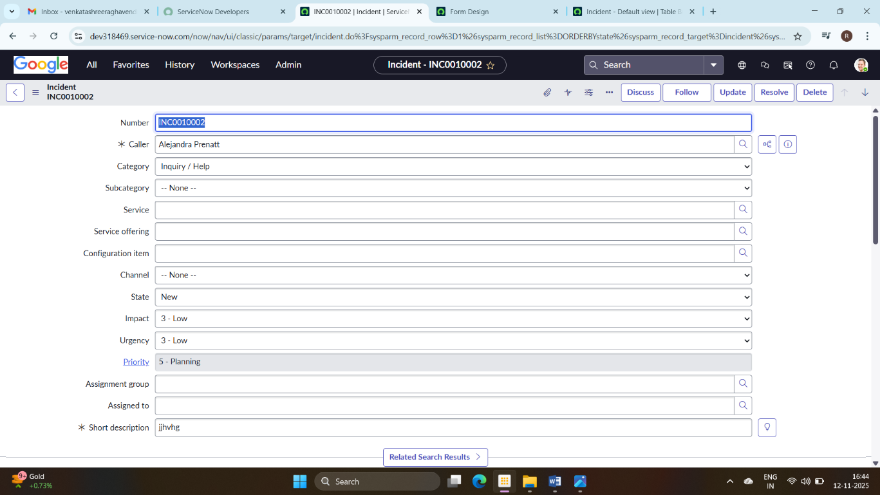
The same can be achieved through form layout by moving “|-split-|” in the selected section to available section
It can also be achieved through form builder by selecting single column option on the RHS.
When you convert it back to the double column (using any of the 3 ways), it doesn’t appear same as before
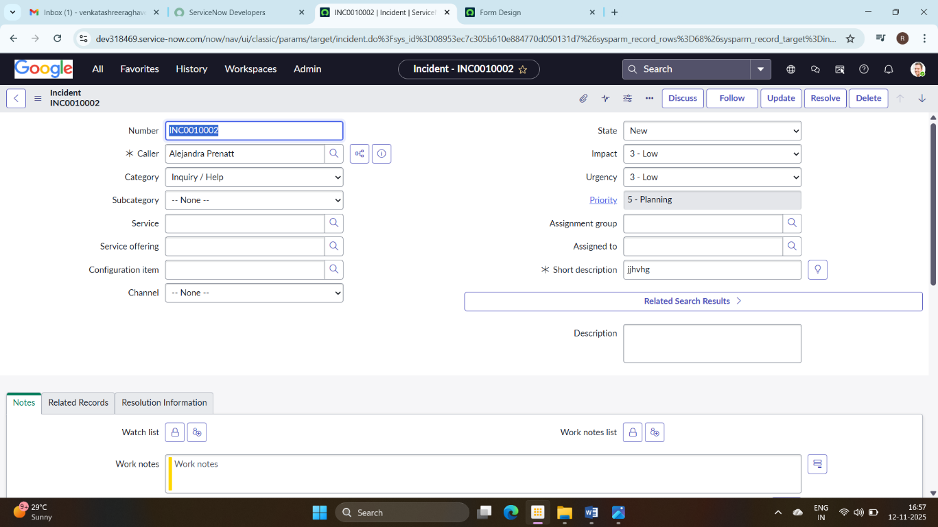
A separate section needs to be created for Description below the main section (which is later merged with the main section) to make to span over two columns(using any of the 3 ways)

