DEVOPS AND FULLSTACK

Name: Pruthagwin Challuri
H.T No.: 2303A51951
Date: 28-01-2026
Batch: 07
Assignment Number: 8/24(week 4) Wednesday
Results:

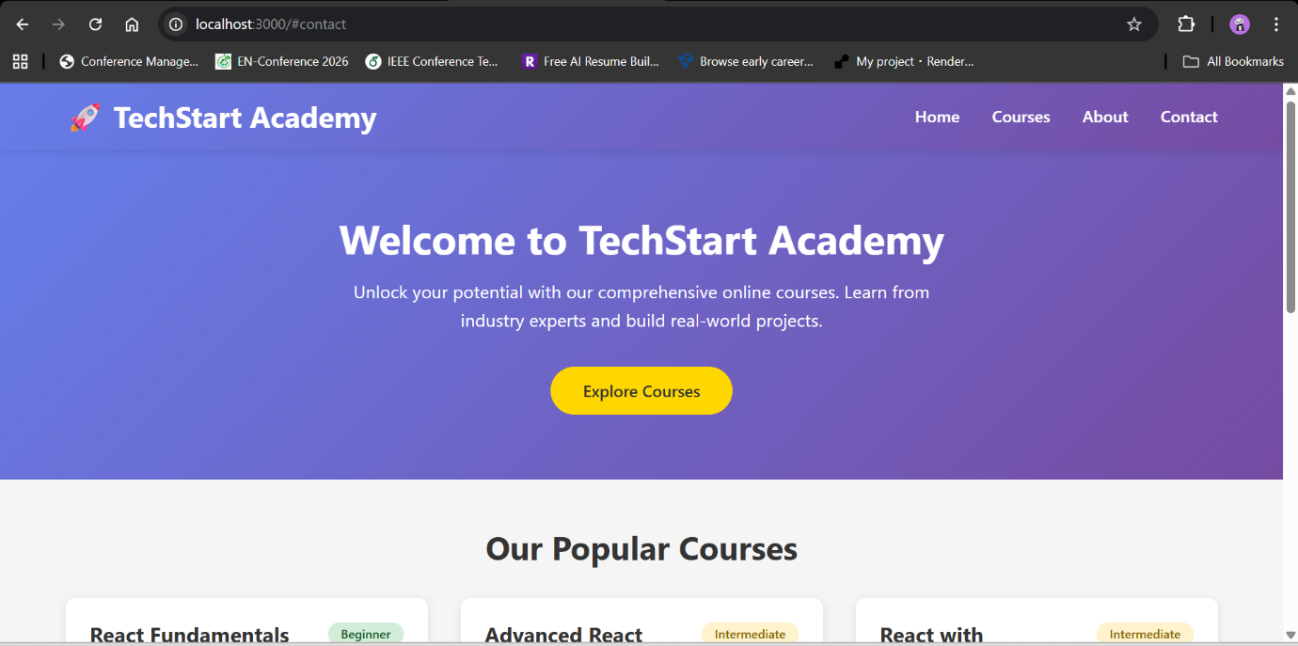

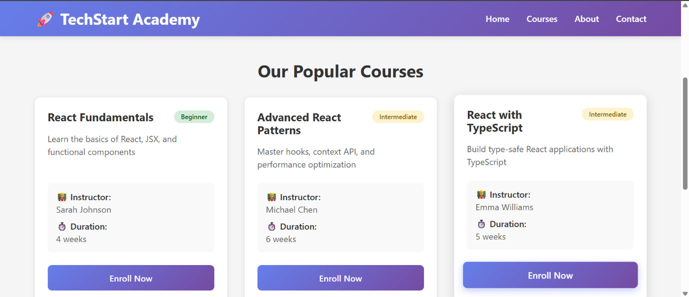

1. How would you set up a new React project using tools like Create React App or Vite?
Ans: I can set up a React project using Create React App or Vite. Create React App is simple and beginner friendly, while Vite is faster and more modern. With Vite, the project setup is quicker, the development server starts instantly, and hot reloading is very smooth. That is why Vite is usually preferred for new projects.

2. What is the role of package.json in a React project?
Ans: package.json is the main configuration file of a React project. It keeps track of all dependencies, defines scripts to run and build the app, and stores basic project information. It helps ensure everyone working on the project uses the same setup.

3. How do you create a functional component in React?
Ans: A functional component is created by writing a JavaScript function that returns JSX. It can accept data using props and manage state using hooks like useState. Functional components are simple, reusable, and commonly used in modern React.

4. How are components rendered inside the main App component?
Ans: Components are rendered inside the App component using JSX. The App component imports child components and displays them as tags. Data is passed from App to other components using props, and lists are rendered using map.

5. What are the benefits of breaking the UI into small reusable components?
Ans: Small reusable components make the code easier to understand and maintain. They reduce repetition, improve readability, make testing easier, and help the application scale as it grows. This also allows teams to work more efficiently.

