Part-1

1. Sift Matching – Brute force

We define two images as match if the ratio of eucledian distance between the closest match and the second closest match is above a threshold. Intuitively if the threshold is small, fewer points are considered and if the threshold is large, closer images are also considered a match. The trade-off is achieved by changing the ratio.

We tried matching using different trade-offs,

For the ratio of 0.7, below are the images and sift descriptors. It can be seen that there are just a couple of sift matched found between these images even though they from the same scene.

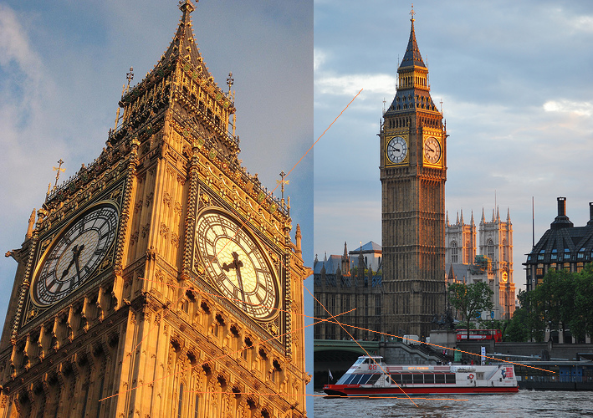

For the ratio of 0.9 however, it can be seen that there are much more SIFT descriptors than the image shown above.

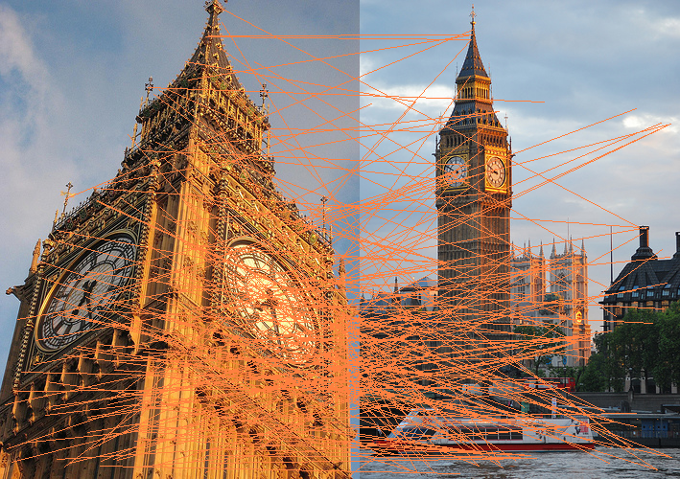

For the threshold of 0.9, when a different scene is used it seems to find a reasonable amount of sift vectors to describe the image.

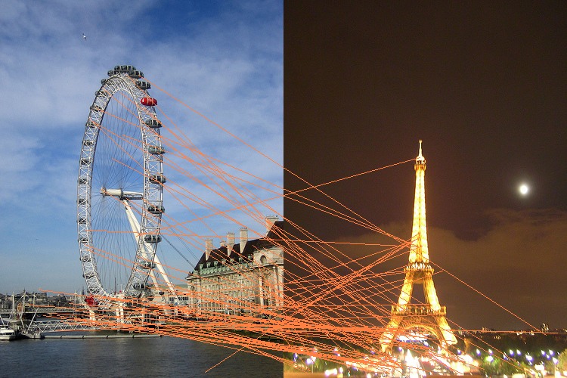

2.

3. Precision of the Image Retrieval Program

Inorder to find calculate the performance of the algorithm, we wrote a wrapper python code which would call the C++ executable with the required parameters. The program initially decipheres the image category by file name and iterates through each category thereby randomly sampling the query image and excludes the query image from the search image parameter. Thus the input image can be never exactly matched, however approximate nearest match in the library is found and precision is calculated.

This process was ran for multiple ratios, and following are the results.

|  |  |  |
| --- | --- | --- |
| **Image Category** | **Ratio of 0.7 / Precision** | **Ratio of 0.9 / Precision** |
| Notredame | **0.44** | 0.33 |
| Tatemodern | 0.11 | **0.22** |
| Sanmarco | 0.33 | 0.33 |
| Bigben | 0.11 | 0.11 |
| Effiel | **0.22** | 0.11 |
| Trafalgar | **0.22** | 0.11 |
| Louvre | **0.25** | 0.0125 |
| Colosseum | 0.11 | 0.11 |
| Empirestate | 0.11 | **0.22** |
| Londoneye | 0.11 | 0.11 |

Overall, the ratio of 0.7 from sift descriptors performed better than the 0.9. However since the query images were randomly sampled, the query image could have also be a bad selection.