Assignment 1 Write-up

**Requesting multiple files**

I have taken four files of 1MB size for the analysis . The trends noticed while requesting four files using persistent and non-persistent is as below:-

**Non – Persistent:-**

Using non-persistent the time taken for file1 = 564ms

Using non-persistent the time taken for file2 = 413ms

Using non-persistent the time taken for file3 = 536ms

Using non-persistent the time taken for file4 = 439ms

**Total time taken for transferring 4(1MB) files is 1952ms .**

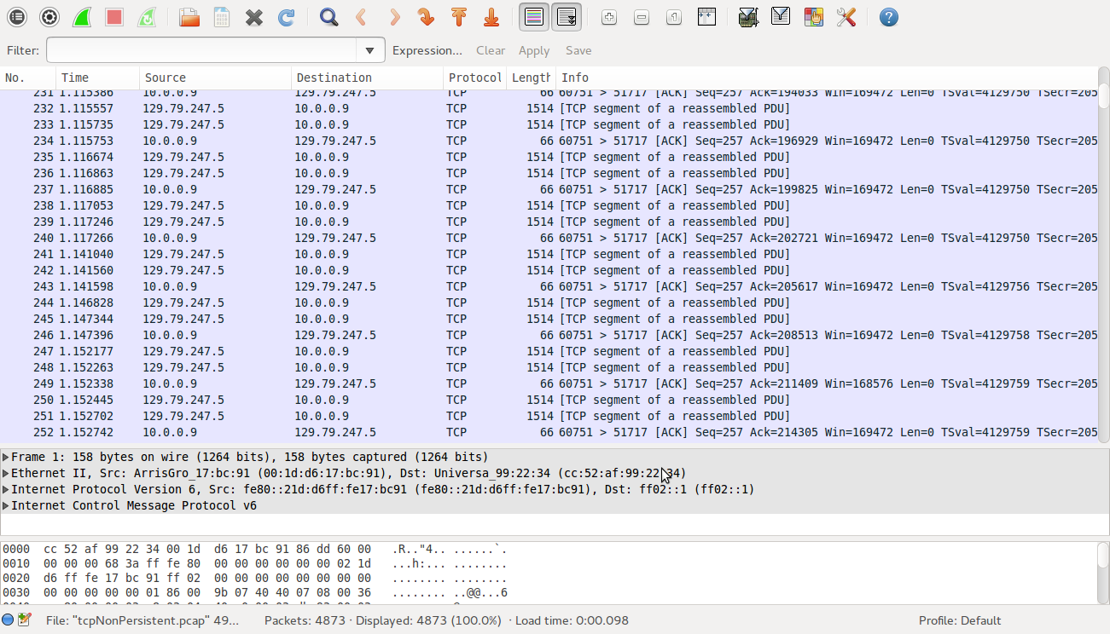

**Persistent:-**

The time taken for transferring all four files using persistent connection is

**Using persistent the time taken for file1,file2,file3 & file4 = 1521ms**

**Inference:-**

It takes 5 RTT for the persistent connection to complete the transfer of 4files

1 (Connection RTT) + 4(Request RTT)

It takes 8 RTT for non-persistent connection to complete the transfer of 4files

1(Connection RTT) + 1(Request RTT) + 1(Connection RTT) + 1(Request RTT) + 1(Connection RTT) + 1(Request RTT) + 1(Connection RTT) + 1(Request RTT)

So time taken in non-persistent connection to serve multiple files will be longer than the time taken by persistent connection. This is because the more the number of files requested the more RTT the non-persistent will have. So time taken will linearly grow.

The files attached for evidence are text files which contain the execution results and the .pcap

which contain the packet capture.

The persistent connection evidence are **persistentResult.txt** and **tcpPersistent.pcap.**

The persistent connection evidence are **nonPersistentResult.txt** and **tcpNonPersistent.pcap.**

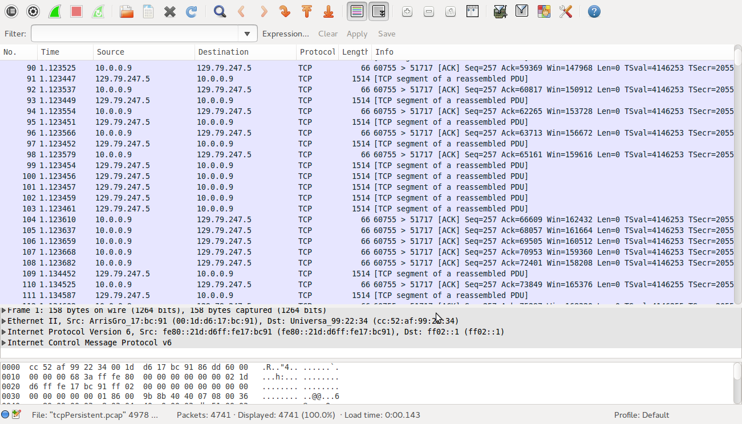

**Requesting single file**

Performing the above analysis for a single file, the following results are noticed.

**Non – Persistent:-**

Using non-persistent the time taken for file1 = 575ms

**Total time taken for transferring 1(1MB) files is 575ms .**

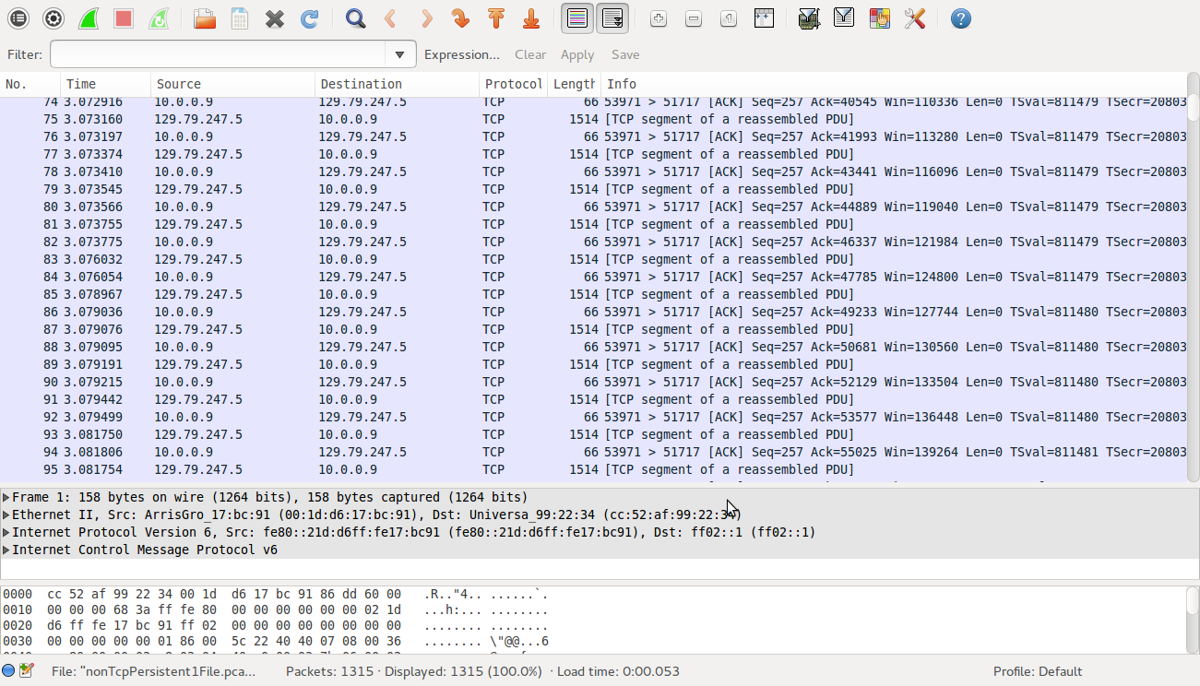

**Persistent:-**

The time taken for transferring one files using persistent connection is

**Using persistent the time taken for file1= 612ms**

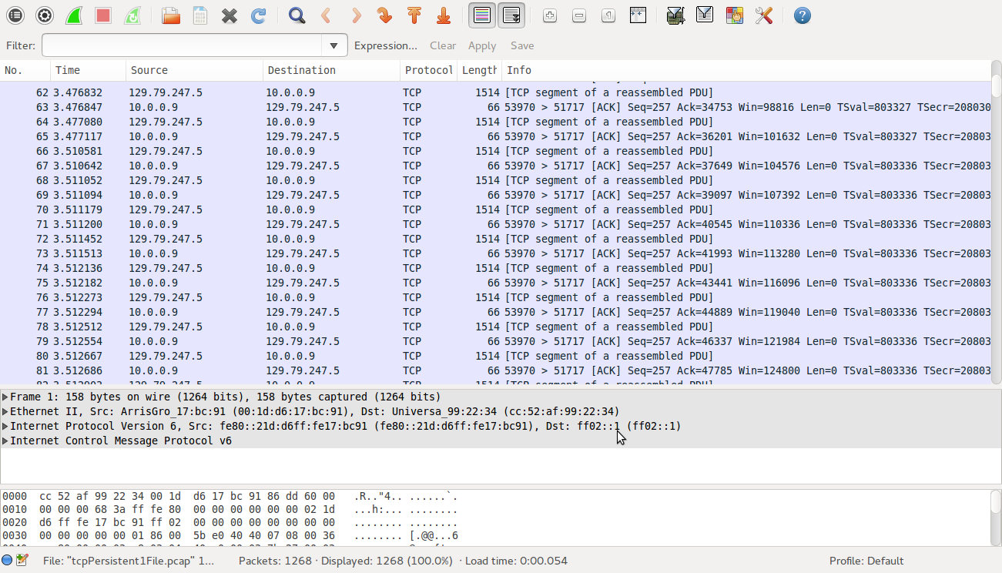

**Inference:-**

From the above result we can notice that the time is very close. This is because the RTT performed is the same in both persistent and non-persistent. Both has 2RTT since a single file is requested. 1RTT for connection establishment and 1RTT for request.

The persistent connection evidence are **persistentResult1File.txt** and **tcpPersistent1File.pcap.**

The persistent connection evidence are **nonPersistentResult1File.txt** and **tcpNonPersistent1File.pcap.**

**UDP Client/Server:-**

There is a packet loss experienced in the UDP connection. When large files are transferred then there seems a possibility of packets being dropped. It is evident when the received file and the sent file are not the same. In the case of small files there is no packet loss experienced.

So when a large file is sent the number of packets transferred is large. The traffic in the channel is high, so there is a possibility of packets being dropped.

The evidence are original **file(Big3.txt)** and transferred **file(udpResult.txt).**