1.

select Datename(month,HireDate),COUNT(month(HireDate))

from HumanResources.Employee

GROUP by DATENAME(month,HireDate);

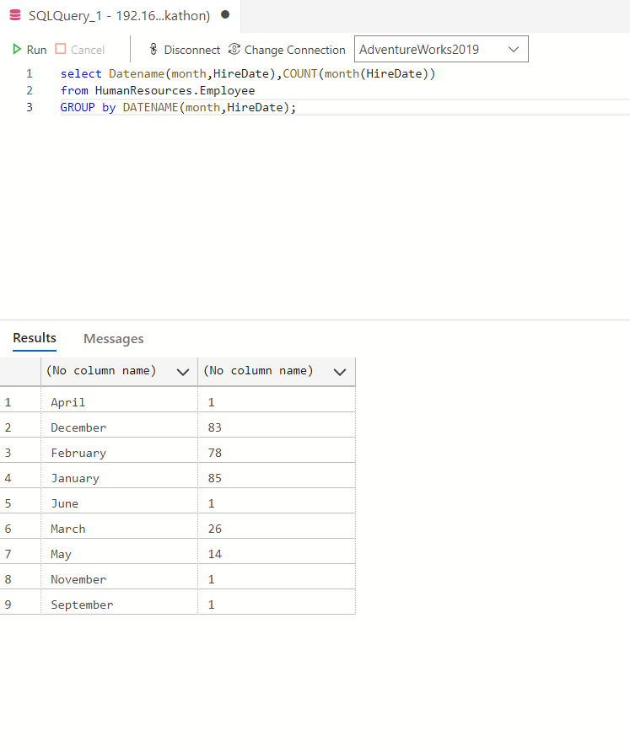

2.

SELECT name AS 'Department Name',

COUNT(\*) AS 'No of Employees'

FROM HumanResources.EmployeeDepartmentHistory

INNER JOIN HumanResources.Department

ON EmployeeDepartmentHistory.DepartmentID = Department.DepartmentID

GROUP BY Department.Name ;

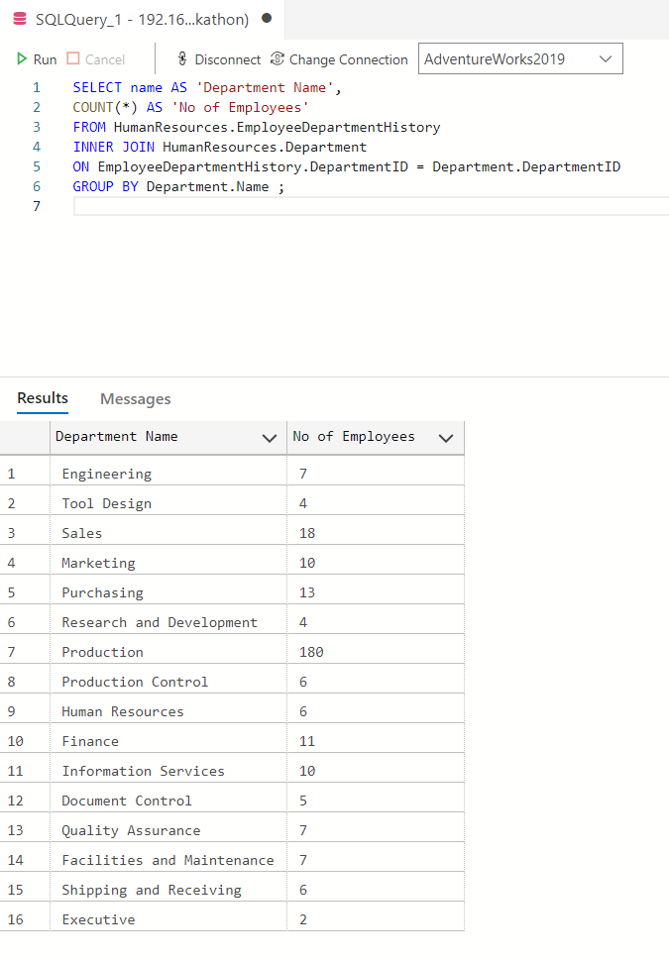

9.

select EndOfDayRate, CountryRegionCode

from Sales.CountryRegionCurrency, Sales.CurrencyRate

INNER JOIN Sales.Currency

on Sales.CurrencyRate.ToCurrencyCode = Sales.Currency.CurrencyCode

WHERE Sales.Currency.CurrencyCode= Sales.CountryRegionCurrency.CurrencyCode

ORDER BY EndOfDayRate;

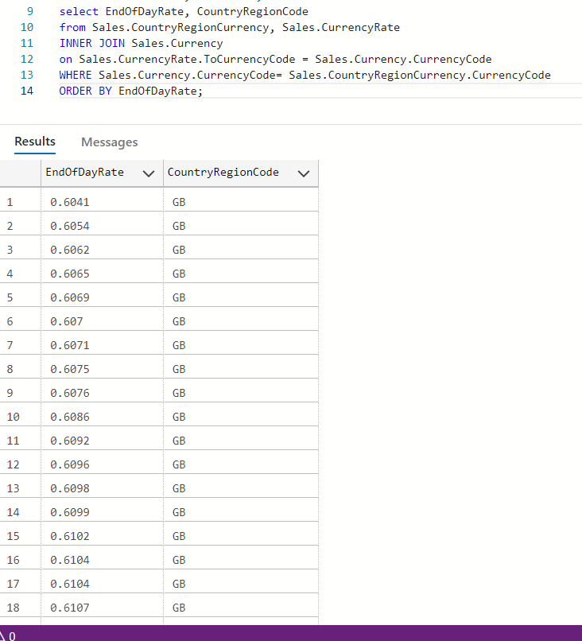

10.

select p.name, od.SalesOrderID,od.SalesOrderDetailID,od.CarrierTrackingNumber,od.OrderQty,od.ProductID,od.UnitPrice,od.SpecialOfferID,od.UnitPriceDiscount,od.LineTotal

from Production.Product as p

inner join Sales.SalesOrderDetail as od on p.ProductID = od.ProductID

inner join Sales.SalesOrderHeader as h on od.SalesOrderID = h.SalesOrderID

inner join Sales.CreditCard as c on h.CreditCardID = c.CreditCardID

where Month(h.OrderDate) = c.ExpMonth

