Open the terminal

Login as root user
sudo -u root -i

Start the hadoop services
start-all.sh
jps

Download Jar
files.cloudera.com/samples/flume-sources-1.0-SNAPSHOT.jar
the jar file location is in /home/hduser/Downloads

Create Environment File
cd /usr/local/flume/conf
ls -l
cp /usr/local/flume/conf/flume-env.sh.template /usr/local/flume/conf/flume-env.sh
ls -l

Set the downloaded jar in the classpath
nano /usr/local/flume/conf/flume-env.sh
FLUME_CLASSPATH="/home/hduser/Downloads/flume-sources-1.0-SNAPSHOT.jar"
press ctrl+x
press y
press enter key

Configure Twitter Agent
cd /usr/local/flume/conf
ls -l
nano flume.conf
copy and paste all Sample Twitter Agent Configuration which is given below..
press ctrl+x key
press y
press enter key

Rename Jar Files
cd /usr/local/flume/lib
ls
mv /usr/local/flume/lib/twitter4j-core-3.0.3.jar /usr/local/flume/lib/twitter4j-core-3.0.3.org
mv /usr/local/flume/lib/twitter4j-media-support-3.0.3.jar /usr/local/flume/lib/twitter4j-media-support-3.0.3.org
mv /usr/local/flume/lib/twitter4j-stream-3.0.3.jar /usr/local/flume/lib/twitter4j-stream-3.0.3.org
ls

RUN
/usr/local/flume/bin/flume-ng agent --conf /usr/local/flume/conf/ -f /usr/local/flume/conf/flume.conf -n TwitterAgent
where we cannot see any errors or not. Whether twitter data is running properly or not. For that open another terminal

Open another terminal

Check Logs
cat /usr/local/flume/lib/logs/flume.log
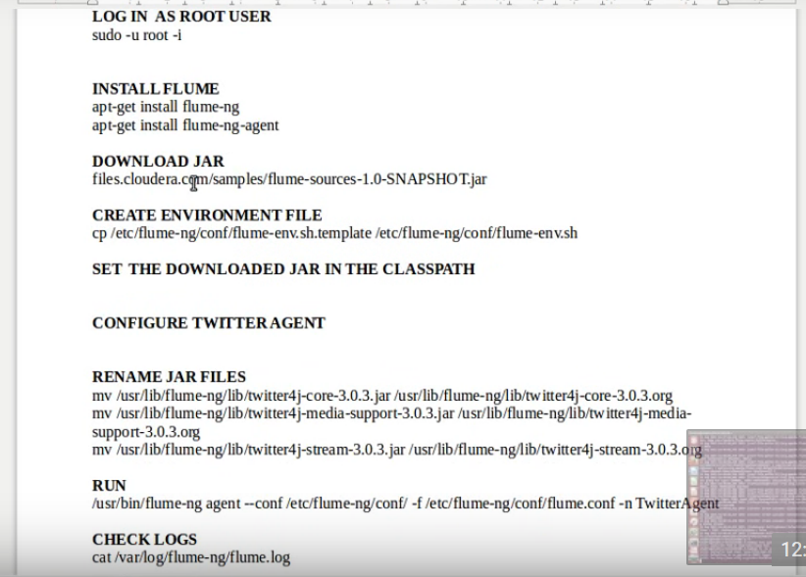

Creating a twitter agent

1. https://apps.twitter.com/
2. sign in with twitter account.
3. You don't currently have any Twitter Apps.
4. Press Create New App button
5. Fill all the details has Application details asked for creating a new application.
Name : RaghavendraTirunagari
Description : Test app for flume
Website : https://apps.twitter.com/app/new
6. After creating an app press on that app to know the keys and access tokens

7. Sample Twitter Agent Configuration

TwitterAgent.sources = Twitter
TwitterAgent.channels = MemChannel
TwitterAgent.sinks = HDFS
TwitterAgent.sources.Twitter.type = org.apache.flume.source.twitter.TwitterSource
TwitterAgent.sources.Twitter.channels = MemChannel

copy the keys and access tokens of your app
TwitterAgent.sources.Twitter.consumerKey = 5ssfBXNvbAOh12DC4h5Gzt9Ba
TwitterAgent.sources.Twitter.consumerSecret = JCAI8LduXHaMf4yMUPsSErSpIMFNGjwMRlXDoueqSfeVSxVZln
TwitterAgent.sources.Twitter.accessToken = 2842424088-VvfzpsXIdzZ4B2m5L75Zatk0j13XB5MqSiW7SAr
TwitterAgent.sources.Twitter.accessTokenSecret = G17JB4ccA4XWCRJjzudIrApYQvpd3uyqM4EqKZFB3QmqC

TwitterAgent.sources.Twitter.keywords = hadoop, big data

TwitterAgent.sinks.HDFS.channels = MemChannel
TwitterAgent.sinks.HDFS.type = hdfs
TwitterAgent.sinks.HDFS.hdfs.path = hdfs://localhost:8020/user/flume/tweets
TwitterAgent.sinks.HDFS.hdfs.fileType = DataStream
TwitterAgent.sinks.HDFS.hdfs.writeformat = Text
TwitterAgent.sinks.HDFS.hdfs.batchSize = 1000
TwitterAgent.sinks.HDFS.hdfs.rollSize = 0
TwitterAgent.sinks.HDFS.hdfs.rollCount = 10000
TwitterAgent.sinks.HDFS.hdfs.rollInterval = 600
TwitterAgent.channels.MemChannel.type = memory
TwitterAgent.channels.MemChannel.capacity = 10000
TwitterAgent.channels.MemChannel.transactionCapacity = 100

