Calibration Fails Before Discrimination: A Leave-One-Site-Out Study of Distribution Shift, Calibration Decay and Explanation Stability in Explainable Heart-Disease Prediction
Golla Raghavendra
Department of Mathematics, University Institute of Sciences, Chandigarh University, Mohali, Punjab 140413, India
raghavendrayadavgolla@gmail.com
Abstract — Machine-learning models for heart-disease prediction are almost always reported on a single cohort, with accuracy as the headline and SHAP plots as the justification for clinical trust. Whether either survives a change of population is rarely tested. We conducted a leave-one-site-out external validation across the four UCI Heart Disease cohorts (N = 920; Cleveland, Hungarian, Switzerland, Long Beach VA), training three model families on eleven commonly recorded predictors and evaluating discrimination, calibration, clinical net benefit and SHAP explanation stability on each held-out site. Internal cross-validated discrimination was uniform (ROC-AUC 0.848–0.889). External discrimination was not: it was preserved at Cleveland (ΔAUC −0.001) and Hungarian (+0.016) but fell substantially at Switzerland (−0.133) and the VA (−0.162). Calibration, by contrast, degraded in every fold, including the two where discrimination was fully preserved — Expected Calibration Error rose by factors of 2.1 to 8.3, and the calibration slope fell to 0.55 at the VA against an ideal of 1. Accuracy concealed this entirely, varying only between 0.753 and 0.800 across folds while specificity collapsed to 0.444. Decomposing explanation instability against a measured explainer noise floor (Kendall τ = 0.945), we found that changing the patient mix barely perturbed SHAP rankings (τ = 0.78–0.96) whereas refitting on the target cohort did (τ = 0.31–0.45, top-5 Jaccard 0.43), showing the instability is attributable to model behaviour rather than to data or estimator noise. Logistic recalibration on half of each target restored calibration (ECE 0.340 → 0.041 at Switzerland) but, being a monotone transform, left discrimination unchanged by construction; retraining at these cohort sizes recovered nothing and degraded the VA fold from 0.679 to 0.619. We conclude that calibration and explanation stability, not accuracy, are the quantities at risk when these models move between sites, and that recalibration is the only intervention available at realistic small-site sample sizes.
Keywords — explainable artificial intelligence; coronary artery disease; external validation; dataset shift; model calibration; SHAP; clinical decision support
1. Introduction
Cardiovascular disease remains the leading cause of death worldwide, and the prospect of identifying at-risk patients from routinely collected clinical variables has made heart-disease prediction one of the most heavily worked problems in applied machine learning. A large and still-growing body of work reports classification accuracies above ninety per cent on public benchmark cohorts, and, increasingly, accompanies those figures with post-hoc explanations from SHAP or LIME offered as evidence that the model is clinically trustworthy.
Two assumptions run silently through this literature. The first is that a model developed on one cohort will behave comparably on another. The second is that the explanations attached to it are a stable property of the model rather than an artefact of the data on which they were computed. Neither assumption is usually tested, and the reporting conventions of the field make it difficult to notice when they fail: accuracy and F1 are prevalence-dependent, so a model transferred to a site with a different case mix can retain a respectable accuracy while its probabilities become unusable and its ranking of patients deteriorates.
This study tests both assumptions directly. Using the four independent cohorts of the UCI Heart Disease collection — which differ sharply in disease prevalence, demography and measurement completeness — we perform a leave-one-site-out external validation and measure what is lost, what is merely apparently lost, and what can be recovered. Our contributions are fourfold. We quantify cross-cohort distribution shift and show it is large and statistically unambiguous. We show that calibration degrades in every transfer direction, including those where discrimination is entirely preserved, and that accuracy conceals this. We introduce a decomposition of explanation instability that separates estimator noise and patient-mix effects from genuine changes in model behaviour, and show that only the last is substantial. Finally, we evaluate recalibration and retraining as remedies, and report the negative result that retraining is not viable at the cohort sizes a small clinical site can realistically supply.
2. Related Work
To characterise current practice we screened twelve representative primary studies of machine learning for heart-disease prediction, spanning 2019 to 2026 and including IEEE Access, Scientific Reports, Computers in Biology and Medicine, Frontiers in Medicine and Intelligence-Based Medicine. Each full text was searched programmatically for nineteen terms covering dataset shift, drift, model degradation, recalibration, retraining, population-stability measures, calibration metrics, decision-curve analysis and explanation stability.
The pattern is consistent. Eight of the twelve report SHAP and five report LIME, but only two report any calibration metric, only one performs a genuine external validation on an independent cohort, and none reports decision-curve analysis, quantifies distribution shift, or measures whether its own explanations are stable. Three further studies name external validation as future work without performing it. A meta-analysis of machine learning in cardiovascular disease has separately criticised the field for reporting discrimination without calibration, a criticism these twelve studies largely bear out.
Concept | Studies reporting it | Concept | Studies reporting it
SHAP explanations | 8 / 12 | Distribution-shift metrics | 0 / 12
LIME explanations | 5 / 12 | Decision-curve analysis | 0 / 12
Calibration (any metric) | 2 / 12 | Explanation stability | 0 / 12
External validation performed | 1 / 12 | Recalibration or retraining | 0 / 12
Table 1. Screen of twelve primary studies in heart-disease machine learning. Post-hoc explanation is near-universal; every quantity that would establish whether a model transfers is absent.
The closest prior work trains on an original Bangladeshi clinical cohort and validates externally against UCI Cleveland with SHAP interpretation, and closes by naming adaptive model updating as unfinished business. That study validates in one direction, reports no calibration metric, and treats its explanations descriptively rather than measuring their stability. The present work addresses those three omissions.
3. Materials and Methods
3.1 Cohorts and features
The UCI Heart Disease collection comprises four independently collected cohorts. The outcome is angiographic disease severity, binarised at the conventional threshold into presence or absence of significant coronary artery disease. Cholesterol values recorded as zero denote missing measurements in this collection and were recoded as missing; failing to do so causes a constant imputed value to act as a site identifier.
Cohort | n | Prevalence | Mean age | Male | chol missing | ca missing | thal missing
Cleveland (USA) | 303 | 45.9% | 54.4 | 68.0% | 0.0% | 1.3% | 0.7%
Hungarian (Budapest) | 294 | 36.1% | 47.8 | 72.4% | 7.8% | 99.0% | 90.5%
Switzerland (Zurich) | 123 | 93.5% | 55.3 | 91.9% | 100.0% | 95.9% | 42.3%
VA (Long Beach) | 200 | 74.5% | 59.4 | 97.0% | 28.0% | 99.0% | 83.0%
Table 2. Cohort characteristics. Prevalence spans 36% to 94%. Fluoroscopy vessel count (ca) and thallium scan (thal) are missing for 90–99% of patients outside Cleveland and were therefore excluded from the transferable feature set.
Because vessel count and thallium result are almost entirely absent outside Cleveland, imputing them would manufacture rather than recover information. All experiments therefore use the eleven predictors recorded at every site: age, sex, chest-pain type, resting blood pressure, serum cholesterol, fasting blood sugar, resting electrocardiogram, maximum heart rate achieved, exercise-induced angina, ST depression and ST slope.
3.2 Design and leakage control
Each cohort is held out in turn as the external target while the remaining three form the development set, giving four transfer directions rather than a single anecdote. Imputation is fitted on development data only — medians for continuous and modes for categorical variables — and applied unchanged to the held-out cohort, so no target-derived statistic enters any fitted object. Three model families are used: penalised logistic regression, a random forest, and gradient-boosted trees. Internal performance is estimated by stratified five-fold cross-validation within the development set, and the operating threshold is fixed at the development Youden point and applied to the target without re-tuning.
3.3 Measurements
Distribution shift is quantified per feature by the Population Stability Index, the two-sample Kolmogorov–Smirnov statistic with Benjamini–Hochberg control across the eleven features, and the standardised Wasserstein distance; multivariate shift is summarised by the cross-validated AUC of a domain classifier trained to separate development from target records, assessed against a 200-fold permutation null. Label shift is tested by χ² on prevalence. Discrimination is reported as ROC-AUC and PR-AUC with 1,000-sample bootstrap percentile intervals. Calibration is reported as Brier score, Expected Calibration Error over ten uniform bins, and the calibration slope and intercept obtained by regressing the outcome on the linear predictor, for which the reference values are 1 and 0 respectively. Clinical utility is summarised by net benefit from decision-curve analysis.
Explanation stability is measured on the SHAP values of the gradient-boosted model. Two quantities are separated. The patient-mix component compares the development model's global ranking computed on development data against the same model's ranking computed on the target, so only the data change. The model component compares the development model's ranking against a target-refitted model's ranking, both computed on the same held-out patients, so only the model changes. Both are benchmarked against an estimator noise floor obtained by refitting the same architecture under five random seeds on identical data, which yielded a mean Kendall τ of 0.945.
Adaptation is evaluated on a stratified half of each target cohort that is never used for fitting. The other half supports intercept-only recalibration, logistic (Platt) recalibration, and full retraining of the same model family.
4. Results
4.1 The cohorts are substantially shifted
Every transfer direction shows unambiguous multivariate shift: the domain classifier separated development from target records with AUC 0.76 to 0.85 in all four folds, against a permutation null p = 0.005 throughout. Between five and nine of the eleven features shifted significantly after false-discovery-rate correction. Maximum heart rate and age carry most of the univariate signal, reaching Population Stability Indices of 0.72 and 0.80 in the VA fold and 1.62 for age in the Hungarian fold, against a conventional major-shift threshold of 0.25. Label shift is equally clear, with prevalence moving from 49.4% in development to 93.5% at Switzerland (χ² = 81.9) and from 50.0% to 74.5% at the VA (χ² = 37.0).
Held-out cohort | age | trestbps | chol | thalach | oldpeak | Domain-classifier AUC | Features shifted (BH)
Cleveland | 0.10 | 0.07 | 0.06 | 0.63 | 0.12 | 0.85 | 5 / 11
Hungarian | 1.62 | 0.19 | 0.05 | 0.08 | 1.06 | 0.85 | 7 / 11
Switzerland | 0.14 | 0.35 | — | 0.51 | 0.10 | 0.76 | 5 / 11
VA | 0.80 | 0.03 | 0.11 | 0.72 | 0.29 | 0.83 | 9 / 11
Table 3. Population Stability Index for the five continuous predictors, with the multivariate domain-classifier summary. Values above 0.25 conventionally indicate major shift. Cholesterol is unmeasurable at Switzerland, where it is entirely missing.
4.2 Discrimination loss is site-specific
Internal cross-validated discrimination was uniform across folds and model families, with ROC-AUC between 0.848 and 0.889 — figures consistent with those routinely published on these data. External discrimination was not uniform. Averaged over the three model families, transfer to Cleveland changed AUC by −0.001 and transfer to Hungarian by +0.016, whereas transfer to Switzerland lost 0.133 and to the VA 0.162 (Fig. 1). The two cohorts that resisted transfer are those whose prevalence is closest to the development mixture; the two that failed are those with the most extreme prevalence and the heaviest missingness.
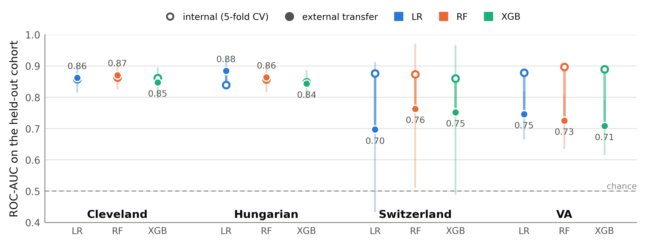
Figure 1. Internal cross-validated discrimination (hollow markers) against external transfer discrimination (filled markers) for each model and held-out cohort. Vertical bars are 1,000-sample bootstrap percentile intervals on the transfer estimate. Discrimination is preserved at Cleveland and Hungarian and lost at Switzerland and the VA; the very wide interval at Switzerland reflects its eight negative cases.
4.3 Calibration degrades everywhere, including where discrimination does not
The central result of this study is that calibration and discrimination do not fail together. Expected Calibration Error rose in all four folds, by a factor of 2.1 at Cleveland, 4.0 at Hungarian, 8.3 at Switzerland and 2.5 at the VA. The Hungarian fold is the clearest demonstration: discrimination there improved slightly, yet ECE rose from 0.040 to 0.158 and the calibration intercept fell to −1.05, indicating systematic over-prediction of risk in a cohort whose true prevalence is lower than the development mixture. At Switzerland the intercept moved in the opposite direction to +2.77, systematic under-prediction at a cohort where 93.5% of patients are diseased. At the VA the calibration slope fell to 0.55, meaning the transferred probabilities are far too extreme in both directions.
Accuracy conceals all of this. Transfer accuracy varied only between 0.753 and 0.800 across the four folds — a spread of under five points — while AUC varied from 0.727 to 0.864 and specificity collapsed from 0.849 at Hungarian to 0.444 at the VA and 0.625 at Switzerland. A reader given only the accuracy column would conclude that the model transferred uniformly well to all four sites. It did not transfer well to two of them, and its probabilities are unusable at three.
4.4 Explanation instability is model-driven, not data-driven
Global SHAP rankings changed very little when the same model was applied to a new cohort: the patient-mix component gave Kendall τ between 0.78 and 0.96, at or close to the measured estimator noise floor of 0.945. Refitting the model on the target cohort and comparing rankings on identical patients gave a markedly different picture, with τ falling to 0.31 at Cleveland, 0.38 at Hungarian and 0.45 at the VA, and a top-five Jaccard overlap of only 0.43 (Fig. 3). Because the data are held constant in that comparison and the estimator noise floor is known, the divergence is attributable to the model itself: a model fitted to the target population distributes attribution differently from the model transferred into it, even when both are interrogated on the same patients.
Chest-pain type and ST depression remained the two leading attributed features in every fold, so the clinical headline is stable; it is the ordering below the top two, and the identity of the fourth and fifth features, that moves. Switzerland could not be assessed on the model component because only eight of its 123 patients are disease-negative, too few to refit a model on half the cohort.
4.5 Recalibration recovers reliability; retraining does not recover performance
Logistic recalibration fitted on half of each target cohort substantially restored calibration on the untouched half: mean ECE fell from 0.340 to 0.041 at Switzerland, from 0.160 to 0.057 at Hungarian, from 0.147 to 0.100 at the VA and from 0.121 to 0.081 at Cleveland (Fig. 2). Because both recalibration maps are monotone transformations of the predicted probability, discrimination is mathematically unchanged by them — AUC is identical before and after — which is precisely the point: recalibration repairs the quantity that failed while leaving untouched the quantity that did not.
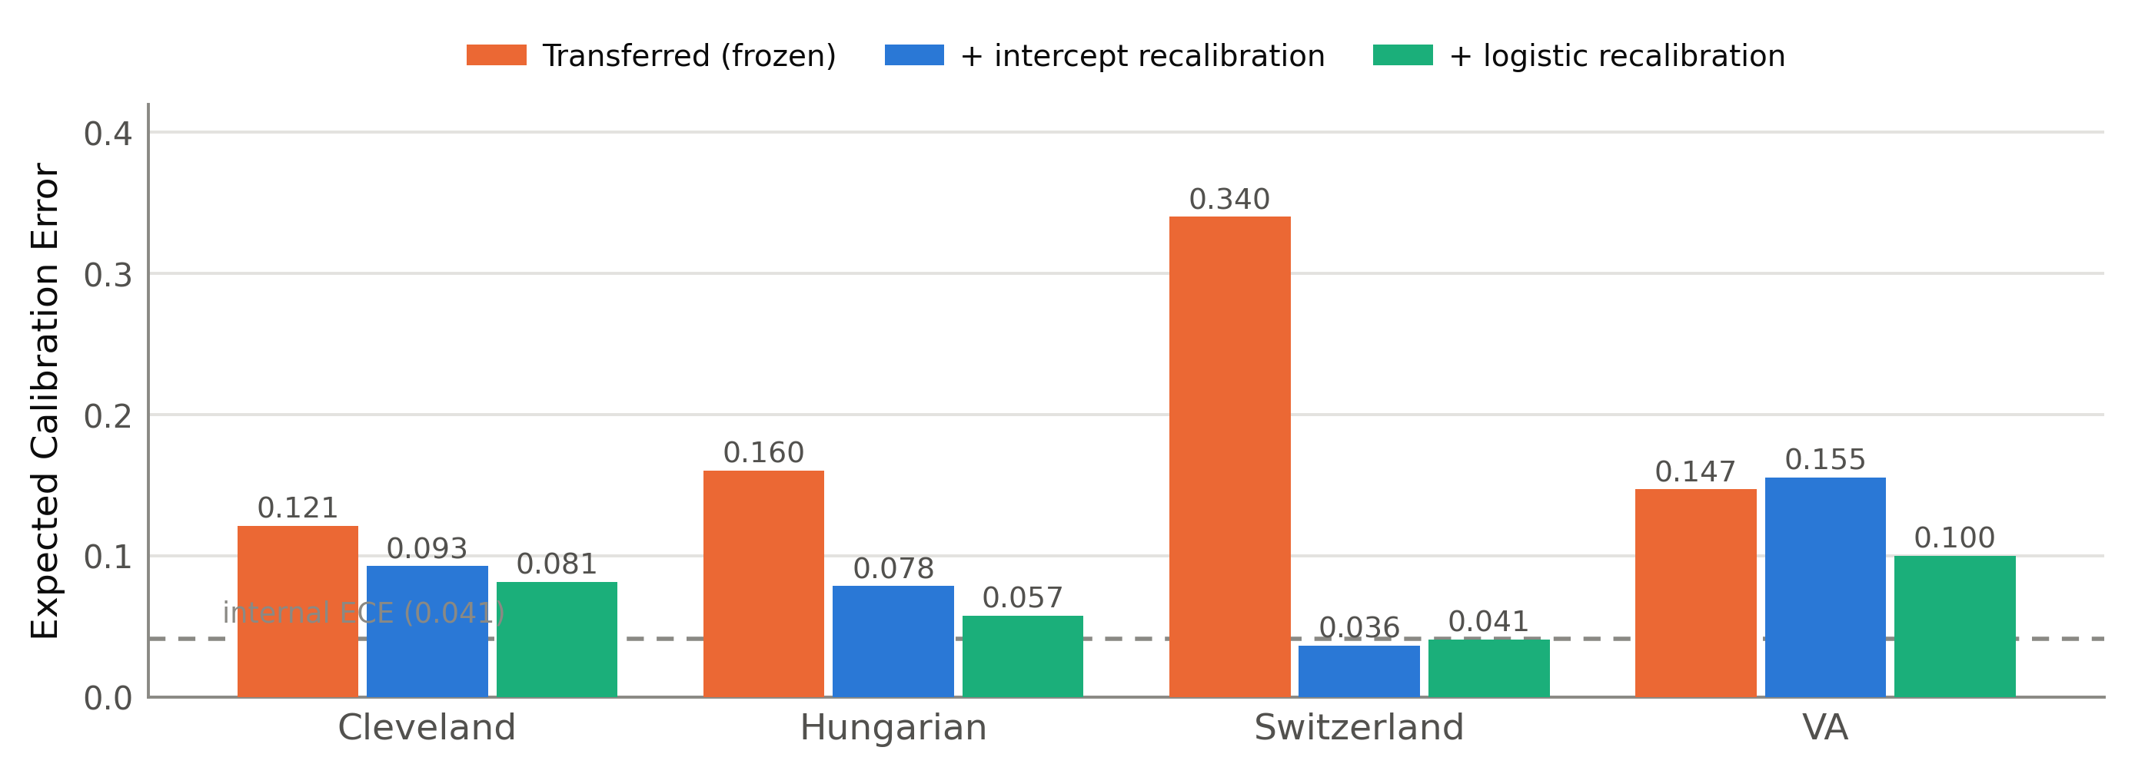
Figure 2. Expected Calibration Error on the untouched evaluation half of each held-out cohort, averaged across the three model families, before and after recalibration fitted on the adaptation half. The dashed line marks mean internal ECE. Recalibration returns three of four cohorts close to internal levels.
Retraining did not help. Refitting each model family on half of the target cohort left discrimination statistically unchanged at Cleveland and Hungarian and actively degraded it at the VA, from a frozen 0.679 to 0.619. At Switzerland retraining was not possible at all: a stratified half of the cohort contains four disease-negative patients. The interpretation is straightforward and, we believe, practically important. At the sample sizes a small clinical site can realistically supply, a few hundred records at most, retraining discards the information contained in the larger development set without acquiring enough new information to replace it. Recalibration, which estimates one or two parameters rather than a whole model, is the only intervention that these sample sizes support.
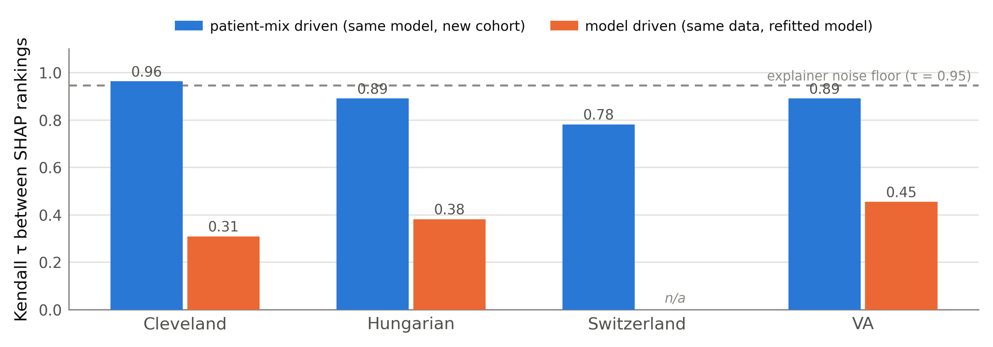
Figure 3. Decomposition of SHAP ranking instability. Changing the patient mix while holding the model fixed leaves rankings near the estimator noise floor; refitting the model while holding the patients fixed moves them far below it. Switzerland cannot be refitted because it contains only eight disease-negative cases.
5. Discussion
Three findings bear on how this literature reports its results. First, discrimination is not a sufficient summary of transfer: two of our four folds preserved AUC completely while their probability estimates became systematically biased in opposite directions. A model that ranks patients correctly but assigns them the wrong absolute risk cannot support a treatment threshold, which is the use to which such models are actually put. Second, accuracy is actively misleading in this setting. Because the four cohorts differ in prevalence by a factor of two and a half, accuracy is dominated by base rate rather than by skill, and it varied least across exactly those folds where the underlying behaviour varied most. Reporting accuracy as the headline figure, as the majority of the screened literature does, systematically obscures transfer failure.
Third, the stability of post-hoc explanations should not be assumed. Our decomposition indicates that the explanations attached to a transferred model are robust to a change of population, but that they do not agree with the explanations a locally fitted model would produce on the same patients. If SHAP rankings are offered to clinicians as an account of why a patient is at risk, then two defensible models trained on different populations will offer materially different accounts of the same patient. That is a property of the models, not an artefact of the explainer, and it deserves to be reported alongside the explanations themselves.
The practical recommendation that follows is modest but concrete. A model moved to a new site should be recalibrated before use, using a few hundred locally labelled records; its calibration slope and intercept should be reported alongside its AUC; and its explanations should be revalidated locally rather than carried over from the development site.
6. Limitations
These cohorts carry no time index, so this study speaks to cross-sectional differences between sites and not to temporal concept drift or degradation over time; we have deliberately avoided the term drift throughout. With four cohorts, site is confounded with case mix, referral threshold, measurement protocol and coding practice, so we can quantify how much is lost but not why. The Switzerland cohort has only eight disease-negative patients, which makes its AUC estimate very imprecise and prevented the model-component explanation analysis and any retraining comparison. The data were collected in 1988 and reflect historical practice: our findings about transfer mechanics should generalise, our findings about particular risk factors should not be read as current clinical evidence. Finally, the outcome is nominally identical across sites but the referral threshold that brings a patient to angiography is not, which is a plausible source of genuine conditional shift that our design can detect only as residual degradation.
7. Conclusion
Across four independent cohorts we found that explainable heart-disease models retain their internal discrimination on some external sites and lose it substantially on others, but lose calibration on all of them — by factors of two to eight in Expected Calibration Error, including at sites where discrimination was fully preserved. Accuracy, the field's dominant reporting metric, concealed this variation almost entirely. Post-hoc explanations proved robust to a change of patient population but not to refitting, indicating that attribution rankings are a property of the fitted model rather than a stable clinical account. Lightweight recalibration restored reliability at every site; retraining, at the sample sizes small sites can supply, did not restore performance and in one cohort reduced it. We recommend that external-validation studies in this area report calibration slope and intercept alongside discrimination, treat accuracy as uninformative under prevalence shift, and validate explanation stability locally before presenting attributions to clinicians.
References
[1] Mohan, S., Thirumalai, C. and Srivastava, G. (2019) 'Effective heart disease prediction using hybrid machine learning techniques', IEEE Access, 7, pp. 81542–81554.
[2] Krittanawong, C., Virk, H.U.H., Bangalore, S. et al. (2020) 'Machine learning prediction in cardiovascular diseases: a meta-analysis', Scientific Reports, 10, 16057.
[3] Wang, K., Tian, J., Zheng, C. et al. (2021) 'Interpretable prediction of 3-year all-cause mortality in patients with heart failure caused by coronary heart disease based on machine learning and SHAP', Computers in Biology and Medicine, 137, 104813.
[4] Jindal, H., Agrawal, S., Khera, R. et al. (2021) 'Heart disease prediction using machine learning algorithms', IOP Conference Series: Materials Science and Engineering, 1022, 012072.
[5] Bhatt, C.M., Patel, P., Ghetia, T. and Mazzeo, P.L. (2023) 'Effective heart disease prediction using machine learning techniques', Algorithms, 16(2), 88.
[6] Subramani, S., Varshney, N., Anand, M.V. et al. (2023) 'Cardiovascular diseases prediction by machine learning incorporation with deep learning', Frontiers in Medicine, 10, 1150933.
[7] Dritsas, E. and Trigka, M. (2024) 'Application of deep learning for heart attack prediction with explainable artificial intelligence', Computers, 13(10), 244.
[8] El-Sofany, H., Bouallegue, B. and Abd El-Latif, Y.M. (2024) 'A proposed technique for predicting heart disease using machine learning algorithms and an explainable AI method', Scientific Reports, 14, 74656.
[9] Laftah, R.H. and Al-Saedi, K.H.K. (2024) 'Explainable ensemble learning models for early detection of heart disease', Journal of Robotics and Control, 5(5), pp. 1412–1430.
[10] Ganie, S.M., Pramanik, P.K.D. and Zhao, Z. (2025) 'Ensemble learning with explainable AI for improved heart disease prediction based on multiple datasets', Scientific Reports, 15, 97547.
[11] Chakraborty, A., Das, U.K., Sazzad, S., Das, P. and Khan, M.M.H. (2026) 'Explainable machine learning for early heart disease risk prediction: insights from a clinical dataset in Bangladesh', Intelligence-Based Medicine, 13, 100352.
[12] Lundberg, S.M. and Lee, S.-I. (2017) 'A unified approach to interpreting model predictions', Advances in Neural Information Processing Systems, 30, pp. 4765–4774.
[13] Van Calster, B., McLernon, D.J., van Smeden, M. et al. (2019) 'Calibration: the Achilles heel of predictive analytics', BMC Medicine, 17, 230.
[14] Vickers, A.J. and Elkin, E.B. (2006) 'Decision curve analysis: a novel method for evaluating prediction models', Medical Decision Making, 26(6), pp. 565–574.
[15] Detrano, R., Jánosi, A., Steinbrunn, W. et al. (1989) 'International application of a new probability algorithm for the diagnosis of coronary artery disease', American Journal of Cardiology, 64(5), pp. 304–310.
Data and reproducibility. All four cohorts are publicly available from the UCI Machine Learning Repository. All results reported here were computed from the raw cohort files under the leave-one-site-out protocol described in Section 3; random seeds are fixed throughout and no figure in this paper is drawn from any source other than those computations.

