**HTML Basics for Beginners**

**Prerequisites to start:**

***Sublime Text:*** *the most popular web editor at the time of this writing. Lightweight and highly customizable, especially if you use its 3rd Party package manager. It’s free, but you will receive regular notifications asking you to pay $60 USD for a license.* [*https://www.sublimetext.com/*](https://www.sublimetext.com/)

***Visual Studio Code:*** *a completely free editor from Microsoft. Very similar to Sublime Text but contains a few other features such as a built-in terminal and Git integration. Also has a 3rd Party package manager.* [*https://code.visualstudio.com/*](https://l.facebook.com/l.php?u=https%3A%2F%2Fcode.visualstudio.com%2F&h=ATPzDNJanZbSrqLfIoRzst-cIWuVSTjFIw24Tum1msyHo_5vqX2WIUjiF1818AePGVUlJDzX-LFPP3Urg059UsQdg8U7xWTkfgDzhWWPpUsXqmy-3kBmb4DIUNiK2VCFivcBaShzDtT_)

***Brackets:*** *a completely free editor from Adobe. It’s codebase is open source, so lots of features are added to it regularly. Some of these features are added to Adobe’s premium web editor, Dreamweaver. Not as feature-rich as Sublime Text and Visual Studio code, but still a great web editor.* [*http://brackets.io/*](https://l.facebook.com/l.php?u=http%3A%2F%2Fbrackets.io%2F&h=ATP1dEBRP2uNi4_zBJ5JH9SyqiGPj7Ko6TcVt53JP4q-jHS3nqTCIarbsEMCWHpWbe9EF-3QkIVI5DMsCQKNesYYDpyH7sXbH4FuGGpDwl6w52XR4Z66PxiObtXNharjskAITRC_NSEd)

***Atom:*** *a completely free editor from GitHub that is also open source, and highly customizable. Can be extended with its package manager, which is internal and not 3rd party.* [*https://atom.io/*](https://atom.io/)

***Notepad++:*** *a completely free, Windows-only editor. It was one of the first barebones web editors to be released. Definitely not as feature-rich as the other editors but still great for writing basic code.* [*https://notepad-plus-plus.org/*](https://l.facebook.com/l.php?u=https%3A%2F%2Fnotepad-plus-plus.org%2F&h=ATMh3QkOvNaXLpZM1-_UM5fr8oZ_B2KRpcDS411em1xUaV5zRytcNZXVX_dpKBBt6GxsuYJqMQRuN0lXh_kGOeuqDxAMzWW2U-n9kbvAnR80V55RAJV8y8NOCDDwU2wrDwIp8TviYiPd)

***Dreamweaver:*** *a premium web editor from Adobe. Lots of features, lots of 3rd party extensions available for it and a great visual editor that’s WYSIWYG (What You See Is What You Get). Since its not open source, it doesn’t add new features as rapidly as some of the other editors. It also is not free, costing you $19.99 a month through Adobe Creative Cloud. But it remains one of the best premium web editors, if not the best.* [*http://www.adobe.com/products/dream...*](http://www.adobe.com/products/dreamweaver.html)

***Webstorm:*** *a premium web editor that’s more modern than Dreamweaver. Lots more modern features, most of which are based around JavaScript...strong support for Angular, React, Karma, etc. If you buy a monthly subscription, it’s a little less expensive than Dreamweaver at $12.99 a month.* [*https://www.jetbrains.com/webstorm/*](https://www.jetbrains.com/webstorm/)

***Netbeans:*** *a completely free web editor that you can use to edit HTML, CSS JavaScript, but is more well-known for its Java integration. It offers several different versions for download so you may want to download the one based around HTML5. Like Notepad++, it’s not as feature-rich as the other editors but still great for writing basic code.* [*https://netbeans.org/*](https://l.facebook.com/l.php?u=https%3A%2F%2Fnetbeans.org%2F&h=ATNZPERUOfWrqdjGa_Ch2bQNtN_qRq_Q8b-jWa9PQat5G_XjycC-Mtnm1jKmp-ypshh7NvLCTC3v2pphCFyzSF7c1CzA7yTKK7zeCmvuE4LinvYbSd9b5tIJYznDWJjWQhRKdtH7TQV-)

***IntelliJ IDEA:*** *a premium web editor that you can use to edit HTML, CSS JavaScript, but is also more well-known for its Java integration. Much more feature-rich than Netbeans and it does offer a free version, but lacks lots a features when compared to the free editors.* [*https://www.jetbrains.com/idea/*](https://l.facebook.com/l.php?u=https%3A%2F%2Fwww.jetbrains.com%2Fidea%2F&h=ATPnEzxE3or4AQPDDW7GsMmPL9-jM2-hzdFSswxrlX6moyV2metab_WwVG8oM9nYUHmFU3bvLmMBAoG8pEVem8bBbAP0C-VTXfGnpThf0BCIah5upu5B4qJPbhyiX3CJ9Bjmip3-x6kE)

*List of free online HTML/CSS/JS editors:*

* *Mozilla Thimble:*[*thimble.mozilla.org*](http://thimble.mozilla.org/)
* *Plunker:*[*Plunker*](http://plnkr.co/)
* *JSBIN:*[*JS Bin*](http://jsbin.com/)
* *CodePen:*[*CodePen*](http://codepen.io/)
* *jsfiddle:*[*Create a new fiddle*](http://jsfiddle.net/)
* *codemagic:*[*codemagic.gr*](http://codemagic.gr/)
* *liveweave:*[*HTML5, CSS3 & JavaScript playground for web designers & developers*](http://liveweave.com/)
* dabblet: [dabblet.com](http://dabblet.com/)
* cssdeck: [HTML5, CSS3, JS Demos, Creations and Experiments](http://cssdeck.com/)

**Tasks Outline:**

When solving the day to day tasks/assignments, strive to create not just code that works, but code that is stylish and concise. Try to write small code which perform just a single task, and then combine those smaller pieces to create more complete web layout design. Be sure to write tags with exactly the specified name for each exercise (to help us evaluate your design).

**Task 1: Pre Assessment**

You will be creating a hand‐coded HTML table for storing tag name, definitions/descriptions and Output in third column the table should either be organized alphabetically or logically, For example

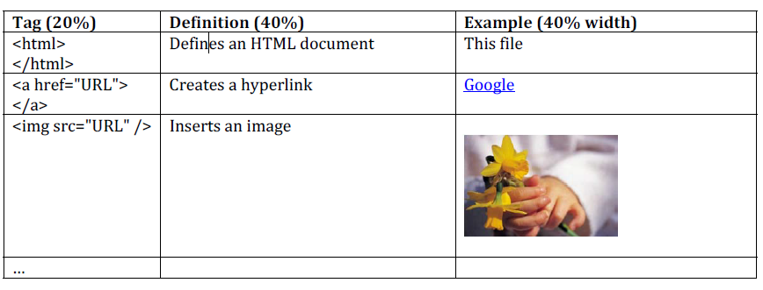

In first column- Tag Name & syntax, Second column- Description in general words as per your understanding and third column- Display the output of corresponding tag.

**Task 2: Miscellaneous**

* Print your name in green.
* Print the numbers 1 - 10, each number being a different color.
* Print the squares of the numbers 1 - 20. Each number should be on a separate line, next to it the number 2 superscripted, an equal sign and the result. (Example: 102 = 100)
* Create links to five different pages on five different websites that should all open in a new window.
* Create a page with a link at the bottom of it that when clicked will jump all the way to the top of the page.

**Task 3:**

Learn how to embed the following sources into a webpage,

A. Website

B. Google Calendar

C. Google Maps

D. Google Form

E. PDF

F. YouTube video

**Task 4:**

Design a form which uses all form-type elements:

Make sure to include text, phone number, search, URL, email, password, date, month, week, time, color, radio button, checkbox, file(single & multiple), auto complete, maxlength for input field, size for input field, readonly, pattern for particular input field, min value & max value, steps to increase count of number, range and submit & reset.

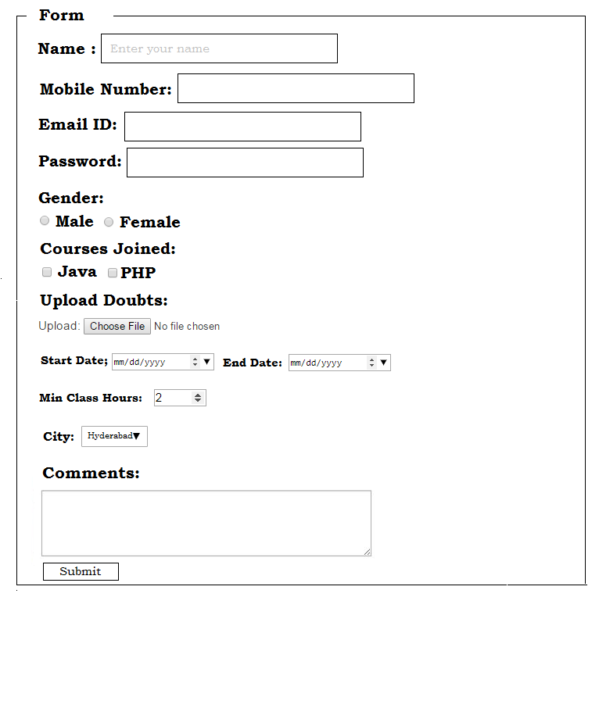

**Task 5:** Develop a Table as depicted below:

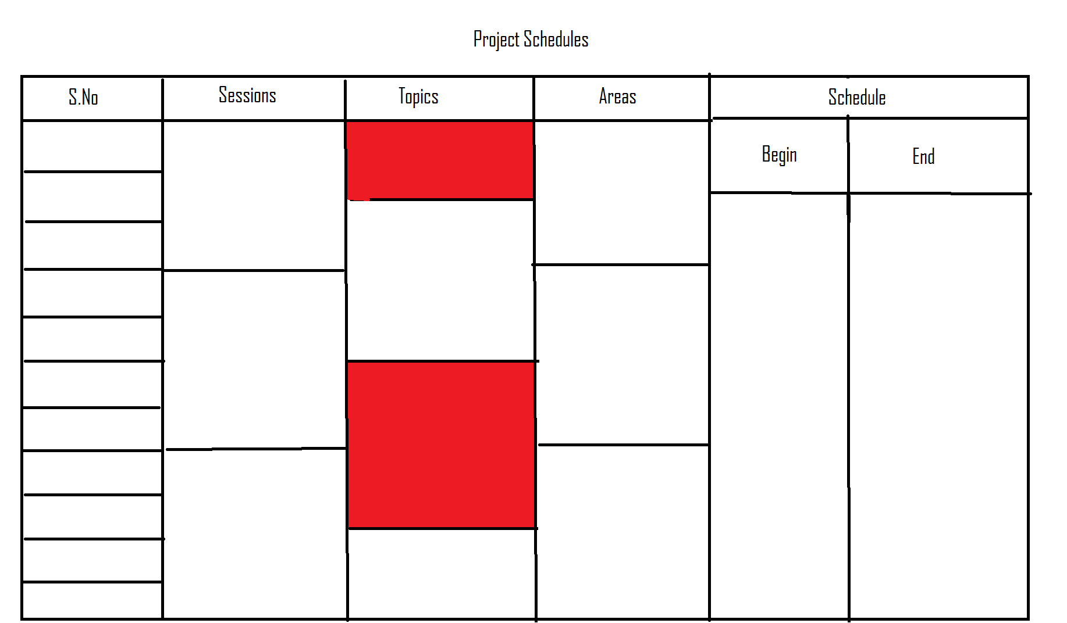

**Task 6:**

**HTML Resume, Basic Tags**

Turn your resume into a web page, using HTML5.

**Optional items to include:**

Name

Email address

Web address

Education

Objective

Work Experience

Skills

Awards

Organizations

Relevant information

**Technical Stuff:**

Create meaningful head tag content

Create lists using <ul><li>information</li><ul>

Create paragraphs using <p>information</p>

Use <h1></h1>, <h2></h2>, etc. for headings and subheadings

**Important:**

**Your tags must be lowercase

**Save as:**

Something like: resume.html