**BCSL657B Lab Setup**

**Step1:InstallNode.js and npm**React relies on Node.js and npm (Node Package Manager), so you’ll need to install them first if you haven’t already.

1. Go to the official [Node.js website](https://nodejs.org/).
2. Download the latest LTS version for your operating system (Windows/macOS/Linux).
3. Install it by following the instructions for your OS. This will also install npm, which comes bundled with Node.js.

**Step 2: Install Visual Studio Code (VSCode)**  
If you haven’t already installed VSCode, follow these steps:

1. Go to the [Visual Studio Code website](https://code.visualstudio.com/).
2. Download and install VSCode for your operating system.

**Step 3: Open VSCode and Install the Required Extensions**

1. Launch VSCode.
2. **Install the following extensions** for better development experience:
   * **ES7 React, Redux/GraphQL, React-Native snippets**: This extension provides useful React snippets to speed up development.
   * **Prettier – Code formatter**: It helps in keeping your code clean and formatted automatically.
   * **Bracket Pair Colorizer**: Helps visually distinguish matching brackets.
   * **ESLint**: For JavaScript/React linting.

**To install an extension:**

* Press Ctrl+Shift+X (Windows/Linux) or Cmd+Shift+X (Mac) to open the Extensions panel.
* Search for the extension by name and click **Install**.

**Step 4: Create a New React Project**  
You can use Create React App to set up a new React project easily. Here’s how to do that:

1. **Open the terminal** in VSCode:
   * Press Ctrl+`` (backtick) to open the terminal, or use the menu Terminal>New Terminal`.
2. **Create a new React app** using npx (no need to install globally):

**npx create-react-app my-app**

*Note:Replace my-app with the name of your project. This will create a new folder called my-app with all the necessary files and configurations.*

**Step 5: Navigate to Your Project Folder**  
Once the create-react-app process finishes, move into your project directory:

**cd my-app**

**Step 6: Start the Development Server**  
To see your React app in action, run the following command in the VSCode terminal:

**npm start**

**Step 7: Edit Your Code**  
Now that everything is set up, you can start modifying the code:

1. Open src/App.js in VSCode.
2. Make some changes to the code. For example, change the text inside the <h1> tag or modify the App component to see updates live in the browser.

**“Fixing the Module not found: Error: Can't resolve 'web-vitals' Error in React”:**

The error you’re seeing occurs because the web-vitals package, which is used for performance monitoring in a React app, is not installed by default in the project or has been removed. Since web-vitals is an optional package, you can safely resolve this issue by either installing the package or removing the code that imports it.

**Option 1: Install the web-vitals package**  
If you want to keep the performance monitoring functionality and resolve the error, simply install the web-vitals package.

1. In the terminal, navigate to your project folder (if not already there):

cd my-dynamic-app

1. Install web-vitals by running the following command:

npm install web-vitals

1. After installation is complete, restart the development server:

npm start

4.This should resolve the error, and your application should compile correctly.

**REACT Lab-BCSL657B**

1.**Use create-react-app to set up a new project. Edit the App.js file to include a stateful component with useState. Add an input field and a <h1> element that displays text based on the input. Dynamically update the <h1> content as the user types.**

Steps to create and run the React application:

**Step 1: Create a new React app**  
First, you need to create a new React app using create-react-app. Open your terminal and run:

npx create-react-app my-dynamic-app

This will set up a new React project in a folder called my-dynamic-app. After the installation is complete, navigate to the project directory:

cd my-dynamic-app

**Step 2: Modify the App.js file**Open the src/App.js file in your favorite code editor and update the code to include a stateful component using the useState hook. Here’s how you can modify it:

**App.js File in Src file**

import React, { useState } from 'react';

import './App.css';

function App() {

  const [text, setText] = useState('');

  const handleChange = (event) => {

    setText(event.target.value);

  };

  return (

    <div className="App">

      <h1>Dynamic Text Display</h1>

      <input

        type="text"

        value={text}

        onChange={handleChange}

        placeholder="Type something..."

      />

      <p>You typed: {text}</p>

    </div>

  );

}

export default App;

**2.Index.js File**

import React from 'react';

import ReactDOM from 'react-dom/client';

import './index.css';

import App from './App';

import reportWebVitals from './reportWebVitals';

const root = ReactDOM.createRoot(document.getElementById('root'));

root.render(

  <React.StrictMode>

    <App />

  </React.StrictMode>

);

// If you want to start measuring performance in your app, pass a function

// to log results (for example: reportWebVitals(console.log))

// or send to an analytics endpoint. Learn more: https://bit.ly/CRA-vitals

reportWebVitals();

**Step 3: Run the application**Back in your terminal, start the development server by running:

npm startThis will open the app in your default web browser, typically at http://localhost:3000, and you should see an input field where you can type, and the content will update dynamically as you type.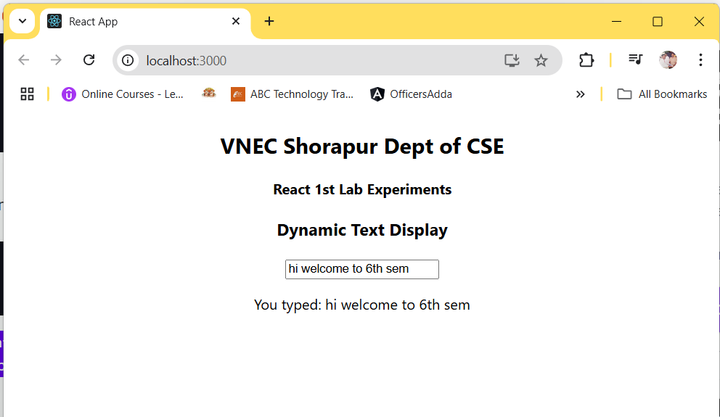

**2.** **Develop a React application that demonstrates the use of props to pass data from a parent component to child components. The application should include the parent component named App that serves as the central container for the application. Create two separate child components, Header: Displays the application title or heading. Footer: Displays additional information, such as copyright details or a tagline. Pass data (e.g., title, tagline, or copyright information) from the App component to the Header and Footer components using props. Ensure that the content displayed in the Header and Footer components is dynamically updated based on the data received from the parent component.**

**Step 1: Create a New React Application**  
First, you need to create a new React app using below command. Open your terminal and run:

npx create-react-app react-props-demo

This will set up a new React project in a folder called **react-props-demo**. After the installation is complete, navigate to the project directory:

cd react-props-demo

**Step 2: Define the Components**

**1. App Component (Parent Component)**  
In src/App.js, we define the parent component App, which will pass data to the child components using props.

import React from 'react';

import Header from './Header';

import Footer from './Footer';

import './App.css';

function App() {

  const title = "Welcome to Veerappa Nisty Engineering";

  const tagline = "Designed and developed by Raghavendra Kulkarni";

  const copyright = "© 2025 Dept of CSE, All Rights Reserved";

  return (

    <div className="App">

      <Header title={title} />

      <Footer tagline={tagline} copyright={copyright} />

    </div>

  );

}

export default App;

**2.** **Header Component (Child Component)**  
Create a new file src/Header.js for the Header component, which will receive the title as a prop.

import React from 'react';function Header(props) {

return (

<header>

<h1>{props.title}</h1>

</header>

);

}export default Header;

**3.** **Footer Component (Child Component)**  
Create a new file src/Footer.js for the Footer component, which will receive the tagline and copyright as props.

import React from 'react';function Footer(props) {

return (

<footer>

<p>{props.tagline}</p>

<p>{props.copyright}</p>

</footer>

);

}export default Footer;

**Step 3: Add Some Basic Styles (Optional)**  
To make the app look better, you can add some basic styles. Open src/App.css (or create a new file) and add the following styles:

.App {

text-align: center;

font-family: Arial, sans-serif;

}header {

background-color: #282c34;

padding: 20px;

color: white;

}footer {

background-color: #282c34;

padding: 10px;

color: white;

position: absolute;

bottom: 0;

width: 100%;

text-align: center;

}

**Step 4: Run the application**  
Back in your terminal, start the development server by running:

npm start

**Output Page:**

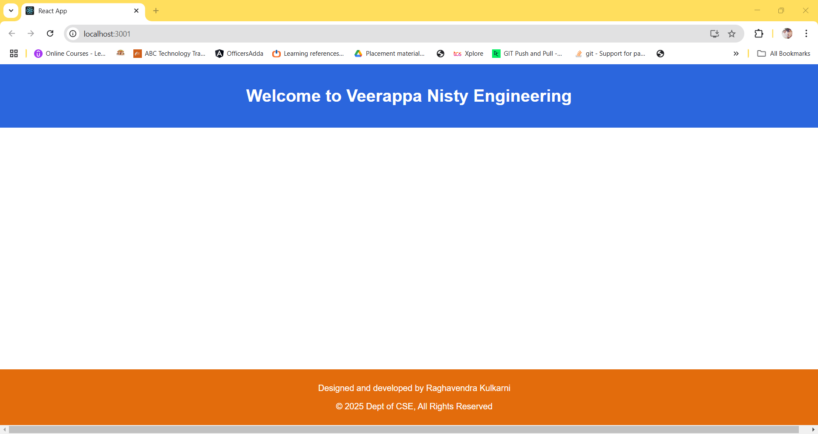

**3. Create a Counter Application using React that demonstrates state management with the useState hook. Display the current value of the counter prominently on the screen. Add buttons to increase and decrease the counter value. Ensure the counter updates dynamically when the buttons are clicked. Use the useState hook to manage the counter’s state within the component. Prevent the counter from going below a specified minimum value (e.g., 0). Add a “Reset” button to set the counter back to its initial value. Include functionality to specify a custom increment or decrement step value.**

**Step 1: Create a new React app**  
First, you need to create a new React app using below command. Open your terminal and run:

npx create-react-app counter-app

This will set up a new React project in a folder called **counter-app**. After the installation is complete, navigate to the project directory:

cd counter-app

**Step 2: Modify the App.js File**

1. **Navigate to the src folder** in the file explorer on the left-hand side of VSCode.
2. Open the App.js file (which contains the default template code).
3. **Replace the content of App.js with the code provided for the Counter App**. Here’s the code to replace inside App.js:

import React, { useState } from 'react';

import './App.css';

function App() {

const [counter, setCounter] = useState(0);

const [step, setStep] = useState(1);

const minValue = 0;

const handleIncrement = () => {

setCounter(prevCounter => prevCounter + step);

};

const handleDecrement = () => {

if (counter - step >= minValue) {

setCounter(prevCounter => prevCounter - step);

}

};

const handleReset = () => {

setCounter(0);

};

const handleStepChange = (event) => {

setStep(Number(event.target.value));

};

return (

<div style={{ textAlign: 'center', marginTop: '50px' }}>

<h1>Counter Application</h1>

<div style={{ fontSize: '48px', margin: '20px' }}>

<span>{counter}</span>

</div>

<div>

<button onClick={handleIncrement}>Increase by {step}</button>

<button onClick={handleDecrement}>Decrease by {step}</button>

<button onClick={handleReset}>Reset</button>

</div>

<div style={{ marginTop: '20px' }}>

<label>

Set Increment/Decrement Step:

<input

type="number"

value={step}

onChange={handleStepChange}

min="1"

style={{ marginLeft: '10px' }}

/>

</label>

</div>

</div>

);

}

export default App;

**Step 3: Modify the App.css (Optional)**  
You can adjust the styling if desired. For example, you can modify App.css to ensure the buttons look good:

.App {

text-align: center;

}

button {

margin: 10px;

padding: 10px;

font-size: 16px;

cursor: pointer;

}

input {

padding: 5px;

font-size: 16px;

}

You can also remove any default styling from the App.css file that is not needed for this project.

**Step 4: Start the Development Server**

In the terminal inside VSCode, run the following command to start the React development

npm start

This will open your browser and navigate to http://localhost:3000/. You should see your Counter Application up and running.

**OutPut:**

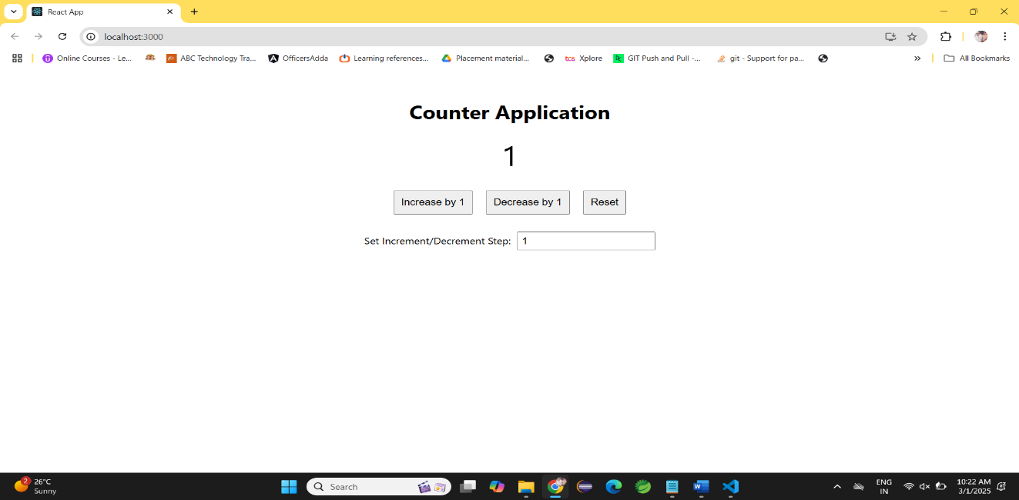

**4.Develop a To-Do List Application using React functional components that demonstrates the use of the useState hook for state management. Create a functional component named ToDoFunction to manage and display the to-do list. Maintain a list of tasks using state. Provide an input field for users to add new tasks. Dynamically render the list of tasks below the input field. Ensure each task is displayed in a user-friendly manner. Allow users to delete tasks from the list. Mark tasks as completed or pending, and visually differentiate them.**

**Step 1: Create a New React Application**

**First, you need to create a new React app using below command. Open your terminal and run:**

npx create-react-app todo-app

This will set up a new React project in a folder called **todo-app**. After the installation is complete, navigate to the project directory:

cd todo-app

**Step 2: Modify the App.js File**

1. **Navigate to the src folder** in the file explorer on the left-hand side of VSCode.
2. Open the App.js file (which contains the default template code).
3. **Replace the content of App.js with the code provided for the todo-app**. Here’s the code to replace inside App.js:

import React, { useState } from 'react';

import './App.css';

const ToDoFunction = () => {

const [tasks, setTasks] = useState([]);

const [newTask, setNewTask] = useState('');

const addTask = () => {

if (newTask.trim()) {

setTasks([

...tasks,

{ id: Date.now(), text: newTask, completed: false },

]);

setNewTask('');

}

};

const deleteTask = (taskId) => {

setTasks(tasks.filter(task => task.id !== taskId));

};

const toggleTaskCompletion = (taskId) => {

setTasks(tasks.map(task =>

task.id === taskId

? { ...task, completed: !task.completed }

: task

));

};

return (

<div className="todo-container">

<h2 className="todo-header">To-Do List</h2>

<div className="todo-input-wrapper">

<input

type="text"

value={newTask}

onChange={(e) => setNewTask(e.target.value)}

placeholder="Add a new task..."

className="todo-input"

/>

<button className="add-task-button" onClick={addTask}>Add Task</button>

</div>

<ul className="todo-list">

{tasks.map((task) => (

<li key={task.id} className={`todo-item ${task.completed ? 'completed' : ''}`} >

<span className="task-text" onClick={() => toggleTaskCompletion(task.id)} >

{task.text} </span>

<button className="delete-button" onClick={() => deleteTask(task.id)} > ❌ </button>

</li>

))}

</ul>

</div>

);

};

export default ToDoFunction;

**Step 3: Modify the App.css (Optional)**  
You can adjust the styling if desired. For example, you can modify App.css to ensure the buttons look good:

.todo-container {

font-family: 'Arial', sans-serif;

max-width: 500px;

margin: 50px auto;

padding: 20px;

border: 1px solid #e0e0e0;

border-radius: 8px;

background-color: #f9f9f9;

box-shadow: 0 4px 8px rgba(0, 0, 0, 0.1);

text-align: center;

}

.todo-header {

color: #4A90E2;

font-size: 2rem;

margin-bottom: 20px;

}

.todo-input-wrapper {

display: flex;

justify-content: center;

margin-bottom: 20px;

}

.todo-input {

width: 70%;

padding: 10px;

border-radius: 4px;

border: 1px solid #ccc;

font-size: 1rem;

outline: none;

}

.add-task-button {

padding: 10px 15px;

margin-left: 10px;

background-color: #4CAF50;

color: white;

border: none;

border-radius: 4px;

font-size: 1rem;

cursor: pointer;

transition: background-color 0.3s;

}

.add-task-button:hover {

background-color: #45a049;

}

.todo-list {

list-style-type: none;

padding-left: 0;

margin: 0;

}

.todo-item {

display: flex;

align-items: center;

justify-content: space-between;

background-color: #fff;

padding: 12px;

margin: 10px 0;

border-radius: 5px;

border: 1px solid #ddd;

box-shadow: 0 2px 4px rgba(0, 0, 0, 0.1);

transition: transform 0.2s ease-in-out;

}

.todo-item:hover {

transform: scale(1.03);

}

.todo-item.completed {

background-color: #f1f1f1;

text-decoration: line-through;

color: #aaa;

}

.task-text {

cursor: pointer;

font-size: 1.1rem;

color: #333;

transition: color 0.3s;

}

.task-text:hover {

color: #4CAF50;

}

.delete-button {

background: none;

border: none;

font-size: 1.1rem;

color: #ff6347;

cursor: pointer;

transition: color 0.3s;

}

.delete-button:hover {

color: #ff4500; }

You can also remove any default styling from the App.css file that is not needed for this project.

**Step 4: Start the Development Server**

1. In the terminal inside VSCode, run the following command to start the React development

npm start

* This will open your browser and navigate to http://localhost:3000/. You should see your Counter Application up and running.

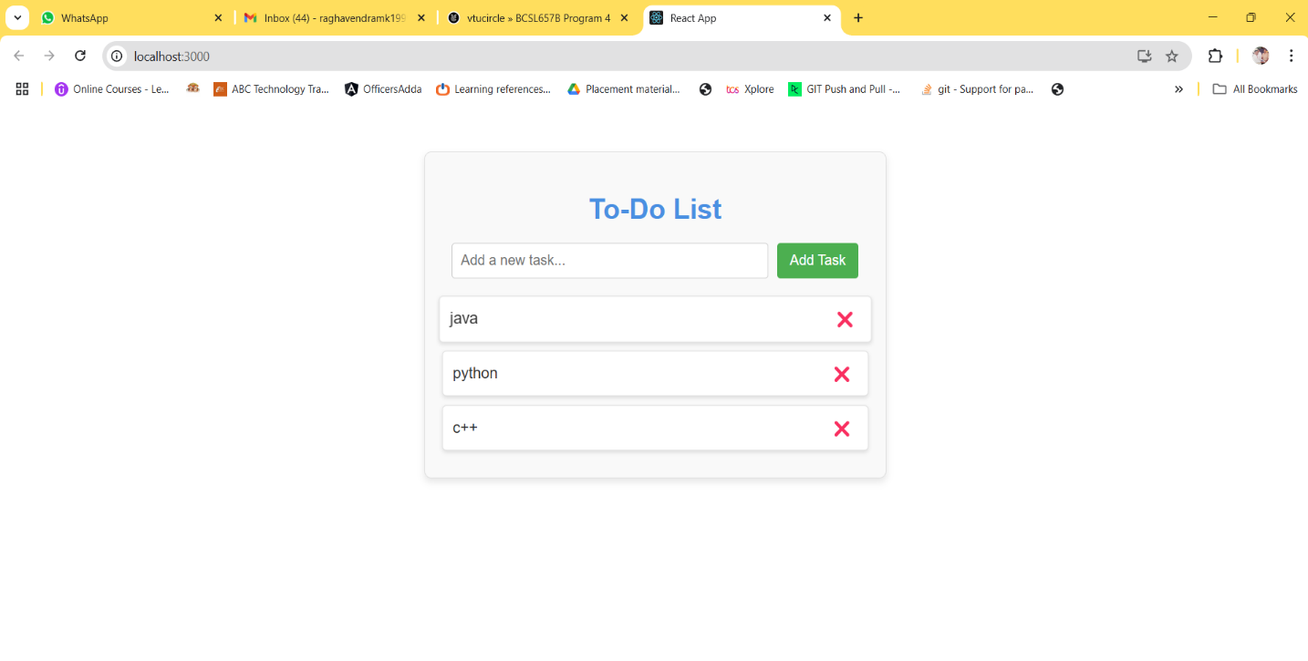

5.Develop a React application that demonstrates component composition and the use of props to pass data. Create two components: FigureList: A parent component responsible for rendering multiple child components. BasicFigure: A child component designed to display an image and its associated caption. Use the FigureList component to dynamically render multiple BasicFigure components. Pass image URLs and captions as props from the FigureList component to each BasicFigure component. Style the BasicFigure components to display the image and caption in an aesthetically pleasing manner. Arrange the BasicFigure components within the FigureList in a grid or list format. Allow users to add or remove images dynamically. Add hover effects or animations to the images for an interactive experience.

Step 1: Create a New React Application

First, you need to create a new React app using below command. Open your terminal and run:

npx create-react-app figure-gallery

This will set up a new React project in a folder called **figure-gallery**. After the installation is complete, navigate to the project directory:

cd figure-gallery

**Step 2: Set Up the Folder Structure**  
Create the folder structure. Here’s how you can organize the directories:

1. **Inside the src folder**:
   * Create a components folder.
   * Inside components, **create BasicFigure.js** and **FigureList.js**

**BasicFigure.js:**

// BasicFigure.js

import React from 'react';

const BasicFigure = ({ imageUrl, caption }) => {

return (

<div className="figure">

<img src={imageUrl} alt={caption} className="figure-image" />

<p className="figure-caption">{caption}</p>

</div>

);

};

export default BasicFigure;

**FigureList.js:** If you want to use your own local images, follow these steps: Create a folder called images inside the public folder. Place your image (for example, placeholder-image.jpg) inside the public/images folder. In your FigureList.js, instead of using an online URL for placeholder images, reference your local image from the public/images folder. When referencing files from the public folder, you can use a relative path starting with /images/.

// FigureList.js

import React, { useState } from 'react';

import BasicFigure from './BasicFigure';

const FigureList = () => {

const [figures, setFigures] = useState([

{ imageUrl: 'https://picsum.photos/400', caption: 'Random Image 1' },

{ imageUrl: 'https://picsum.photos/400', caption: 'Random Image 2' },

{ imageUrl: 'https://picsum.photos/400', caption: 'Random Image 3' },

{ imageUrl: 'https://picsum.photos/400', caption: 'Random Image 4' },

]);

const addFigure = () => {

const newFigure = {

imageUrl: `https://picsum.photos/400?random=${figures.length + 1}`,

caption: `Random Image ${figures.length + 1}`,

};

setFigures([...figures, newFigure]);

};

const removeFigure = () => {

const updatedFigures = figures.slice(0, -1);

setFigures(updatedFigures);

};

return (

<div className="figure-list-container">

<div className='button-box'>

<button onClick={addFigure} className="action-button">Add Image</button>

<button onClick={removeFigure} className="action-button">Remove Image</button>

</div>

<div className="figure-list">

{figures.map((figure, index) => (

<BasicFigure key={index} imageUrl={figure.imageUrl} caption={figure.caption} />

))}

</div>

</div>

);

};

export default FigureList;

**Step 3. App Component(src/App.js):**  
In your **src/App.js**, import the FigureList component and use it or copy the below code and paste it into the **App.js** file.

// App.js

import React from 'react';

import FigureList from './components/FigureList';

import './App.css';

const App = () => {

return (

<div className="app">

<h1>Dynamic Image Gallery</h1>

<FigureList />

</div>

);

};

export default App;

**Step 4: Add Some Basic Styles(src/App.css)**  
Add some styles in **src/App.css** to make the layout nicer. Copy the below code and paste it into the **App.css** file

*{

padding: 0;

margin: 0;

box-sizing: border-box;

}

h1 {

background: #000;

color: #fff;

padding: 10px;

text-align: center;

}

.figure-list-container {

display: flex;

flex-direction: column;

align-items: center;

margin: 20px;

}

.button-box {

display: block;

text-align: center;

padding: 10px;

margin-bottom: 20px;

}

.action-button {

padding: 10px 20px;

margin: 10px;

background-color: #4CAF50;

color: white;

border: none;

border-radius: 5px;

cursor: pointer;

font-size: 16px;

transition: background-color 0.3s ease;

}

.action-button:hover {

background-color: #45a049;

}

.figure-list {

display: flex;

flex-wrap: wrap;

justify-content: center;

gap: 15px;

}

.figure-list img {

max-width: 200px;

max-height: 200px;

border: 2px solid #ccc;

border-radius: 8px;

}

figure {

display: flex;

flex-direction: column;

align-items: center;

}

figcaption {

margin-top: 8px;

font-size: 14px;

color: #555;

}

.figure {

display: flex;

flex-direction: column;

align-items: center;

border: 2px solid #ddd;

border-radius: 8px;

padding: 10px;

box-shadow: 0 4px 6px rgba(0, 0, 0, 0.1);

transition: transform 0.2s ease, box-shadow 0.2s ease;

}

.figure:hover {

transform: translateY(-5px);

box-shadow: 0 6px 12px rgba(0, 0, 0, 0.2);

}

.figure-image {

max-width: 200px;

max-height: 200px;

border-radius: 8px;

object-fit: cover;

}

.figure-caption {

margin-top: 10px;

font-size: 14px;

color: #555;

text-align: center;

}

**Step 5: Run the application**  
Back in your terminal, start the development server by running:

npm start

**OUTPUT:**

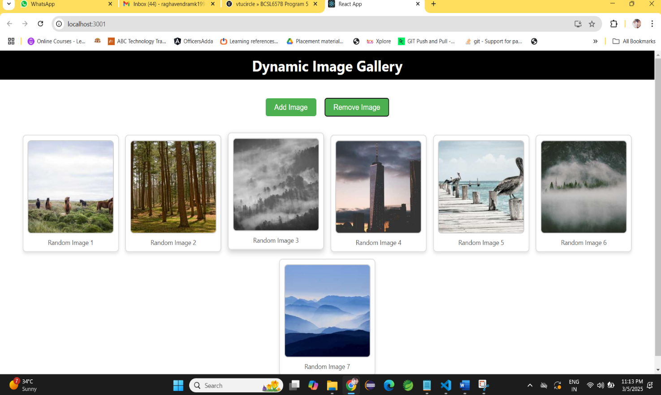

**6.**Design and implement a React Form that collects user input for name, email, and password. Form Fields are Name, Email, Password. Ensure all fields are filled before allowing form submission. Validate the email field to ensure it follows the correct email format (e.g., example@domain.com). Optionally enforce a minimum password length or complexity. Display error messages for invalid or missing inputs. Provide visual cues (e.g., red borders) to highlight invalid fields. Prevent form submission until all fields pass validation. Log or display the entered data upon successful submission (optional). Add a “Show Password” toggle for the password field. Implement client-side sanitization to ensure clean input.

**Step 1: Create a New React Application**  
First, you need to create a new React app using below command. Open your terminal and run:

npx create-react-app react-form

This will set up a new React project in a folder called **react-form**. After the installation is complete, navigate to the project directory

cd react-form

**Step 2: Set Up the Folder Structure**  
Create the folder structure. Here’s how you can organize the directories:

1. **Inside the src folder**:
   * Create a components folder.
   * Inside components, create**Form.js** file
   * Inside components , create Form.css file

**Form.js**

import React, { useState, useEffect, useCallback } from 'react';

import './Form.css';

const Form = () => {

const [formData, setFormData] = useState({

name: '',

email: '',

password: '',

});

const [errors, setErrors] = useState({

name: '',

email: '',

password: '',

});

const [showPassword, setShowPassword] = useState(false);

const [isFormValid, setIsFormValid] = useState(false);

const handleChange = (e) => {

const { name, value } = e.target;

setFormData((prevState) => ({

...prevState,

[name]: value.trim(),

}));

};

const validateForm = useCallback(() => {

let isValid = true;

const newErrors = { name: '', email: '', password: '' };

if (!formData.name) {

newErrors.name = 'Name is required.';

isValid = false;

}

const emailPattern = /^[a-zA-Z0-9._-]+@[a-zA-Z0-9.-]+\.[a-zA-Z]{2,4}$/;

if (!formData.email || !emailPattern.test(formData.email)) {

newErrors.email = 'Please enter a valid email address.';

isValid = false;

}

if (!formData.password) {

newErrors.password = 'Password is required.';

isValid = false;

} else if (formData.password.length < 6) {

newErrors.password = 'Password must be at least 6 characters long.';

isValid = false;

}

setErrors(newErrors);

setIsFormValid(isValid);

}, [formData]);

useEffect(() => {

validateForm();

}, [formData, validateForm]);

const handleSubmit = (e) => {

e.preventDefault();

if (isFormValid) {

console.log('Form Data:', formData);

setFormData({

name: '',

email: '',

password: '',

});

}

};

return (

<div className="form-container">

<h2 className="form-title">Registration Form</h2>

<form onSubmit={handleSubmit} className="form">

<div className="form-group">

<label htmlFor="name" className="form-label">Name</label>

<input

type="text"

id="name"

name="name"

value={formData.name}

onChange={handleChange}

className={`form-input ${errors.name ? 'error' : ''}`}

placeholder="Enter your name"

/>

{errors.name && <div className="error-message">{errors.name}</div>}

</div>

<div className="form-group">

<label htmlFor="email" className="form-label">Email</label>

<input

type="email"

id="email"

name="email"

value={formData.email}

onChange={handleChange}

className={`form-input ${errors.email ? 'error' : ''}`}

placeholder="Enter your email"

/>

{errors.email && <div className="error-message">{errors.email}</div>}

</div>

<div className="form-group">

<label htmlFor="password" className="form-label">Password</label>

<input

type={showPassword ? 'text' : 'password'}

id="password"

name="password"

value={formData.password}

onChange={handleChange}

className={`form-input ${errors.password ? 'error' : ''}`}

placeholder="Enter your password"

/>

{errors.password && <div className="error-message">{errors.password}</div>}

</div>

<div className="form-group password-toggle">

<label>

<input

type="checkbox"

checked={showPassword}

onChange={() => setShowPassword(!showPassword)}

/>

Show Password

</label>

</div>

<div className="form-group">

<button type="submit" className="form-submit" disabled={!isFormValid}>

Submit

</button>

</div>

</form>

</div>

);

};

export default Form;

**Step 3. App Component(src/App.js):**  
In your **src/App.js**, import the **Form** component and use it or copy the below code and paste it into the **App.js** file.

**App.js:**

import Form from './components/Form';

import './App.css';

    function App() {

      return (

        <div className="App">

          <Form />

        </div>

      );

    }

export default App;

**Step 4: Add Some Basic Styles(src/Form.css)**  
Add some styles in **src/Form.css** to make the layout nicer. Copy the below code and paste it into the **Form.css** file.

.form-container {

width: 100%;

max-width: 500px;

margin: 0 auto;

padding: 20px;

background-color: #f7f7f7;

border-radius: 8px;

box-shadow: 0 4px 8px rgba(0, 0, 0, 0.1);

}

.form-title {

text-align: center;

font-size: 24px;

margin-bottom: 20px;

color: #333;

}

.form {

display: flex;

flex-direction: column;

}

.form-group {

margin-bottom: 15px;

}

.form-label {

font-size: 14px;

font-weight: 600;

color: #555;

}

.form-input {

width: 100%;

padding: 12px;

margin-top: 5px;

border: 1px solid #ddd;

border-radius: 4px;

font-size: 16px;

box-sizing: border-box;

}

.form-input.error {

border-color: red;

}

.error-message {

color: red;

font-size: 12px;

margin-top: 5px;

}

.password-toggle {

margin-bottom: 20px;

}

.form-submit {

padding: 12px;

background-color: #4CAF50;

color: white;

border: none;

border-radius: 4px;

font-size: 16px;

cursor: pointer;

transition: background-color 0.3s;

}

.form-submit:disabled {

background-color: #ccc;

cursor: not-allowed;

}

.form-submit:hover:not(:disabled) {

background-color: #45a049;

}

**Step 5: Run the application**  
Back in your terminal, start the development server by running:

npm start

OutPut:

**Before Data Enter:**

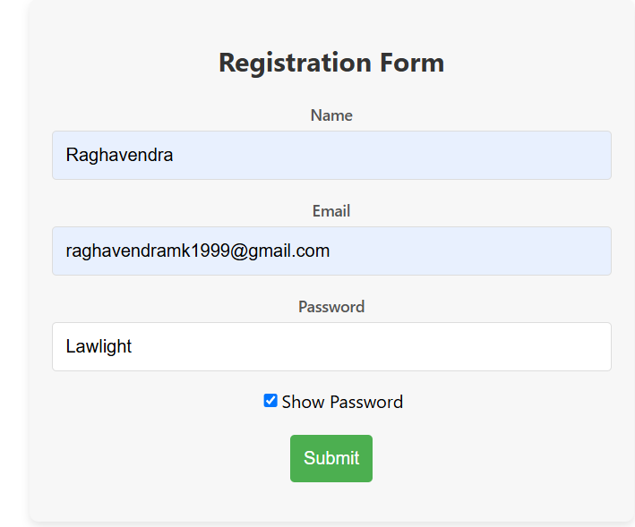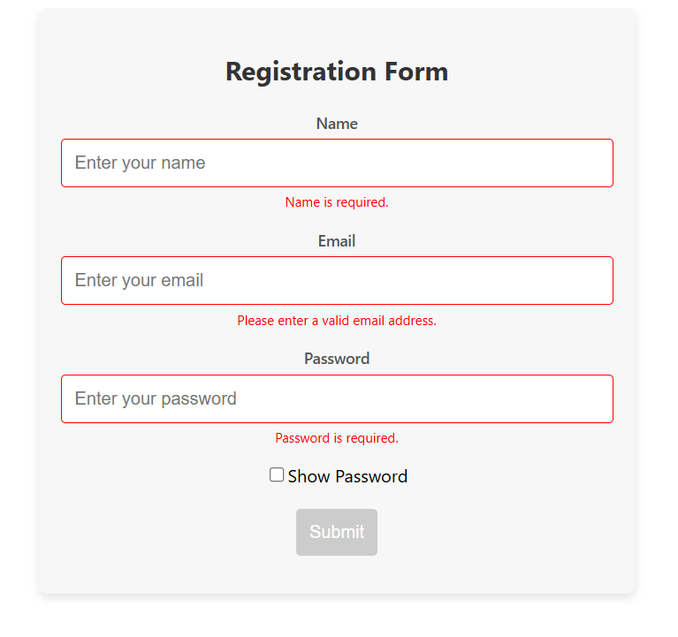

**After Data Enter:**

**7.Develop a React Application featuring a ProfileCard component to display a user’s profile information, including their name, profile picture, and bio. The component should demonstrate flexibility by utilizing both external CSS and inline styling for its design. Display the following information: Profile picture, User’s name, A short bio or description Use an external CSS file for overall structure and primary styles, such as layout, colors, and typography. Apply inline styles for dynamic or specific styling elements, such as background colors or alignment. Design the ProfileCard to be visually appealing and responsive. Ensure the profile picture is displayed as a circle, and the name and bio are appropriately styled. Add hover effects or animations to enhance interactivity. Allow the background color of the card to change dynamically based on a prop or state.**

**Step 1: Create a New React Application**  
First, you need to create a new React app using below command. Open your terminal and run:

npx create-react-app profile-card-app

This will set up a new React project in a folder called **profile-card-app**. After the installation is complete, navigate to the project directory:

cd profile-card-app

**Step 2: Set Up the Folder Structure**

* Inside the **src folder,** create a new file **ProfileCard.js** to define the ProfileCard component.
* After that copy and paste below code in the **ProfileCard.js** file.

**ProfileCard.js:**

import React, { useState } from 'react';

const ProfileCard = ({ name, bio, profilePicture }) => {

  const [bgColor, setBgColor] = useState('#f0f0f0');

  const handleMouseEnter = () => {

    setBgColor('#d1c4e9');

  };

  const handleMouseLeave = () => {

    setBgColor('#f0f0f0');

  };

  return (

    <div

      className="profile-card"

      style={{ backgroundColor: bgColor }}

      onMouseEnter={handleMouseEnter}

      onMouseLeave={handleMouseLeave}

    >

      <img

        src={profilePicture}

        alt={`${name}'s profile`}

        className="profile-picture"

      />

      <div className="profile-info">

        <h2 className="profile-name">{name}</h2>

        <p className="profile-bio">{bio}</p>

      </div>

    </div>

  );

};

export default ProfileCard;

**Step 3: Modify the App.js File**

* Inside the **src folder** modify the **src/App.js** file.
* Now, use the **ProfileCard** component in**App.js** and pass sample data to display a user’s profile.

import React from 'react';

import ProfileCard from './ProfileCard';

import './App.css';

const App = () => {

return (

<div className="App">

<ProfileCard

name="Dr. Sharanbasappa Sali PRINCIPAL,"

bio=" It is my pleasure to welcome you to Veerappa Nisty Engineering College (VNEC), an Institution under Sharnabasava Vidya Vardhak Sangha which was established in 1903 to do Akshara Dasoha to the Educationally deprived region with a vision of “Quality Education, with strong commitment to provide professional education with thrust on creativity and innovation along with a sense of social responsibility, human values and concern for social commitment”.."

profilePicture="https://encrypted-tbn0.gstatic.com/images?q=tbn:ANd9GcS6Z9PNHhb6BkHBVp0pXJKW0z6Ws835XHaWaA&s "

/>

</div>

);

};

**Step 3: Modify the App.css**

* You can adjust the styling if desired. For example, you can modify **App.css** to ensure the profile look good. Copy the below code and paste it in the **App.css** file.

body {

font-family: 'Segoe UI', Tahoma, Geneva, Verdana, sans-serif;

background-color: #f4f7fa;

display: flex;

justify-content: center;

align-items: center;

height: 100vh;

margin: 0;

}

.profile-card {

width: 320px;

padding: 30px;

border-radius: 15px;

text-align: center;

background-color: #ffffff;

box-shadow: 0 6px 12px rgba(0, 0, 0, 0.1);

transition: transform 0.3s ease, box-shadow 0.3s ease, background-color 0.3s ease;

cursor: pointer;

overflow: hidden;

margin: 20px;

}

.profile-card-container {

display: flex;

justify-content: center;

align-items: center;

height: 100vh;

width: 100%;

}

.profile-card:hover {

transform: translateY(-10px);

box-shadow: 0 12px 24px rgba(0, 0, 0, 0.2);

background-color: #f3f4f6;

}

.profile-picture {

width: 130px;

height: 130px;

border-radius: 50%;

object-fit: cover;

border: 4px solid #fff;

transition: transform 0.3s ease, box-shadow 0.3s ease;

}

.profile-card:hover .profile-picture {

transform: scale(1.1);

box-shadow: 0 4px 8px rgba(0, 0, 0, 0.1);

}

.profile-info {

font-family: 'Segoe UI', Tahoma, Geneva, Verdana, sans-serif;

}

.profile-name {

font-size: 1.8rem;

font-weight: 600;

color: #333;

margin-bottom: 15px;

transition: color 0.3s ease;

}

.profile-card:hover .profile-name {

color: #5e35b1;

}

.profile-bio {

font-size: 1.1rem;

color: #555;

line-height: 1.5;

margin-bottom: 0;

transition: color 0.3s ease;

}

.profile-card:hover .profile-bio {

color: #444;

}

.profile-card-container {

display: flex;

justify-content: center;

align-items: center;

height: 100vh;

width: 100%;

background-color: #f4f7fa;

}

export default App;

**Step 4: Start the Development Server**

1. In the terminal inside VSCode, run the following command to start the React development.

npm start

* This will open your browser and navigate to http://localhost:3000/. You should see your **ProfileCard** application up and running.

**OUTPUT:**

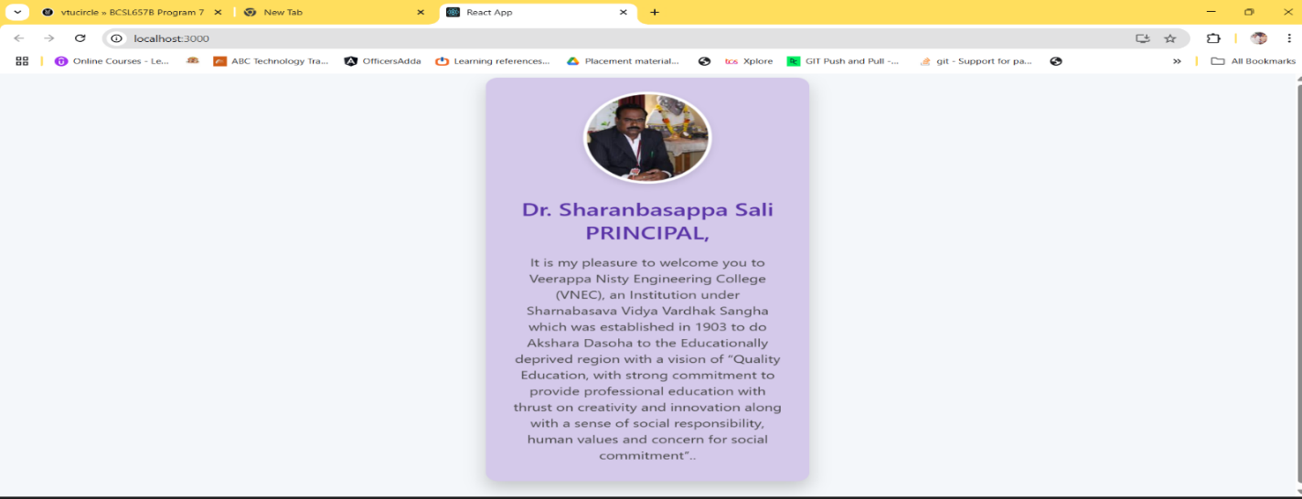

**8.Develop a Reminder Application that allows users to efficiently manage their tasks. The application should include the following functionalities: Provide a form where users can add tasks along with due dates. The form includes task name, Due date, An optional description. Display a list of tasks dynamically as they are added. Show relevant details like task name, due date, and completion status. Include a filter option to allow users to view all Tasks and Display all tasks regardless of status. Show only tasks marked as completed. Show only tasks that are not yet completed.**

**Step 1: Create a New React Application**  
First, you need to create a new React app using below command. Open your terminal and run:

npx create-react-app react-reminder-app

This will set up a new React project in a folder called **react-reminder-app**. After the installation is complete, navigate to the project directory:

cd react-reminder-app

**Step 2: Set Up the Folder Structure**  
Create the folder structure. Here’s how you can organize the directories:

1. **Inside the src folder**:
   * Create a **components** folder.
   * Inside components, create**Filter.js** , **TaskForm.js** and **TaskList.js** files. Copy below code and paste it into the different files.

**TaskForm.js:**

import React, { useState } from 'react';

function TaskForm({ addTask }) {

const [taskName, setTaskName] = useState('');

const [dueDate, setDueDate] = useState('');

const [description, setDescription] = useState('');

const handleSubmit = (e) => {

e.preventDefault();

if (taskName && dueDate) {

const newTask = {

id: Date.now(),

name: taskName,

dueDate: dueDate,

description,

completed: false,

};

addTask(newTask);

setTaskName('');

setDueDate('');

setDescription('');

}

};

return (

<form onSubmit={handleSubmit}>

<div>

<input

type="text"

placeholder="Task Name"

value={taskName}

onChange={(e) => setTaskName(e.target.value)}

/>

</div>

<div>

<input

type="date"

value={dueDate}

onChange={(e) => setDueDate(e.target.value)}

/>

</div>

<div>

<textarea

placeholder="Description (optional)"

value={description}

onChange={(e) => setDescription(e.target.value)}

/>

</div>

<button type="submit">Add Task</button>

</form>

);

}

export default TaskForm;

**Filter.js:**

import React from 'react';

function Filter({ setFilter }) {

return (

<div>

<button onClick={() => setFilter('all')}>All Tasks</button>

<button onClick={() => setFilter('completed')}>Completed Tasks</button>

<button onClick={() => setFilter('not-completed')}>Pending Tasks</button>

</div>

);

}

export default Filter;

**TaskList.js:**

import React from 'react';

function TaskList({ tasks, setTasks }) {

const toggleTaskCompletion = (taskId) => {

setTasks(

tasks.map((task) =>

task.id === taskId ? { ...task, completed: !task.completed } : task

)

);

};

const deleteTask = (taskId) => {

setTasks(tasks.filter((task) => task.id !== taskId));

};

return (

<div>

{tasks.length > 0 ? (

<ul>

{tasks.map((task) => (

<li key={task.id}>

<h3>{task.name}</h3>

<p>Due Date: {task.dueDate}</p>

{task.description && <p>Description: {task.description}</p>}

<p>Status: {task.completed ? 'Completed' : 'Not Completed'}</p>

<button onClick={() => toggleTaskCompletion(task.id)}>

{task.completed ? 'Mark as Not Completed' : 'Mark as Completed'}

</button>

<button onClick={() => deleteTask(task.id)}>Delete</button>

</li>

))}

</ul>

) : (

<p>No tasks available!</p>

)}

</div>

);

}

export default TaskList;

**Step 3. App Component(src/App.js):**  
In your **src/App.js**, import the **Filter.js**, **TaskForm.js** and **TaskList.js** component and use it or copy the below code and paste it into the **App.js** file.

import React, { useState } from 'react';

import TaskForm from './components/TaskForm';

import TaskList from './components/TaskList';

import Filter from './components/Filter';

import './App.css';

function App() {

const [tasks, setTasks] = useState([]);

const [filter, setFilter] = useState('all');

const addTask = (task) => {

setTasks([...tasks, task]);

};

const handleFilterChange = (status) => {

setFilter(status);

};

const filteredTasks = tasks.filter((task) => {

if (filter === 'completed') return task.completed;

if (filter === 'not-completed') return !task.completed;

return true;

});

return (

<div className="App">

<h1>Task Reminder</h1>

<TaskForm addTask={addTask} />

<Filter setFilter={handleFilterChange} />

<TaskList tasks={filteredTasks} setTasks={setTasks} />

</div>

);

}

export default App;

**Step 4: Add Styles(src/App.css)**  
Add some styles in **src/App.css** to make the layout nicer. Copy the below code and paste it into the **App.css** file.

body {

font-family: 'Segoe UI', Tahoma, Geneva, Verdana, sans-serif;

margin: 0;

padding: 0;

background-color: #f0f4f8;

display: flex;

justify-content: center;

align-items: center;

min-height: 100vh;

}

.App {

width: 550px;

padding: 30px;

background-color: #ffffff;

border-radius: 12px;

box-shadow: 0 4px 16px rgba(0, 0, 0, 0.1);

transition: transform 0.3s ease, box-shadow 0.3s ease;

}

.App:hover {

transform: translateY(-5px);

box-shadow: 0 8px 24px rgba(0, 0, 0, 0.2);

}

h1 {

font-size: 2.2rem;

color: #333;

text-align: center;

margin-bottom: 10px;

margin-top: 0;

}

form {

display: flex;

flex-direction: column;

gap: 20px;

}

input,

textarea {

padding: 12px;

font-size: 1rem;

border: 1px solid #ccc;

border-radius: 8px;

transition: border-color 0.3s ease;

}

input:focus,

textarea:focus {

border-color: #4CAF50;

outline: none;

}

button {

background-color: #4CAF50;

color: white;

border: none;

padding: 12px;

font-size: 1rem;

border-radius: 8px;

cursor: pointer;

transition: background-color 0.3s ease, transform 0.3s ease;

}

button:hover {

background-color: #45a049;

}

button:active {

transform: scale(0.98);

}

textarea {

resize: vertical;

min-height: 120px;

}

input[type="date"] {

padding: 12px;

}

div {

display: flex;

flex-direction: column;

gap: 10px;

}

ul {

list-style-type: none;

padding: 0;

}

li {

background-color: #fafafa;

margin: 15px 0;

padding: 20px;

border-radius: 12px;

box-shadow: 0 4px 12px rgba(0, 0, 0, 0.1);

transition: transform 0.3s ease, box-shadow 0.3s ease;

}

li:hover {

transform: translateY(-5px);

box-shadow: 0 8px 20px rgba(0, 0, 0, 0.2);

}

h3 {

margin: 0;

font-size: 1.5rem;

color: #333;

font-weight: 600;

}

p {

margin: 5px 0;

color: #666;

}

button {

background-color: #007BFF;

color: white;

border: none;

padding: 8px 15px;

font-size: 1rem;

border-radius: 8px;

cursor: pointer;

transition: background-color 0.3s ease, transform 0.3s ease;

margin-right: 10px;

}

button:hover {

background-color: #0056b3;

}

button:active {

background-color: #003f8d;

}

button:last-child {

background-color: #e74c3c;

}

button:last-child:hover {

background-color: #c0392b;

}

button:last-child:active {

background-color: #7f1c1c;

}

.completed {

text-decoration: line-through;

color: #bbb;

}

div {

display: flex;

gap: 20px;

justify-content: center;

}

button {

background-color: #f1f1f1;

color: #333;

padding: 12px 18px;

font-size: 1rem;

border: 1px solid #ccc;

border-radius: 8px;

cursor: pointer;

transition: background-color 0.3s ease, transform 0.3s ease;

}

button:hover {

background-color: #ddd;

}

button:active {

transform: scale(0.98);

}

button:focus {

outline: none;

border-color: #007BFF;

}

**Step 5: Run the application**

1. In the terminal inside VSCode, run the following command to start the React development.

npm start

* This will open your browser and navigate to http://localhost:3000/. You should see your **task reminder**application up and running.

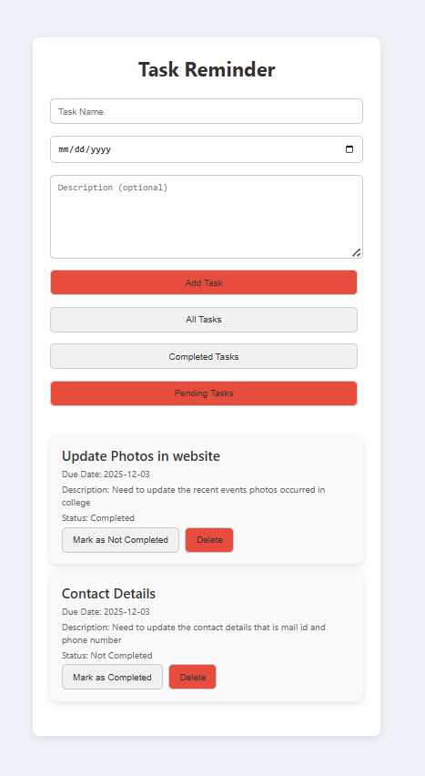**OUTPUT:**

**9.Design a React application that demonstrates the implementation of routing using the react-router-dom library. The application should include the Navigation Menu: Create a navigation bar with links to three distinct pages, Home, About, Contact. Develop separate components for each page (Home, About, and Contact) with appropriate content to differentiate them. Configure routes using react-router-dom to render the corresponding page component based on the selected link. Use BrowserRouter and Route components for routing. Highlight the active link in the navigation menu to indicate the current page.**

**Step 1: Create a New React Application**  
First, you need to create a new React [app](https://vtucircle.com/BCSL657B-Program-9/) using below command. Open your terminal and run:

npx create-react-app my-routing-app

This will set up a new React project in a folder called **my-routing-app**. After the installation is complete, navigate to the project directory:

**Step 2: Install react-router-dom**

1. In the terminal inside VSCode, install react-router-dom:

npm install react-router-dom

**Step 3: Set Up the Folder Structure**  
Create the folder structure. Here’s how you can organize the directories:

1. **Inside the src folder**:
   * Create a **components** folder.
   * Inside components, create**Home.js** , **About.js**, **Contact.js and Navbar.js** files. Copy below code and paste it into the different files.

**Home.js:**

import React from 'react';

const Home = () => {

return (

<div>

<h2>Home Page</h2>

**<p>Welcome to VNEC!</p>**

</div>

);

};

export default Home;

**About.js:**

import React from 'react';

const About = () => {

  return (

    <div>

      <h2>About VNEC</h2>

      <p>Veerappa Nisty Engineering College is the only Engineering college situated in Yadgir District !</p>

    </div>

  );

};

export default About;

**Contact.js:**

import React from 'react';

const Contact = () => {

  return (

    <div>

      <h2>Contact Details</h2>

      <p>Get in touch with us through the Contact Page!</p>

      <p>ph:7899961941</p>

      <p>Mialid:raghavendramk1999@gmail.com</p>

    </div>

  );

};

export default Contact;

**Navbar.js:**

import React from 'react';

import { NavLink } from 'react-router-dom';

const Navbar = () => {

  return (

    <nav>

      <ul>

        <li>

          <NavLink  to="/" className={({ isActive }) => (isActive ? 'active' : '')} > Home</NavLink>

        </li>

        <li>

          <NavLink

            to="/about"

            className={({ isActive }) => (isActive ? 'active' : '')}

          >

            About

          </NavLink>

        </li>

        <li>

          <NavLink

            to="/contact"

            className={({ isActive }) => (isActive ? 'active' : '')}

          >

            Contact

          </NavLink>

        </li>

      </ul>

    </nav>

  );

};

export default Navbar;

**Step 4. App Component(src/App.js):**  
In your **src/App.js**, import the **Home.js**, **About.js**, **Contact.js** and **Navbar.js** component and use it or copy the below code and paste it into the **App.js** file.

**App.js**

import React from 'react';

import { BrowserRouter as Router, Route, Routes } from 'react-router-dom';

import Navbar from './components/Navbar';

import Home from './components/Home';

import About from './components/About';

import Contact from './components/Contact';

import './App.css'

const App = () => {

  return (

    <Router>

      <div>

        <Navbar />

        <div style={{ padding: '20px' }}>

          <Routes>

            <Route path="/" element={<Home />} />

            <Route path="/about" element={<About />} />

            <Route path="/contact" element={<Contact />} />

          </Routes>

        </div>

      </div>

    </Router>

  );

};

export default App;

**Step 5: Add Styles(src/App.css)**  
Add some styles in **src/App.css** to make the layout nicer. Copy the below code and paste it into the **App.css** file.

body {

font-family: Arial, sans-serif;

background-color: #f4f4f4;

margin: 0;

padding: 0;

}

div {

margin: 0 auto;

max-width: 960px;

padding: 20px;

}

h2 {

color: #333;

padding-bottom: 20px;

}

nav {

background-color: #333;

padding: 10px;

border-radius: 5px;

margin-bottom: 20px;

}

ul {

list-style: none;

display: flex;

gap: 15px;

justify-content: center;

margin: 0;

padding: 0;

}

li {

display: inline;

}

a {

text-decoration: none;

color: white;

padding: 8px 16px;

border-radius: 4px;

}

a:hover {

background-color: #444;

}

a.active {

background-color: #1e90ff;

color: white;

font-weight: bold;

}

p {

color: #555;

font-size: 1.1rem;

line-height: 1.6;

}

**Step 6: Set Up the Entry Point (index.js)**

1. Open **src/index.js** and ensure the entry point is correct:

import React from 'react';

import ReactDOM from 'react-dom/client';

import App from './App';

const rootElement = document.getElementById('root');

const root = ReactDOM.createRoot(rootElement);

root.render(<App />);

**Step 7: Run the App**

1. Now that you’ve set up everything, go back to your terminal and run:

npm start

* This will start your React app, and it should automatically open in your default browser at http://localhost:3000.

**OUTPUT:**

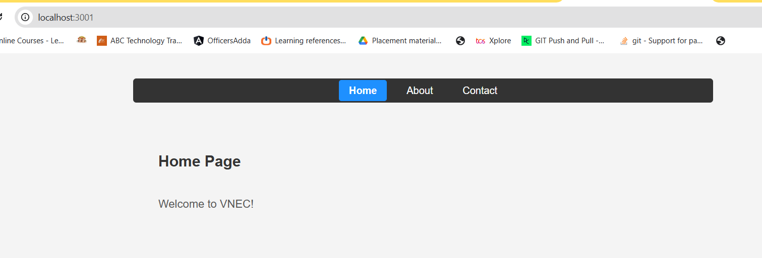

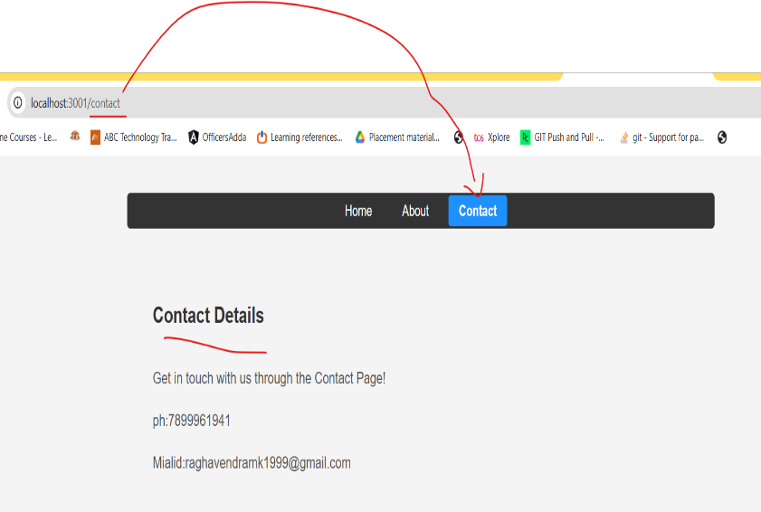

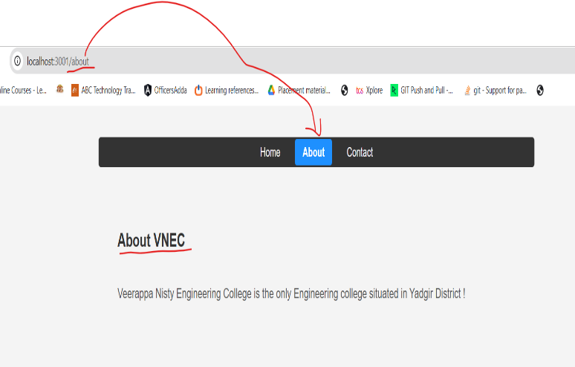

**10.**Design a React application featuring a class-based component that demonstrates the use of lifecycle methods to interact with an external API. The component should fetch and update data dynamically based on user interactions or state changes. Use the componentDidMount lifecycle method to fetch data from an API when the component is initially rendered. Display the fetched data in a structured format, such as a table or list. Use the componentDidUpdate lifecycle method to detect changes in the component’s state or props. Trigger additional API calls to update the displayed data based on user input or actions (e.g., filtering, searching, or pagination). Implement error handling to manage issues such as failed API requests or empty data responses. Display appropriate error messages to the user when necessary. Allow users to perform actions like filtering, searching, or refreshing the data. Reflect changes in the displayed data based on these interactions.

**Step 1: Create a New React Application**

* First, you need to create a new React [app](https://vtucircle.com/BCSL657B-Program-10/) using below command. Open your terminal and run:

npx create-react-app data-fetcher

This will set up a new React project in a folder called **data-fetcher**. After the installation is complete, navigate to the project directory:

cd data-fetcher

**Step 2: Update src/App.js:**

* **Navigate to the src folder** in the file explorer on the left-hand side of VSCode.
* Open the **App.js** file (which contains the default template code).
* **Replace the content of App.js with the code provided for the data-fetcher**. Here’s the code to replace inside App.js:

App.js:

import React, { Component } from 'react';

const API_URL = 'https://jsonplaceholder.typicode.com/users';

class DataFetcher extends Component {

constructor(props) {

super(props);

this.state = {

data: [],

filteredData: [],

searchQuery: '',

error: null,

loading: false,

};

}

componentDidMount() {

this.fetchData();

}

fetchData = async () => {

this.setState({ loading: true, error: null });

try {

const response = await fetch(API_URL);

if (!response.ok) {

throw new Error('Failed to fetch data');

}

const data = await response.json();

this.setState({ data, filteredData: data, loading: false });

} catch (error) {

this.setState({ error: error.message, loading: false });

}

};

componentDidUpdate(prevProps, prevState) {

if (prevState.searchQuery !== this.state.searchQuery) {

this.filterData();

}

}

handleSearchChange = (event) => {

this.setState({ searchQuery: event.target.value });

};

filterData = () => {

const { data, searchQuery } = this.state;

if (searchQuery.trim() === '') {

this.setState({ filteredData: data });

} else {

const filteredData = data.filter((item) =>

item.name.toLowerCase().includes(searchQuery.toLowerCase())

);

this.setState({ filteredData });

}

};

renderError = () => {

const { error } = this.state;

return error ? <div className="error">{`Error: ${error}`}</div> : null;

};

render() {

const { filteredData, searchQuery, loading } = this.state;

return (

<div className="data-fetcher">

<h1>User Data</h1>

{this.renderError()}

<div className="search-bar">

<input

type="text"

value={searchQuery}

onChange={this.handleSearchChange}

placeholder="Search by name"

/>

</div>

{loading ? (

<div>Loading...</div>

) : (

<table>

<thead>

<tr>

<th>Name</th>

<th>Email</th>

<th>City</th>

</tr>

</thead>

<tbody>

{filteredData.length > 0 ? (

filteredData.map((item) => (

<tr key={item.id}>

<td>{item.name}</td>

<td>{item.email}</td>

<td>{item.address.city}</td>

</tr>

))

) : (

<tr>

<td colSpan="3" className='error'>No results found.</td>

</tr>

)}

</tbody>

</table>

)}

<button onClick={this.fetchData}>Refresh Data</button>

</div>

);

}

}

export default DataFetcher;

**Step 3: Update src/index.js:**

* Replace the default content of **src/index.js** with this code to ensure the component is rendered in your application

import React from 'react';

import ReactDOM from 'react-dom/client';

import './App.css';

import DataFetcher from './App';

const root = ReactDOM.createRoot(document.getElementById('root'));

root.render(

<React.StrictMode>

<DataFetcher />

</React.StrictMode>

);

**Step 4: Modify the App.css**

* You can adjust the styling if desired. For example, you can modify **App.css** to ensure the UI look good:

**App.css:**

* {

  padding: 0;

  margin: 0;

  box-sizing: border-box;

}

body {

  font-family: Arial, sans-serif;

  margin: 0;

  padding: 0;

  background-color: #f4f4f4;

}

button {

  border-radius: 5px;

  border: none;

  cursor: pointer;

  color: #fff;

  font-weight: bold;

  background: rgb(99, 221, 121);

  margin-top: 20px;

  padding: 10px;

}

.data-fetcher {

  width: 80%;

  margin: 0 auto;

  padding: 20px;

  background-color: #fff;

  border-radius: 8px;

  box-shadow: 0 4px 8px rgba(0, 0, 0, 0.1);

}

h1 {

  text-align: center;

  color: #333;

}

.search-bar {

  margin: 20px 0;

  text-align: center;

}

.search-bar input {

  padding: 8px;

  width: 60%;

  font-size: 16px;

  border: 1px solid #000;

  border-radius: 4px;

}

table {

  width: 100%;

  margin-top: 20px;

  border-collapse: collapse;

}

table th,

table td {

  padding: 10px;

  text-align: left;

  border-bottom: 1px solid #ddd;

}

.error {

  color: rgb(221, 50, 12);

  text-align: center;

}

Step 5: Start the Development Server

1. In the terminal inside VSCode, run the following command to start the React development.

npm start

* This will open your browser and navigate to https://localhost:3000/. You should see your Counter Application up and running.

**OUTPUT**:

