**Basic UNIX COMMANDS**

Execute the below commands by launching the unix terminal

1. Fetch the working directory

pwd

1. display a message "welcome to the world on unix"

echo "welcome to the world on unix"

1. display the login name and the home directory

echo $LOGNAME

echo $HOME

1. list the users who have connected to the unix terminal

who

1. Display the system date and time of the unix terminal

date

1. display todays calendar

cal

1. Get the manual documentation of cat command

man cat

1. clear the terminal screen

clear #or ctrl l

1. execute the below :
   1. create a file with the name SampleFile in the current working directory and enter some contents(at least 10 lines)

cat>SampleFile

* 1. display the contents of SampleFile

cat SampleFile

* 1. append some contents to the file SampleFile

cat>>SampleFile

* 1. create a copy of the file SampleFile with the name SampleFile.txt in the same directory

cp SampleFile SampleFile.txt

* 1. display the contents of the current working directory

ls

* 1. remove the file SampleFile

rm SampleFile

* 1. Create a directory with the name Labs

mkdir Labs

* 1. move the file SampleFile.txt into the directory Labs

mv SampleFile.txt Labs

* 1. Create a sub-directory Day1/session1/assign1 within the Labs directory

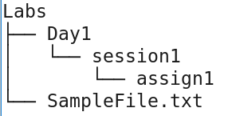

mkdir -p Labs/Day1/session1/assign1

* 1. create empty files file1 file2 file3 in the current directory

touch file1 file2 file3

* 1. copy these empty files created to Day1/session1/assign1 directory

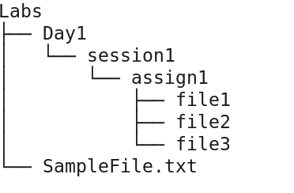

cp file1 file2 file3 Labs/Day1/session1/assign1

* 1. remove the empty files in the current directory

rm file1 file2 file3

* 1. display the contents of Labs/Day1/session1/assign1 directory

ls Labs/Day1/session1/assign1

* 1. change the directory to Day1/session1 using relative path

cd Labs/Day1/session1

* 1. create a sub-directory assign2 under Day1/Session1 using absolute path and confirm its creation

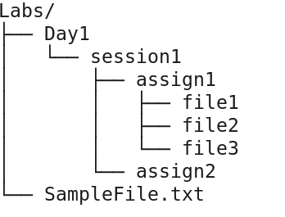

mkdir /home/raghavendra/Labs/Day1/session1/assign2

ls

* 1. get back to the Labs directory

cd ../..

* 1. provide the detailed listing of the files and directories in your home directory

ls $HOME or ls /user/raghavendra

* 1. remove the directory assign2 which is under Day1/sesssion1 using absolute path

rmdir Day1/session1/assign2

* 1. remove the entire directory structure under Day1

rm -r Day1

* 1. rename the File SampleFile.txt in Labs Directory as sample

mv SampleFile.txt sample

1. display the first 5 lines of the file sample

head -n 5 sample

1. display the last 5 files of the file sample

tail -n 5 sample

**fs Shell COMMANDS**

1. Create a directory on HDFS with the name Labs

hadoop fs -mkdir Labs or hadoop fs -mkdir /user/raghavendra/Labs

Confirm the creation using: hadoop fs -ls

1. Connect to the Namenode webUI and get the Absolute path of the Labs folder.

https://machinename:50070

1. copy the file sample to HDFS into the Labs directory

hadoop fs -put sample Labs

hadoop fs -ls Labs

1. Remove the file sample on the local file system

rm sample

1. Display the contents of the file SampleFile.txt on HDFS

hadoop fs -cat /user/raghavendra/Labs/sample

or

hadoop fs -cat Labs/sample

1. Rename the file SampleFile.txt on HDFS to sample.txt in the same path

hadoop fs -mv Labs/sample Labs/sample.txt

hadoop fs -ls Labs

1. Retrieve the file sample file to the local file system with the name SampleFile.txt and display its contents

hadoop fs -get Labs/sample.txt ./SampleFile.txt

cat SampleFile.txt