NETWORKING COMMANDS:

Tcpdump

tcpdump is a powerful and widely used command-line packet sniffer or packet analyzer tool that is used to capture or filter TCP/IP packets that are received or transferred over a network on a specific interface for analysis.

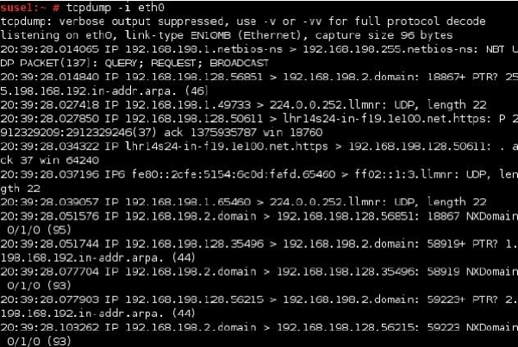

Netstat

Displays active TCP connections, ports on which the computer is listening, Ethernet statistics, IP routing table, IPv4 statistics, and IPv6 statistics. It indicates the state of a TCP connection. it's a helpful tool in finding problems and determining the amount of traffic on the network as a performance measurement.

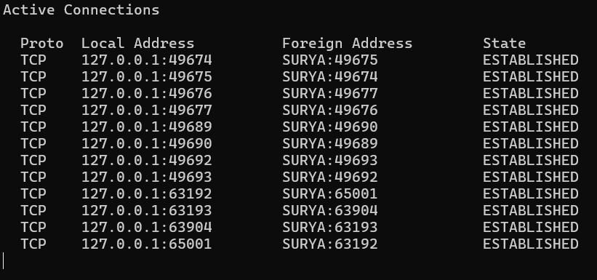

ifconfig / ipconfig

Displays basic current TCP/IP network configuration. It is very useful to troubleshoot networking problems. ipconfig/all is used to provide detailed information such as IP address, subnet mask, MAC address, DNS server, DHCP server, default gateway, etc. ipconfig/renew is used to renew a DHCP-assigned IP address, whereas ipconfig/release is used to discard the assigned DHCP IP address.

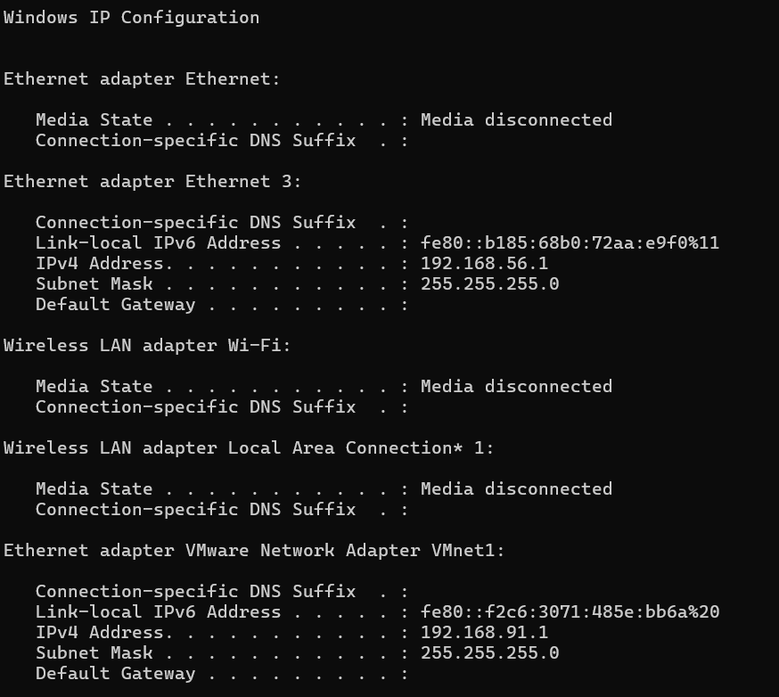

nslookup

It provides a command-line utility for querying DNS table of a DNS Server. It returns IP address for the given host name.



traceroute / tracert

Displays the path taken to a destination by sending ICMP Echo Request messages to the destination with TTL field values. The path displayed is the list of nearest router interfaces taken along each hop in the path between source host and destination

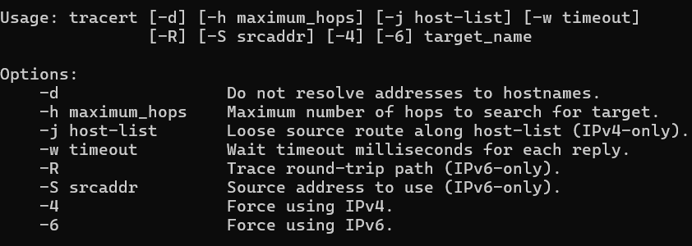

ping

Verifies IP-level connectivity to another TCP/IP computer by sending Internet Control Message Protocol (ICMP) Echo Request messages. The receipt of corresponding Echo Reply messages are displayed, along with round-trip times. Ping is the primary TCP/IP command used to troubleshoot connectivity, reachability, and name resolution.

