**PROJECT:**

**LAUNCH 2 EC2 INSTANCES**

**OS:UBUNTU,T2MEDIUM,RAM 10GB**

**ALLOW SSH, HTTP,HTTPS,**

**THEN LAUNCH THE INSTANCES**

**NAME THE INSTENCES AS 1.JENKINS 2.DOCKER**

**GO TO GOOGLE SEARCH BAR AND SEARCH FOR FREE CSS TEMPLATES**

[**https://www.free-css.com/free-css-templates**](https://www.free-css.com/free-css-templates)

* **DOWNLOAD ANY ONE CSS TEMPLATE AND EXTRACT THE FILES**
* **GO TO GIT HUB AND CREATE A NEW REPO**

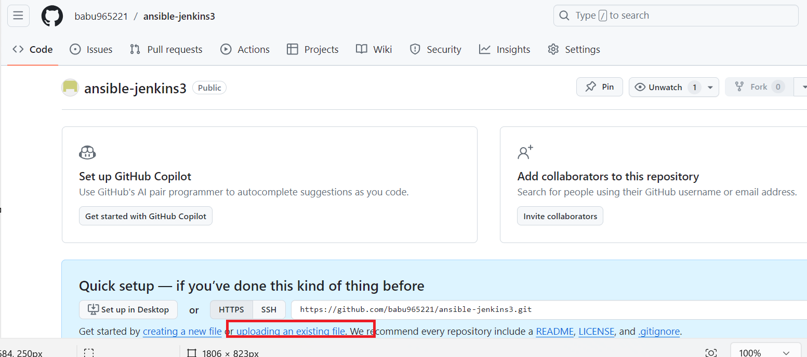

* **SELECT UPLOADING AN EXISTING FILE**
* **DRAG YOUR FILES TO REPO**
* **COMMIT THE CHANGES**
* **CREATE A NEW FILE DOCKER IN GIT HUB**

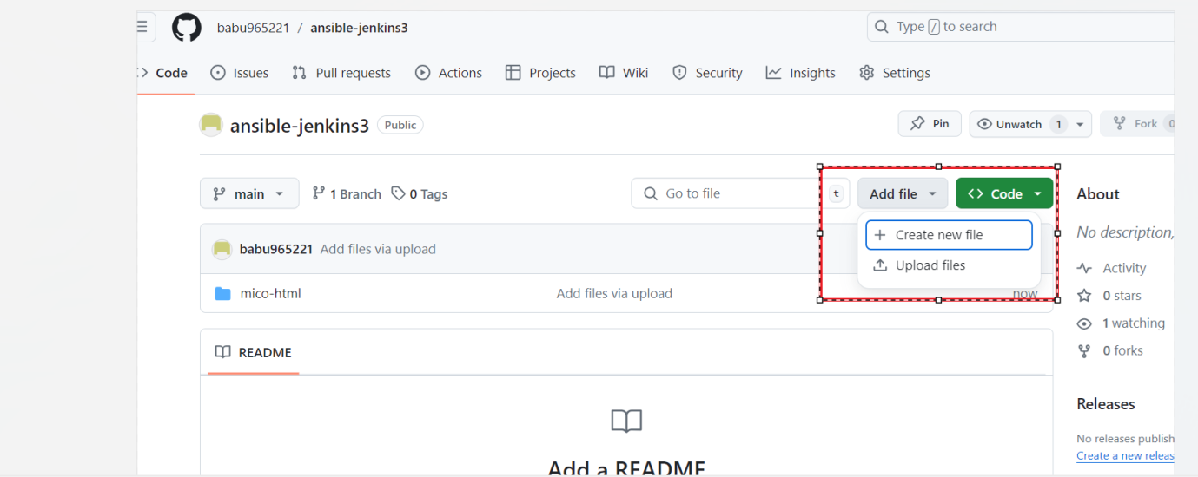

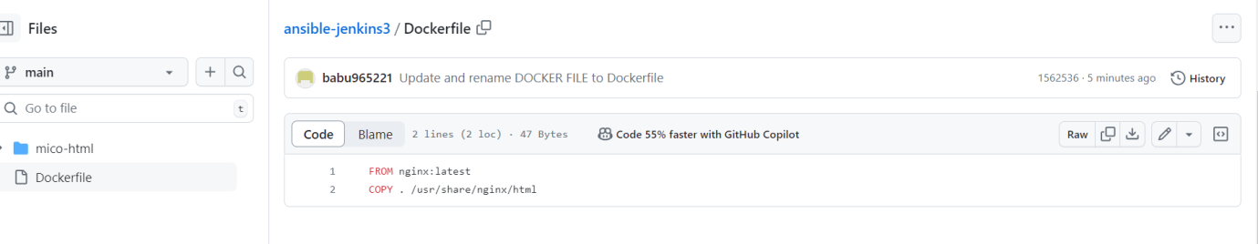

* **COMMIT THE CHANGES**
* **GO TO CONSOLE START YOUR INSTANCES USING PUTTY**
* **INSTALL THE JENKINS AND JAVA ON JENKINS SERVER(SERVER1)**
* [**https://www.jenkins.io/doc/book/installing/linux/#debianubuntu**](https://www.jenkins.io/doc/book/installing/linux/#debianubuntu)

**sudo wget -O /usr/share/keyrings/jenkins-keyring.asc \**

**https://pkg.jenkins.io/debian-stable/jenkins.io-2023.key**

**echo "deb [signed-by=/usr/share/keyrings/jenkins-keyring.asc]" \**

**https://pkg.jenkins.io/debian-stable binary/ | sudo tee \**

**/etc/apt/sources.list.d/jenkins.list > /dev/null**

**sudo apt-get update**

**sudo apt-get install jenkins**

**COPY THAT AND INSTALL JENKINS**

**sudo apt update**

**sudo apt install fontconfig openjdk-17-jre**

**java -version**

**openjdk version "17.0.8" 2023-07-18**

**OpenJDK Runtime Environment (build 17.0.8+7-Debian-1deb12u1)**

**OpenJDK 64-Bit Server VM (build 17.0.8+7-Debian-1deb12u1, mixed mode, sharing)**

**COPY AND INSTALL THE JAVA**

* **sudo snap install openjdk**
* 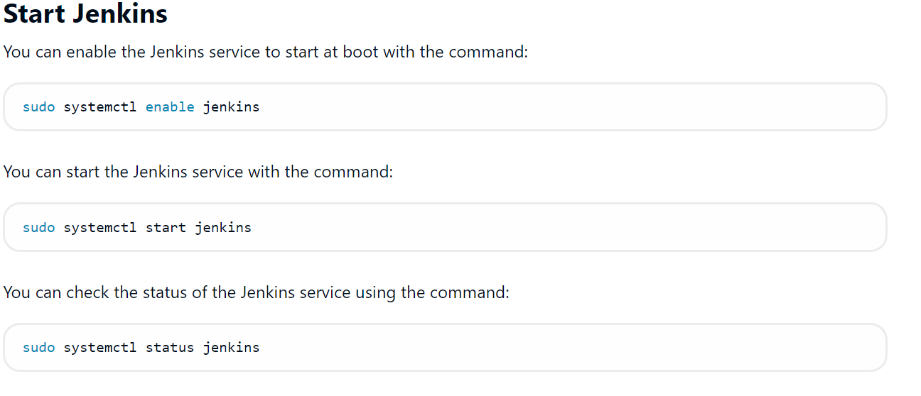

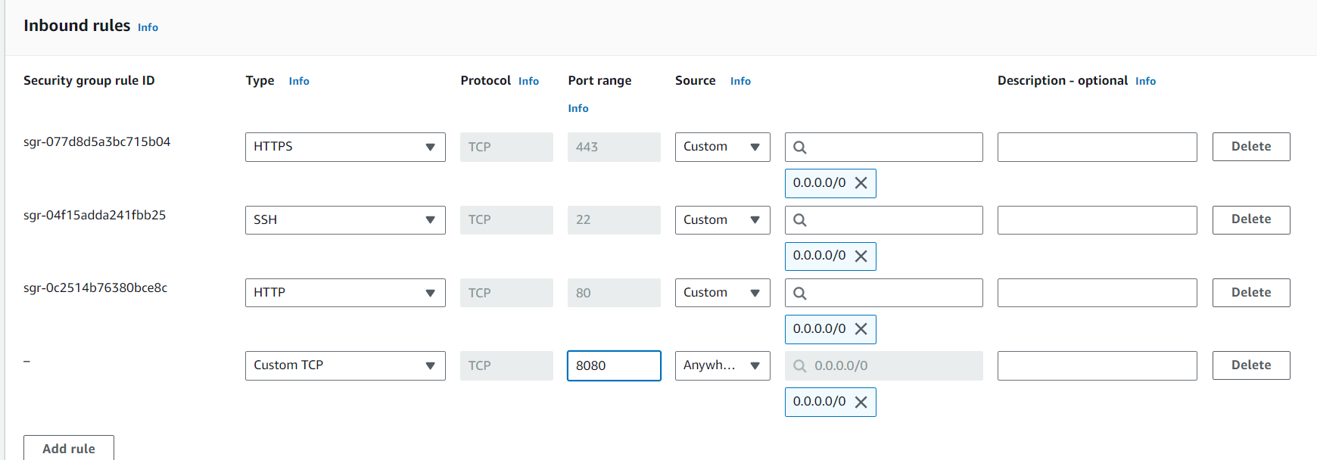

* **IN IN BOUND RULES ADD NEW RULE ALLOW PORT 8080**
* **START YOUR JENKINS**
* **INTALL ANSIBLE IN JENKINS SERVER(SERVER1)**
* [**https://docs.ansible.com/ansible/latest/installation_guide/installation_distros.html#installing-ansible-on-ubuntu**](https://docs.ansible.com/ansible/latest/installation_guide/installation_distros.html#installing-ansible-on-ubuntu)
* **$ sudo apt update**
* **$ sudo apt install software-properties-common**
* **$ sudo add-apt-repository --yes --update ppa:ansible/ansible**
* **$ sudo apt install ansible**
* 
* **sudo apt install python3-pip**
* **pip install docker --break-system-packages**
* cd /etc/ansible
* ls
* sudo vim hosts
* 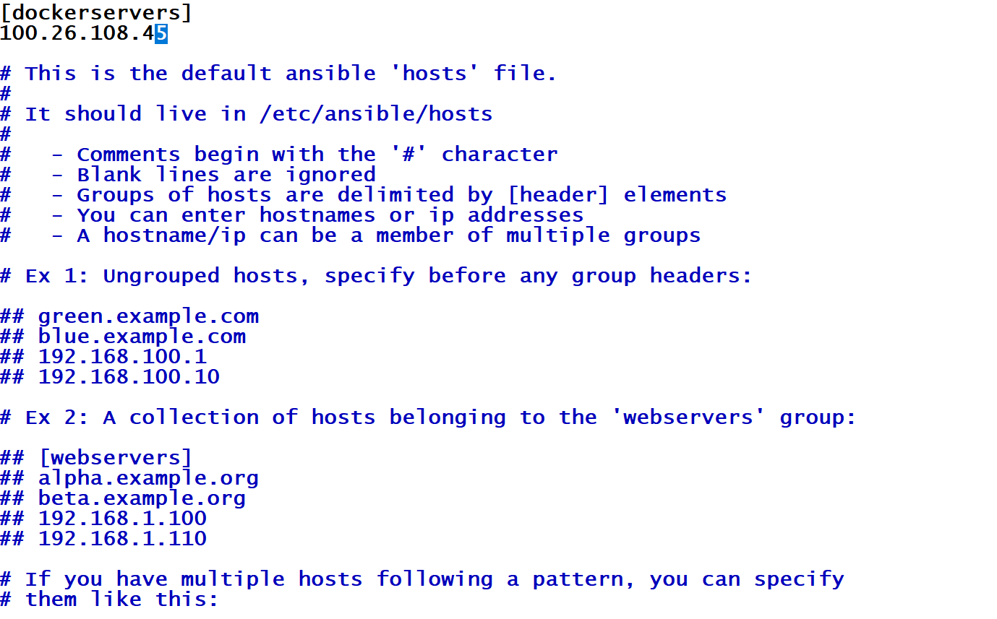
* Save the changes wq!

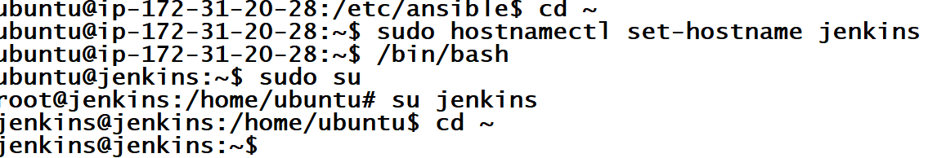

* Mkdir playbooks
* cd playbooks/
* ssh-keygen

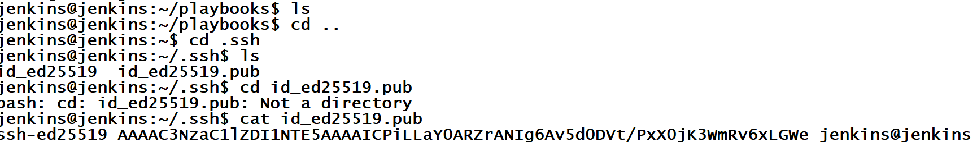

* **GO TO SERVER 2 AND CONNECT AND INSTALL DOCKER**

# Add Docker's official GPG key:

sudo apt-get update

sudo apt-get install ca-certificates curl

sudo install -m 0755 -d /etc/apt/keyrings

sudo curl -fsSL https://download.docker.com/linux/ubuntu/gpg -o /etc/apt/keyrings/docker.asc

sudo chmod a+r /etc/apt/keyrings/docker.asc

# Add the repository to Apt sources:

echo \

"deb [arch=$(dpkg --print-architecture) signed-by=/etc/apt/keyrings/docker.asc] https://download.docker.com/linux/ubuntu \

$(. /etc/os-release && echo "$VERSION_CODENAME") stable" | \

sudo tee /etc/apt/sources.list.d/docker.list > /dev/null

sudo apt-get update

* sudo apt-get install docker-ce docker-ce-cli containerd.io docker-buildx-plugin docker-compose-plugin
* docker ps
* we get the error so called permissions denied
* sudo usermod -aG docker ubuntu
* newgrp docker
* docker ps
* sudo su
* ssh-keygen
* cd ~
* ls –la
* cd .ssh
* ls
* vim autherized-keys(need to comment and copy the ssh keyof jrenkins server to docker server)
* 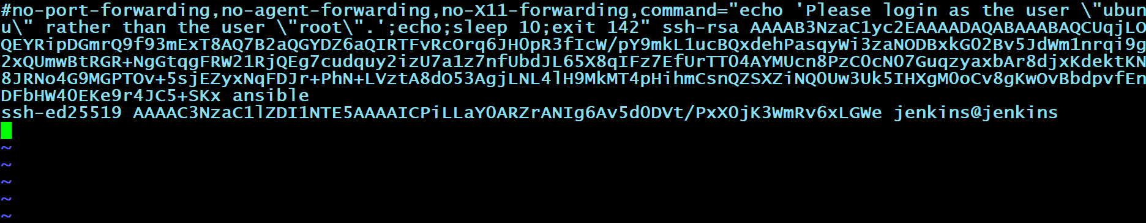
* sudo systemctl reload ssh
* go to Jenkins server and connect docker server from here
* ssh root@publicip of docker
* exit
* ls
* cd ..
* cd playbooks/
* nano deployment.yaml
* 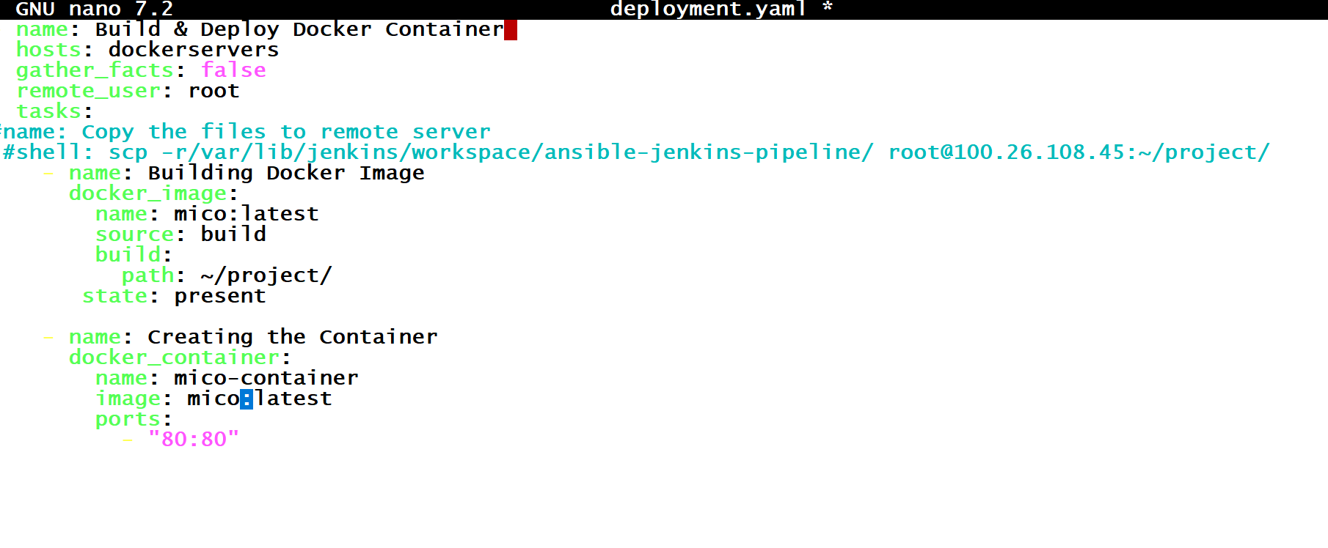
* Save the file (ctrl+x)
* Enter the y
* After hi the enter then it will save
* Go to Jenkins server
* Create a freestyle project (ansible-jenkins-pipeline)
* Go to Source Code Management

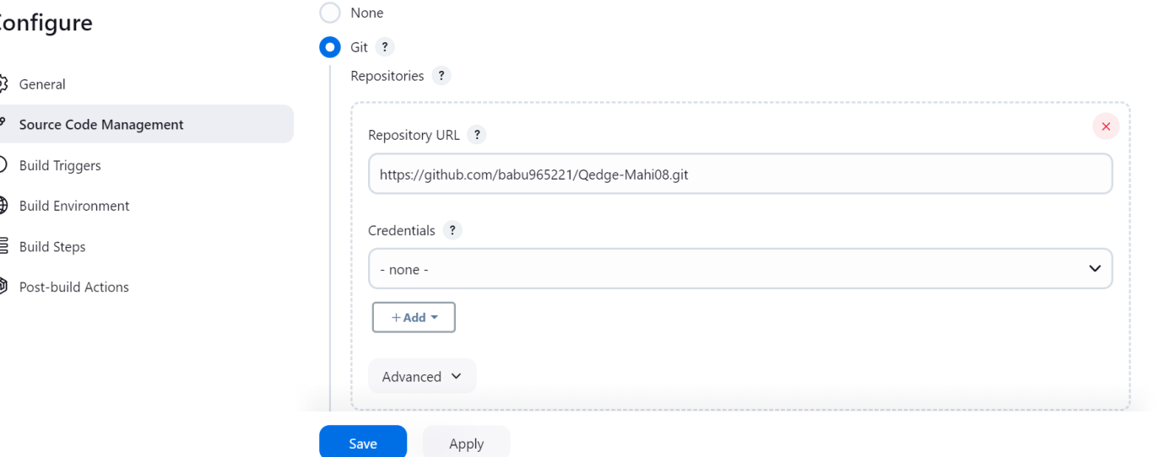

* Bulid now
* After your job successful go to git hub and add webhook
* 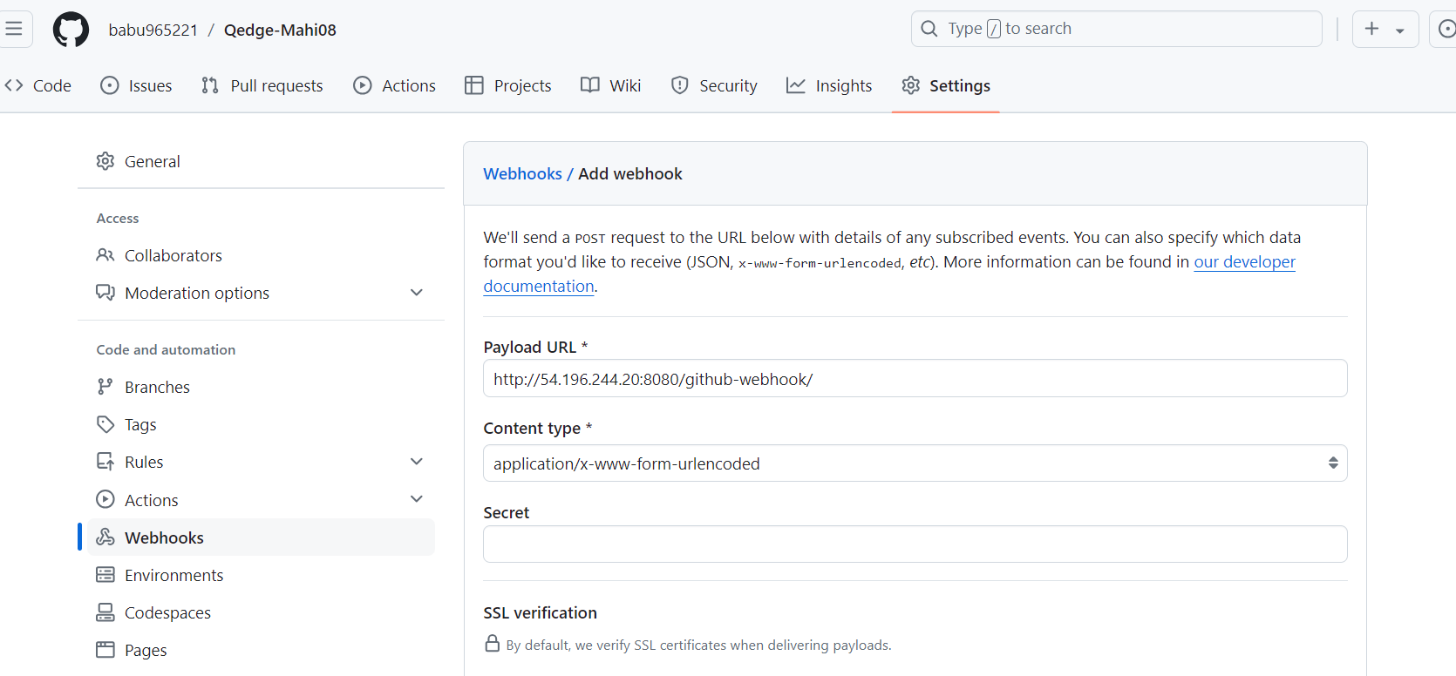
* Copy the Jenkins url and paste in webhook as shown in above image
* Select Let me select individual events.
* Select pullrequest and pushes
* 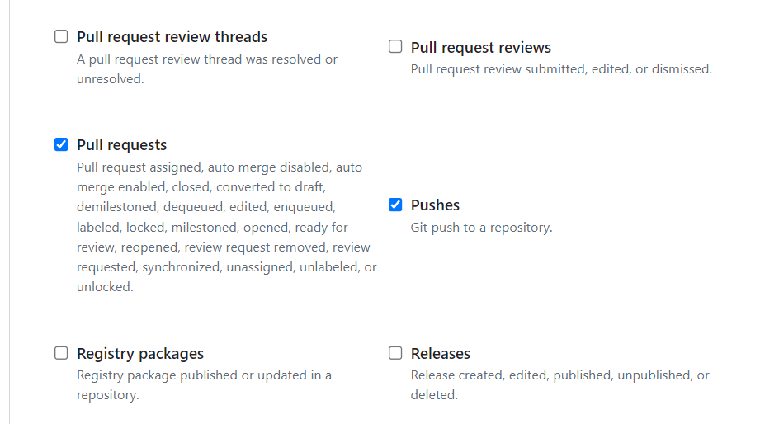
* Add webhook
* In git hub go to your reopo codes open your docker file and make some changes and commit the changes
* 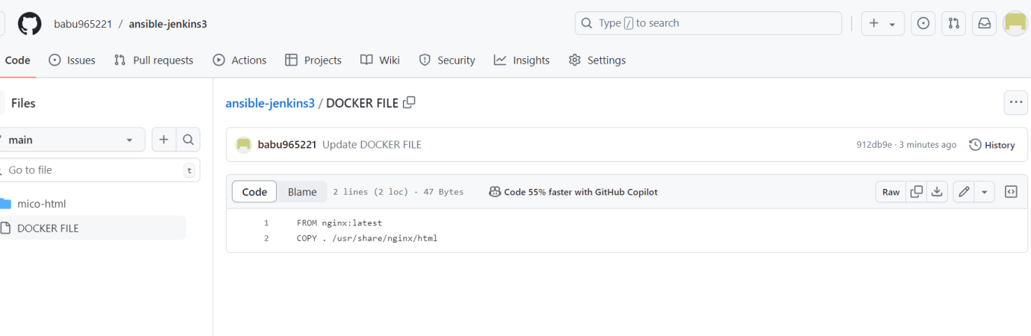
* Then it automatically build the job in Jenkins because of webhook configuration
* Got Jenkins server terminal
* jenkins@jenkins:~/playbooks$ scp -r /var/lib/jenkins/workspace/ansible-jenkins-pipeline/ [root@100.26.108.45:~/project/](mailto:root@100.26.108.45:~/project/)
* go to docker server
* now go and check the docker server
* ls
* cd ansible-jenkins-pipeline
* ls
* mv ./* ../
* cd ..
* ls
* for ref please check bellow immage
* 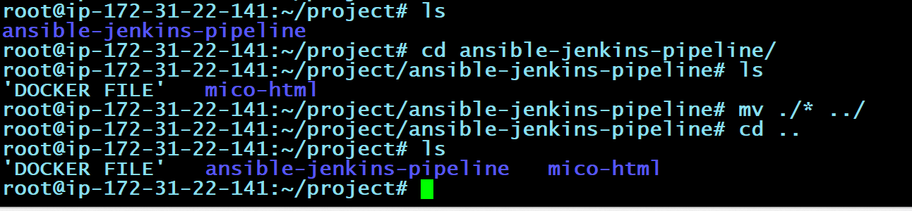

Go to Jenkins server terminal

* Run the command ansible-playbook deployment.yaml
* Go to Jenkins portal
* Go job configuration add buildstep (exicuteshell)
* 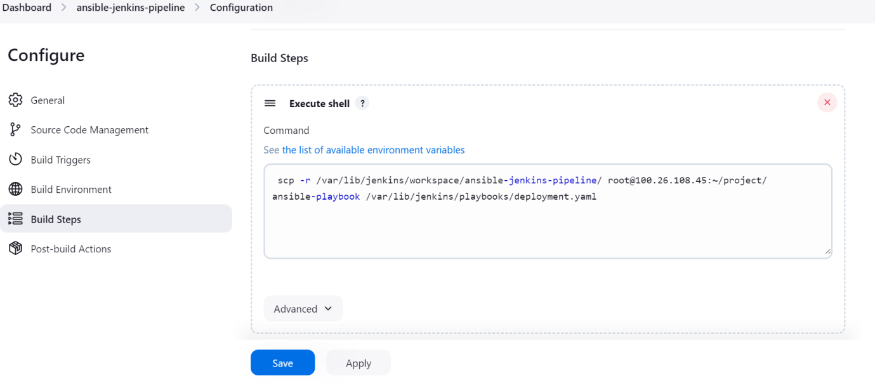
* Bulid now
* Then check the console output
* Now copy the public ip of docker(target server) and paste it in web check your output