Basic Authentication for Rest API:

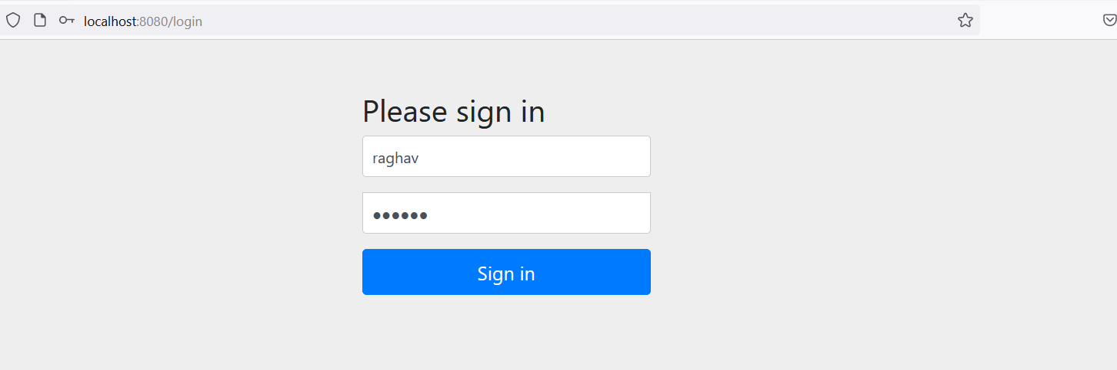

Fetch all the Customers: **http://localhost:8080/cust/**

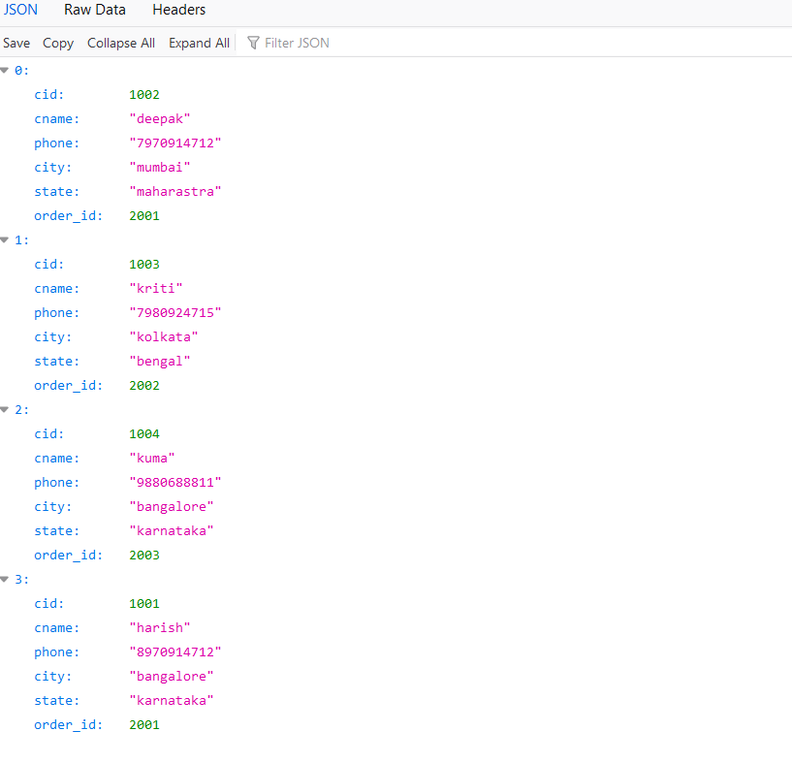

Fetch Customer by ID : **http://localhost:8080/cust/custById/1004**

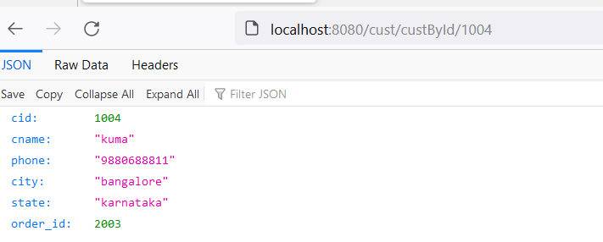

Fetch Customer and Order details: **http://localhost:8080/cust/orderDetails**

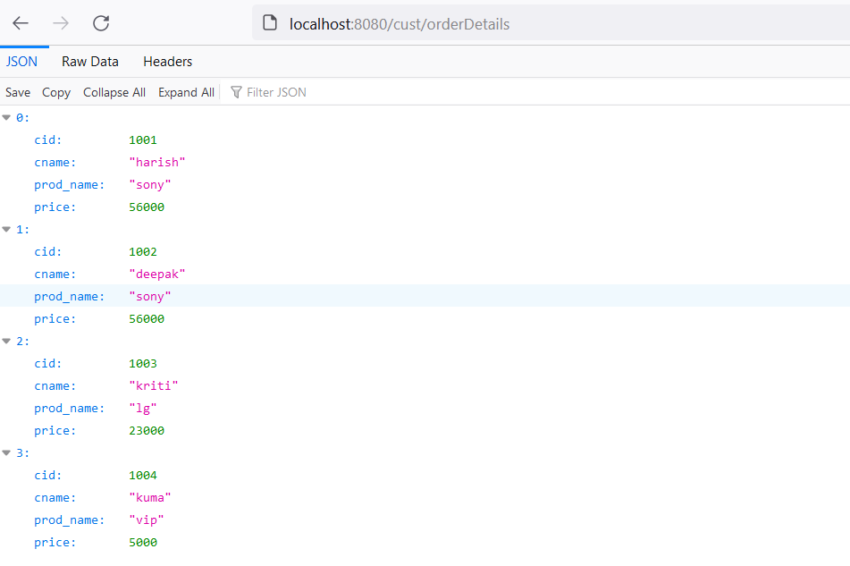

Update Customer City: **http://localhost:8080/cust/updCity/1002/chennai**

