- Architecture Diagram

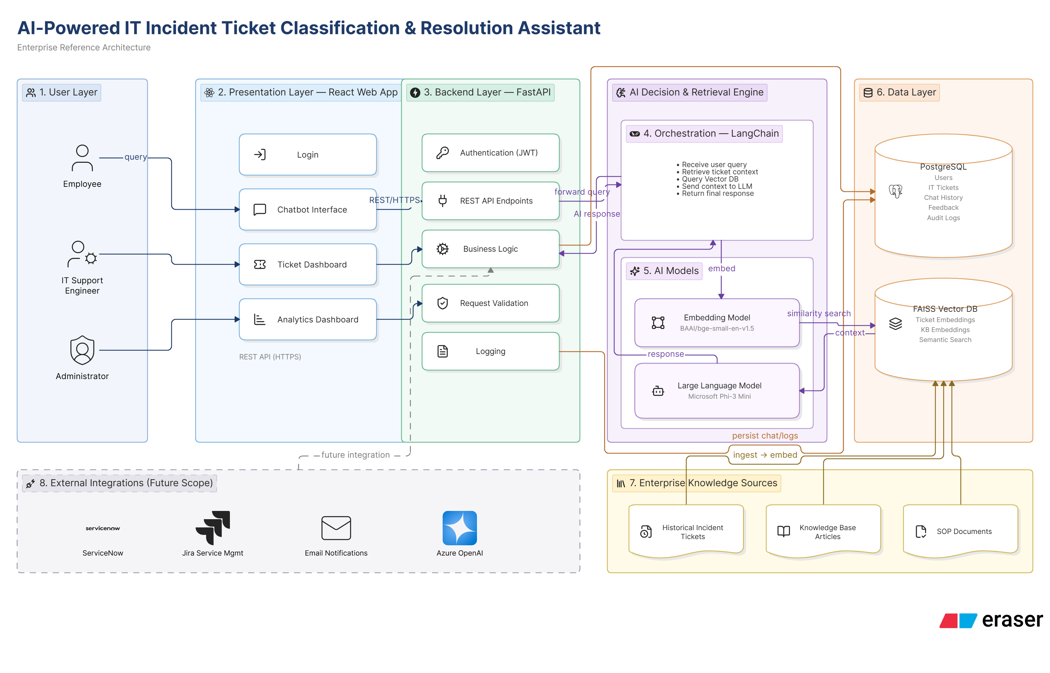

- Component Diagram

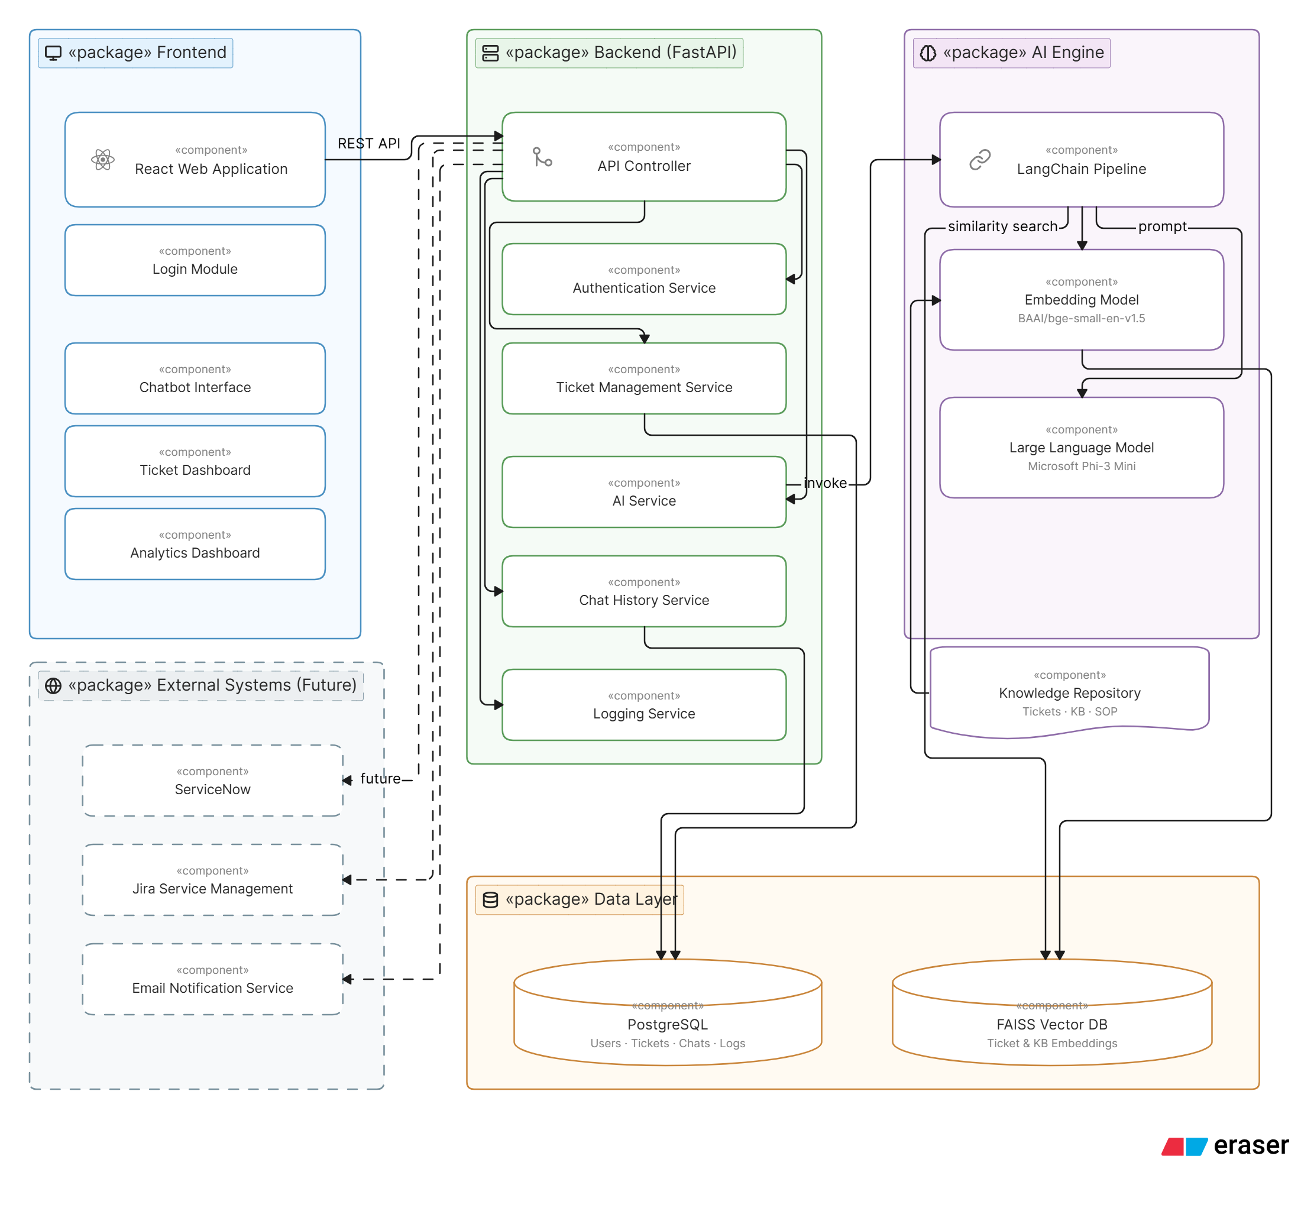

Component | Technology | Purpose / Why it is Needed
Frontend | React.js | Provides a user-friendly web interface for employees, support engineers, and administrators to interact with the system.
Authentication | JWT (JSON Web Token) | Ensures that only authorized users can securely access the application.
Backend | FastAPI | Acts as the central controller that receives user requests, executes business logic, and communicates with AI services and databases.
API Controller | FastAPI | Routes incoming API requests to the appropriate backend services.
Ticket Management Service | FastAPI | Handles ticket creation, retrieval, updates, and status management.
AI Service | LangChain | Coordinates the AI workflow by retrieving relevant information, building prompts, and communicating with the language model.
Embedding Model | BAAI/bge-small-en-v1.5 | Converts user queries and historical tickets into vector embeddings to enable semantic similarity search.
Large Language Model (LLM) | Microsoft Phi-3 Mini | Understands user queries, analyzes retrieved context, and generates intelligent responses, classifications, and resolution recommendations.
Vector Database | FAISS | Stores vector embeddings and retrieves the most similar historical tickets and knowledge base articles based on meaning rather than exact keywords.
Relational Database | PostgreSQL | Stores structured application data such as users, tickets, chat history, feedback, and audit logs.
Knowledge Repository | Historical Tickets, Knowledge Base Articles, SOP Documents | Provides enterprise knowledge that the AI uses to generate context-aware and accurate responses.

- Azure account setup done

- Environment setup for development in VSCode done

