Design and Development of Mobile Application for Chronic Health Management

A Report
Submitted to
The School of Engineering, Technology and Media
National University

In Partial Fulfillment of the Requirements
for the Degree of Master of Science in Computer Science

By
Nayonika Rudra, Raghav Kadaba, Visala Varanasi and Venu Reddy
March 2014

Design and Development of Mobile Application for Chronic Health Management

A report submitted to the School of Engineering, Technology and Media, National University, in partial fulfillment of the requirements for the Degree of Master of Science in Computer Science by:

____________________
Nayonika Rudra

____________________
Raghav Kadaba

____________________
Visala Varanasi

____________________
Venu Reddy

The report is hereby approved by:

________________________________
Pradip Peter Dey, Ph.D.
Professor, School of Engineering, Technology and Media
National University

________________________________
Bhaskar Raj Sinha, Ph.D.
Professor, School of Engineering, Technology and Media
National University

__________________________
Date

ACKNOWLEDGEMENT

It is with great pleasure and admiration that we express our heart-felt gratitude to our beloved guide Dr. Arun K. Datta for his able guidance, motivation and untiring support throughout the course of this project. His exemplary work ethic, un-parallel vision and energy have been, and will always be a constant inspiration to all of us.
This document on ‘Design and Development of a Mobile Application for Chronic Health Management’ has been completed as a part of the research at the National University
Community Research Institute (NUCRI) under the direct supervision of Prof. Arun K.Datta Ph.D. and his team. It contains information that is proprietary and NUCRI posses’ sole copyright for this document. Transmittal, receipt, or possession of this document does not express license, or imply rights to use, sell, design, manufacture, or to have manufactured, any product, concept, or service from this information. We would also like to take this opportunity, to express profound gratitude and deep regards to professors Dr. Pradip Peter Dey, and Dr. Bhaskar Raj Sinha for exemplary guidance, motivation, monitoring and constant encouragement which helped us meet all the project goals and objectives.
We are obliged to the staff members of National University, for the valuable information provided by them in their respective fields. We are grateful to Dr. Thomas MacCalla and Yumiko Iwai from NUCRI for their cooperation during the period of our assignment. We are also grateful to all the professors and staff members of the department of Computer Science at National University, for developing and teaching an engaging and challenging curriculum which has enabled the students to think independently and has prepared them to contribute greatly towards development of the Computer Science field.
Abstract

Chronic diseases are among the most prevalent, costly, and preventable of all health problems. Chronic health management is extremely expensive and is affecting the economy of the country. Majority of the healthcare costs these days are for the chronic health management. It has been realized in recent past that the cost of chronic health management can be significantly reduced with the help of modern technologies such as the Mobile phone technology. Mobile technology has a lot of potential and promise in the day-to-day monitoring of a patient’s health. The impact of mobile technology is two folds; (1) it can enable the patients to monitor their health on a regular basis and reach their health and economic objectives. (2) It enables the health care providers to constantly keep track of patient’s health and make appropriate recommendations without requiring the patients to visit the hospitals or clinics. The physiological factors that play a vital role in health monitoring are height, weight, blood sugar, blood pressure etc. It is not feasible for patients suffering from chronic health conditions to regularly go to healthcare providers for constant checkups to manage and maintain their health. This is the kind of situation where in a mobile application can play a significant role in collecting patients physiological data at patients home and storing the same on centralized servers where physicians can access the data enabling them to better monitor the patients condition and progress. The mobile application should be able to collect the different physiological data such as Weight, Blood pressure, and Blood sugar etc. Although, there are multiple physiological parameters that are to be monitored for chronic health management, as part of this project, we propose to develop an Application on the iOS platform that can enable users manage their chronic illness and well-being through capturing and storing their weight metric. The iOS platform was specifically chosen because of its wide install base, ease of use and a strong development community. The mobile application will collect the weight via Bluetooth, calculate the BMI based on height entered, and provide recommendation for calorie intake/day. The Application will use the Healthy choices database to store the measured data under patient profile. The patient weight collected by the Application can then be used to help in setting fitness goals, check patient progress with data stored over a period of time and the application coming up with graphical charts of weight against time Weeks/Months/Year. Such a representation can be an indicator of patients overall health. The Application will also have the ability to alert the user about measuring their weight on a daily/weekly/monthly basis as recommended by the primary healthcare provider. By collecting and storing the patient physiological data electronically, primary healthcare providers can track patient’s progress over a time and make appropriate adjustments in treatment thereby enhancing the quality of healthcare delivery. By implementing the weight measurement as part of the Mobile Application for Chronic health management, a strong base will be laid to add support for more devices and their corresponding physiological data measurements ex. Blood pressure monitor, thermometer etc.

Introduction

Chronic diseases are the largest cause of death in the world [3]. Chronic diseases are diseases that persist over a long period of time. Many chronic diseases are linked to lifestyle choices that are within one’s own hands to change [2]. In 2002, the leading chronic diseases—cardiovascular disease, cancer, chronic respiratory disease, and diabetes—caused 29 million deaths worldwide [3]. To determine and adjust treatment for these diseases, clinicians depend heavily on patient reports of symptoms, side effects, and functional status. Typically, patients report at clinic visits that are months apart, and recall accuracy can be highly variable [8]. Thus, chronic diseases require continuous monitoring of patients by physicians in order to keep the condition of the patient at the appropriate level [1]. This can be done in two ways; a. The patient is under constant medical care provided by a trained medical professional who would monitor and report the patient’s health and, b. Patients monitor their health and report the progress to their health care provider. Empowering the patients to monitor their health have many benefits including better possibilities for managing chronic care, controlling health delivery costs, increasing quality of life and quality of health services and the distinct possibility of predicting and thus avoiding serious complications [4].

Over the years, ‘mHealth’ has emerged as the technology that can empower patients with chronic diseases. It has the potential to improve healthcare and the quality of life for the elderly and chronic patients [5]. mHealth can be defined as the "emerging mobile communications and network technologies for healthcare systems”[7]. This emerging concept represents the evolution of e-health systems from traditional desktop “telemedicine” platforms to wireless and mobile configurations. Current and emerging developments in wireless communications integrated with developments in pervasive and wearable technologies will have a radical impact on future health-care delivery systems [9]. In 2011, US Secretary of Health and Human Services Kathleen Sebelius referred to mHealth as “the biggest technology breakthrough of our time”. mHealth could benefit ambulatory individuals in two general ways; (1) Allow them to more easily and reliably self-diagnose their acute symptoms, and (2) enhance monitoring, tracking, and communication of various bio-metric information (ex. Blood pressure, Weight, Glucose levels etc.) for individuals with chronic medical conditions [6].

Monitoring, tracking and communication of the patient physiological data can be done using a combination of mobile phone and either wearable sensors or through conventional health monitoring devices such as Blood pressure monitors, weighing scales etc. that have been enhanced with capabilities to embrace the mHealth revolution. There is a lot of research going on in the field of wearable sensors that are used to get physiological data measurements from human body. In fact, there is one such research project underway here at National University Community Research Institute (NUCRI) under the leadership of Dr. Arun Datta in collaboration with the Calit2 Qualcomm Institute, UCSD. Although there is a lot of potential and promise for the wearable sensors in mHealth, due to its infancy at this point in time, we decided to go with the traditional health monitoring devices paired with the mobile phone for monitoring, tracking and communication of the patient physiological data. Smartphones have come a long way over the years. Now, when the users buy a phone, they just don’t by into the phone but the entire ecosystem that the phone is part of. At the moment, there are three main Mobile ecosystems; (a) iOS ecosystem, (b) Android ecosystem, and (c) Windows ecosystem. When it comes to smartphones themselves, from the time it was released in 2007, iPhone from Apple Inc. has been credited with revolutionizing the smartphone industry and has been a dominant platform for mobile data creation and consumption. The iOS platform and its ecosystem as a whole has become the de-facto choice for App development for most of the third party App developers which is evident from the Apple App store revenue crossing $10 Billion in 2013 [10]. With its large install base, simplicity, popularity and a strong development community iOS platform became our choice for the development of a Mobile Application for chronic health management.

Mobile Application for Chronic Health Management:

Chronic health management requires continuous monitoring of patients by physicians in order to keep the condition of the patient at the appropriate level [1]. Health Monitoring of the patient encompasses the monitoring of patients physiological data such as Blood Pressure, Weight, Blood Glucose etc. For Example, in the case of a patient suffering from Hypertension, it is essential to monitor his/her blood pressure every day and at times multiple times a day. It is not physically and economically viable for the patient to visit a clinic for blood pressure measurement every time. This and issues such as these are what Mobile Application for chronic health management strives to address. Mobile Application for chronic health management’s emphasis is on Home care. It enables the patient to measure, collect and store physiological data such as Weight, Blood pressure, temperature etc. right from home using his/her mobile phone paired with health monitoring devices such as Weighing machine, Blood pressure monitor, Digital Thermometer etc. Each of these devices stream the data to the Mobile Application using Bluetooth technology. The mobile application in turn stores these values locally on the phone for comparison and also on a centralized server that the healthcare providers have access to. This way, the healthcare providers can monitor the health of patients suffering from chronic diseases constantly and make recommendations based on the patient’s progress thereby enhancing the quality of care.

Chronic Health Management requires the monitoring of different physiological data. As part of this project, our focus area is on measuring, collecting and storing of patient’s weight. A mobile application will be developed that will interact with a Bluetooth enabled weighing scale using Bluetooth technology. The mobile application will collect the weight from the weighing scale as and when the patient starts the App and uses the weighing scale. The weight data collected from the weighing scale will be displayed to the user and stored onto the phone. The weight data is also stored on the patient’s personalized profile on the Healthy Choices portal. Apart from collecting patients weight, the patient will be able to track his/her BMI, get comparison of weight across weeks/months/year through charts, get recommendations on the optimal calorie intake based on the weight and BMI.

Requirements

- System will provide a gateway for wellness management. Patients will keep a record of health data on daily basis and generate reports on need basis (weekly/monthly/yearly)
- System Security - There will be a two pronged approach in dealing with security;
  - Mobile Phone Security - All the smartphones have security systems in place that secure all the applications and their data on the phone. These systems require 4 digit pins and or fingerprint scans, design patterns etc. to access the phones. It is strongly recommended that all users enable the security systems on their phones.
  - Patient Data Security - The mobile application will implement user based authentication using username and password. The patient is required to setup an account on the Healthy Choices portal to use the system. The system will provide a mechanism to reset the user password incase the user forgets his/her password.
  - Data Access Control - The system will implement role based access control. Users will be allowed to insert/view/edit data forms based on their roles.
- Compliance
  - The system deals with storing user health data and hence it needs to be HIPAA compliant
  - This system will also store health information of school children and hence the system needs to be FERPA compliant.
- System Availability: System should have a high availability rate. System should always be available to individuals safely and securely. Physicians should have role-based access to the Health report securely whenever required.
- System will provide users with the ability to calculate health related metrics such as BMI, BMR, Optimal daily calorie Intake, Body Fat percentage etc.
- Reporting Functionality: Patients will be able to generate their health reports by utilizing the Graphing tools that will be made available to them. Users can visualize their current health conditions, as they will have the ability to plot graphs of their weight, BMI and BMR over Days, Weeks, Months or Years.
- This system will provide users with the ability to manage their prescribed medication. Once the patient enters the prescription details into the Mobile Application, the application will alert the user to take medication based on the prescription; that is, if the prescription requires the patient to take the medication thrice a day, an alert will be generated accordingly. The patient will also have the ability to check off on the medication once consumed so that there is a record of the medication consumed. Also, since the physicians have access to the patients data, they can see how the patient is responding to the prescribed medication by looking at the physiological data thereby enabling them to make decisions regarding the medication or seeing the patient in person.
- System will allow patients to download their health data in the PDF format. For enhanced security, patients can encrypt the PDF file with a password
- Mobile Application will have an Frequently asked Questions (FAQ) section which educates users about the System, Application and its features.

Features of the Future:

- User Activity Monitor: System will support user activity monitoring by using one or more of the following techniques;
  - User activity monitoring by pairing dedicated activity-tracking devices with mobile phone application.
  - Collecting data from sensors such as GPS and accelerometers that are built into smartphones and analyzing the collected data to interpret the user activity in the Mobile Application.
  - Accessing user activity data stored in dedicated motion tracking chips (M7) that are embedded in the iPhone 5S line of smartphones and using it in the Mobile Application.

Project Plan

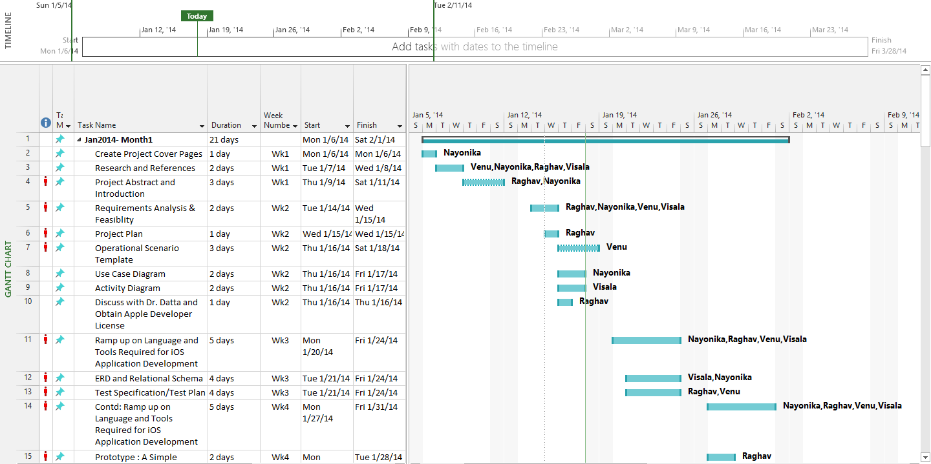

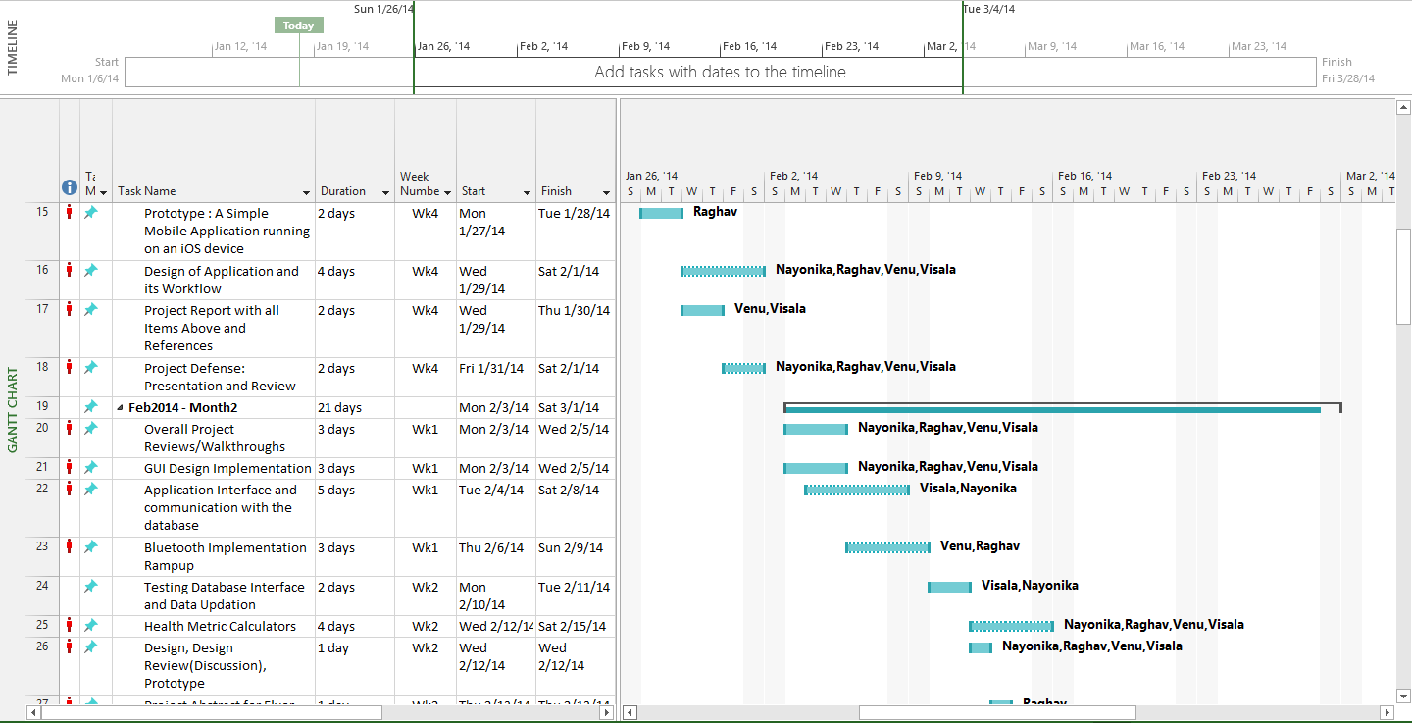

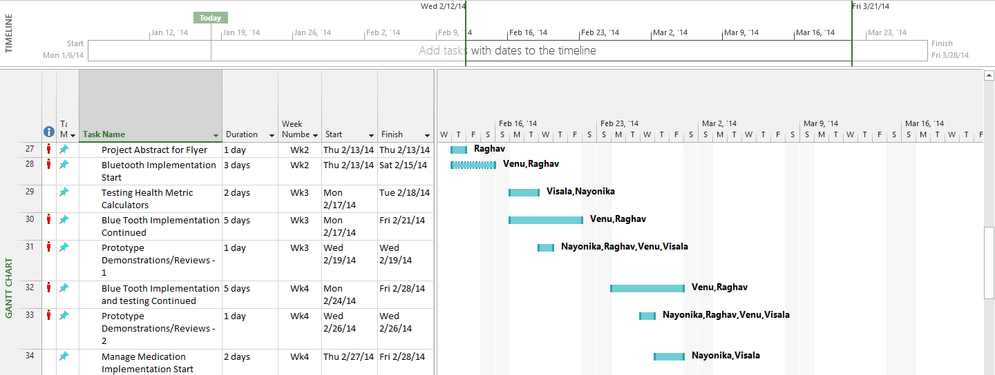

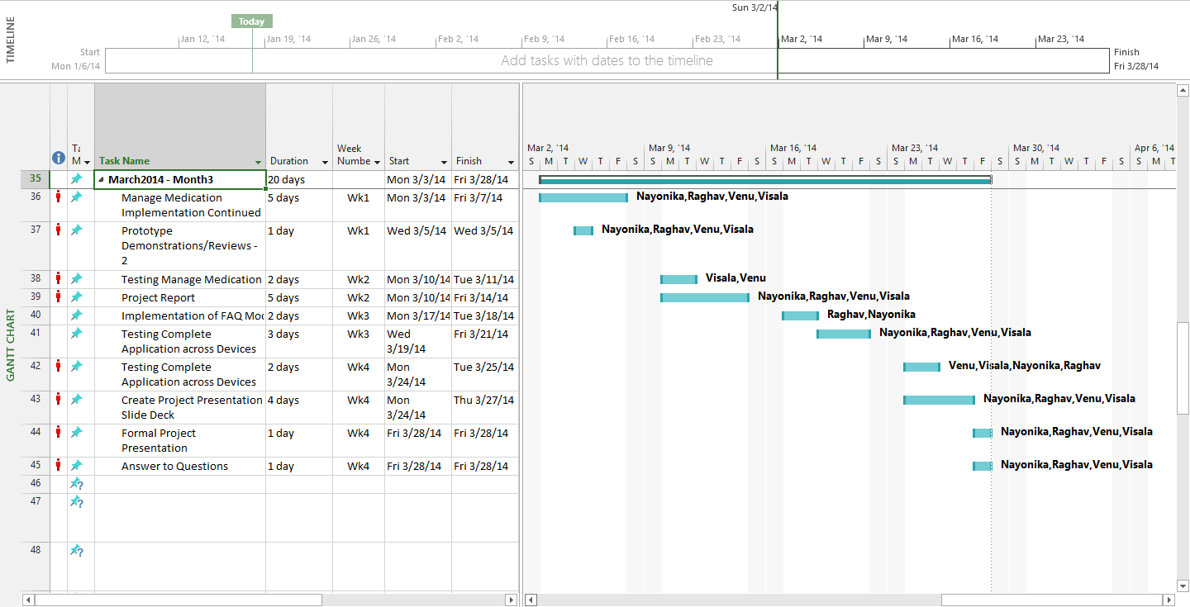

System Design:

Use Case Diagram:

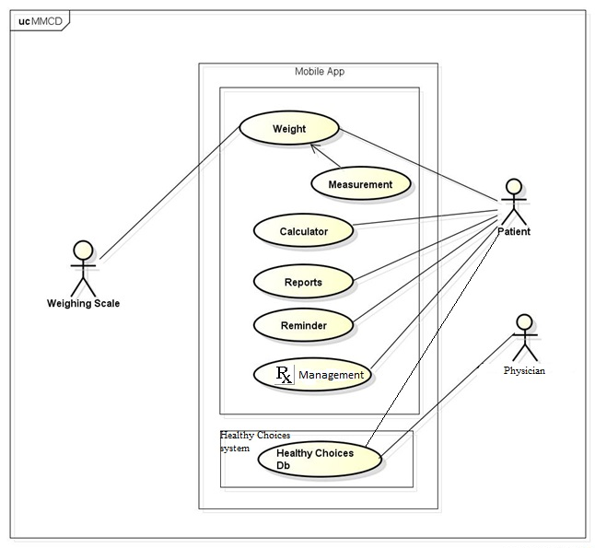

Activity Diagram:

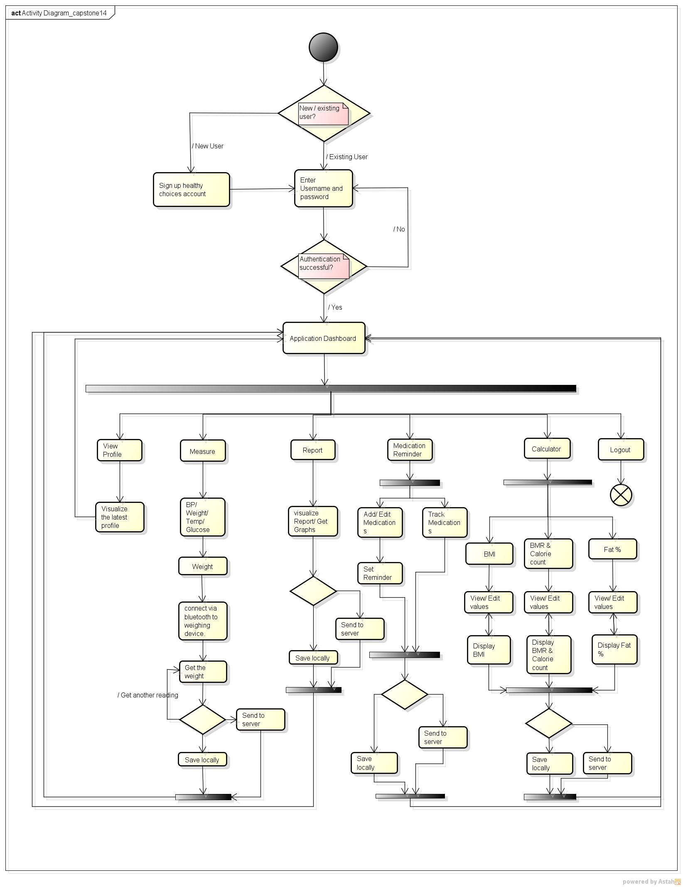

Operational Scenario Template:

Table 10.11 Operational Scenario Template (Humphrey)

Student(s) | Venu Reddy Ravula, Varanasi Visala, Raghav Kadaba, Nayonika Rudra | Date | 1/16/14
Program/Project |  | Program #
Instructor |  | Language

Construct operational scenarios to cover the normal and abnormal program uses, including user errors:

Scenario # 1 |  |  | User Objective: Registration
Scenario Objective: To show Registration
Source: | Step | Action: |  | Comments
User | 1 | Open Mobile Application
Mobile app | 2 | Ask for login credentials |  | Ask for login credentials or Register for new users
Mobile app | 3 | Register if new user
User | 4 | Clicks to register |  | User is using the app for the first time.
Mobile app | 5 | Redirects to Healthy choices website registration page.
User | 6 | User enters First Name, Last Name, Gender, Education Level, Race/Ethnicity, Email address, password and confirm password.
Mobile app | 7 | Redirects to the application login page &  Asks for username and password.
User | 8 | Enter user id and password
Mobile app | 9 | Registers and displays dashboard with various options like Profile, Measurement, Calculator, Activity Tracker, Report, FAQ’S, Manage Medication and Logout
User | 10 | Clicks on profile
Mobile app | 11 | Displays profile page with user details
User | 12 | Clicks on back
Mobile app | 13 | Displays dashboard
User | 14 | Clicks on logout
Mobile app | 15 | Logs the user out and displays home page

Table 10.12 Operational Scenario Template (Humphrey)

Student(s) | Venu Reddy Ravula, Varanasi Visala, Raghav Kadaba, Nayonika Rudra | Date
Program/Project |  | Program #
Instructor |  | Language

Construct operational scenarios to cover the normal and abnormal program uses, including user errors:

Scenario # 2 |  |  | User Objective: Weight Measurement
Scenario Objective: To show Weight Measurement
Source: | Step | Action: |  | Comments
User | 1 | Open Mobile Application
Mobile app | 2 | Ask for Login Credentials
User | 3 | Enters user name and password |  | This step is repeated until successful login
Mobile app | 4 | Login successful displays dashboard with options Profile, Measurement, Calculator, Activity Tracker, Reports, FAQ’S, Manage Medication and Logout
User | 5 | Clicks the Measurement from dashboard
Mobile app | 6 | Displays the Measurement Screen with options B.P, Weight, Temperature and Glucose
User | 7 | User Clicks the Weight
Mobile app | 8 | Displays Connect, Save and Send |  | Connect –connects the mobile app to the Bluetooth enabled weighing machine.
User | 9 | Clicks measure.
Mobile app | 10 | System response- Not connected |  | This step is repeated until successfully pairing is established.
User | 11 | Checks the Bluetooth connection and again Clicks the measure. |  | As soon as user selects measure the app receives weight reading.
Mobile app | 12 | Displays the weight. |  | User can now save latest weight in his device or send to server or can recalculate the weight by selecting measure. But user can’t edit the weight or manually enter the weight.
User | 13 | Clicks Send
Mobile app | 14 | No Internet connection |  | To send it to the server mobile device should connect to internet
User | 15 | Check the internet connection and again click on Send
Mobile app | 16 | Successfully Sent. |  | Its save in mobile device and update in the server
User | 19 | Clicks back |  | User can go back to main menu.
Mobile app | 20 | Displays the Measurement Screen with options B.P, Weight, Temperature and Glucose
User | 21 | Clicks back
Mobile app | 22 | Go backs to Main screen |  | User can select any option from the main screen or simply logout
User | 23 | Clicks Logout
Mobile app | 24 | Logs the user out and displays home page

Table 10.13 Operational Scenario Template (Humphrey)

Student(s) | Venu Reddy Ravula, Varanasi Visala, Raghav Kadaba, Nayonika Rudra | Date
Program/Project |  | Program #
Instructor |  | Language

Construct operational scenarios to cover the normal and abnormal program uses, including user errors:

Scenario # 3 |  |  | User Objective: BMI Calculator
Scenario Objective: User check BMI
Source: | Step | Action: |  | Comments
User | 1 | Open Mobile Application
Mobile app | 2 | Asks for login credentials
User | 3 | Enter the correct user name and password
Mobile app | 4 | Login successful displays dashboard with options Profile, Measurement, Calculator, Activity Tracker, Reports, FAQ’S, Manage Medication and Logout
User | 5 | User clicks on Calculator
Mobile app | 6 | Displays the Screen with options BMI, BMR and Fat%
User | 7 | Clicks on BMI
Mobile app | 8 | Displays with Weight and Height(Auto Populated from Database), BMI Table, BMI with an empty textbox and Calculate |  | User Can edit Height and Weight but can’t enter manually BMI Value in the textbox. . BMI table consist of BMI Range, Weight status and Health Risks.
User | 9 | Clicks On Calculate
Mobile app | 10 | Displays the BMI Value in textbox and save to website with date and time |  | User Can now compare his BMI with the table.
User | 11 | Clicks back
Mobile app | 12 | Displays the Screen with options BMI, BMR and Fat% |  | User can select any option from the main screen or simply go back
User | 13 | Clicks back
Mobile app | 14 | Go backs to Main screen |  | User can select any option from the main screen or simply logout
User | 15 | Clicks Logout
Mobile app | 16 | Logs the user out and displays home page

Table 10.14 Operational Scenario Template (Humphrey)

Student(s) | Venu Reddy Ravula, Varanasi Visala, Raghav Kadaba, Nayonika Rudra | Date
Program/Project |  | Program #
Instructor |  | Language

Construct operational scenarios to cover the normal and abnormal program uses, including user errors:

Scenario # 4 |  |  | User Objective: BMR Calculator
Scenario Objective: User Calculate BMR and Calorie count
Source: | Step | Action: |  | Comments
User | 1 | Open Mobile Application
Mobile app | 2 | Asks for login credentials
User | 3 | Enter the correct user name and password
Mobile app | 4 | Login successful displays dashboard with options Profile, Measurement, Calculator, Activity Tracker, Reports, FAQ’S, Manage Medication and Logout
User | 5 | User clicks on Calculator
Mobile app | 6 | Displays the Screen with options BMI, BMR and Fat%
User | 7 | Clicks on BMR
Mobile app | 8 | Displays with Weight and Height(Auto Populated from Database), Activity level, BMR with an empty textbox, Calorie count with an empty textbox and Calculate |  | User Can edit Height and Weight but can’t enter manually BMR Value in the textbox. Activity Level is selected manually with the drop down menu having an option of five activity levels  1) Sedentary  2) Somewhat Active  3) Moderately Active  4) Very Active  5) Extremely Active
User | 9 | User select the Activity Level and clicks on Calculate
Mobile app | 10 | Displays the BMR Value and Calorie count in textbox and save to website with date and time |  | Calorie count is the required calories per person in a day.
User | 11 | Clicks back
Mobile app | 12 | Displays the Screen with options BMI, BMR and Fat% |  | User can select any option from the main screen or simply go back
User | 13 | Clicks back
Mobile app | 14 | Go backs to Main screen |  | User can select any option from the main screen or simply logout
User | 15 | Clicks Logout
Mobile app | 16 | Logs the user out and displays home page

Table 10.15 Operational Scenario Template (Humphrey)

Student(s) | Venu Reddy Ravula, Varanasi Visala, Raghav Kadaba, Nayonika Rudra | Date
Program/Project |  | Program #
Instructor |  | Language

Construct operational scenarios to cover the normal and abnormal program uses, including user errors:

Scenario # 5 |  |  | User Objective: FAT % Calculator
Scenario Objective: User Calculate FAT %
Source: | Step | Action: |  | Comments
User | 1 | Open Mobile Application
Mobile app | 2 | Asks for login credentials
User | 3 | Enter the correct user name and password
Mobile app | 4 | Login successful displays dashboard with options Profile, Measurement, Calculator, Activity Tracker, Reports, FAQ’S, Manage Medication and Logout
User | 5 | User clicks on Calculator
Mobile app | 6 | Displays the Screen with options BMI, BMR and Fat%
User | 7 | Clicks on Fat %
Mobile app | 8 | Displays with BMI, Age and Gender (Auto Populated from Database), Fat% with an empty textbox and Calculate |  | System takes the latest calculated BMI value from the database and calculates the Fat %.
User | 9 | Clicks on Calculate
Mobile app | 10 | Displays the Fat% Value in textbox and save to website with date and time |  | Calculates the Fat% value and displays
User | 11 | Clicks back
Mobile app | 12 | Displays the Screen with options BMI, BMR and Fat% |  | User can select any option from the main screen or simply go back
User | 13 | Clicks back
Mobile app | 14 | Go backs to Main screen |  | User can select any option from the main screen or simply logout
User | 15 | Clicks Logout
Mobile app | 16 | Logs the user out and displays home page

Table 10.16 Operational Scenario Template (Humphrey)

Student(s) | Venu Reddy Ravula, Varanasi Visala, Raghav Kadaba, Nayonika Rudra | Date
Program/Project |  | Program #
Instructor |  | Language

Construct operational scenarios to cover the normal and abnormal program uses, including user errors:

Scenario # 6 |  |  | User Objective: Reports
Scenario Objective: User Check the Reports
Source: | Step | Action: |  | Comments
User | 1 | Open Mobile Application
Mobile app | 2 | Asks for login credentials
User | 3 | Enter the correct user name and password
Mobile app | 4 | Login successful displays dashboard with options Profile, Measurement, Calculator, Activity Tracker, Reports, FAQ’S, Manage Medication and Logout
User | 5 | User clicks on Reports
Mobile app | 6 | Displays the Screen with options Days, Weekly, Monthly, Get Graph and Save Graph. |  | User can check the graph on daily basis (by selecting From and To dates) or weekly basis (by selecting From and To dates) or monthly basis (by selecting From and To dates).
User | 7 | Clicks on get graph
Mobile app | 8 | Please Select the dates |  | User Can’t click on the get graphs without selecting the dates
User | 9 | Enter the dates in weekly and clicks on get graph.
Mobile app | 10 | Displays with graph.
User | 11 | Clicks on save graph
Mobile app | 12 | Save the graph with date and time.
User | 13 | Clicks back
Mobile app | 14 | Go backs to Main screen |  | User can select any option from the main screen or simply logout
User | 15 | Clicks Logout
Mobile app | 16 | Logs the user out and displays home page

Table 10.17 Operational Scenario Template (Humphrey)

Student(s) | Venu Reddy Ravula, Varanasi Visala, Raghav Kadaba, Nayonika Rudra | Date
Program/Project |  | Program #
Instructor |  | Language

Construct operational scenarios to cover the normal and abnormal program uses, including user errors:

Scenario # 7 |  |  | User Objective: Manage Medication
Scenario Objective:
Source: | Step | Action: |  | Comments
User | 1 | Open Mobile Application
Mobile app | 2 | Asks for login credentials
User | 3 | Enter the correct user name and password
Mobile app | 4 | Login successful displays dashboard with options Profile, Measurement, Calculator, Activity Tracker, Reports, FAQ’S, Manage Medication and Logout
User | 5 | User clicks on Manage Medication
Mobile app | 6 | Displays the Screen with Set Remainder and Track Remainder
User | 7 | Clicks on the Set Remainder
Mobile app | 8 | Displays the Screen with options Medication Name, Dosage, No of days and Add Medicine |  | User can enter the Medication name, Dosage, and no of days. Then user can add medicine.
User | 9 | Enter medication name, Dosage, No of days and Add Medicine
Mobile app | 10 | Successfully added
User | 11 | Clicks on back
Mobile app | 12 | Displays the Screen with Set Remainder and Track Remainder
User | 13 | Clicks on Track Remainder
Mobile app | 14 | Displays the track of medicines
User | 15 | Clicks back
Mobile app | 16 | Displays the Screen with Set Remainder and Track Remainder
User | 17 | Clicks Back
Mobile app | 18 | Go backs to Main screen
User | 19 | Clicks Logout
Mobile app | 20 | Logs the user out and displays home page

Database Design

Entity Relation Diagram:

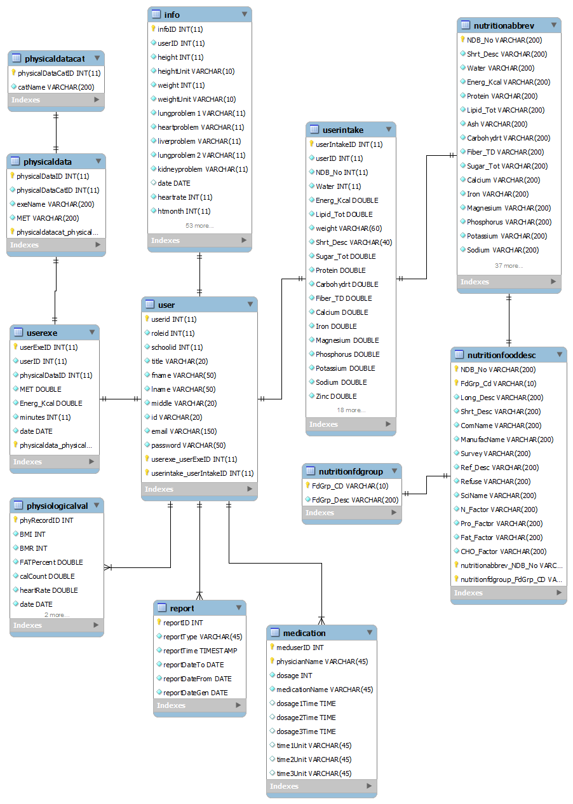

Mobile Application Local Database:

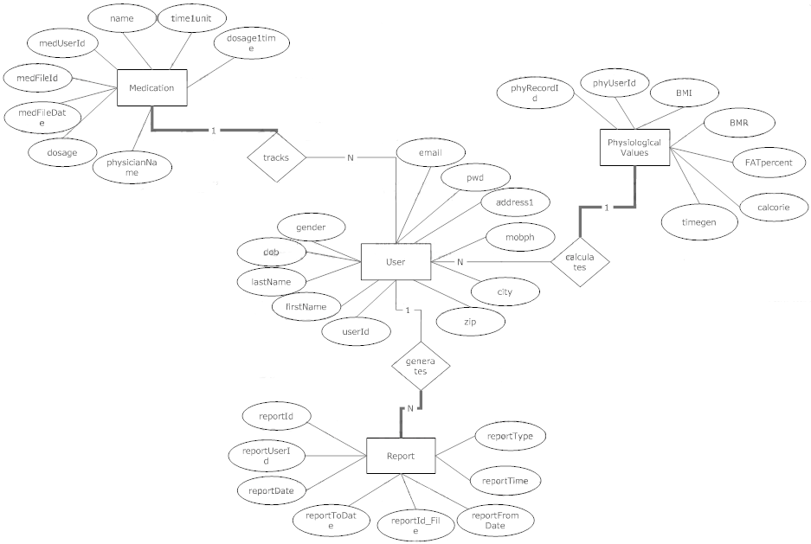

Relational Schema

Relational Schema for Healthy Choices:

bmi_percentile
gender | age | P3 | P5 | P10 | P25
P50 | P75 | P85 | P90
country
countryid | name | lang
diet_record
Ddate | Dtime | imageId | calorie | userId | id
district
districtid | stateid | name
exercise
exerciseID | activity_1hr | firstlb | secondlb | thirdlb | fourthlb
exerciseCatID
exercisecat
exerciseCatID | name
frc_case
id | studentId | userName | status | entryDate | caseLog
info
infoID | userID | height | heightUnit | weight | weightUnit
lungproblem1 | date | heartrate | htmonth | htday | htyear
bpsystolic | bpdiastolic | respiratoryrate | sleepproblem | wtmonth | wtday
wtyear | cholestrol | enoguhwater | fat | fatunit | ftdate
bphour | bpmin | hrhour | hrmin | bodytemp | btmonth
measureDate | bornMonth | bornYear | age | glucose | asthama
lkup_grade
id | name | description
lkup_school
id | name | description | orientation
mydiary
id | userID | comments | date
nutritionabbrev
NDB_No | Shrt_Desc | Water | Energ_Kcal | Protein | Lipid_Tol
Ash | Carbohydrt | Fiber_TD | Sugar_Tot | Calcium | Iron
Potassium | Sodium | Zinc | Copper | Maganese | Selenium
Vit_C | Thiamin | Riboflavin | Niacin | Panto_Acid | Magnesium
nutritiondv
nutDVID | Nutrient | Unit of Measure | Daily Values
nutritionfdgroup
FdGrp_CD | FdGrp_Desc
nutritionfooddesc
NDB_No | FdGrp_Cd | Long_Desc | Shrt_Desc | ComName | Survey
ManufacName | Ref_Desc | Refuse | SciName | N_Factor
nutritionsuggestion
nutritionSuggID | macronutrient | ageGroup | level | suggestion | multiplier
Fat_Factor | CHO_Factor
physicaldata
physicalIDataID | physicalIDataCatID | exeName | MET
physicaldatacat
physicalDataCatID | catName
role
roleid | name
school
schoolid | districtid | name | address1 | address2 | city
zipcode | website
state
stateid | countryid | name
student
id | lastName | firstName | middleName | dob | address
city | state | zip | phone | phoneChoice
gradeId | class | ethinicity | gpa | score1 | score2
scoreType1 | scoreType2 | numOfSib | contactLast | contactFirst
healthInsurance | livingSituation | studentCode | gender | langInHome | isReferred
refId | entryDate
sys_email
sys_msg_id | id | type | msg_to | msg_cc | msg_bcc
msg_subj | msg_body | time_sent | sent
teacher
id | studentId | firstName | lastName | phone | email
schoolId | schoolDistrict
test
id | studentId | testName | testDate | vo2 | 20pacer
15pacer | oneMileMin | oneMileSec | walkTest | height
weight | weightChoice | bmi | fat | glucose | asthma
trunkLift | flexed | curlUp | pushUp | pullUp
stretch | backSaver | aerobics | intensity | flexibility | skin
activityData | fitnessScore | activityLog | cholestrol
user
userid | roleid | schoolid | title | fname | lname
middle | id | email | password
userappointment
userAppID | userID | appDate | appTime | appReason | appLocation
appSpecDiv | appPhysician | appRemHrs | appPhn
userexe
userExeID | userID | physicalDataID | MET | Energ_Kcal | minutes
date
userexercise
userexeID | exerciseID | activity_1hr | firstlb | secondlb | thirdlb
userhc
userID | firstName | lastName | gender | email | password
height | heightUnit | weight | weightUnit | hearrate
bpdiastolic | respiratoryrate | hrday | hrmonth | hryear | bpday
bpmonth | bpyear | rrday | title | btime
age | bmiAbove85 | genominKnown | glucose | lungproblem1 | asthma
lungproblem2 | enoughwater | liverproblem
userinfo
userid | gender | dob | grade | ethinicity | race
address1 | address2 | city | state | countryid | zipcode
homeph | mobileph | alt_email | phonechoice1 | phonechoice2 | website
userintake
userIntakeID | userID | NDB_No | Water | Energ_Kcal | Lipid_Tot
weigth | Shrt_Desc | Sugar_Tot | Protein | Carbo | Fiber_TD
Calcium | Iron | Magnesium | Phosphorous | Potassium | Sodium
Zinc | Copper | Manganese | Selenium | Vit_C | Thiamin
Riboflavin | Niacin | Vit_B6 | Folate_Tot | Vit_B12 | date
users
id | userName | role | password | firstName | lastName
userschool
userid | school_id | jobtitle | workphone | degree | major
year | peteacher | peteacher_other
medication
physicianName | UserId | name | date | dosage | dosage1time
time1unit | dosage2time | time2unit | dosage3time | time3unit
report
userid | reportID | reportId_File | reportType | reportTime | reportToDate
reportFromDate
physiologicalValue
phyRecordId | userid | BMI | BMR | FATpercent | Calorie
heartrate | date | time

Relational Schema for the Mobile Database:

user
userID | firstName | lastName | gender | dob | email
password | address1 | address2 | city | state | country
zip | mobph | height | weightUnit | heightUnit | weight
physiologicalValue
phyRecordId | phyUserid | BMI | BMR | FATpercent | Calorie
heartrate | phyRecdate | timegen
report
reportID | reportUserid | reportId_File | reportType | reportTime | reportToDate
reportFromDate
medication
medFileId | medUserId | name | medFileDate | physicianName | dosage
dosage1time | time1unit | dosage2time | time2unit | dosage3time | time3unit

Test Plan



References

[1] Ati, M.; Omar, W.; Hussain, A., "Knowledge based system framework for managing chronic diseases based on service oriented architecture," Information Science and Digital Content Technology (ICIDT), 2012 8th International Conference on , vol.1, no., pp.20,23, 26-28 June 2012
[2] Department of Health, New York State, http://www.health.ny.gov/diseases/chronic/
[3] Yach D, Hawkes C, Gould C, Hofman KJ. The Global Burden of Chronic Diseases: Overcoming Impediments to Prevention and Control. JAMA. 2004;291(21):2616-2622. doi:10.1001/jama.291.21.2616.
[4] Home care delivery through the mobile telecommunications platform: the Citizen Health System (CHS) perspective
N.5 Maglaveras, V Koutkias, I Chouvarda, D.G Goulis, A Avramides, D Adamidis, G Louridas, E.A Balas
International journal of medical informatics 18 December 2002 (volume 68 issue 1 Pages 99-111)
[5] Chiarini, Giovanni; Ray, Pradeep; Akter, Shahriar; Masella, Cristina; Ganz, Aura, "mHealth Technologies for Chronic Diseases and Elders: A Systematic Review," Selected Areas in Communications, IEEE Journal on , vol.31, no.9, pp.6,18, September 2013
[6] Steinhubl SR, Muse ED, Topol EJ. Can Mobile Health Technologies Transform Health Care?. JAMA. 2013;310(22):2395-2396. doi:10.1001/jama.2013.281078.
[7] Istepanian, Robert; Laxminarayan, Swamy; Pattichis, Constantinos S., M-Health: Emerging Mobile Health Systems, Edited by R. Istepanian, S. Laxminarayan, and C. S. Pattichis. 2006 XXX, 624 p. 182 illus. 0-387-26558-9. Berlin: Springer, 2006.
[8] Deborah Estrin1 and Ida Sim, Open mHealth Architecture: An Engine for Health Care Innovation, www.sciencemag.org, SCIENCE VOL 330 5 NOVEMBER 2010, Published by AAAS
[9] Istepanian, R.S.H.; Jovanov, E.; Zhang, Y.T., "Guest Editorial Introduction to the Special Section on M-Health: Beyond Seamless Mobility and Global Wireless Health-Care Connectivity," Information Technology in Biomedicine, IEEE Transactions on , vol.8, no.4, pp.405,414, Dec. 2004. doi: 10.1109/TITB.2004.840019
[10] Apple Press Info, App Store Sales Top $10 Billion in 2013, https://www.apple.com/pr/library/2014/01/07App-Store-Sales-Top-10-Billion-in-2013.html

Section added as test for GitHub --- Raghav

Section Added by Nayonika

Section added again by raghav

