LAB 7

Leetcodes

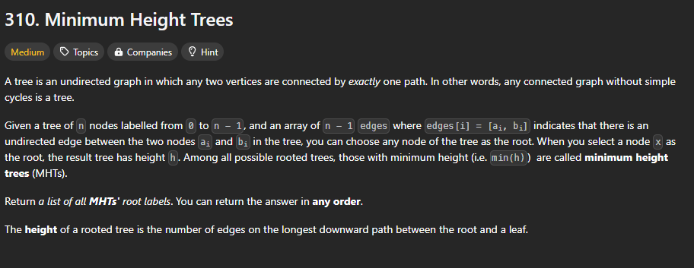

#include <stdlib.h>

#define MAX_N 20000

int* findMinHeightTrees(int n, int** edges, int edgesSize, int* edgesColSize, int* returnSize) {

    if (n == 1) {

        int* res = (int*)malloc(sizeof(int));

        res[0] = 0;

        *returnSize = 1;

        return res;

    }

    int* graph[MAX_N];

    int graphSize[MAX_N] = {0};

    int degree[MAX_N] = {0};

    for (int i = 0; i < n; i++) {

        graph[i] = (int*)malloc(sizeof(int) * MAX_N);

    }

    for (int i = 0; i < edgesSize; i++) {

        int u = edges[i][0];

        int v = edges[i][1];

        graph[u][graphSize[u]++] = v;

        graph[v][graphSize[v]++] = u;

        degree[u]++;

        degree[v]++;

    }

    int* leaves = (int*)malloc(sizeof(int) * n);

    int front = 0, back = 0;

    for (int i = 0; i < n; i++) {

        if (degree[i] == 1) {

            leaves[back++] = i;

        }

    }

    int remainingNodes = n;

    while (remainingNodes > 2) {

        int leavesCount = back - front;

        remainingNodes -= leavesCount;

        for (int i = 0; i < leavesCount; i++) {

            int leaf = leaves[front++];

            for (int j = 0; j < graphSize[leaf]; j++) {

                int neighbor = graph[leaf][j];

                degree[neighbor]--;

                if (degree[neighbor] == 1) {

                    leaves[back++] = neighbor;

                }

            }

        }

    }

    *returnSize = back - front;

    int* result = (int*)malloc(sizeof(int) * (*returnSize));

    for (int i = 0; i < *returnSize; i++) {

        result[i] = leaves[front++];

    }

    for (int i = 0; i < n; i++) {

        free(graph[i]);

    }

    free(leaves);

    return result;

}

**OUTPUT-**

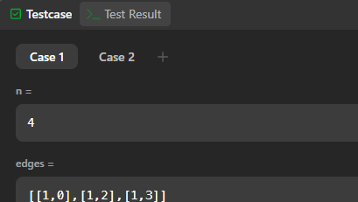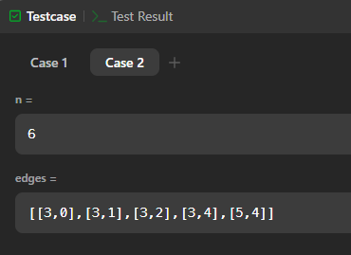

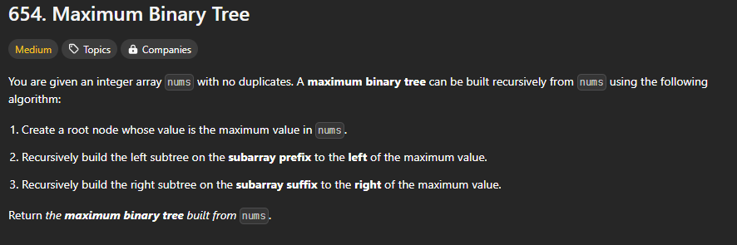

struct TreeNode* constructMaximumBinaryTree(int* nums, int numsSize){

int max = -1, idx = -1;

for (int i = 0; i < numsSize; i++){

if (nums[i] > max){

max = nums[i];

idx = i;

}

}

int size1 = idx;

int size2 = numsSize - idx - 1;

int * pref = nums;

int * suff = nums + idx + 1;

struct TreeNode * root = malloc(sizeof(struct TreeNode));

root->val = max;

if (size1 != 0){

root->left = constructMaximumBinaryTree(pref, size1);

}

else root->left = NULL;

if (size2 != 0){

root->right = constructMaximumBinaryTree(suff, size2);

}

else root->right = NULL;

return root;

}

OUTPUT-

