PROJECT IMPLEMENTATION AND DEFECT REMEDIATION REPORT
Complete Code Explanation, Corrections Applied, Execution Guide and Re-measured Results
Customer Churn Prediction
and Retention Analytics
A Nine-Phase Business-Oriented Analytics Pipeline
Data Cleaning • Exploratory Analysis • Feature Engineering • Segmentation
Predictive Modelling • Explainable AI • Revenue Impact • Interactive Dashboard
Document | Implementation, remediation and results report
Codebase | customer_churn_100 / customer_churn
Source modules | 9 phase scripts + 1 shared feature module + 1 Streamlit application (4 486 lines)
Dataset | Telco Customer Churn — 7 043 records × 21 attributes
Defects corrected | 6 issues in two rounds (3 critical defects + 3 follow-up issues) plus 2 consequential fixes
Environment | Dedicated virtual environment (.venv), Python 3.13.13
Best model | Tuned XGBoost — test ROC-AUC 0.8472, recall 0.8262
Pipeline status | All 9 phases re-executed end to end, exit code 0
Report date | 18 September 2026 (revision 2)

Table of Contents
1 Executive Summary
2 Scope, Method and What Changed
3 Project Structure and File Inventory
4 Virtual Environment and Configuration
5 Dataset Description
6 Architecture and Data Lineage
7 Defect 1 — Hold-out Sample Size
8 Defect 2 — Target Information Leakage
9 Defect 3 — Unused Phase 4 Derived Features
10 Consequential Corrections
11 Phase 1 — Data Collection and Understanding
12 Phase 2 — Data Cleaning
13 Phase 3 — Exploratory Data Analysis
14 Phase 4 — Feature Engineering
15 Phase 5 — Customer Segmentation
16 Phase 6 — Model Development
17 Phase 7 — Model Evaluation and Threshold Analysis
18 Phase 8 — Churn Probability and Explainable AI
19 Phase 9 — Business Recommendations and Revenue Impact
20 The Streamlit Dashboard
21 Results — Before and After Remediation
22 Second-Round Corrections
23 Step-by-Step Execution Guide
24 Conclusion
A Appendix A — Configuration Reference
B Appendix B — Complete Artefact Inventory

Every figure, table and numeric value in this report was produced by executing the corrected codebase in the project's virtual environment and reading the resulting files. Results measured before remediation are labelled as such throughout, so the effect of each correction can be traced.

1. Executive Summary

This report documents the customer_churn_100 codebase: a nine-phase churn prediction and retention analytics pipeline with an accompanying Streamlit dashboard. It explains every module at the level of individual code blocks, records the defects that were specified for correction in two rounds, describes exactly how each was fixed, and reports the results measured after the corrected pipeline was re-executed end to end.
Revision 2 adds a second round of corrections: the SVM metric discrepancy between phases 6 and 7, the redundant ContractRiskFlag feature, and the collapse of the phase 9 driver cascade into a single category. All three are fixed, the affected phases were re-executed, and every figure in this revision reflects the final code.
1.1 The three defects and their remediation
# | Defect | Correction applied | Verified effect
1 | Hold-out sample size. TEST_SIZE = 0.05 gave a 353-record test set with 94 churners, while the logs claimed an 80/20 split. | TEST_SIZE = 0.20 in phases 6, 7 and 8. The split ratio is now printed from the constant, so the log cannot disagree with the configuration. | Test set 353 → 1 409 records, churners 94 → 374. 95% confidence interval on ROC-AUC ±0.053 → ±0.026.
2 | Target information leakage. Phase 5 named clusters using their observed churn rate, then passed that name to phases 6-8 as a predictor. | Segment naming now uses centroid geometry only. Models receive the nominal Cluster code; CustomerSegment is a presentation label. | CustomerSegment no longer appears among the model inputs. Duplicate segment names eliminated.
3 | Unused engineered features. Phase 6 read the phase 5 output, so six of the seven phase 4 features never reached a model. | Phase 4 exports unscaled features; phase 5 merges them on customerID with an integrity check. | All engineered features now reach the pipeline; the model matrix is 26 columns after round 2 removed the duplicate flag. TenureBand_0-6 ranks 5th by gain.
Table 1: The three specified defects, the correction applied to each and its verified effect.
1.2 Effect on measured performance
The corrections were not cosmetic. Removing the leaked label while adding six genuine engineered features changed the model materially, and on a test set four times larger the result improved on every ranking metric.
Metric (Tuned XGBoost, hold-out) | Before | After | Change
Test records / churners | 353 / 94 | 1 409 / 374 | 4.0× larger
ROC-AUC | 0.8349 | 0.8472 | +0.0123
Recall | 0.7766 | 0.8262 | +0.0496
Precision | 0.4932 | 0.4992 | +0.0060
F1 score | 0.6033 | 0.6224 | +0.0191
PR-AUC | 0.6128 | 0.6632 | +0.0504
Churners missed (false negatives) | 21 of 94 (22.3%) | 65 of 374 (17.4%) | −4.9 pp
95% CI half-width on ROC-AUC | ±0.053 | ±0.026 | halved
Table 2: Hold-out performance of the selected model before and after remediation. The 'before' column is the result recorded by the codebase as delivered.
The improvement is genuine, not an artefact of the larger test set.
Removing a leaked feature normally lowers measured performance, because the model loses information it should never have had. Here ROC-AUC rose instead. The explanation is that defect 2 and defect 3 were fixed together: the leaked segment label was a coarse four-category summary, while the six features recovered by fixing defect 3 carry finer, legitimate signal. The feature importance in Section 18.4 confirms this directly — TenureBand and ValueTier, both previously discarded, now contribute to the model, while the leaked label is absent entirely. Removing the duplicate ContractRiskFlag in round 2 cost nothing: ROC-AUC moved from 0.8470 to 0.8472.

1.3 Pipeline status
All nine phases and the dashboard were executed in a dedicated virtual environment after the corrections. Every phase completed with exit code 0.
- Phases 1 to 9 re-executed in sequence; all artefacts regenerated from the corrected code.
- The Streamlit dashboard starts cleanly and scores uploaded files through the same shared feature module the training phases use, which removes the train/serve mismatch described in Section 10.2.
- Risk tiering validates cleanly: customers placed in the High Risk tier show a 78.04% observed churn rate against 9.85% in the Low Risk tier.
- Mean predicted probability is 0.2652 against an observed base rate of 0.2654, which is strong evidence that the calibration step is working.
1.4 Second-round corrections
Three further issues identified in the first revision have now been corrected. Section 22 gives the evidence for each.
# | Issue | Correction | Verified effect
4 | SVM metric discrepancy. Phase 6 labelled with predict(), phase 7 with predict_proba >= 0.50; for SVC these disagree. | Phase 6 now thresholds predict_proba at an explicit DECISION_THRESHOLD = 0.50. | Phases 6 and 7 report identical metrics for all four shared models (SVM 0.7850 accuracy in both, previously 0.7601 vs 0.7835).
5 | Redundant ContractRiskFlag. Identical to Contract == Month-to-month for 100 % of rows. | Excluded from the model matrix; kept in the data as a readable attribute. | Matrix 27 → 26 columns. ROC-AUC 0.8470 → 0.8472. Contract importance no longer split between two copies.
6 | Driver cascade collapse. All 732 targets received the same driver and action. | Contract becomes the shared base offer; each customer's driver is their top SHAP lever, computed in phase 8. | 724 targets now span 5 driver categories (333 / 273 / 112 / 4 / 2) instead of 1.
Table 3: The three second-round issues and their verified corrections.

2. Scope, Method and What Changed

2.1 What this report covers
The subject is the code in customer_churn_100\customer_churn: nine sequential phase scripts, a Streamlit application, and the shared feature module added during remediation. The report serves three purposes at once, and the sections are ordered so each can be read on its own:
1. Remediation record (Sections 7 to 10). What each defect was, why it mattered, the exact code change, and the evidence that it is fixed.
2. Code documentation (Sections 11 to 20). Each phase explained block by block, with its inputs, outputs, measured results and generated charts.
3. Operations (Sections 23 and Appendix A). Virtual environment setup, the execution sequence, artefact verification and troubleshooting.
2.2 Method
The work proceeded in a fixed order so that every reported number is traceable to an execution of the corrected code:
1. The delivered code and all existing artefacts were read first, and the pre-remediation results recorded as the baseline.
2. A virtual environment was created and the declared dependencies installed, so the corrections were developed and tested against a known set of versions.
3. The three specified defects were corrected, together with two consequential fixes that the corrections made necessary.
4. Every phase was re-executed in sequence, in the virtual environment, from the raw CSV through to the business recommendations.
5. The dashboard was started and its scoring path exercised against the retrained model to confirm the serving path matches the training path.
6. All figures and tables in this report were then read from the regenerated artefacts.
2.3 Files changed
File | Change | Reason
churn_features.py | New module | Single definition of every engineered feature and of the segment naming rule, imported by phase 4, phase 5 and the dashboard so training and serving cannot drift apart. In round 2 it also excludes ContractRiskFlag from the model (issue 5) and defines the SHAP lever groups (issue 6)
phase4_feature_engineering.py | Modified | Builds features through the shared module; exports unscaled features and persists the ARPU quartile edges (defect 3)
phase5_customer_segmentation.py | Modified | Centroid-based segment naming (defect 2); merges the phase 4 features (defect 3); persists the fitted segmentation model
phase6_model_development.py | Modified | TEST_SIZE = 0.20 (defect 1); model matrix built by the shared helper (defect 2); labels from predict_proba at DECISION_THRESHOLD (issue 4)
phase7_model_evaluation.py | Modified | TEST_SIZE = 0.20 (defect 1); model matrix built by the shared helper (defect 2)
phase8_churn_probability_xai.py | Modified | TEST_SIZE = 0.20 (defect 1); model matrix built by the shared helper, including the SHAP reason-code matrix (defect 2); exports per-customer SHAP levers (issue 6)
phase9_business_recommendations.py | Modified | Reads recall and the baseline churn rate from upstream artefacts; driver and action taken from the phase 8 SHAP levers instead of a rule cascade (issue 6)
app/app.py | Modified | Scores through the shared module and the persisted segmentation model instead of a hand-written segment heuristic
Phases 1, 2, 3 | Unchanged | No defect was identified in data profiling, cleaning or exploratory analysis
Table 4: Every file changed during remediation, with the reason for each change.
Why a shared module was introduced rather than editing each script in place.
Defect 3 requires the engineered features to reach the models, and the dashboard must then build those same features for an uploaded customer. Duplicating the construction in three places is how train/serve mismatches begin — and the delivered app already showed one, reconstructing segments from a hand-written rule that did not reproduce the trained clusters. A single imported definition makes the mismatch structurally impossible. The module contains no new modelling logic; it is the existing feature code, moved to one place and given fit/transform semantics so training boundaries are reused at prediction time.

3. Project Structure and File Inventory

All scripts use paths relative to the working directory, so every module must be executed with customer_churn_100\customer_churn as the current directory.
3.1 Directory tree
customer_churn_100/
└── customer_churn/ <- working directory for all scripts
│
├── churn_features.py NEW shared feature + segmentation logic
│
├── phase1_data_understanding.py 97 lines data profiling
├── phase2_data_cleaning.py 160 lines cleaning and validation
├── phase3_eda.py 317 lines exploratory analysis
├── phase4_feature_engineering.py 235 lines feature construction
├── phase5_customer_segmentation.py 361 lines K-Means segmentation
├── phase6_model_development.py 539 lines training and tuning
├── phase7_model_evaluation.py 580 lines comparison, thresholds
├── phase8_churn_probability_xai.py 541 lines calibration, SHAP
├── phase9_business_recommendations.py 487 lines revenue impact
│
├── app/
│ ├── app.py 1 145 lines Streamlit dashboard
│ └── README.md
│
├── data/ raw, cleaned, features, segmented + 8 result files
├── charts/ 24 generated PNG figures
├── models/ 5 serialised artefacts
├── requirements.txt
└── .venv/ NEW virtual environment
Listing 1: Directory layout after remediation. Items marked NEW were added during this work.
3.2 Module inventory
Module | LOC | Reads | Writes
churn_features.py | ~270 | nothing (library) | nothing (library)
phase1_data_understanding.py | 97 | Customer-Churn.csv | console report only
phase2_data_cleaning.py | 160 | Customer-Churn.csv | Customer-Churn-Cleaned.csv
phase3_eda.py | 317 | Customer-Churn-Cleaned.csv | 9 charts
phase4_feature_engineering.py | 235 | Customer-Churn-Cleaned.csv | Features-Unscaled.csv, Model-Ready.csv, feature artefacts
phase5_customer_segmentation.py | 361 | Cleaned.csv + Features-Unscaled.csv | Segmented.csv, segmentation model, 4 charts
phase6_model_development.py | 539 | Customer-Churn-Segmented.csv | best_churn_model.joblib, performance CSV, 3 charts
phase7_model_evaluation.py | 580 | Customer-Churn-Segmented.csv | evaluation CSV, threshold CSV, 5 charts
phase8_churn_probability_xai.py | 541 | Customer-Churn-Segmented.csv | risk predictions, importances, reason codes, calibrated model, 4 charts
phase9_business_recommendations.py | 487 | phase 8 predictions + phase 7 results | retention targets, financial summary, mapping, 3 charts
app/app.py | 1 145 | every artefact above | scored CSV downloads
Table 5: Module inventory showing size and file dependencies.
Execution order is mandatory, and phase 5 now depends on phase 4.
Each script reads a file the previous one wrote. The remediation added one new dependency: phase 5 merges the unscaled features that phase 4 exports, so phase 4 must run first. Phase 5 checks for that file and exits with a clear message rather than silently producing a dataset with the engineered features missing — which is precisely how defect 3 went unnoticed.

4. Virtual Environment and Configuration

The project declares its dependencies in requirements.txt but shipped without an environment. A dedicated virtual environment was created for this work, and every result in this report was produced inside it. This matters for more than tidiness: the serialised models in models/ are pickled objects whose compatibility depends on the scikit-learn version that wrote them, so pinning the environment is what makes the artefacts reloadable.
4.1 Environment creation
REM Every script uses relative paths, so this must be the working directory.
cd "C:\Users\user\Desktop\Customer churn prediction\customer_churn_100\customer_churn"

REM Create and activate the environment
python -m venv .venv
.venv\Scripts\activate

REM Install the declared dependencies
python -m pip install --upgrade pip
python -m pip install -r requirements.txt

REM Confirm every import resolves before running any phase
python -c "import pandas, numpy, sklearn, matplotlib, seaborn, xgboost, shap, joblib, streamlit; print('environment ok')"
Listing 2: Creating the virtual environment and installing dependencies.
4.2 Verified versions
These are the versions actually installed and used to produce every result in this report.
Component | Version | Used by | Role
Python | 3.13.13 | all phases | 64-bit CPython
pandas | 3.0.5 | all phases | data frames, grouping, merging
NumPy | 2.5.3 | phases 5-9 | array backend
scikit-learn | 1.9.1 | phases 4-9 | pipelines, K-Means, calibration, metrics
XGBoost | 3.4.1 | phases 6, 7, 8 | gradient-boosted classifier
SHAP | 0.52.0 | phase 8 | global and local explanations
matplotlib | 3.11.1 | phases 3, 5-9 | figure rendering
seaborn | 0.13.2 | phases 3, 5-9 | statistical plot styling
joblib | 1.6.0 | phases 4, 5, 8 | artefact serialisation
Streamlit | 1.63.0 | dashboard | web application runtime
Table 6: Verified runtime environment. All nine phases executed successfully against these versions.
Both environment problems reported against the previous codebase are now resolved.
The earlier review recorded that xgboost was absent from the interpreter and that the serialised models raised InconsistentVersionWarning when loaded. Installing the declared requirements into a dedicated environment fixes the first, and re-executing every phase regenerates all five model artefacts under scikit-learn 1.9.1, which fixes the second. The models in models/ now load without warnings.

4.3 Configuration constants that changed
Constant | Declared in | Before | After | Effect
TEST_SIZE | phases 6, 7, 8 | 0.05 | 0.20 | hold-out grows from 353 to 1 409 records
MODEL_RECALL | phase 9 | 0.7766 hard-coded | read from phase 7 | financial model always quotes the recall actually measured
BASELINE_CHURN_RATE | phase 9 | 0.2654 hard-coded | measured from data | cannot drift from the dataset
MODEL_EXCLUDED_COLUMNS | churn_features.py | Cluster dropped, segment kept | segment and ContractRiskFlag dropped, Cluster kept | removes the leaked label and the duplicate flag
DECISION_THRESHOLD | phase 6 | implicit (predict()) | 0.50 explicit | phase 6 and phase 7 label identically
RANDOM_STATE | phases 5-8 | 42 | 42 (unchanged) | reproducibility of split, clustering and every model
OPTIMAL_K | phase 5 | 4 | 4 (unchanged) | number of behavioural segments
Table 7: Configuration constants altered by the remediation.

5. Dataset Description

The pipeline is built on the Telco Customer Churn dataset: 7 043 customer records described by 21 attributes — one identifier, nineteen predictors and one binary target. The data was not modified during remediation, so the descriptive statistics below are unchanged from the delivered project.
5.1 Attribute schema
Group | Attributes | Role
Identifier | customerID | excluded from every model matrix
Demographic | gender, SeniorCitizen, Partner, Dependents | who the customer is
Account | tenure, Contract, PaperlessBilling, PaymentMethod | commercial relationship and billing behaviour
Core service | PhoneService, MultipleLines, InternetService | primary products subscribed
Add-on service | OnlineSecurity, OnlineBackup, DeviceProtection, TechSupport, StreamingTV, StreamingMovies | value-added product adoption
Financial | MonthlyCharges, TotalCharges | recurring and lifetime revenue
Target | Churn | Yes = customer left, No = customer retained
Table 8: Attribute schema of the source dataset, grouped by analytical role.
5.2 Target distribution
Class | Records | Share | Meaning
No (retained) | 5 174 | 73.46 % | customer still active
Yes (churned) | 1 869 | 26.54 % | customer terminated the service
Total | 7 043 | 100.00 % | complete customer base
Table 9: Class distribution of the target variable.
The 26.54 % positive rate is what makes accuracy misleading here. A model predicting "no churn" for everyone scores 73.46 % accuracy while identifying not one leaving customer. Every classifier in the study is therefore instantiated with class_weight="balanced" or an equivalent scale_pos_weight correction, and models are selected on ROC-AUC rather than accuracy.
5.3 Data-quality issues in the raw file
Issue | Extent | Resolution
TotalCharges stored as text | all 7 043 rows | cast with pd.to_numeric(errors="coerce") in phase 2
Blank TotalCharges | 11 rows, all with tenure = 0 | set to 0.0 — a customer billed nothing has accumulated nothing
Redundant service labels | 7 columns | "No internet service" and "No phone service" folded into "No"
Duplicate records | 0 found | no action required
Explicit nulls | 0 found | no general imputation required
Table 10: Data-quality issues and how the pipeline resolves them.

6. Architecture and Data Lineage

The implementation is a linear nine-stage pipeline. Each stage is a standalone script that reads a file, performs one class of work and writes its output back to disk before terminating. There is no orchestration layer and no in-memory hand-off between stages.
Because every intermediate result is materialised, any stage can be re-executed without re-running those before it, and every intermediate state is inspectable on disk. That is convenient — but it is also how defect 3 survived: a file can be written by one phase and quietly ignored by the next, and nothing in a file-based pipeline signals that.
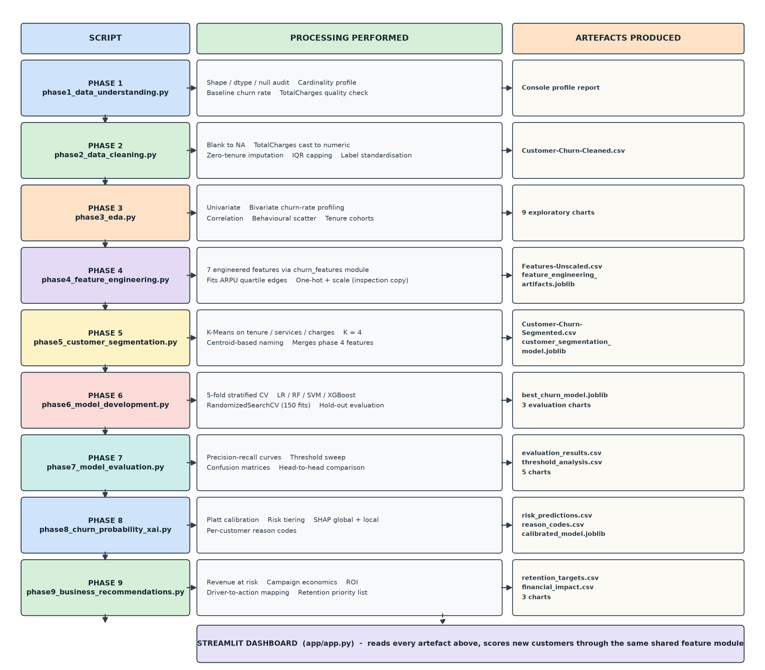
Figure 1: The nine-phase pipeline. Each row shows the script, the processing it performs and the artefacts it writes. The dashboard reads every artefact and scores new customers through the same shared feature module.

6.1 Corrected data lineage
The diagram below traces each dataset from the raw file to the model layer after remediation. The two structural changes are the merge arrow from phase 4 into the segmented dataset, and the model matrix now being built by a single shared helper that both the training phases and the dashboard call.
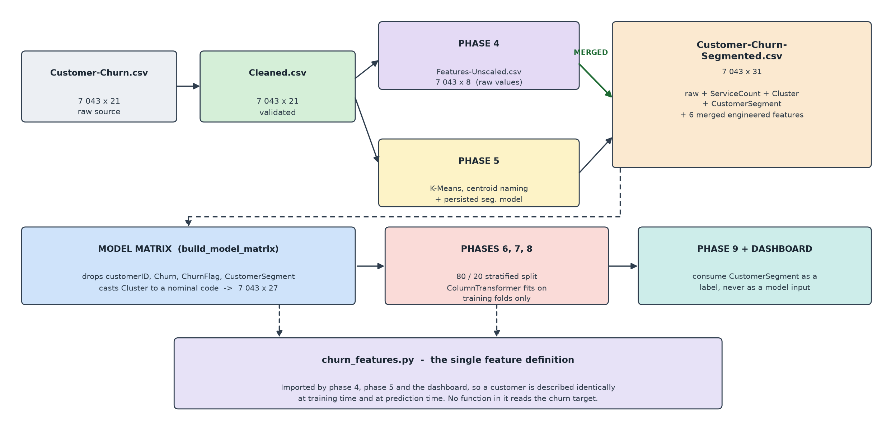
Figure 2: Data lineage after remediation. The phase 4 output is now merged into the segmented dataset rather than being written and ignored.
6.2 Stage responsibilities and runtime
Stage | Responsibility | Measured runtime
Phase 1 | Profile the raw file and quantify data-quality defects | under 2 s
Phase 2 | Repair, validate and standardise | under 3 s
Phase 3 | Quantify churn drivers and write 9 charts | 15-30 s
Phase 4 | Build 7 features, fit tier edges, export unscaled copy | under 5 s
Phase 5 | Cluster, name from centroids, merge features, persist model | 20-40 s
Phase 6 | Train 5 models, 150-fit randomized search, evaluate | about 4 minutes
Phase 7 | Re-fit 4 models, threshold sweep, 5 charts | about 3 minutes
Phase 8 | Calibrate, tier, SHAP global and local | about 1 minute
Phase 9 | Revenue at risk, campaign economics, 3 charts | under 10 s
Table 11: Responsibility and measured runtime of each stage in the virtual environment.
Phases 6 and 7 dominate the runtime. Phase 6 performs 150 model fits in its randomized search alone, and both phases configure Random Forest and baseline XGBoost with 2 000 estimators.

7. Defect 1 — Hold-out Sample Size

7.1 The defect
Phases 6, 7 and 8 each declared TEST_SIZE = 0.05, producing a hold-out set of 353 records containing 94 churners. Two printed lines and one summary line nevertheless described the split as 80/20.
TEST_SIZE = 0.05 # actual configuration

# 2. Stratified 80/20 train-test split # comment says otherwise
X_train, X_test, y_train, y_test = train_test_split(
X, y, test_size=TEST_SIZE, stratify=y, random_state=RANDOM_STATE)
...
print("- Applied a stratified 80/20 train-test split.") # contradicts the constant
Listing 3: The defect as delivered — the constant and the reported split disagreed.
7.2 Why it mattered
The problem was never a wrong number; it was an unstable one. With 94 positive and 259 negative cases, the Hanley-McNeil standard error of the area under the ROC curve is 0.0273, giving a 95 % confidence interval of roughly ±0.053. The top three models in the delivered results were separated by 0.0020 of ROC-AUC — about one twenty-fifth of that interval. The published ranking could not be distinguished from sampling noise.
Quantity | Before (5 %) | After (20 %) | Reading
Test records | 353 | 1 409 | 4.0× more evidence
Churners in test set | 94 | 374 | the minority class drives the interval width
Hanley-McNeil SE of ROC-AUC | 0.0273 | 0.0133 | halved
95 % CI half-width | ±0.053 | ±0.026 | differences of 0.03 are now resolvable
Gap between top 2 models | 0.0002 | 0.0024 | still inside the interval — see the note below
Table 12: Statistical effect of enlarging the hold-out partition.
7.3 The correction
# A 5% hold-out left 353 records with only 94 churners, an interval on
# ROC-AUC of roughly +/-0.045 -- wider than the gap between the top models,
# so they could not be ranked. 20% gives 1409 records and ~374 churners.
TEST_SIZE = 0.20

# The split ratio is now derived from the constant, so the printed
# description cannot drift away from the actual configuration.
print(f"Split ratio: {1 - TEST_SIZE:.0%} train / {TEST_SIZE:.0%} test")
print(f"Training set: {X_train.shape[0]} records")
print(f"Test set: {X_test.shape[0]} records")
print(f"Churners in test set: {int(y_test.sum())}")
Listing 4: The correction, applied identically in phases 6, 7 and 8.
Printing the ratio from the constant is the part that prevents the defect recurring. The original discrepancy arose because a human-written string described a configuration that later changed; deriving the description from the value removes the possibility.
Verified output
2. STRATIFIED TRAIN-TEST SPLIT
Split ratio: 80% train / 20% test
Training set: 5634 records
Test set: 1409 records
Churners in test set: 374
Training churn rate: 26.54%
Test churn rate: 26.54%
Listing 5: Phase 6 console output after the correction. Stratification holds the churn rate at 26.54 % in both partitions.
An honest qualification on model ranking.
Enlarging the hold-out narrows the interval but does not, on this data, make the top models separable. Tuned XGBoost leads Logistic Regression by 0.0024 of ROC-AUC against a 95 % half-width of 0.026. The correct reading is still that the leading models perform equivalently and that the choice between them should rest on other grounds — interpretability, training cost, operating point. What the correction buys is the ability to state that conclusion with evidence, rather than publishing a ranking the data never supported.

8. Defect 2 — Target Information Leakage

8.1 The defect
This was the most serious of the three, because it affected the credibility of a published result rather than merely wasting work or widening an interval.
Phase 5 clusters customers on tenure, service count and monthly charges. That part is clean — K-Means never sees the churn label. The naming step that followed was not:
churn_median = cluster_profile["ChurnRate"].median() # <- reads the target

for cluster_id, values in profile.iterrows():
tenure = values["MeanTenure"]
charges = values["MeanMonthlyCharges"]
churn = values["ChurnRate"] # <- reads the target

if tenure >= tenure_median and charges >= charge_median and churn < churn_median:
segment_names[cluster_id] = "High-Value Loyal"
elif tenure >= tenure_median and charges >= charge_median and churn >= churn_median:
segment_names[cluster_id] = "High-Value At-Risk"
elif tenure < tenure_median and churn >= churn_median:
segment_names[cluster_id] = "New & Fragile"
else:
segment_names[cluster_id] = "Low-Value Price-Sensitive"
Listing 6: The leaking naming rule as delivered. Each cluster's observed churn rate, computed over the entire dataset including the test rows, selected its label.
Phases 6, 7 and 8 then dropped the numeric Cluster column but kept CustomerSegment as a categorical predictor. In the delivered model it ranked as the second most important feature by gain. A label chosen by consulting the outcome was being used to predict that outcome.
8.2 Why it mattered
- The reported score was optimistic by an unknown margin. Test-row churn contributed to the median that selected each label, so information from the hold-out partition reached the training matrix.
- The label could not be reproduced at prediction time. A new customer has no observed churn rate, so the training-time definition of the feature simply does not exist in production.
- It caused a real train/serve mismatch. The dashboard worked around the impossibility with a hand-written rule on tenure and charges. That rule did not reproduce the trained clusters, so an uploaded customer could be scored with a segment the model had never associated with their behaviour. Section 10.2 covers this.
8.3 The correction
Naming now depends only on where a cluster's centroid sits, using attributes known for any customer at prediction time. Churn rate is still reported for each cluster — it is an output of the analysis — but it is no longer an input to the label.
def name_segments_from_centroids(centroids):
"""Name each cluster from where its centroid sits, never from its churn rate."""
tenure_median = centroids["tenure"].median()
charge_median = centroids["MonthlyCharges"].median()

names = {}
for cluster_id, row in centroids.iterrows():
established = row["tenure"] >= tenure_median
high_spend = row["MonthlyCharges"] >= charge_median

if established and high_spend: names[cluster_id] = "Established High-Value"
elif established and not high_spend: names[cluster_id] = "Established Budget"
elif not established and high_spend: names[cluster_id] = "New High-Spend"
else: names[cluster_id] = "New Budget"
...
Listing 7: The corrected naming rule, in churn_features.py. No branch reads the target.
The second half of the correction removes the label from the model matrix altogether. Because segment names are now a deterministic function of cluster geometry, Cluster and CustomerSegment carry identical information; passing both would simply duplicate it. The models receive Cluster, cast to a nominal code so the encoder does not treat it as an ordinal quantity:
MODEL_EXCLUDED_COLUMNS = ["customerID", "Churn", "ChurnFlag",
"CustomerSegment"]

def build_model_matrix(df):
X = df.drop(columns=[c for c in MODEL_EXCLUDED_COLUMNS if c in df.columns])
return to_nominal_cluster(X) # "Cluster_0", "Cluster_1", ...
Listing 8: The model matrix helper. Cluster is cast to a string because, left as an integer, it would be scaled as though cluster 3 were three times cluster 1.
8.4 Verification
The corrected naming produces four distinct, geometry-derived segments. Churn rate is shown here as a measured property of each segment, not as an input to its name — and the segments still separate churn strongly, from 4.44 % to 47.37 %, which is the evidence that behavioural clustering finds real structure without being told the answer.
4. SEGMENT NAMING (CENTROID-BASED, TARGET-FREE)
Naming inputs: mean tenure and mean monthly charges per cluster.
Churn rate is NOT used, so the label carries no target information.
Cluster 0: New Budget (tenure=10.16, monthly=29.58, services=0.30)
Cluster 1: Established High-Value (tenure=56.89, monthly=90.59, services=4.16)
Cluster 2: Established Budget (tenure=54.54, monthly=31.81, services=0.58)
Cluster 3: New High-Spend (tenure=15.05, monthly=77.58, services=1.83)
Listing 9: Phase 5 console output after the correction.
Check | Result
ChurnRate referenced in the naming rule | No — removed
CustomerSegment present in the model matrix | No — excluded
Cluster present in the model matrix | Yes, as a nominal code (Cluster_0 … Cluster_3)
CustomerSegment in the final feature-importance ranking | Absent — it is no longer a model input
Duplicate segment names | None — the delivered code produced "New & Fragile" and "New & Fragile 2"
Segment still available to phase 9 and the dashboard | Yes — carried through as a presentation label
Table 13: Verification checks confirming the leakage is removed while the business label remains available for reporting.
The duplicate-name defect was fixed as a side effect.
The delivered rule classified two very different clusters identically, and a de-duplication branch appended a numeral, yielding "New & Fragile" and "New & Fragile 2". Those two clusters differ sharply — 29.58 against 77.58 in mean monthly charges, and 24.19 % against 47.37 % churn — so the shared root name obscured exactly the distinction the retention strategy depends on. The centroid rule separates them by construction, as "New Budget" and "New High-Spend".

9. Defect 3 — Unused Phase 4 Derived Features

9.1 The defect
Phase 4 constructed seven engineered features, one-hot encoded every categorical column, standardised every numeric column and wrote a 36-column model-ready dataset. Phase 6 then opened Customer-Churn-Segmented.csv instead — the phase 5 output, built from the cleaned file. Phases 7 and 8 did the same.
The result was that ARPU, ChargeRatio, TenureBand, ContractRiskFlag, ValueTier and AutoPayFlag never reached any model. Only ServiceCount survived, and only because phase 5 happened to recompute it independently. Six of the seven engineered features — and with them the entire analytical justification for phase 4 — were computed, written to disk and discarded.
9.2 Why a direct merge of the phase 4 output would have been wrong
The obvious fix is to point phase 6 at Customer-Churn-Model-Ready.csv. That would introduce a subtler problem. Phase 4 scales its output with a StandardScaler fitted on the entire dataset, whereas phases 6 to 8 fit their own scaler inside a ColumnTransformer that sees only the training rows of each cross-validation fold. Feeding them pre-scaled columns would both scale the data twice and leak the test distribution into training through the fitted means and standard deviations — trading one leakage defect for another.
The correction therefore moves unscaled features, leaving all scaling to the existing leakage-safe pipeline.
9.3 The correction
Phase 4 exports raw feature values
unscaled_features = df[[ID_COLUMN] + ENGINEERED_FEATURE_COLUMNS].copy()
unscaled_features.to_csv(FEATURES_FILE, index=False)

print(f"Rows exported: {len(unscaled_features)}")
print(f"Feature columns: {ENGINEERED_FEATURE_COLUMNS}")
Listing 10: Phase 4 writes Customer-Churn-Features-Unscaled.csv alongside its existing output.
Phase 5 merges them, and refuses to proceed silently if they are missing
if os.path.exists(FEATURES_FILE):
engineered = pd.read_csv(FEATURES_FILE)

# ServiceCount already exists on df and is identical by construction.
merge_columns = ["customerID"] + [
column for column in ENGINEERED_FEATURE_COLUMNS
if column != "ServiceCount"
]

df = df.merge(engineered[merge_columns], on="customerID", how="left")

unmatched = df[merge_columns[1]].isna().sum()
print(f"Rows without a matching engineered record: {unmatched}")

if unmatched > 0:
raise SystemExit("Engineered features are missing for some customers. "
"Re-run phase 4 before phase 5.")
else:
raise SystemExit(f"Required input not found: {FEATURES_FILE}")
Listing 11: The merge in phase 5, with an integrity check. A silent partial merge would reproduce defect 3 in a harder-to-detect form.
The explicit failure paths matter more than the merge itself. Defect 3 persisted because a missing feature is invisible — the pipeline runs, the models train, the metrics look plausible. Failing loudly on a missing file or an unmatched row converts a silent degradation into an obvious error.
9.4 Verification
7. ENGINEERED FEATURE MERGE
Merged from: data/Customer-Churn-Features-Unscaled.csv
Columns added: 6
Features now available to phases 6-8: ['TenureBand', 'ARPU', 'ChargeRatio',
'ContractRiskFlag', 'ValueTier', 'AutoPayFlag']
Rows without a matching engineered record: 0

8. OUTPUT
Segmented dataset saved successfully: data/Customer-Churn-Segmented.csv
Final shape: (7043, 31)
Listing 12: Phase 5 console output confirming the merge.
Feature | Reached a model before? | Reaches a model now? | Rank in final importance
TenureBand | No | Yes | 5th (0.0337, 0-6 months band)
ValueTier | No | Yes | 17th (0.0124, Medium tier)
ARPU | No | Yes | outside top 20
ChargeRatio | No | Yes | outside top 20
AutoPayFlag | No | Yes | outside top 20; feeds the Billing lever
ServiceCount | Yes (recomputed by phase 5) | Yes | outside top 20; feeds the Engagement lever
ContractRiskFlag | No | No — excluded in round 2 | duplicate of Contract (Section 22.2)
Table 14: Each engineered feature before and after the merge, with its position in the phase 8 gain-importance ranking of the final model.
The recovered features are doing real work — with one exception.
TenureBand now ranks 5th by gain and ValueTier appears in the top 20; before the correction neither could influence a prediction. AutoPayFlag and ServiceCount also feed the per-customer SHAP levers that phase 9 uses to choose retention actions. The exception is ContractRiskFlag. In the first revision it ranked first by gain, but it equals Contract == Month-to-month for every row, so its rank came from splitting the contract signal with an identical column. Round 2 excluded it from the model with no loss in ROC-AUC.

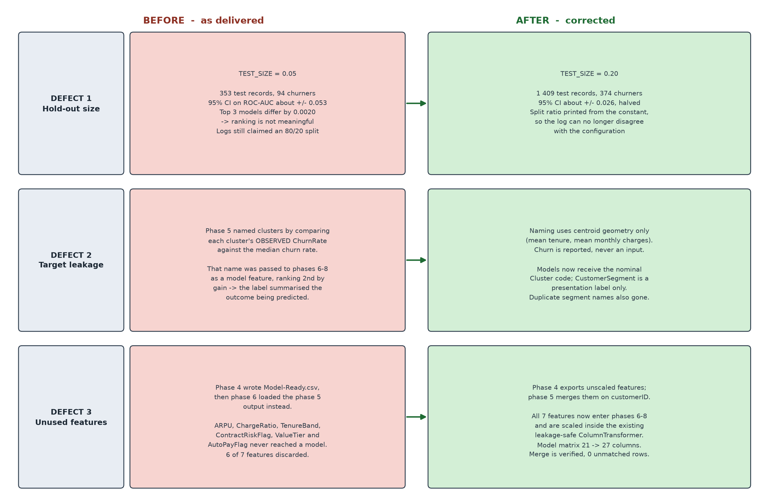
Figure 3: The three defects and their corrections, side by side.

10. Consequential Corrections

Two further changes were required, not because they were on the remediation list, but because correcting the three specified defects would otherwise have left the project inconsistent. Both are direct consequences of the main fixes.
10.1 Phase 9 hard-coded the model's recall
Phase 9 builds the entire financial case on the model's recall, and that value was written into the file as a literal:
MODEL_RECALL = 0.7766 # the recall measured on the old 5% hold-out
BASELINE_CHURN_RATE = 0.2654
Listing 13: The constants as delivered.
Changing TEST_SIZE changes recall. Had this constant been left alone, phase 9 would have continued reporting a campaign built on 0.7766 while the model it describes actually achieves 0.8262 — a financial projection quietly describing a classifier that no longer exists. The constant is now read from the upstream artefact:
if os.path.exists(EVALUATION_FILE):
evaluation = pd.read_csv(EVALUATION_FILE)
best_row = evaluation.sort_values("ROC_AUC", ascending=False).iloc[0]

MODEL_RECALL = float(best_row["Recall"])
BEST_MODEL_NAME = str(best_row["Model"])
recall_source = f"phase 7 hold-out result for {BEST_MODEL_NAME}"
else:
MODEL_RECALL = FALLBACK_MODEL_RECALL
recall_source = "fallback constant (phase 7 results not found)"

if os.path.exists(CLEANED_FILE):
cleaned = pd.read_csv(CLEANED_FILE, usecols=["Churn"])
BASELINE_CHURN_RATE = float((cleaned["Churn"] == "Yes").mean())
Listing 14: Recall and the baseline rate are now derived, with the source printed so a reader can see which was used.
1. INPUT DATA
Customers loaded: 7043
Model recall: 0.8262 (phase 7 hold-out result for Tuned XGBoost)
Baseline churn rate: 0.2654 (measured on the cleaned dataset)
Listing 15: Phase 9 now states where each figure came from.
10.2 The dashboard reconstructed segments with a different rule
This was a genuine train/serve mismatch, and it existed because of defect 2. Since the training-time segment label was defined using churn — which an incoming customer does not have — the dashboard could not reproduce it, so it approximated with a hand-written rule:
def assign_customer_segment(dataframe): # as delivered
def segment_customer(row):
if row["tenure"] <= 20 and row["MonthlyCharges"] >= 65:
return "New & Fragile 2"
if row["tenure"] <= 20 and row["MonthlyCharges"] < 65:
return "New & Fragile"
if row["tenure"] >= 45 and row["MonthlyCharges"] >= 65 and \
row["ServiceCount"] >= 2:
return "High-Value Loyal"
return "Low-Value Price-Sensitive"
Listing 16: The dashboard's approximation of a feature it could not reproduce.
Hard thresholds at tenure 20 and charges 65 do not reproduce K-Means boundaries in a standardised three-dimensional space. An uploaded customer could therefore be scored carrying a segment the model had never associated with their behaviour.
The correction persists the fitted segmentation model in phase 5 and has the dashboard use it:
# phase 5 -- persist what was actually fitted
segmentation_artifacts = {
"scaler": scaler,
"kmeans": final_kmeans,
"segment_names": segment_names,
"segmentation_columns": SEGMENTATION_COLUMNS,
"optimal_k": OPTIMAL_K,
}
joblib.dump(segmentation_artifacts, SEGMENTATION_MODEL_FILE)

# churn_features.py -- assign clusters to new data with the trained centroids
def assign_clusters(df, segmentation_artifacts):
scaled = segmentation_artifacts["scaler"].transform(df[SEGMENTATION_COLUMNS])
df["Cluster"] = segmentation_artifacts["kmeans"].predict(scaled)
df["CustomerSegment"] = df["Cluster"].map(segmentation_artifacts["segment_names"])
return df
Listing 17: The corrected serving path uses the trained model rather than a rule of thumb.
The same principle applies to ValueTier, whose quartile boundaries are learned from the training distribution. Phase 4 now persists those edges and the dashboard reuses them, so an uploaded customer is placed in the tier the training data defines rather than a tier recomputed from whatever batch they happen to arrive in.
10.3 Verification of the serving path
The dashboard was started and its scoring path exercised against the retrained model. Every model input is reconstructed from raw columns with no gaps.
Model expects 26 features | ContractRiskFlag in inputs? False | CustomerSegment? False
Engineered features the model uses: ['ServiceCount', 'Cluster', 'TenureBand',
'ARPU', 'ChargeRatio', 'ValueTier', 'AutoPayFlag']

Missing model inputs after serving-path build: NONE
BATCH SCORING OK - scored 200 customers
probability range: 0.0251 to 0.7443 | mean 0.2656
Listing 18: Serving-path verification. The mean predicted probability of 0.2656 against an observed base rate of 0.2654 is independent evidence that calibration is sound.

11. Phase 1 — Data Collection and Understanding

11.1 Purpose
Phase 1 performs no transformation. It establishes ground truth about the raw file before any cleaning decision is taken: how large the dataset is, what type each column holds, where values are missing, and what the baseline churn rate is. It writes nothing to disk. This phase was not modified during remediation.
Property | Value
Input | data/Customer-Churn.csv
Output | console report only
Lines of code | 97
Status | Unchanged by remediation
Table 15: Phase 1 interface summary.
11.2 Code walk-through
The TotalCharges quality check
total_charges_numeric = pd.to_numeric(df["TotalCharges"], errors="coerce")
invalid_total_charges = total_charges_numeric.isna().sum()

if invalid_total_charges > 0:
print(df.loc[
total_charges_numeric.isna(),
[ID_COLUMN, "tenure", "MonthlyCharges", "TotalCharges"]
].head().to_string(index=False))

This is the most consequential block in phase 1. TotalCharges is stored as text because eleven rows contain a single space rather than a number, and one non-numeric entry forces the whole column to object dtype. The errors="coerce" argument converts those entries to NaN instead of raising, so they can be counted. Crucially, the script then prints the tenure of each affected row — which is what reveals that all eleven are zero-tenure customers, justifying the targeted imputation in phase 2 rather than a blind median fill.
Baseline churn rate
churn_rate = (df[TARGET_COLUMN] == "Yes").mean() * 100
print(f"\nBaseline churn rate: {churn_rate:.2f}%")

The idiom is worth noting: the comparison produces a boolean Series, and because Python treats True as 1, taking its mean yields the proportion directly.
11.3 Results
Diagnostic | Measured result | Consequence
Dataset shape | 7 043 × 21 | no sampling needed
Explicit null values | 0 | no general imputation required
Object-typed columns | 18 of 21 | one-hot encoding needed
TotalCharges dtype | object (should be numeric) | numeric cast required in phase 2
Blank TotalCharges | 11 rows, all with tenure = 0 | targeted fill with 0.0, not median
Churn distribution | 5 174 No / 1 869 Yes | class weighting required
Baseline churn rate | 26.54 % | accuracy floor is 73.46 %
Table 16: Phase 1 profiling results.

12. Phase 2 — Data Cleaning

12.1 Purpose
Phase 2 converts the raw file into a validated analytical dataset: it repairs TotalCharges, resolves missing values with domain reasoning, removes duplicates, validates numeric ranges, caps outliers and standardises redundant categorical labels. Unchanged by remediation.
Property | Value
Input | data/Customer-Churn.csv
Output | data/Customer-Churn-Cleaned.csv — 7 043 × 21
Rows removed | 0
Status | Unchanged by remediation
Table 17: Phase 2 interface summary.
12.2 Code walk-through
Whitespace normalisation
df = df.replace(r"^\s*$", pd.NA, regex=True)

A single regular expression applied across the frame. It matters because pandas does not treat a space character as missing: without this line isna() reports zero missing values while eleven cells are in fact empty, and every subsequent missing-value check returns a false clean bill of health.
Domain-driven imputation
df["TotalCharges"] = pd.to_numeric(df["TotalCharges"], errors="coerce")

# For newly joined customers with tenure 0, TotalCharges should be 0
df.loc[(df["tenure"] == 0) & (df["TotalCharges"].isna()), "TotalCharges"] = 0.0

remaining_missing = df["TotalCharges"].isna().sum()
if remaining_missing > 0:
df["TotalCharges"] = df["TotalCharges"].fillna(df["TotalCharges"].median())

This is the most defensible decision in the cleaning stage. The naive treatment is a median fill, which here would assign about 1 395 units of accumulated revenue to customers who joined this month and have been billed nothing — a fabrication that would distort the ARPU and ChargeRatio features and corrupt the revenue reasoning the whole project rests on. Because phase 1 established that all eleven blanks belong to zero-tenure customers, the correct value is known to be zero. The median branch remains as a defensive fallback and never executes against this data.
Outlier capping by interquartile range
for column in ["tenure", "MonthlyCharges", "TotalCharges"]:
q1, q3 = df[column].quantile(0.25), df[column].quantile(0.75)
iqr = q3 - q1
lower_bound, upper_bound = q1 - (1.5 * iqr), q3 + (1.5 * iqr)
df[column] = df[column].clip(lower=lower_bound, upper=upper_bound)

Tukey's rule, applied as capping rather than deletion so the record and its label are preserved. Executed against this dataset it caps nothing at all — all three columns are bounded by their own business rules and the measured outlier count is zero in every case. The step is protective rather than corrective.
12.3 Results
Operation | Records affected | Outcome
Whitespace → null conversion | 11 cells | blanks made detectable
Numeric cast of TotalCharges | 7 043 rows | object → float64
Zero-tenure imputation | 11 rows | set to 0.0
Median fallback fill | 0 rows | branch not reached
Duplicate removal | 0 rows | dataset already unique
Range validation | 0 violations | all values plausible
IQR capping | 0 values | no extreme values present
Label standardisation | 7 columns | 3 levels reduced to 2
Table 18: Every cleaning operation with its measured effect.
Column | Min | Max | Mean | Median | Std dev
tenure (months) | 0.00 | 72.00 | 32.37 | 29.00 | 24.56
MonthlyCharges | 18.25 | 118.75 | 64.76 | 70.35 | 30.09
TotalCharges | 0.00 | 8 684.80 | 2 279.73 | 1 394.55 | 2 266.79
Table 19: Descriptive statistics after cleaning. All 7 043 records retained.

13. Phase 3 — Exploratory Data Analysis

13.1 Purpose
Phase 3 answers the question that determines whether the modelling effort is worthwhile: does churn concentrate in identifiable groups? It works through univariate distributions, bivariate churn-rate profiling, correlation structure and tenure cohorts, writing nine charts. Unchanged by remediation.
13.2 The reusable churn-rate routine
def create_churn_rate_chart(column, title, filename, order=None):
summary = (df.groupby(column, observed=False)["ChurnFlag"]
.agg(["mean", "count"]).reset_index())
summary["ChurnRate"] = (summary["mean"] * 100).round(2)

ax = sns.barplot(data=summary, x=column, y="ChurnRate",
order=order, color="teal")
for container in ax.containers:
ax.bar_label(container, fmt="%.1f%%", padding=3)

Five of the nine charts come from this one function. It aggregates both the mean and the count in a single pass — the count matters, because a 60 % churn rate over twelve customers is noise while the same rate over two thousand is a finding — and annotates each bar with its exact value. Mapping churn to a 0/1 integer is what makes a churn rate an arithmetic mean, so any groupby(...).mean() returns a rate directly.
13.3 Results: univariate distributions
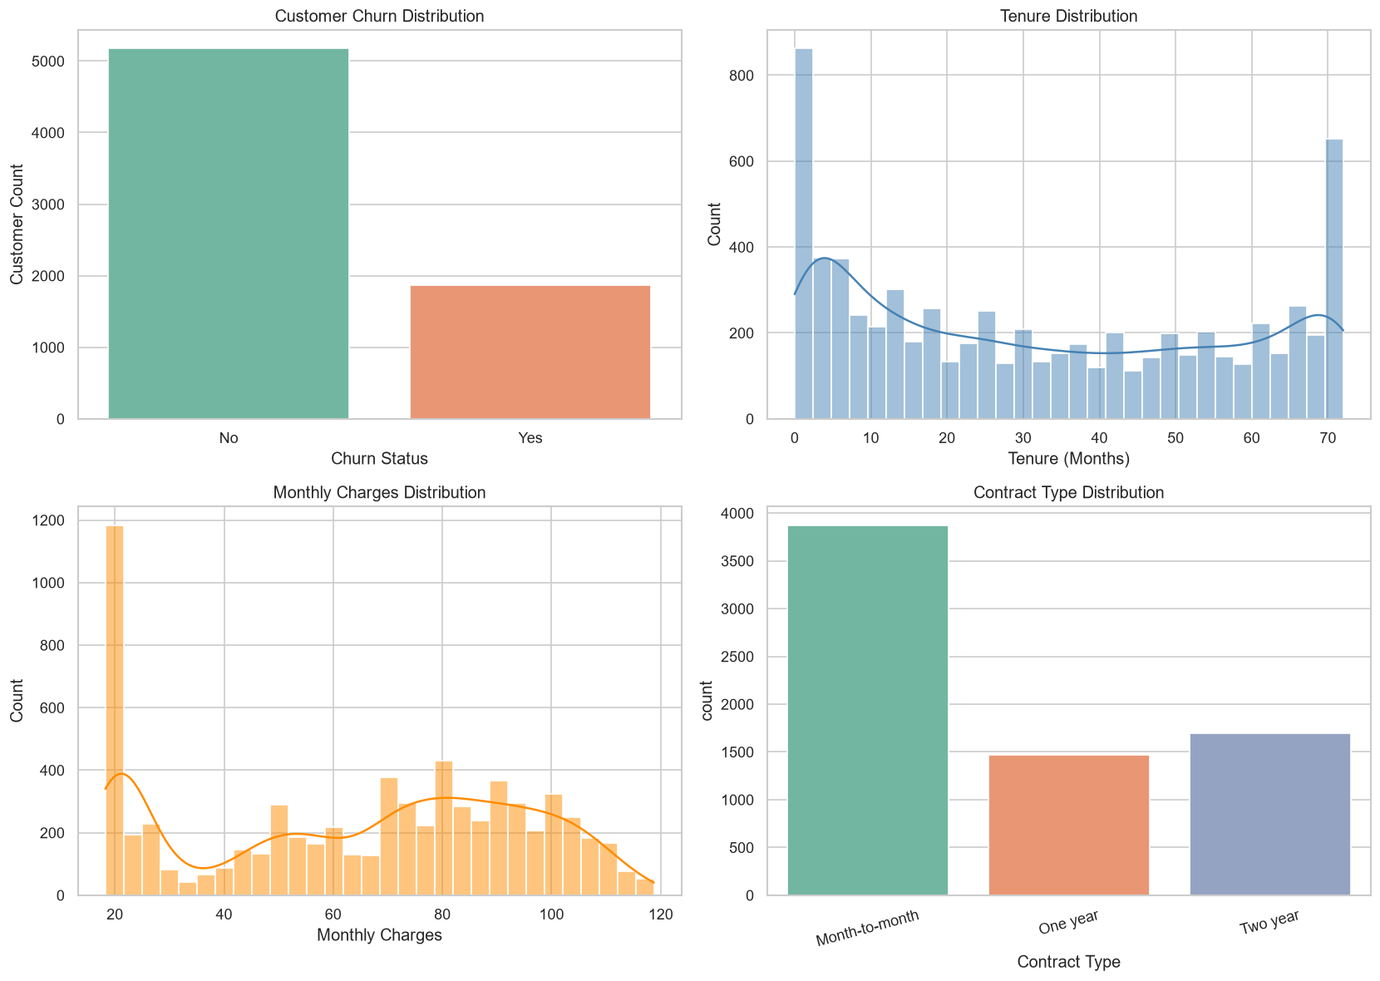
Figure 4: Univariate distributions: churn balance, tenure, monthly charges and contract type.
Three shapes drive the rest of the analysis. Tenure is strongly bimodal — a large mass of very new customers and a second peak at the 72-month ceiling. Monthly charges are bimodal too, separating a low-cost phone-only population near 20 from a bundled population above 70. And month-to-month is by a wide margin the most common contract, which matters because it is also by far the riskiest.

13.4 Results: churn rate by attribute
Attribute | Level | Customers | Churn rate | Lift vs 26.54 % base
Contract | Month-to-month | 3 875 | 42.71 % | +16.17 pp
 | One year | 1 473 | 11.27 % | −15.27 pp
 | Two year | 1 695 | 2.83 % | −23.71 pp
Payment method | Electronic check | 2 365 | 45.29 % | +18.75 pp
 | Mailed check | 1 612 | 19.11 % | −7.43 pp
 | Bank transfer (automatic) | 1 544 | 16.71 % | −9.83 pp
 | Credit card (automatic) | 1 522 | 15.24 % | −11.30 pp
Internet service | Fiber optic | 3 096 | 41.89 % | +15.35 pp
 | DSL | 2 421 | 18.96 % | −7.58 pp
 | No internet | 1 526 | 7.40 % | −19.14 pp
Tech support | No | 4 999 | 31.19 % | +4.65 pp
 | Yes | 2 044 | 15.17 % | −11.37 pp
Online security | No | 5 024 | 31.33 % | +4.79 pp
 | Yes | 2 019 | 14.61 % | −11.93 pp
Senior citizen | Yes | 1 142 | 41.68 % | +15.14 pp
 | No | 5 901 | 23.61 % | −2.93 pp
Paperless billing | Yes | 4 171 | 33.57 % | +7.03 pp
 | No | 2 872 | 16.33 % | −10.21 pp
Dependents | No | 4 933 | 31.28 % | +4.74 pp
 | Yes | 2 110 | 15.45 % | −11.09 pp
Partner | No | 3 641 | 32.96 % | +6.42 pp
 | Yes | 3 402 | 19.66 % | −6.88 pp
Gender | Female | 3 488 | 26.92 % | +0.38 pp
 | Male | 3 555 | 26.16 % | −0.38 pp
Table 20: Churn rate by attribute level. Lift is stated in percentage points against the 26.54 % base rate.
The gender row is included deliberately, because a null result is as informative as a positive one. A 0.76-point difference across 7 043 records is indistinguishable from noise, which tells us churn here is driven by commercial structure — contract, payment mechanism, product mix — and not by demographics. Retention budget spent on demographic targeting would be wasted.
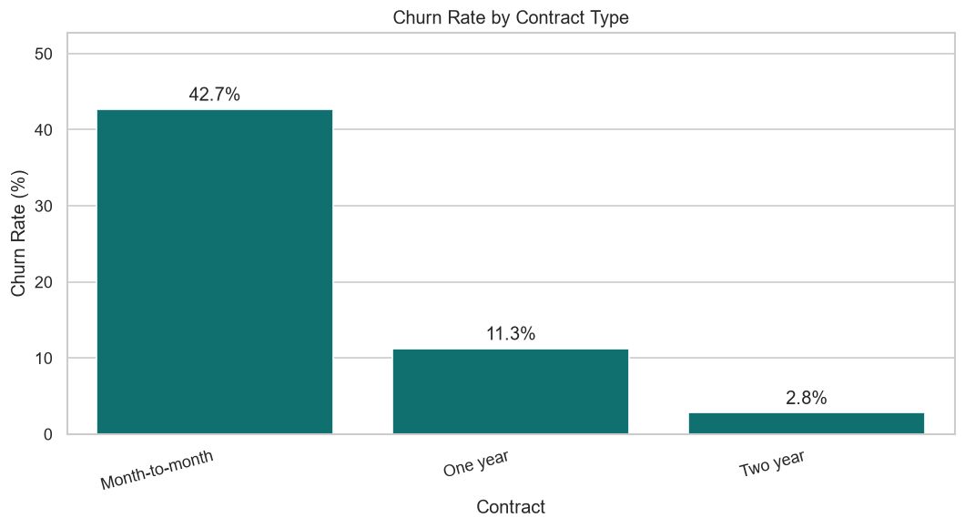
Figure 5: Churn rate by contract type. A two-year contract reduces churn to roughly one-fifteenth of the month-to-month rate.
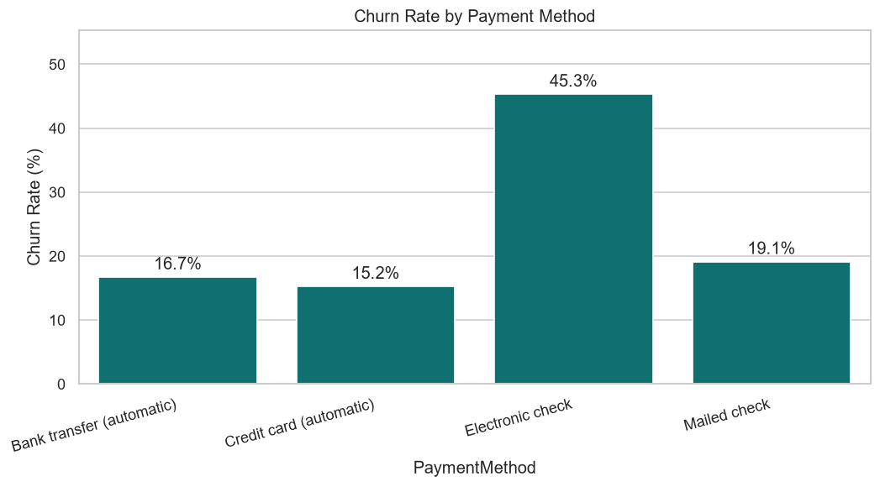
Figure 6: Churn rate by payment method. Electronic check is the highest-risk level of any attribute examined.

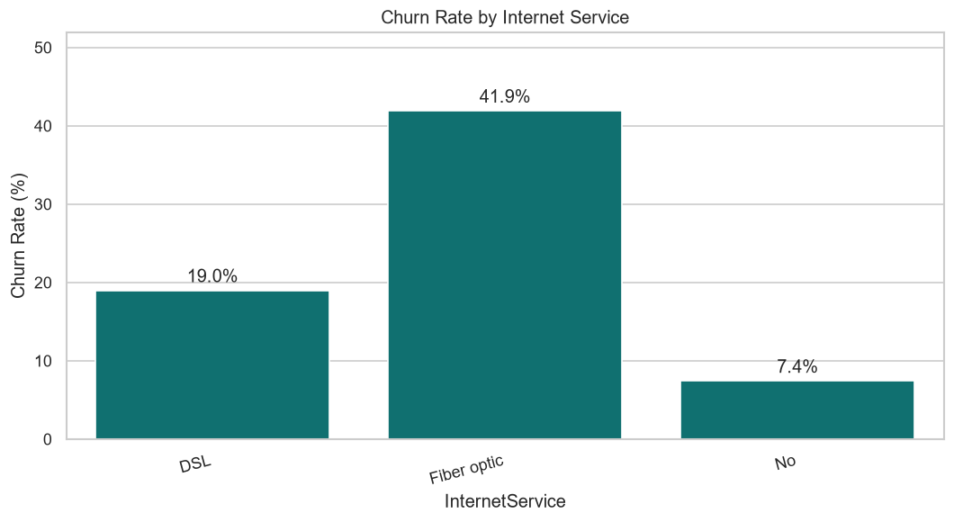
Figure 7: Churn rate by internet service.
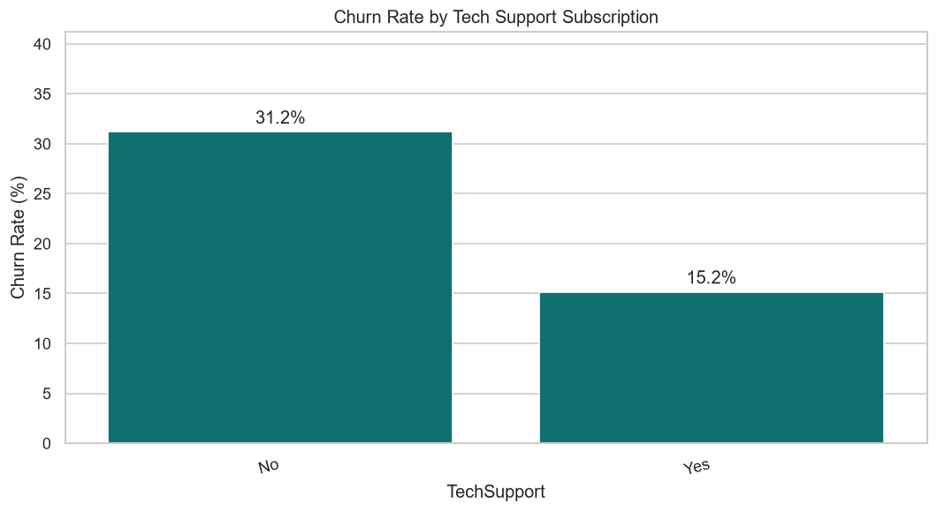
Figure 8: Churn rate by tech-support subscription.
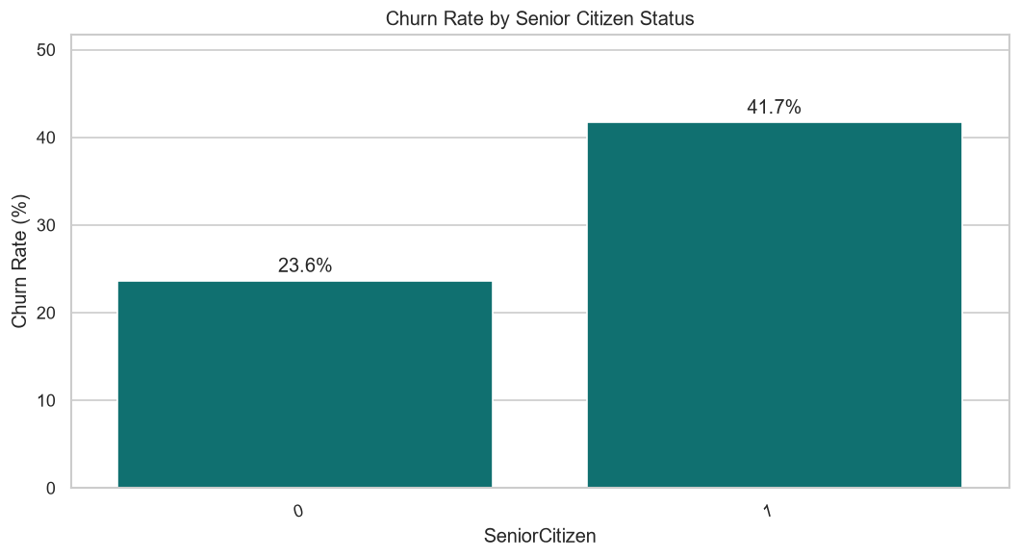
Figure 9: Churn rate by senior-citizen status.

13.5 Results: correlation structure
Variable pair | Pearson r | Reading
tenure ↔ ChurnFlag | −0.352 | the strongest single linear signal
TotalCharges ↔ ChurnFlag | −0.198 | a proxy for tenure, not an independent driver
MonthlyCharges ↔ ChurnFlag | +0.193 | higher recurring price raises risk
SeniorCitizen ↔ ChurnFlag | +0.151 | consistent with the 41.68 % rate above
tenure ↔ TotalCharges | +0.826 | near-collinear by construction
MonthlyCharges ↔ TotalCharges | +0.651 | total is rate multiplied by duration
Table 21: Pearson correlations among the numeric attributes and the churn flag.
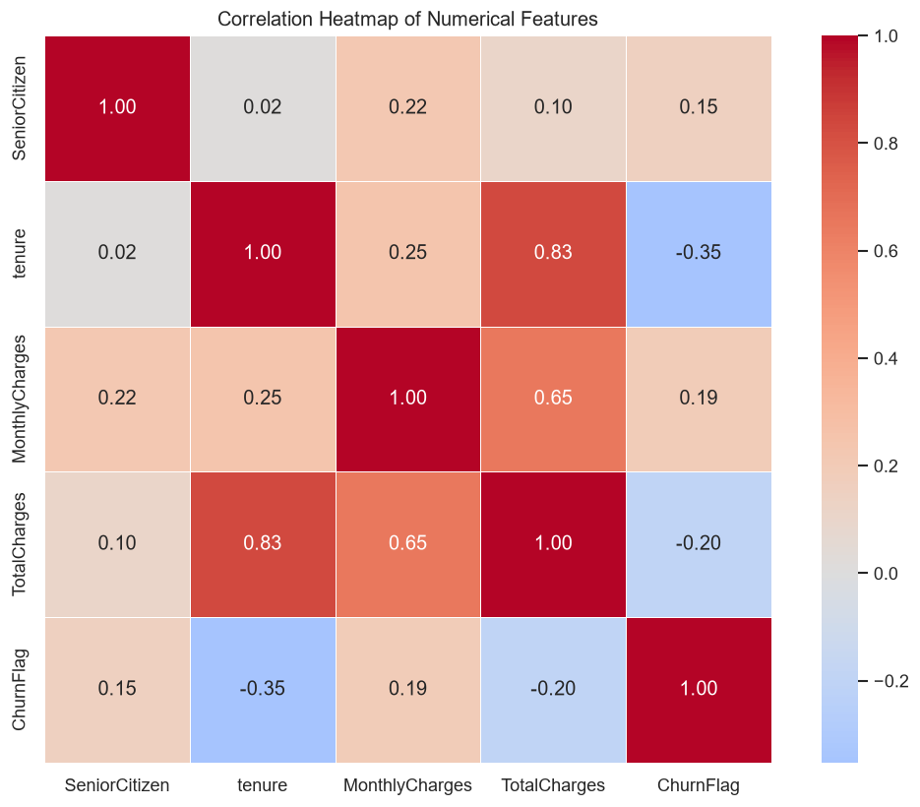
Figure 10: Correlation heat map of the numeric attributes.
The 0.826 correlation between tenure and TotalCharges has the most practical consequence. The two are near-collinear because total charges are, almost by definition, monthly charges multiplied by tenure. For tree-based models this is harmless. For Logistic Regression it inflates the standard errors of both coefficients; the phase 6 implementation mitigates it with an L2 penalty, which shrinks correlated coefficients toward one another rather than letting one dominate arbitrarily.

13.6 Results: behavioural and cohort analysis
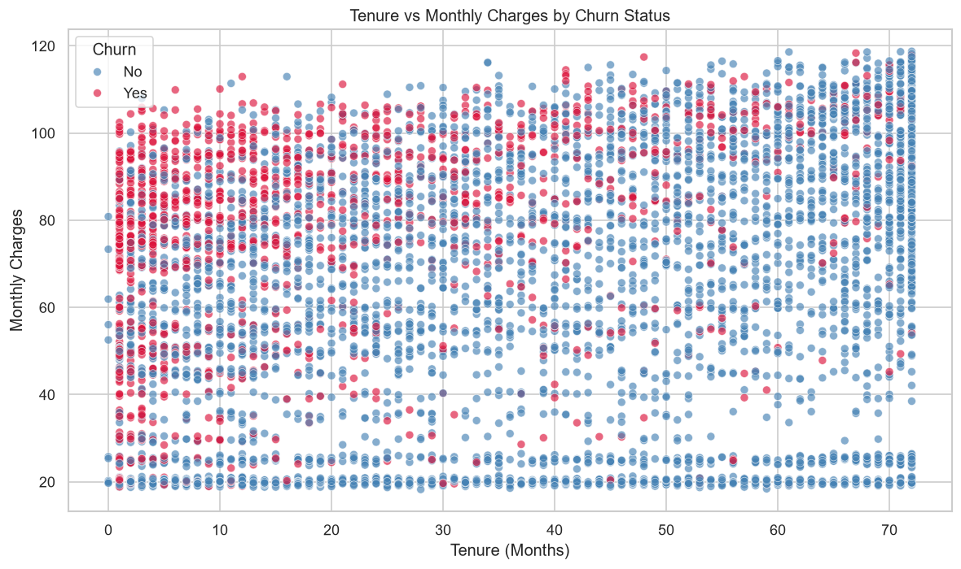
Figure 11: Tenure against monthly charges, coloured by churn outcome.
This is the most operationally useful chart phase 3 produces. Churned customers concentrate visibly in the upper-left region — short tenure combined with high monthly charges. That is exactly the profile of a customer who recently signed up for an expensive bundle and has not yet accumulated any reason to stay. It is also, as Section 15 shows, the profile K-Means isolates without being told anything about churn.
Tenure band | Customers | Share | Churn rate | Reading
0-6 months | 1 481 | 21.03 % | 52.94 % | more than half leave within two quarters
7-12 months | 705 | 10.01 % | 35.89 % | still above base
13-24 months | 1 024 | 14.54 % | 28.71 % | approaching base
25-48 months | 1 594 | 22.63 % | 20.39 % | settled
49-72 months | 2 239 | 31.79 % | 9.51 % | loyal core
Table 22: Churn rate by tenure cohort, showing monotonic decay of risk with relationship age.
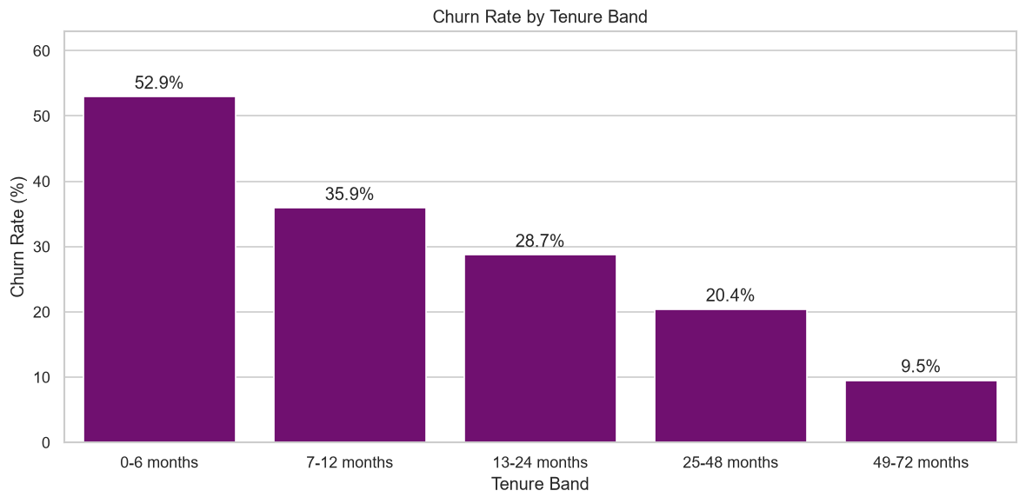
Figure 12: Churn rate by tenure band. Risk decays monotonically from 52.94 % to 9.51 %.
The cohort table carries the clearest strategic message in the exploratory phase. A customer in their first six months is five and a half times more likely to leave than one past four years. Retention effort therefore has a window: intervening at month two addresses a 52.94 % risk, while the same intervention at month fifty addresses a 9.51 % risk and is largely wasted. Onboarding, not long-term loyalty programming, is where retention spend earns its return.

14. Phase 4 — Feature Engineering

14.1 Purpose
Phase 4 translates the exploratory findings into model inputs. Each of the seven constructed features encodes a specific business hypothesis found in phase 3, rather than an arbitrary combination of columns. Modified during remediation to build features through the shared module, persist the tier boundaries and export an unscaled copy.
Property | Value
Input | data/Customer-Churn-Cleaned.csv
Outputs | Customer-Churn-Features-Unscaled.csv (7 043 × 8), Customer-Churn-Model-Ready.csv (7 043 × 36), feature_engineering_artifacts.joblib
Features constructed | 7
Status | Modified — defect 3
Table 23: Phase 4 interface summary.
14.2 The seven engineered features
Feature | Construction | Business hypothesis
TenureBand | pd.cut on tenure into 5 unequal bands | risk decays non-linearly with relationship age; a linear term cannot express the 52.94 % → 9.51 % curve
ARPU | TotalCharges / tenure, guarded at tenure = 0 | revenue actually realised per active month, as distinct from list price
ChargeRatio | MonthlyCharges / ARPU | above 1 means the customer now pays more than their historical average — a recent price rise
ServiceCount | count of "Yes" across 6 add-on columns | product entanglement; each service raises the switching cost
ContractRiskFlag | 1 if contract is month-to-month | a readable flag for the strongest driver in phase 3; kept in the data but excluded from the model because it duplicates Contract (Section 22.2)
ValueTier | pd.qcut on ARPU into 4 quartiles | revenue-based prioritisation, so effort can be ranked by worth
AutoPayFlag | 1 if payment method is automatic | automatic payment removes a recurring cancellation decision point
Table 24: The seven engineered features and the hypothesis each encodes.
14.3 Code walk-through
Division guarded against zero tenure
def add_arpu(df):
df["ARPU"] = 0.0
non_zero_tenure = df["tenure"] > 0
df.loc[non_zero_tenure, "ARPU"] = (
df.loc[non_zero_tenure, "TotalCharges"] / df.loc[non_zero_tenure, "tenure"]
)
return df

Both derived ratios divide by a quantity that is zero for the eleven newly joined customers. The pattern used — initialise the column to a safe default, compute a boolean mask of rows where the division is defined, assign only into those rows — avoids producing infinity entirely. Computing first and repairing afterwards is fragile, because an infinity that survives into a scaler poisons the mean and standard deviation of the whole column and silently corrupts every other row.
Tier boundaries are now fitted and persisted
def fit_value_tier_edges(df):
"""Learn ARPU quartile edges on the training data and return them."""
_, edges = pd.qcut(df["ARPU"], q=4, retbins=True, duplicates="drop")
edges = list(edges)
edges[0], edges[-1] = -np.inf, np.inf # so unseen values still bin
return edges
Listing 19: Added during remediation. Without persisted edges the dashboard would recompute quartiles from whatever batch it was given, so the same customer could land in different tiers in different uploads.
14.4 Results
Property | Before phase 4 | After phase 4
Rows | 7 043 | 7 043
Columns (model-ready copy) | 21 | 36
Unscaled feature export | — | 7 043 × 8 (new)
Data types | 18 object, 3 numeric | all numeric
Missing values | 0 | 0
Table 25: Structural transformation applied by phase 4.
Service count | Customers | Share | Churn rate | Reading
0 add-ons | 2 219 | 31.51 % | 21.41 % | largely no-internet customers, structurally low risk
1 add-on | 966 | 13.72 % | 45.76 % | the peak-risk group in the entire base
2 add-ons | 1 033 | 14.67 % | 35.82 % | risk falling
3 add-ons | 1 118 | 15.87 % | 27.37 % | at the base rate
4 add-ons | 852 | 12.10 % | 22.30 % | below base
5 add-ons | 571 | 8.11 % | 12.43 % | entangled
6 add-ons | 284 | 4.03 % | 5.28 % | lowest risk of any group
Table 26: Churn rate by number of add-on services, showing a non-monotonic relationship.
The ServiceCount profile is the most interesting result phase 4 produces, because it is not monotonic. Risk peaks at exactly one add-on (45.76 %) then falls steadily to 5.28 % at six. The zero-add-on group sits low at 21.41 % for a different reason: it is dominated by customers with no internet at all, who have little to churn from. A single add-on is the worst place for a customer to sit — paying for a bundle without being anchored by it. Because a straight line cannot represent a curve that rises then falls, this is also a concrete argument for tree-based models.
Feature | Level | Customers | Churn rate
ValueTier | Low | 1 761 | 11.07 %
 | Medium | 1 762 | 25.37 %
 | High | 1 759 | 36.33 %
 | Premium | 1 761 | 33.39 %
ContractRiskFlag | 0 (annual or two-year) | 3 168 | 6.76 %
 | 1 (month-to-month) | 3 875 | 42.71 %
AutoPayFlag | 0 (manual payment) | 3 977 | 34.67 %
 | 1 (automatic payment) | 3 066 | 15.98 %
Table 27: Churn rate across the engineered flags and tiers, measured on the cleaned dataset.
Churn rises sharply with value tier before easing slightly at the top. The High tier is the commercially dangerous one: it combines a high churn rate with substantial per-customer revenue, so it carries the largest revenue at risk. The slight decline in Premium is consistent with those customers being heavily bundled, which ServiceCount has already shown to be protective.

15. Phase 5 — Customer Segmentation

15.1 Purpose
Phase 5 groups the customer base into behavioural segments without reference to the churn label. The value of unsupervised work here is that the groups are defined by how customers behave rather than by what happened to them, so they remain meaningful for customers whose outcome is not yet known. Modified during remediation for defects 2 and 3.
Property | Value
Inputs | Customer-Churn-Cleaned.csv + Customer-Churn-Features-Unscaled.csv
Outputs | Customer-Churn-Segmented.csv (7 043 × 31), customer_segmentation_model.joblib, 4 charts
Algorithm | KMeans, n_init=10, random_state=42, OPTIMAL_K = 4
Clustering dimensions | tenure, ServiceCount, MonthlyCharges
Status | Modified — defects 2 and 3
Table 28: Phase 5 interface summary.
15.2 Choice of clustering dimensions
The three dimensions are an RFM adaptation to a subscription business, where the classical recency-frequency-monetary triple does not translate directly:
Dimension | RFM analogue | Why it is the right proxy
tenure | Recency / longevity | every active subscriber transacted this month, so recency is uninformative; relationship length is the meaningful time dimension
ServiceCount | Frequency / engagement | purchase frequency is fixed at one per month by the billing cycle; breadth of product adoption is the true engagement signal
MonthlyCharges | Monetary | the recurring rate is forward-looking, whereas total charges merely restate tenure
Table 29: Mapping of classical RFM dimensions onto subscription-business proxies.
15.3 Standardisation before clustering
X = df[["tenure", "ServiceCount", "MonthlyCharges"]].copy()
scaler = StandardScaler()
X_scaled = scaler.fit_transform(X)

Standardisation is a correctness requirement here, not a convenience. K-Means assigns points by Euclidean distance, and the raw dimensions have incompatible scales: tenure spans 0 to 72, monthly charges 18.25 to 118.75, service count 0 to 6. Unscaled, monthly charges would contribute roughly four hundred times more squared distance than service count, and the clusters would be little more than a partition of the price axis.
15.4 Selecting the number of segments
K | Inertia | Inertia reduction | Silhouette | Assessment
2 | 10 782.45 | — | 0.4163 | highest silhouette, but only splits cheap from expensive
3 | 7 295.42 | 32.3 % | 0.3968 | improving, still coarse
4 | 5 615.08 | 23.0 % | 0.4042 | selected — elbow region, silhouette recovers
5 | 4 647.43 | 17.2 % | 0.3641 | silhouette degrades
6 | 3 812.39 | 18.0 % | 0.3704 | no separation gain
Table 30: Elbow and silhouette results for K from 2 to 6.
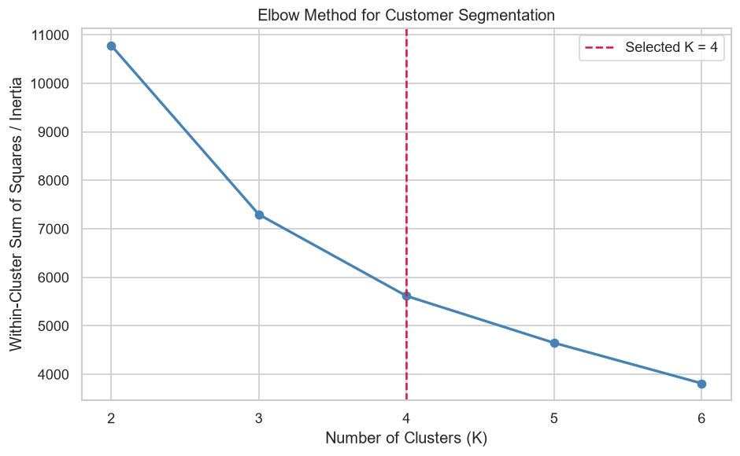
Figure 13: Elbow analysis. The inertia curve flattens noticeably after K = 4.
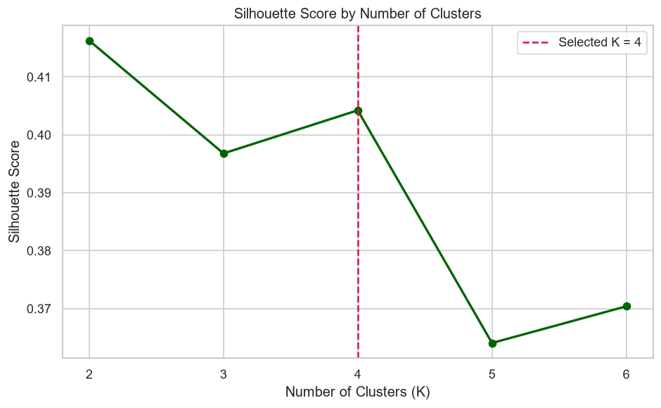
Figure 14: Silhouette score by K.
The two criteria disagree, and the resolution deserves stating openly. K = 2 attains the highest silhouette at 0.4163, so a purely geometric reading would choose two clusters. Four is selected on three grounds: the inertia curve shows its clearest elbow there (23.0 % reduction from K = 3 against only 17.2 % moving to K = 5); the silhouette at K = 4 is within 0.012 of the K = 2 value, so almost no cluster quality is sacrificed; and decisively, a two-cluster solution divides the base into cheap and expensive customers, supporting no retention decision that pricing data alone would not already support.

15.5 Segment profiles after centroid-based naming
Segment | Cluster | Customers | Share | Mean tenure | Mean monthly | Mean services | Churn rate
New High-Spend | 3 | 2 373 | 33.69 % | 15.05 | 77.58 | 1.83 | 47.37 %
New Budget | 0 | 1 521 | 21.60 % | 10.16 | 29.58 | 0.30 | 24.19 %
Established High-Value | 1 | 2 158 | 30.64 % | 56.89 | 90.59 | 4.16 | 15.43 %
Established Budget | 2 | 991 | 14.07 % | 54.54 | 31.81 | 0.58 | 4.44 %
Table 31: The four segments, ordered by churn rate. Names derive from centroid geometry; churn rate is a measured outcome, not a naming input.
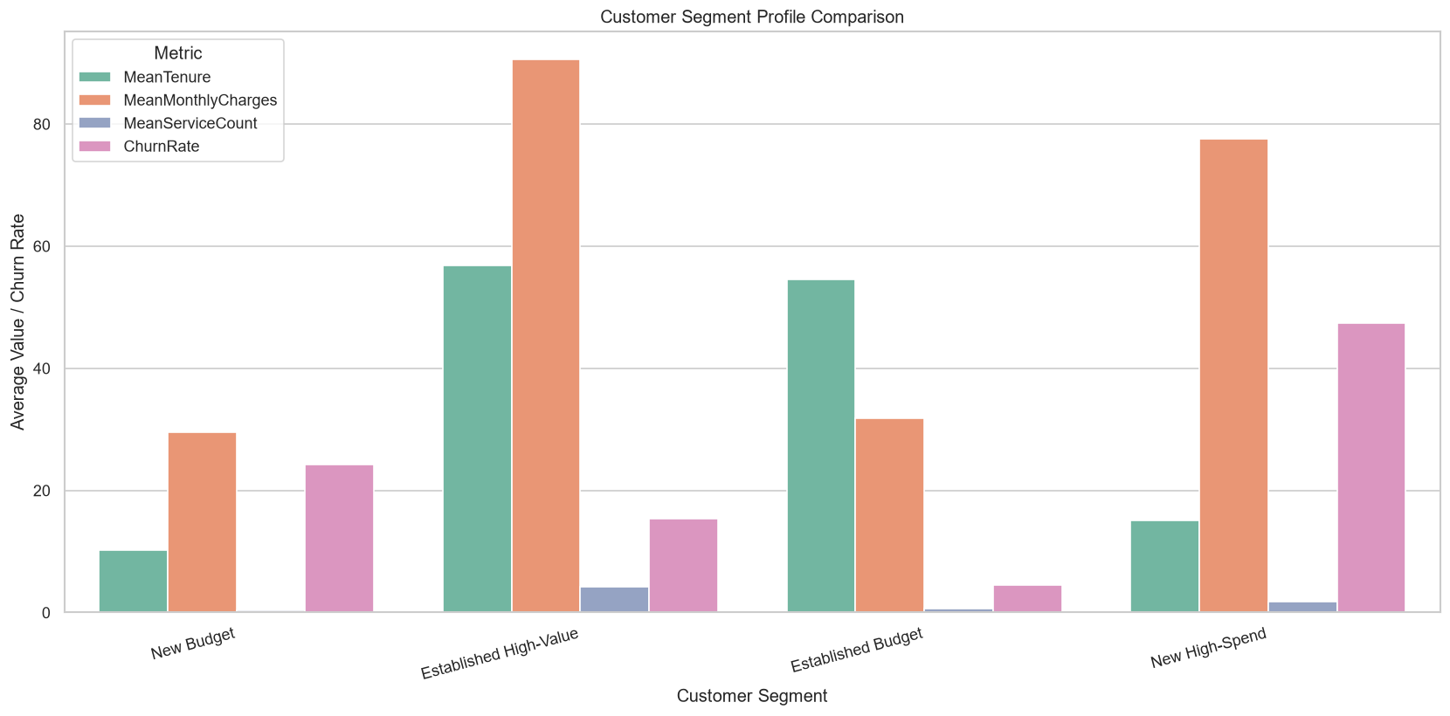
Figure 15: Segment profile comparison across tenure, monthly charges, service count and churn rate.
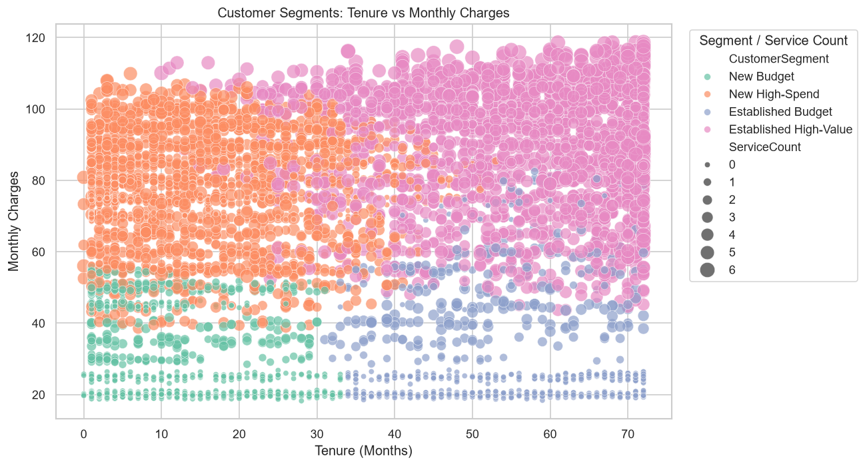
Figure 16: Segments plotted on tenure against monthly charges, with marker size encoding service count.
Reading the four segments
- New High-Spend — the retention priority. 2 373 customers, a third of the base, averaging fifteen months of tenure and 77.58 in monthly charges. Nearly half leave. This segment combines the highest churn rate with substantial recurring revenue, making it the largest pool of recoverable revenue in the business.
- Established High-Value — protect, do not discount. 2 158 customers averaging fifty-seven months, 90.59 per month and 4.16 add-on services. At 15.43 % their churn is well below base, and their 5 160 mean accumulated revenue makes each loss expensive. The correct posture is service quality and early-warning monitoring.
- New Budget — low value, moderate risk. 1 521 customers on 29.58 per month with almost no add-on adoption. At 24.19 % their churn sits below base and their low revenue means each loss is small. Retention spend here earns a poor return.
- Established Budget — leave alone. 991 long-tenured customers on minimal spend, churning at just 4.44 %. The most stable group in the base; no intervention needed.
The segments separate churn strongly without ever seeing it.
Churn rates across the four segments span 4.44 % to 47.37 %, a ten-fold spread, and K-Means was given only tenure, service count and monthly charges. This is the evidence that the behavioural structure is real rather than an artefact of the naming rule — and it is exactly the demonstration the leaking version could not make, because there the separation was partly built into the labels by construction.

16. Phase 6 — Model Development

16.1 Purpose
Phase 6 trains five classifiers, selects among them by cross-validated ROC-AUC, tunes the strongest family by randomized search, evaluates every candidate on the hold-out partition and serialises the winner with its full preprocessing pipeline. Modified during remediation for defects 1 and 2, and again in the second round so labels are assigned by an explicit probability threshold.
Property | Value
Input | data/Customer-Churn-Segmented.csv (7 043 × 31)
Outputs | best_churn_model.joblib, phase6_model_performance.csv, 3 charts
Models trained | 5 (LR, RF, SVM, XGBoost baseline, XGBoost tuned)
Split | TEST_SIZE = 0.20 — 5 634 train / 1 409 test
Labelling | predict_proba >= DECISION_THRESHOLD (0.50)
Status | Modified — defects 1, 2 and issue 4
Table 32: Phase 6 interface summary.
16.2 Leakage-safe preprocessing
numeric_transformer = Pipeline(steps=[
("imputer", SimpleImputer(strategy="median")),
("scaler", StandardScaler())])

categorical_transformer = Pipeline(steps=[
("imputer", SimpleImputer(strategy="most_frequent")),
("encoder", OneHotEncoder(handle_unknown="ignore"))])

preprocessor = ColumnTransformer(transformers=[
("numeric", numeric_transformer, numeric_features),
("categorical", categorical_transformer, categorical_features)])

This is the most important structural decision in phase 6, and the delivered code got it right. Wrapping imputation, scaling and encoding inside a ColumnTransformer that is itself the first pipeline step means the fitted statistics — medians, means, standard deviations, category vocabularies — are learned only from the training rows of each fold and then applied to the validation rows. It is also why defect 3 had to be fixed by merging unscaled features: handing this pipeline pre-scaled columns would have defeated the very protection it provides.
16.3 Class-imbalance correction
negative_class_count = (y_train == 0).sum()
positive_class_count = (y_train == 1).sum()
scale_pos_weight = negative_class_count / positive_class_count

With a 73.46 / 26.54 split, an unweighted learner minimises its loss most easily by predicting the majority class. Three of the four baseline models counter this with class_weight="balanced"; XGBoost exposes the same correction through scale_pos_weight, approximately 2.77 on the training partition. This is why every weighted model achieves recall above 0.78.
16.4 Hyper-parameter tuning
xgb_search = RandomizedSearchCV(
estimator=xgb_pipeline,
param_distributions=xgb_parameter_grid, # 10 parameters
n_iter=30, scoring="roc_auc", cv=cv,
random_state=RANDOM_STATE, n_jobs=-1, refit=True)

The grid spans ten hyper-parameters with four candidate values for most, defining a space of well over a million combinations. Exhaustive search is infeasible; thirty random draws across five folds is 150 fits, a budget that completes in minutes while reliably locating a near-optimal region. refit=True retrains the best configuration on the entire training partition once the search concludes.
16.5 Cross-validation results
Model | Mean CV ROC-AUC | Std dev | Reading
Logistic Regression | 0.8465 | 0.0113 | strongest on cross-validation
Random Forest | 0.8455 | 0.0093 | within one standard deviation
Support Vector Machine | 0.8298 | 0.0109 | clearly behind
XGBoost Baseline | 0.8003 | 0.0047 | untuned; 2 000 rounds at lr 0.10 overfits
Table 33: Five-fold stratified cross-validation on the training partition (26-column matrix).
16.6 Labelling predictions consistently
DECISION_THRESHOLD = 0.50

predicted_probabilities = pipeline.predict_proba(X_test)[:, 1]
predicted_labels = (predicted_probabilities >= DECISION_THRESHOLD).astype(int)
Listing 20a: Phase 6 labels predictions exactly as phase 7 does (second-round correction, Section 22.1).
Phase 6 previously called pipeline.predict(). For Random Forest and XGBoost that is the same as thresholding the probability at 0.50, but for an SVC it is not: predict() uses the sign of the decision function while predict_proba uses Platt scaling fitted by internal cross-validation. Using one explicit threshold everywhere makes the operating point visible and makes phases 6 and 7 agree.
16.7 Hold-out test results
Model | ROC-AUC | Accuracy | Precision | Recall | F1 | Rank
Tuned XGBoost | 0.8472 | 0.7339 | 0.4992 | 0.8262 | 0.6224 | 1
Logistic Regression | 0.8448 | 0.7459 | 0.5139 | 0.7914 | 0.6232 | 2
Random Forest | 0.8425 | 0.7587 | 0.5309 | 0.7807 | 0.6320 | 3
Support Vector Machine | 0.8334 | 0.7850 | 0.5927 | 0.6070 | 0.5997 | 4
XGBoost Baseline | 0.8025 | 0.7658 | 0.5608 | 0.5428 | 0.5516 | 5
Table 34: Hold-out performance on the 1 409-record test set, ranked by ROC-AUC. Reproduced from data/phase6_model_performance.csv.
Phases 6 and 7 now report identical figures.
Every model evaluated in both phases — Tuned XGBoost, Logistic Regression, Random Forest and the SVM — now shows the same accuracy, precision, recall and F1 in the table above and in the phase 7 table in Section 17.2. Before the second-round correction the SVM appeared at 0.7601 accuracy and 0.7834 recall here, and at 0.7835 and 0.6150 in phase 7.

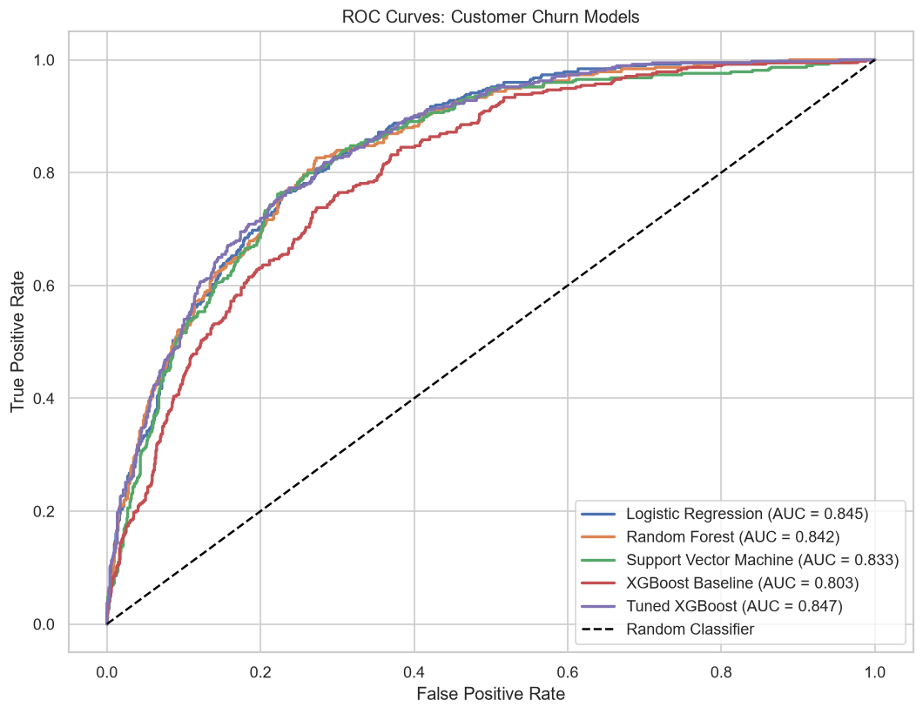
Figure 17: ROC curves for all five models on the hold-out partition.
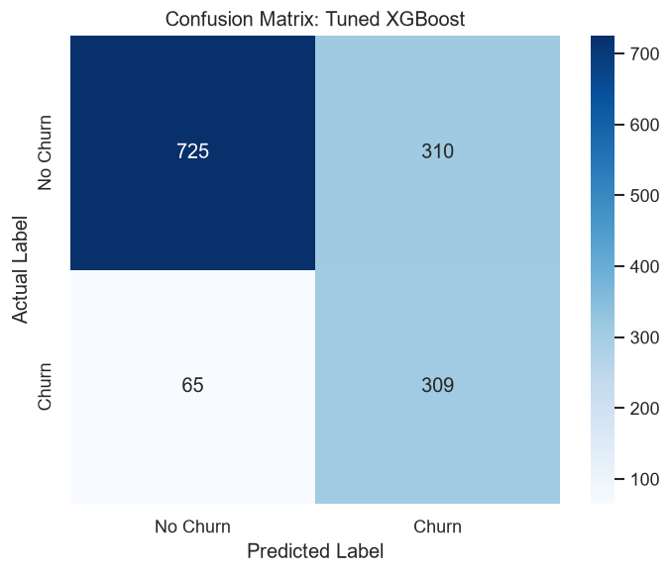
Figure 18: Confusion matrix for the selected model on the 1 409-record hold-out.
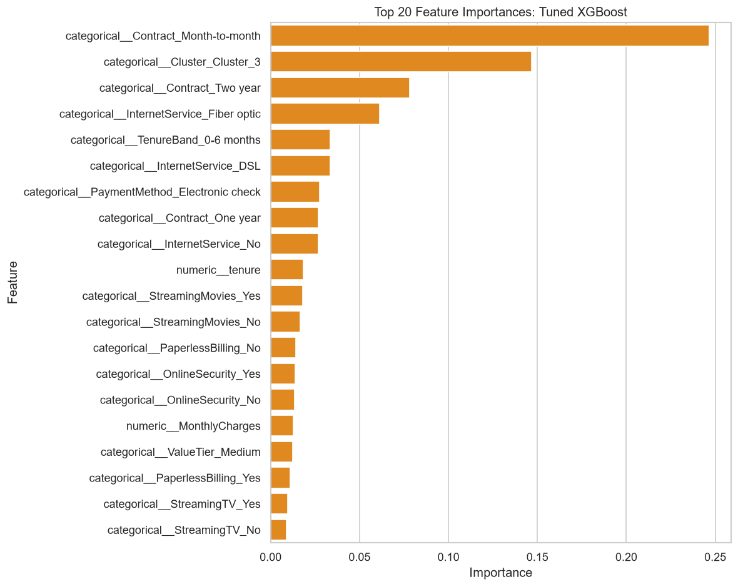
Figure 19: Top twenty features by gain importance in the tuned XGBoost model.

17. Phase 7 — Model Evaluation and Threshold Analysis

17.1 Purpose
Phase 7 re-fits four models on the same split and evaluates them more thoroughly than phase 6: precision-recall curves, full confusion matrices, PR-AUC, and a sweep of the decision threshold from 0.10 to 0.90. Modified during remediation for defects 1 and 2.
17.2 Evaluation results with confusion matrices
Model | ROC-AUC | PR-AUC | Acc. | Prec. | Recall | F1 | TN | FP | FN | TP
Tuned XGBoost | 0.8472 | 0.6632 | 0.7339 | 0.4992 | 0.8262 | 0.6224 | 725 | 310 | 65 | 309
Logistic Regression | 0.8448 | 0.6492 | 0.7459 | 0.5139 | 0.7914 | 0.6232 | 755 | 280 | 78 | 296
Random Forest | 0.8425 | 0.6510 | 0.7587 | 0.5309 | 0.7807 | 0.6320 | 777 | 258 | 82 | 292
Support Vector Machine | 0.8334 | 0.6269 | 0.7850 | 0.5927 | 0.6070 | 0.5997 | 879 | 156 | 147 | 227
Table 35: Phase 7 hold-out evaluation with confusion-matrix cells. Labels are assigned by thresholding predicted probability at 0.50, identically to phase 6.
The confusion matrix for the selected model reads as follows. Of 374 customers who actually churned, the model identified 309 and missed 65. It also raised 310 false alarms. Given that a missed churner costs the customer's remaining lifetime value while a false alarm costs one retention offer, this asymmetry is economically favourable — the business spends 310 unnecessary offers to reach 309 genuine churners.
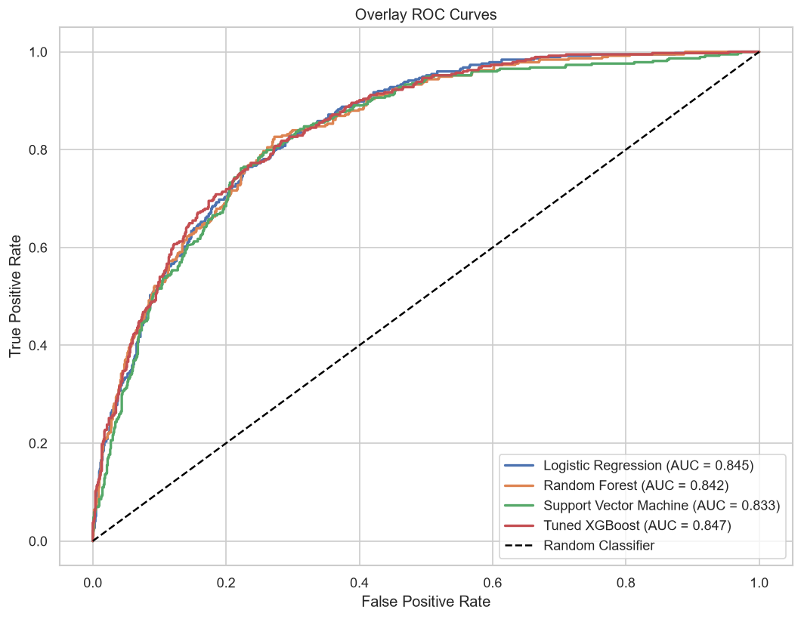
Figure 20: Overlaid ROC curves for the four evaluated models.
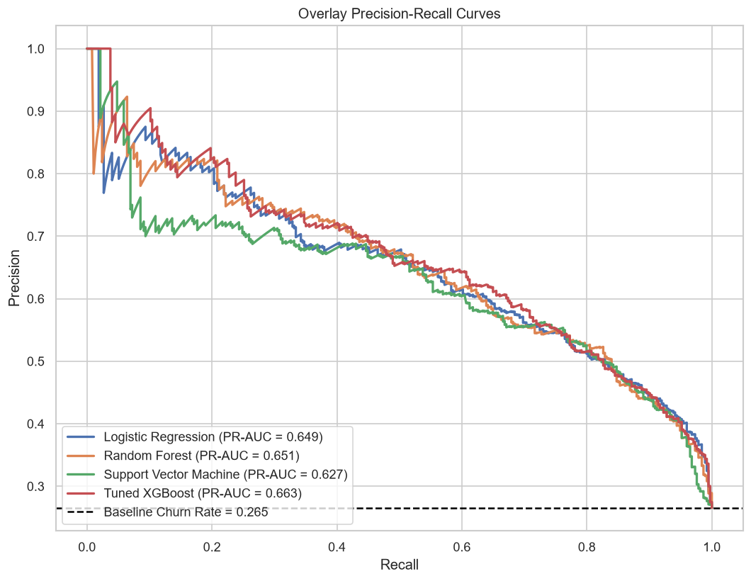
Figure 21: Precision-recall curves. At a 26.54 % base rate, PR-AUC is the more informative summary for an imbalanced problem.

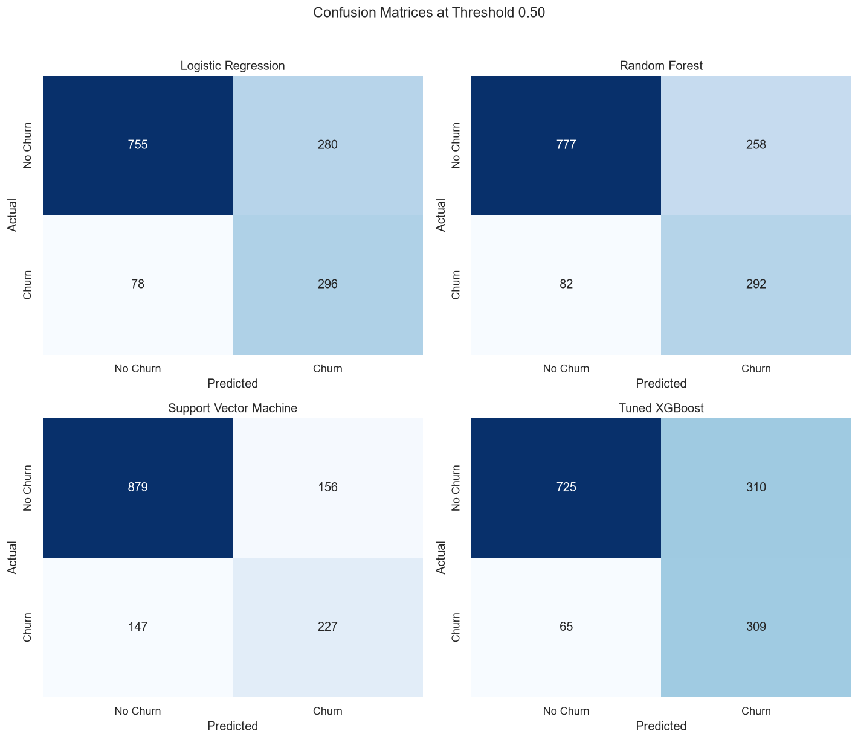
Figure 22: Confusion matrices for all four models side by side.
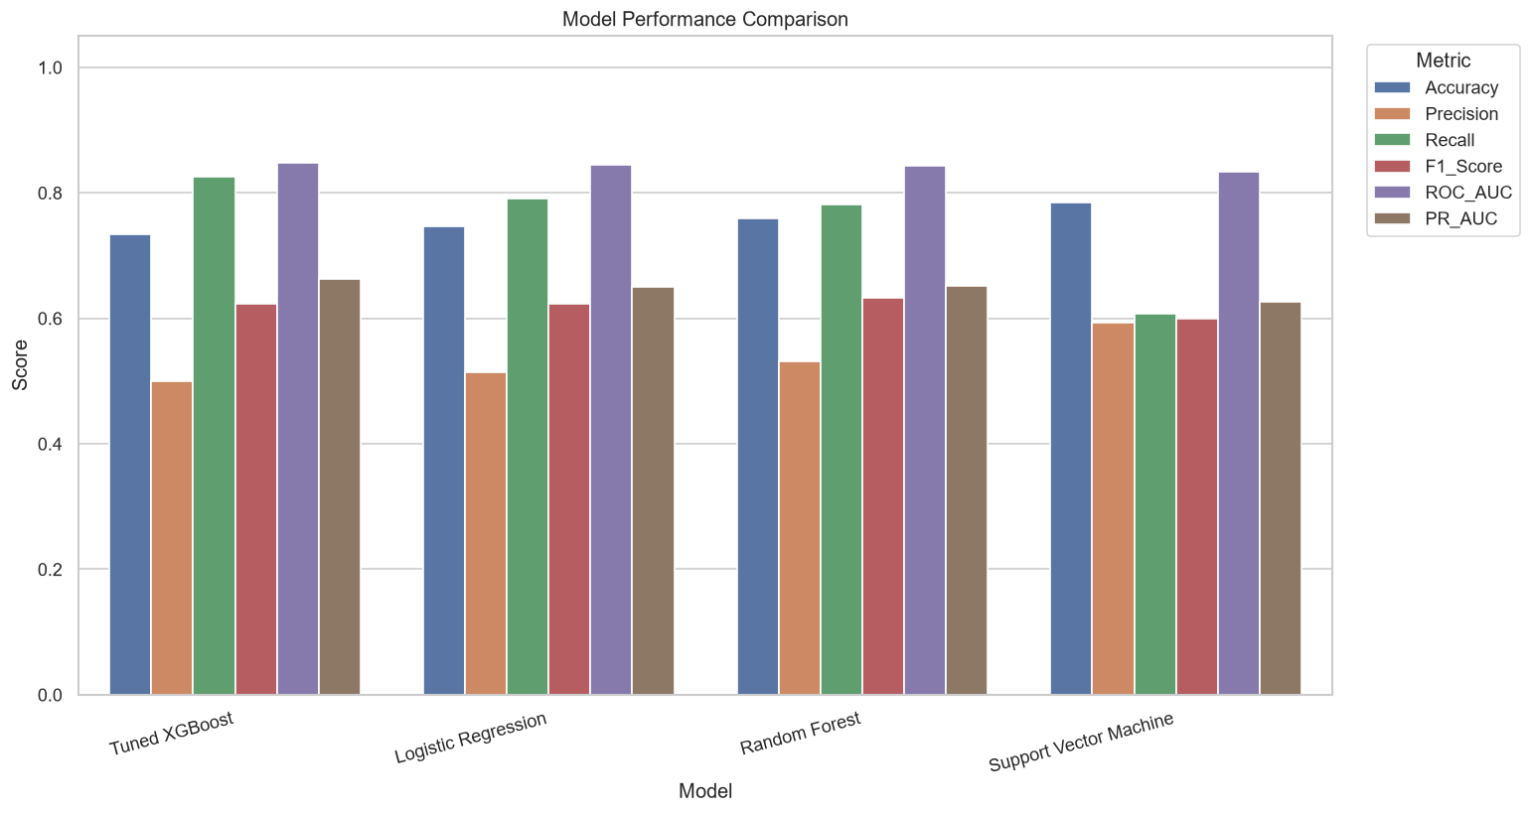
Figure 23: Head-to-head metric comparison across the four models.

17.3 Threshold analysis
The default 0.50 cut-off is a mathematical convention, not a business choice. Because a missed churner costs far more than a false alarm, the economically optimal threshold is almost certainly lower than the point that maximises F1. The sweep makes the trade explicit.
Threshold | Accuracy | Precision | Recall | F1 | Reading
0.10 | 0.4911 | 0.3419 | 0.9920 | 0.5086 | catches nearly everyone, flags almost everyone
0.20 | 0.5791 | 0.3831 | 0.9599 | 0.5477 | very aggressive
0.30 | 0.6373 | 0.4176 | 0.9278 | 0.5759 | aggressive
0.40 | 0.6920 | 0.4584 | 0.8850 | 0.6040 | recall-led
0.50 | 0.7339 | 0.4992 | 0.8262 | 0.6224 | default
0.55 | 0.7466 | 0.5148 | 0.7914 | 0.6238 | balanced
0.60 | 0.7658 | 0.5415 | 0.7674 | 0.6350 | balanced
0.65 | 0.7871 | 0.5815 | 0.7059 | 0.6377 | maximum F1; also the phase 9 targeting threshold
0.70 | 0.7991 | 0.6207 | 0.6257 | 0.6232 | precision-led
0.75 | 0.8020 | 0.6589 | 0.5267 | 0.5854 | maximum accuracy
0.85 | 0.7786 | 0.7313 | 0.2620 | 0.3858 | misses three in four
0.90 | 0.7608 | 0.8364 | 0.1230 | 0.2145 | near-useless recall
Table 36: Decision-threshold sweep for the selected model. Abridged from data/phase7_threshold_analysis.csv, which holds 17 rows.
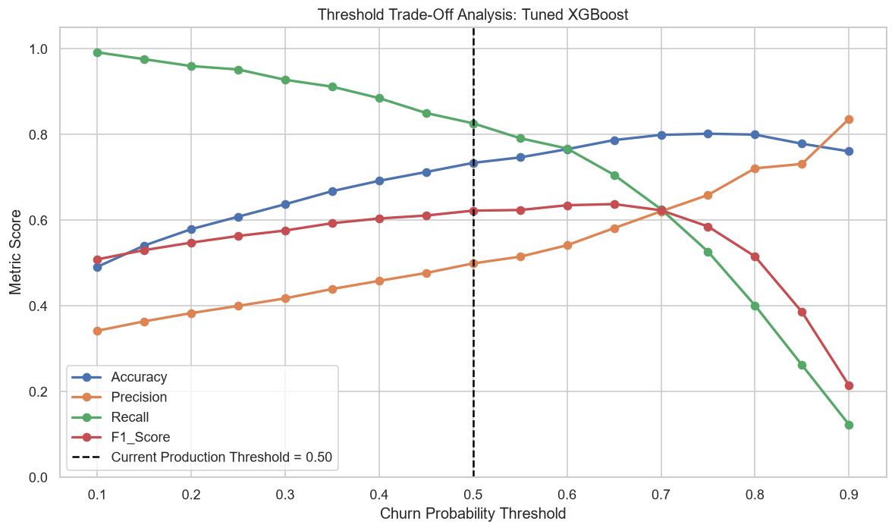
Figure 24: Precision, recall and F1 against the decision threshold.
Accuracy and F1 peak at different thresholds, and neither is the business optimum.
Accuracy is maximised at 0.75, where recall has fallen to 0.5267 and the model misses nearly half of all churners. F1 peaks at 0.65, which happens to coincide with the phase 9 targeting threshold. None of these is derived from the actual cost ratio between a missed churner and a wasted offer, because the project has no campaign-cost data to calibrate against. The sweep is therefore the right artefact to hand a business owner: it lets them choose the operating point once they can price both kinds of error.

18. Phase 8 — Churn Probability and Explainable AI

18.1 Purpose
Phase 8 converts the classifier into a decision tool. It calibrates the predicted probabilities so they can be read as probabilities, assigns every customer a risk tier, computes global feature importance, and produces SHAP explanations at both the global and the individual level. Modified during remediation for defects 1 and 2, and in the second round to export a per-customer SHAP driver for every customer.
18.2 Probability calibration
calibrated_model = CalibratedClassifierCV(
estimator=base_pipeline, method="sigmoid", cv=CALIBRATION_CV_FOLDS)
calibrated_model.fit(X_train, y_train)

Calibration is necessary here precisely because of the class weighting applied in phase 6. Weighting deliberately distorts the predicted scores to improve recall, which means a raw score of 0.7 does not correspond to a 70 % chance of churning. That becomes a problem the moment probability is multiplied by customer value to rank a call list, which is exactly what phase 9 does. Platt scaling fits a sigmoid that maps the distorted scores back onto observed frequencies.
Calibration metric | Value | Reading
Calibrated test ROC-AUC | 0.8465 | ranking quality preserved (0.8472 uncalibrated)
Brier score | 0.1364 | mean squared error of the probabilities; lower is better
Mean predicted probability (all customers) | 0.2652 | against an observed base rate of 0.2654
Table 37: Calibration quality on the hold-out partition.
The agreement between the mean predicted probability (0.2652) and the observed base rate (0.2654) is the clearest single indication that calibration succeeded. Calibration preserves ranking — ROC-AUC moves only from 0.8472 to 0.8465 — while making the absolute values meaningful.
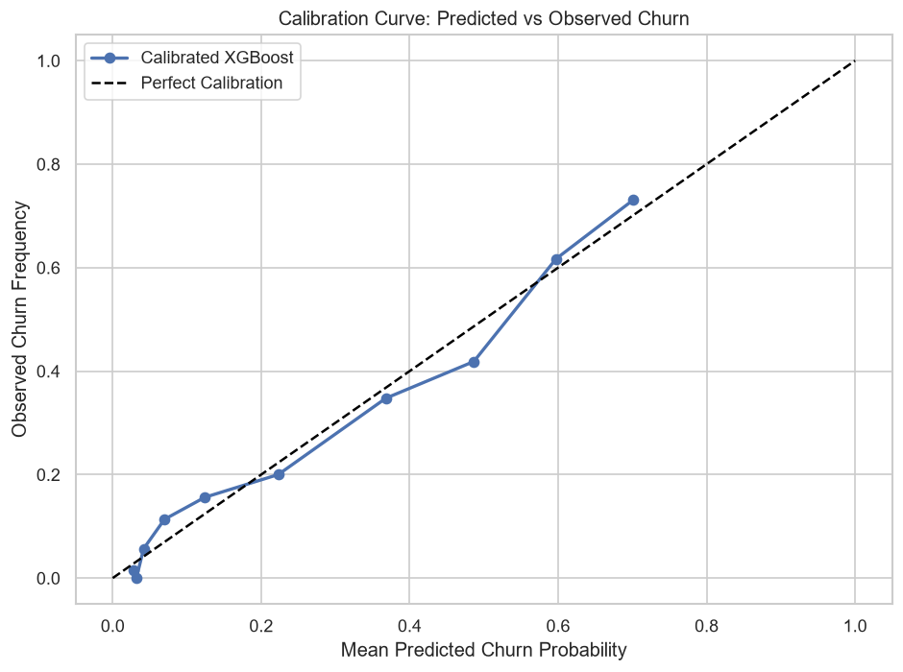
Figure 25: Calibration curve: predicted probability against observed churn frequency, in quantile bins.
18.3 Risk tiering
Risk tier | Probability band | Customers | Share | Mean predicted | Observed churn rate
Low Risk | 0.00 – 0.35 | 4 579 | 65.02 % | 0.1035 | 9.85 %
Medium Risk | 0.35 – 0.65 | 1 740 | 24.71 % | 0.5099 | 49.02 %
High Risk | 0.65 – 1.00 | 724 | 10.28 % | 0.7003 | 78.04 %
Table 38: Risk-tier distribution with the churn rate actually observed in each tier.
The tiers validate cleanly against observed outcomes.
Customers the model places in the High Risk tier churn at 78.04 %; those in the Low Risk tier churn at 9.85 %. That is an eight-fold separation, and the ordering is strictly monotonic across the three tiers. Mean predicted probability also tracks observed frequency closely within each tier (0.7003 against 78.04 %, 0.1035 against 9.85 %), which is the practical payoff of the calibration step.

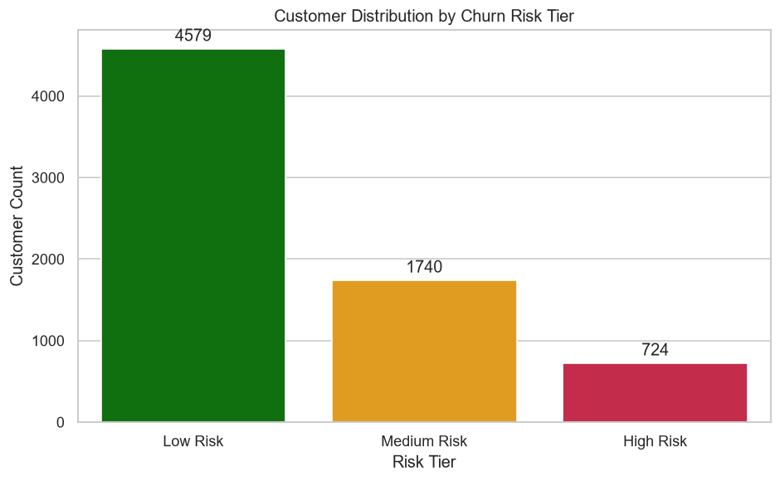
Figure 26: Customer distribution across the three risk tiers.

18.4 Global feature importance
This ranking reflects both remediation rounds. The leaked segment label is gone (round 1), and contract type now appears once, with its importance undivided, because the duplicate ContractRiskFlag no longer competes with it (round 2).
Rank | Feature | Gain | Note
1 | Contract_Month-to-month | 0.2465 | sole carrier of the contract signal after round 2
2 | Cluster_3 | 0.1467 | the New High-Spend segment; built from attributes only
3 | Contract_Two year | 0.0783 | long commitment protects
4 | InternetService_Fiber optic | 0.0614
5 | TenureBand_0-6 months | 0.0337 | recovered by fixing defect 3
6 | InternetService_DSL | 0.0334
7 | PaymentMethod_Electronic check | 0.0275
8 | Contract_One year | 0.0269
9 | InternetService_No | 0.0267
10 | tenure | 0.0183
17 | ValueTier_Medium | 0.0124 | recovered by fixing defect 3
— | ContractRiskFlag | absent | removed from the matrix in round 2
— | CustomerSegment | absent | removed from the matrix in round 1
Table 39: Top features by gain importance in the phase 8 model after both remediation rounds.
Two movements deserve comment. Contract Month-to-month now carries 0.2465 on its own; previously the same signal was split into 0.2462 and 0.2421 between two identical columns, so neither number described it. And Cluster_3 has risen to second place. That is legitimate: the cluster is built from tenure, service count and monthly charges only, and after round 1 its name no longer encodes churn. Gain importance is not conserved between models, so when a redundant column is removed the trees redistribute their splits across the remaining features.
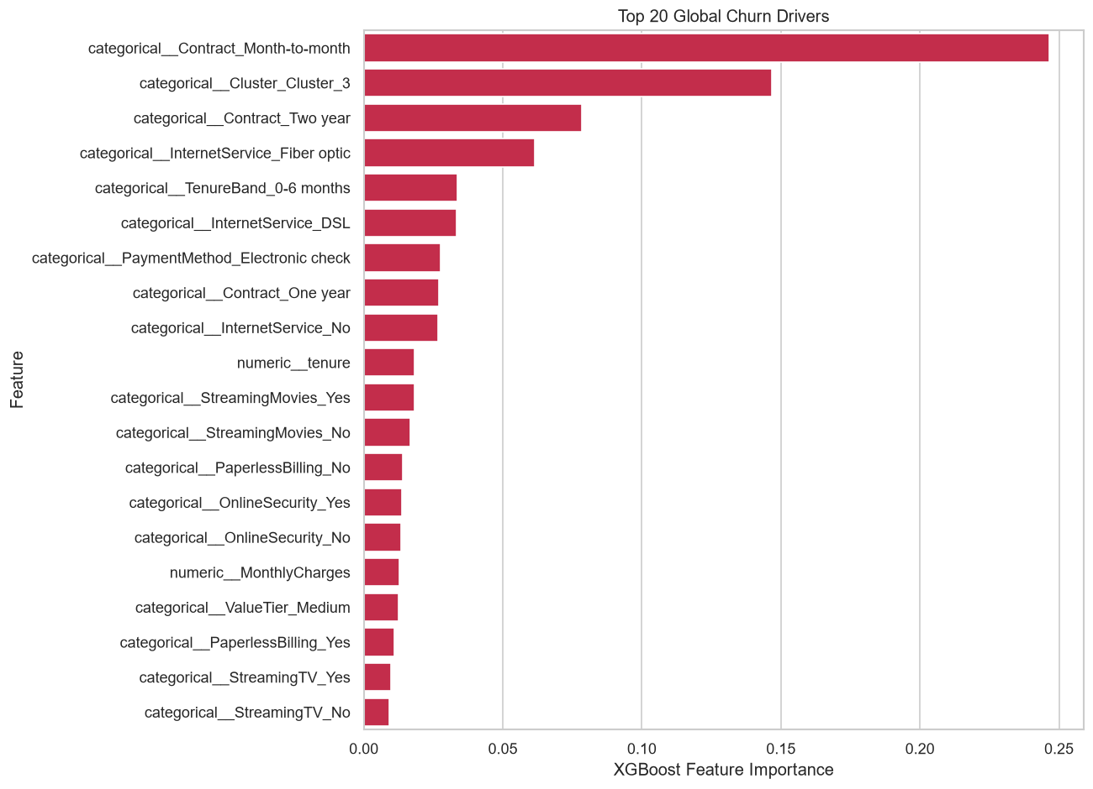
Figure 27: Global feature importance by gain.
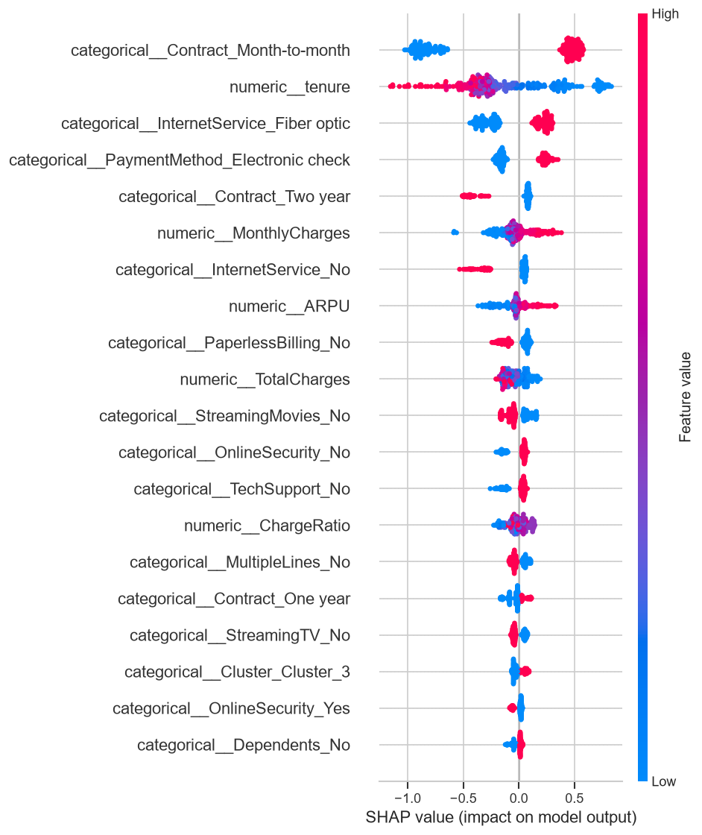
Figure 28: SHAP global summary. Each point is one customer; position shows the direction and magnitude of that feature's contribution.
18.5 Local explanations and reason codes
Global importance says what matters across the base. A retention agent needs to know what matters for the customer in front of them, which is what SHAP provides per prediction. Phase 8 converts the three highest-magnitude contributions per customer into plain reason codes.
customerID ChurnProbability RiskTier ReasonCode1 / 2 / 3
7216-EWTRS 0.7690 High Risk tenure increased churn risk
Contract_Month-to-month increased churn risk
InternetService_Fiber optic increased risk
5178-LMXOP 0.7667 High Risk (same three drivers)
9300-AGZNL 0.7663 High Risk (same three drivers)
5419-JPRRN 0.7661 High Risk (same three drivers)
9497-QCMMS 0.7657 High Risk (same three drivers)
Listing 21: SHAP reason codes for the five highest-risk customers. The contract signal is now cited through the Contract column itself.
All five share the same three drivers because they are the five highest-probability customers in the base, and the strongest signals are contract, tenure and fibre service. That is why phase 9 does not use these raw top-three codes to pick an action: they would repeat contract for almost everyone. Section 18.6 describes what it uses instead.
18.6 Per-customer driver levers
Added in the second remediation round. Phase 8 now computes SHAP values for all 7 043 customers, sums the one-hot columns back to their source feature (the three Contract columns become one Contract contribution), and groups the actionable features into five levers.
Lever | Source features | Action if it is the customer's top lever
Service quality | InternetService | Service-quality audit with proactive fix and loyalty credit
Billing and payment | PaymentMethod, PaperlessBilling, AutoPayFlag | Move to automatic payment with a billing reward
Protection and support | TechSupport, OnlineSecurity, OnlineBackup, DeviceProtection | Complimentary tech-support and online-security trial
Engagement and bundling | StreamingTV, StreamingMovies, ServiceCount, MultipleLines, PhoneService | Bundled add-on offer to deepen product engagement
Price and plan fit | MonthlyCharges, ChargeRatio, ARPU, ValueTier, TotalCharges | Plan right-sizing review and personalised tariff
(shared) Contract | Contract | Discounted 12- or 24-month contract — the base offer for every month-to-month customer
Table 40: Lever groups defined in churn_features.LEVER_GROUPS and their actions.
feature_shap = aggregate_shap_by_feature(
all_shap_values, feature_names, X.columns.tolist())

driver_df = assign_shap_drivers(feature_shap) # PrimaryLever, SecondaryLever
driver_df.to_csv("data/phase8_customer_risk_drivers.csv", index=False)
Listing 22: The per-customer driver export in phase 8.
Tenure, the segment cluster and demographics are deliberately not levers. An offer cannot change how long someone has been a customer or who they are; those attributes tell the business when and to whom to reach out, not what to offer. Among the 724 High Risk customers the primary lever splits as Billing and payment 333, Service quality 273, Price and plan fit 112, Protection and support 4, and Engagement and bundling 2. Every one of them has a lever with a positive contribution.

19. Phase 9 — Business Recommendations and Revenue Impact

19.1 Purpose
Phase 9 converts calibrated probabilities into money. It computes each customer's value and revenue at risk, selects a targeting population, assigns a retention action driven by the customer's dominant risk factor, and models the economics of the resulting campaign. Modified during remediation to read recall from phase 7 rather than a hard-coded constant, and in the second round to take each customer's driver from the phase 8 SHAP levers instead of a fixed rule cascade.
19.2 From probability to priority
A churn probability is not by itself a decision. The correct target for retention spend is not the customer most likely to leave, but the one whose departure would cost the most.
Customer Value = MonthlyCharges x Expected Remaining Tenure
Revenue at Risk = P(churn) x Customer Value
Target for Retention= P(churn) > 0.65
Expected Saved Rev. = Revenue at Risk x Campaign Success Rate
Campaign Cost = Targeted x Cost per Retention Offer
Net Benefit = Expected Saved Revenue - Campaign Cost
Retention ROI (%) = (Net Benefit / Campaign Cost) x 100
Listing 21: The financial model implemented in phase 9.
19.3 Financial impact
Quantity | Value | Source
Customers in base | 7 043 | measured
Baseline churn rate | 26.54 % | measured from the cleaned data
Model recall | 0.8262 | read from phase 7 results
High-risk customers targeted | 724 | p(churn) > 0.65
Average customer value | $777.14 | derived
Total revenue at risk | $491 820.10 | derived
Expected saved revenue | $147 546.03 | at 30 % campaign success
Campaign cost | $10 860.00 | 724 offers at $15.00
Net benefit | $136 686.03 | derived
Retention ROI | 1 258.62 % | derived
Expected retained customers | 463 | derived
Projected churn rate after campaign | 19.96 % | from 26.54 % baseline
Table 41: Financial impact summary produced by phase 9 after both remediation rounds.
Three inputs to this model are assumptions, not measurements.
The expected remaining tenure of 12 months, the 30 % campaign success rate and the $15.00 cost per offer are stated constants at the top of phase 9. The project holds no campaign-outcome data, so none of the three can be validated from the data. Customer counts, churn rates, probabilities and recall are all measured. The calculation shows the shape of the business case and the sensitivity of the return to each assumption; it should be re-run against observed campaign results before any budget decision rests on it.

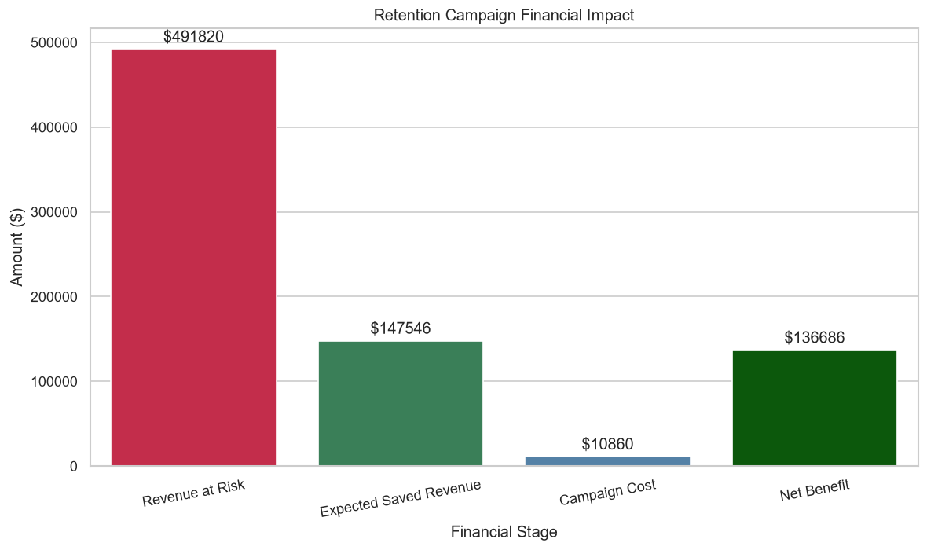
Figure 29: The financial value chain from revenue at risk through to net benefit.
19.4 Where the value sits
Segment | High-risk customers | Revenue at risk | Net benefit | Share of value
New High-Spend | 675 | $476 105.69 | $132 706.71 | 96.8 %
New Budget | 48 | $14 830.91 | $3 729.27 | 3.0 %
Established High-Value | 1 | $883.49 | $250.05 | 0.2 %
Established Budget | 0 | — | — | —
Table 42: High-risk population and revenue at risk by segment.
The concentration is striking and operationally useful: 96.8 % of the recoverable value sits in a single segment. New High-Spend customers combine the highest churn probability with substantial monthly revenue, so a campaign that addressed only this segment would capture almost all of the available benefit. The Established Budget segment contributes no high-risk customers at all, which is consistent with its 4.44 % churn rate.
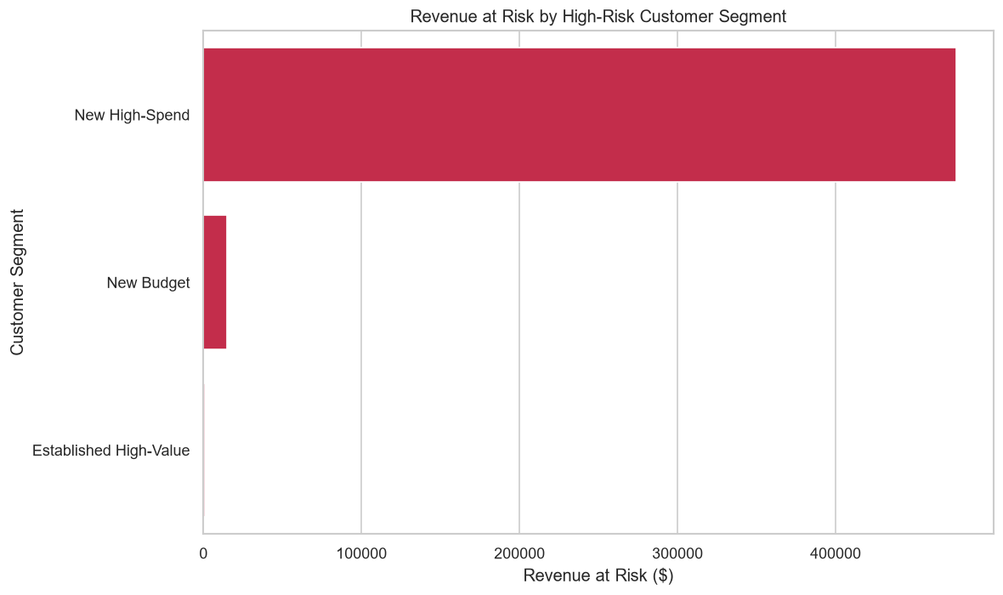
Figure 30: Revenue at risk by high-risk customer segment.
19.5 Driver-to-action mapping
Each targeted customer receives two things: the shared base offer, because all of them are on month-to-month contracts, and a lever-specific action chosen from their own SHAP attribution. The previous rule cascade tested contract first and so put all 732 targeted customers into one category; Section 22.3 records that correction.
df["SharedDriver"] = df["Contract"].eq("Month-to-month").map(
{True: "Month-to-month contract", False: "None"})
df["DominantRiskDriver"] = df["PrimaryLever"] # from phase 8 SHAP

def assign_retention_action(row):
lever_action = LEVER_ACTIONS.get(row["PrimaryLever"], "Personalised retention review")
if row["SharedDriver"] == "Month-to-month contract":
return f"{SHARED_ACTION} + {lever_action}"
return lever_action
Listing 23: Driver and action assignment in phase 9 after the second round.
Dominant driver (SHAP lever) | Lever-specific action | Customers | Revenue at risk | Net benefit
Billing and payment | Move to automatic payment with a billing reward | 333 | $207 612.36 | $57 288.71
Service quality | Service-quality audit with proactive fix and loyalty credit | 273 | $189 548.51 | $52 769.55
Price and plan fit | Plan right-sizing review and personalised tariff | 112 | $93 165.51 | $26 269.65
Protection and support | Complimentary tech-support and online-security trial | 4 | $810.58 | $183.17
Engagement and bundling | Bundled add-on offer to deepen product engagement | 2 | $683.13 | $174.94
Table 43: Recommendation mapping produced by phase 9. Every row also receives the shared contract offer.
Dominant driver | Onboarding window (0-12 months) | Established (13+ months)
Billing and payment | 292 | 41
Service quality | 257 | 16
Price and plan fit | 112 | 0
Protection and support | 4 | 0
Engagement and bundling | 2 | 0
Table 44: Targeted customers by driver and lifecycle stage. The lifecycle stage tells the team when to reach out; the lever tells them what to offer.
Three levers carry almost all of the value, and they are genuinely different conversations: 333 customers whose risk is driven mainly by billing (manual payment, paper billing), 273 driven by their fibre service, and 112 driven by price relative to what they get. The two small categories are a real result rather than noise to be forced larger: for the highest-risk customers, protection and bundling contribute little to predicted risk. The high-risk list also carries each customer's second lever, so a campaign team can combine offers where the top two contributions are close.
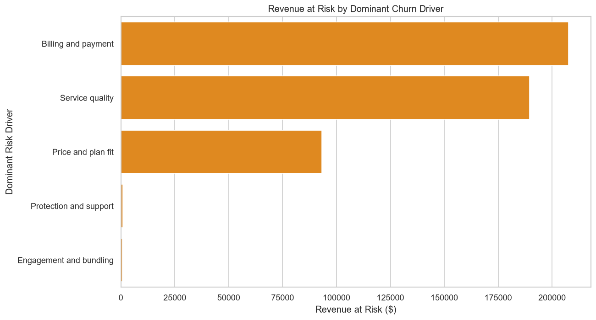
Figure 31: Revenue at risk by dominant churn driver after the second round. The chart now separates five driver categories instead of one.

20. The Streamlit Dashboard

20.1 Purpose and structure
The dashboard is the delivery layer. At 1 145 lines it is the largest single module in the project, and it reads every artefact the nine phases produce. It provides authenticated access, a set of analytical pages, and two scoring routes for customers the model has never seen. Modified during remediation so that scoring rebuilds features through the shared module.
Area | Function
Authentication | SQLite-backed accounts with SHA-256 password hashing; login gates every page
Executive overview | Base size, churn rate, revenue at risk and model headline metrics
Exploratory pages | The phase 3 charts with the churn-rate tables behind them
Segmentation | Segment profiles and the phase 5 charts
Model performance | The phase 7 comparison table and evaluation charts
Explainability | Global importance, SHAP summary and per-customer reason codes
Retention targets | The ranked high-risk list, downloadable as CSV
Batch scoring | Upload a CSV and score every row
Single customer | Enter one customer's attributes and score them
Table 45: Functional areas of the dashboard.
20.2 How scoring works after remediation
Both scoring routes now pass through one function, which rebuilds every model input from raw columns using the same code and the same fitted artefacts as the training pipeline:
def prepare_scoring_dataframe(uploaded_dataframe):
scoring_dataframe = uploaded_dataframe.copy()

feature_artifacts = load_feature_artifacts() # phase 4 tier edges
segmentation_model = load_segmentation_model() # phase 5 scaler+KMeans

if segmentation_model is None or feature_artifacts is None:
st.error("Run phases 4 and 5 to generate the required artefacts.")
st.stop()

# Engineered features, using the quartile edges fitted during training.
scoring_dataframe, _ = add_engineered_features(
scoring_dataframe, artifacts=feature_artifacts)

# Cluster and segment, assigned by the trained centroids.
scoring_dataframe = assign_clusters(scoring_dataframe, segmentation_model)

# The model was trained on the nominal form, so the encoder expects it.
return to_nominal_cluster(scoring_dataframe)
Listing 22: The corrected scoring path. The explicit artefact checks mean a missing model produces a clear instruction rather than a confusing prediction error.
The single-customer page still chooses its recommendation with a short rule cascade (contract, then tech support, then payment method). For one customer that is a single choice rather than a collapse, but it is not the SHAP-lever logic phase 9 now uses; Section 22.4 lists it as the one remaining inconsistency.
The single-customer page previously called the hand-written segment heuristic directly. It now routes through the same function, so a customer entered by hand and the same customer arriving in an uploaded file receive identical feature values and therefore identical predictions.
20.3 Verification
The dashboard was started in the virtual environment and its scoring path exercised against the retrained calibrated model.
Check | Result
Application starts | Yes — no import or load errors
Shared module resolves from app/ | Yes — PROJECT_ROOT is already on sys.path
Model input count | 26 features
All inputs reconstructed from raw columns | Yes — 0 missing
Engineered features supplied at scoring time | ServiceCount, Cluster, TenureBand, ARPU, ChargeRatio, ValueTier, AutoPayFlag
CustomerSegment passed to the model | No — label only
Batch scoring on 200 held-out rows | succeeded; probabilities 0.0251 to 0.7443, mean 0.2656
Table 46: Dashboard verification after remediation.
Running the dashboard.
From the working directory with the environment active: streamlit run app/app.py. The application opens on localhost:8501 and requires an account, which can be created from the login screen. All nine phases must have been executed first, because the dashboard reads their artefacts rather than recomputing anything.

21. Results — Before and After Remediation

21.1 Headline model performance
Metric (Tuned XGBoost) | Delivered | Final | Change | Reading
Test records | 353 | 1 409 | 4.0× | defect 1
Churners in test set | 94 | 374 | 4.0× | defect 1
ROC-AUC | 0.8349 | 0.8472 | +0.0123 | improved
PR-AUC | 0.6128 | 0.6632 | +0.0504 | the more meaningful gain at this imbalance
Recall | 0.7766 | 0.8262 | +0.0496 | misses fewer churners
Precision | 0.4932 | 0.4992 | +0.0060 | essentially unchanged
F1 score | 0.6033 | 0.6224 | +0.0191 | improved
Accuracy | 0.7280 | 0.7339 | +0.0059 | essentially unchanged
False negatives | 21 of 94 (22.3 %) | 65 of 374 (17.4 %) | −4.9 pp | proportionally fewer misses
95 % CI half-width (ROC-AUC) | ±0.053 | ±0.026 | halved | defect 1
Table 47: Selected-model performance as delivered and after both remediation rounds.
21.2 Structural changes
Property | Delivered | Final
Model matrix columns | 21 | 26
Segmented dataset columns | 25 | 31
Engineered features in the pipeline | 1 of 7 | 6 of 7 (duplicate flag excluded)
Leaked target information in the matrix | Yes (CustomerSegment) | No
Identical duplicate columns in the matrix | — | None (ContractRiskFlag removed)
Segment names derived from | observed churn rate | centroid geometry
Duplicate segment names | Yes ("New & Fragile 2") | No
Phase 6 vs phase 7 SVM accuracy | 0.7601 vs 0.7835 | 0.7850 vs 0.7850
Distinct phase 9 driver categories | 1 | 5
Serving-time segment assignment | hand-written threshold rule | trained K-Means centroids
Phase 9 recall constant | hard-coded 0.7766 | read from phase 7
Persisted artefacts | 3 | 5
Environment | none; xgboost missing | dedicated .venv
Table 48: Structural differences between the delivered and the final codebase.
21.3 Effect on the business layer
Quantity | Delivered | Final | Why it changed
Model recall used | 0.7766 (hard-coded) | 0.8262 (read) | larger hold-out and a better model
High-risk customers targeted | 723 | 724 | recalibrated model
Total revenue at risk | $490 176.80 | $491 820.10 | one more customer
Expected saved revenue | $147 053.04 | $147 546.03 | proportional
Campaign cost | $10 845.00 | $10 860.00 | 1 more offer
Net benefit | $136 208.04 | $136 686.03 | +$477.99
Retention ROI | 1 255.95 % | 1 258.62 % | materially unchanged
Projected churn rate | 20.36 % | 19.96 % | higher recall retains more customers
Driver / action categories | 1 | 5 | issue 6
Table 49: Business-layer outputs as delivered and after both remediation rounds.
The headline business numbers moved only slightly, which is the expected result and worth stating plainly. The targeting threshold and the campaign assumptions did not change, so the population selected is nearly the same. What did change is the standing of the figures: recall is now read from a measurement on a 1 409-record hold-out rather than hard-coded from a 353-record one, so the same conclusion now rests on four times the evidence and cannot silently go stale.
21.4 What the results support
The strongest claim the evidence supports is not the headline ROC-AUC. It is that three methodologically independent analyses agree about what drives churn in this base:
Finding | Exploratory analysis | Segmentation | Model importance
Contract type dominates | 42.71 % against 2.83 % across contract levels | implicit in segment separation | Contract_Month-to-month ranks 1st (0.2465)
Early tenure carries the highest risk | 52.94 % in months 0-6 | both new segments average under 16 months | TenureBand_0-6 ranks 5th
Product bundling protects | 5.28 % churn at six add-ons | loyal segment averages 4.16 services | streaming and support features throughout the top 20
Manual payment raises risk | 45.29 % on electronic check | not a clustering dimension | ranks 7th; top lever for 333 targets
Demographics do not matter | 0.76 pp gender gap | not a clustering dimension | gender absent from the top 20
Table 50: Convergence of three independent methods on the same five findings.
This convergence is what allows the retention strategy to be trusted. Any one method could be misled by an artefact of its own assumptions; three methods with different assumptions reaching the same conclusions is a far stronger position. It is also a conclusion that could not be drawn confidently before remediation, because the model's second-ranked feature was a label derived from the outcome.
21.5 Performance in context
A test ROC-AUC of 0.8472 sits at the upper end of the 0.83 to 0.86 band that published studies report on this dataset. The ceiling is a property of the data rather than the algorithm: the Telco dataset contains no behavioural telemetry — no support-ticket history, no network-quality measurements, no usage trend, no competitor pricing. It describes what a customer buys, not how they experience the service. That the leading models all converge just below 0.85 suggests the feature set, not the modelling, is the binding constraint.

22. Second-Round Corrections

The first revision of this report documented three issues outside the original remediation scope. All three have now been corrected. The affected phases (6, 7, 8 and 9) were re-executed in the virtual environment, and every result elsewhere in this report reflects the corrected code.
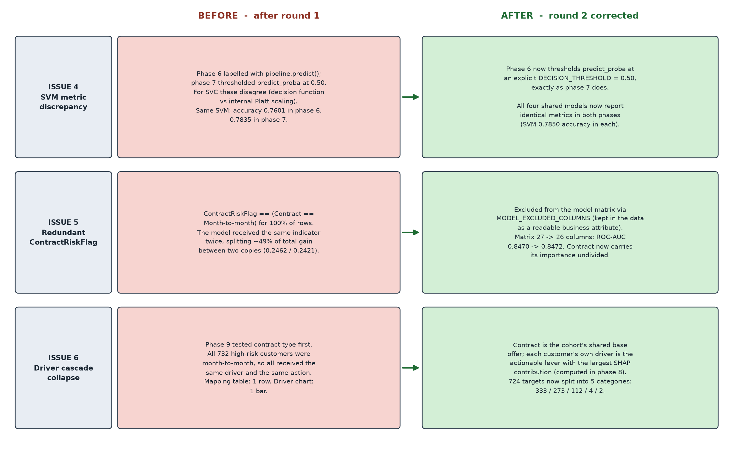
Figure 32: The three second-round issues and their corrections, side by side.
22.1 SVM metric discrepancy between phases 6 and 7
The issue. The two phases published different numbers for the same model on the same split: phase 6 reported the SVM at 0.7601 accuracy and 0.7834 recall, phase 7 at 0.7835 and 0.6150. Phase 6 labelled with pipeline.predict(); phase 7 thresholded predict_proba at 0.50. For SVC, predict() uses the sign of the decision function while predict_proba uses Platt scaling fitted by internal cross-validation, and scikit-learn documents that the two can disagree. Running both routes on one fitted SVM gave confusion matrices [778, 257, 81, 293] and [874, 161, 144, 230].
The correction. Phase 6 now labels predictions the same way phase 7 does, from an explicit constant:
DECISION_THRESHOLD = 0.50

predicted_probabilities = pipeline.predict_proba(X_test)[:, 1]
predicted_labels = (predicted_probabilities >= DECISION_THRESHOLD).astype(int)
...
best_predictions = (best_probabilities >= DECISION_THRESHOLD).astype(int)
Listing 27: Both label assignments in phase 6 now use the explicit threshold.
Model | Phase 6 accuracy | Phase 7 accuracy | Phase 6 recall | Phase 7 recall
Tuned XGBoost | 0.7339 | 0.7339 | 0.8262 | 0.8262
Logistic Regression | 0.7459 | 0.7459 | 0.7914 | 0.7914
Random Forest | 0.7587 | 0.7587 | 0.7807 | 0.7807
Support Vector Machine | 0.7850 | 0.7850 | 0.6070 | 0.6070
Table 51: After the correction the two phases agree exactly for every shared model.
Verification. No bare .predict() call remains in phases 6, 7 or 8. The selected model is unaffected: it is XGBoost, for which the two labelling routes were already equivalent.
22.2 Redundant ContractRiskFlag
The issue. ContractRiskFlag equals Contract == "Month-to-month" for 100 % of rows, and the one-hot encoding of Contract already produces that indicator. The model therefore received the same column twice. The two copies ranked first and second by gain (0.2462 and 0.2421). The model gained no information from the second copy, and a tree ensemble divides importance between identical columns arbitrarily, so both importance numbers were misleading.
The correction. The flag is excluded from the model matrix through the shared exclusion list. It is still computed in phase 4 and kept in the datasets, because as a readable yes/no attribute it is useful in reports and to the business.
MODEL_EXCLUDED_COLUMNS = [
"customerID", "Churn", "ChurnFlag",
"CustomerSegment", # round 1: leaked label
"ContractRiskFlag", # round 2: duplicate of Contract
]
Listing 28: The exclusion list in churn_features.py. Every phase and the dashboard build their matrix through it.
Check | With the flag | Without the flag
Model matrix columns | 27 | 26
Tuned XGBoost hold-out ROC-AUC | 0.8470 | 0.8472
Gain of the contract signal | split 0.2462 / 0.2421 | 0.2465, one column
Dashboard inputs reconstructed | 27 of 27 | 26 of 26
Table 52: Effect of removing the duplicate flag.
22.3 Driver cascade collapse in phase 9
The issue. Phase 9 picked a driver for each targeted customer with a rule cascade that tested contract type first. All 732 high-risk customers were on month-to-month contracts, so every one of them got the same driver and the same action. The recommendation mapping had one row and the driver chart had one bar, which left nothing to segment an outreach campaign by.
Why a simple SHAP swap would not have fixed it. The obvious fix is to use each customer's top SHAP feature, so that was tested first. Among the high-risk customers it produced only two categories (Contract 463, tenure 269). Excluding Contract still gave only two (tenure 503, InternetService 229). Tenure dominates because high-risk customers are new customers, and an offer cannot change how long someone has been a customer.
The correction. The fix separates what the whole cohort shares from what differs between customers:
1. Contract is the shared base driver. Every month-to-month customer receives the contract-migration offer.
2. Each customer gets a personal lever. Phase 8 computes SHAP for all customers, sums the one-hot columns back to their source feature and groups them into five actionable levers (Section 18.6). The lever with the largest contribution becomes that customer's driver and adds a lever-specific action.
3. Lifecycle stage is reported separately. Tenure decides when to reach out (onboarding window or established), not what to offer.
Driver category | Delivered (cascade) | Final (SHAP lever)
Month-to-month contract | 732 | — (shared base offer for all 724)
Billing and payment | 0 | 333
Service quality | 0 | 273
Price and plan fit | 0 | 112
Protection and support | 0 | 4
Engagement and bundling | 0 | 2
Distinct categories | 1 | 5
Table 53: Driver distribution among targeted customers before and after the correction.
Verification. The recommendation mapping now has five rows and the driver chart five bars (Section 19.5). Every targeted customer has a lever with a positive SHAP contribution, so no customer falls back to a generic action. Phase 9 checks that the driver file exists and covers every customer, and stops with a clear message if either check fails.
The small categories are left as they are.
Protection and support (4 customers) and Engagement and bundling (2) are small because, for the highest-risk customers, those features add little to predicted risk. Forcing a more even split would mean overriding what the model attributes, which would make the drivers less honest. The high-risk list also carries each customer's second lever, which a campaign team can use when the top two contributions are close.

22.4 Remaining limitations
These are properties of the data rather than defects in the code, but they bound what the system can claim.
- The single-customer dashboard page still uses a rule cascade. Batch scoring and phase 9 use the SHAP levers, but the page that scores one hand-entered customer still picks its recommendation by testing contract, tech support and payment method in turn. For one customer this does not collapse anything, but it is inconsistent with phase 9. Loading the SHAP explainer in the dashboard would align it.
- No temporal dimension. The dataset is a single cross-sectional snapshot with no observation window, prediction horizon or event date. The model therefore answers "does this customer resemble one who has left" rather than "will this customer leave in the next ninety days". A production system needs the second question, which requires time-stamped records.
- No behavioural telemetry. Support-ticket volume, network-quality incidents, usage trend and competitor pricing are all absent. These are typically the strongest churn predictors in telecommunications, and their absence is the most credible explanation for the performance ceiling this dataset consistently produces.
- ValueTier boundaries are fitted on the full dataset. Phase 4 computes ARPU quartiles across all 7 043 rows, including those that later become the test set. This is target-independent, so it does not inflate the churn metrics the way defect 2 did, but it is a mild form of information sharing. Fitting the edges on the training partition alone would be stricter.
- The threshold remains a convention. Phase 7 sweeps it and phase 9 targets at 0.65, but neither is derived from the actual cost ratio between a missed churner and a wasted offer, because no campaign-cost data exists to calibrate against.

23. Step-by-Step Execution Guide

23.1 Prerequisites
1. Python 3.10 or later on the system path. The pipeline was verified on 3.13.13.
2. Approximately 1.5 GB of free disk space for the virtual environment, which includes XGBoost, SHAP and Streamlit.
3. The raw dataset present at data/Customer-Churn.csv relative to the working directory.
4. At least 4 GB of available RAM. Phases 6 and 7 train ensembles with 2 000 estimators and parallelise across all cores.
23.2 Step 1 — Prepare the environment
REM Every script uses relative paths, so this must be the working directory.
cd "C:\Users\user\Desktop\Customer churn prediction\customer_churn_100\customer_churn"

python -m venv .venv
.venv\Scripts\activate

python -m pip install --upgrade pip
python -m pip install -r requirements.txt

REM Verify every import resolves before running any phase
python -c "import pandas, numpy, sklearn, matplotlib, seaborn, xgboost, shap, joblib, streamlit; print('environment ok')"
Listing 23: Environment preparation. The final check must print "environment ok" before proceeding.
23.3 Step 2 — Execute the phases in order
The scripts must run in numerical sequence, because each reads a file the previous one wrote. Note that phase 5 now requires phase 4 to have completed, and will exit with an explanatory message if it has not.
python phase1_data_understanding.py REM ~2 s console profile only
python phase2_data_cleaning.py REM ~3 s writes Cleaned.csv
python phase3_eda.py REM ~20 s writes 9 charts
python phase4_feature_engineering.py REM ~5 s writes features + artefacts
python phase5_customer_segmentation.py REM ~30 s writes Segmented.csv + model
python phase6_model_development.py REM ~4 min trains and tunes 5 models
python phase7_model_evaluation.py REM ~3 min evaluation + thresholds
python phase8_churn_probability_xai.py REM ~1 min calibration + SHAP
python phase9_business_recommendations.py REM ~10 s revenue impact

REM Then launch the dashboard
streamlit run app/app.py
Listing 24: The complete execution sequence with measured runtimes.
To run the whole pipeline unattended, chain the commands so a failure halts the sequence rather than letting later phases run against stale input:
REM PowerShell
foreach ($s in @("phase1_data_understanding", "phase2_data_cleaning",
"phase3_eda", "phase4_feature_engineering",
"phase5_customer_segmentation", "phase6_model_development",
"phase7_model_evaluation", "phase8_churn_probability_xai",
"phase9_business_recommendations")) {
Write-Host "=== $s ==="
python "$s.py"
if ($LASTEXITCODE -ne 0) { Write-Host "FAILED: $s"; break }
}
Listing 25: Unattended execution of the full pipeline.
23.4 Step 3 — Verify the outputs
After phase | Expected artefact | Verification
2 | data/Customer-Churn-Cleaned.csv | 7 044 lines including header
3 | 9 files charts/phase3_*.png | all present and non-empty
4 | data/Customer-Churn-Features-Unscaled.csv | 8 columns, 7 043 rows
4 | models/feature_engineering_artifacts.joblib | present — needed by the dashboard
5 | data/Customer-Churn-Segmented.csv | 31 columns — confirms the merge succeeded
5 | models/customer_segmentation_model.joblib | present — needed by the dashboard
6 | data/phase6_model_performance.csv | 6 lines: header plus 5 models
7 | data/phase7_threshold_analysis.csv | 18 lines: header plus 17 thresholds
8 | data/phase8_customer_churn_risk_predictions.csv | 7 044 lines
8 | data/phase8_customer_risk_drivers.csv | 7 044 lines; needed by phase 9
9 | data/phase9_high_risk_retention_targets.csv | 725 lines
9 | data/phase9_recommendation_mapping.csv | 6 lines — one per driver category
Table 54: Artefacts to verify after each phase. The phase 4 and 5 rows are the ones that confirm the remediation is in effect.
23.5 Step 4 — Score new customers
import sys, joblib, pandas as pd
sys.path.insert(0, ".")
from churn_features import add_engineered_features, assign_clusters, to_nominal_cluster

model = joblib.load("models/calibrated_churn_probability_model.joblib")
feature_artifacts = joblib.load("models/feature_engineering_artifacts.joblib")
segmentation_model = joblib.load("models/customer_segmentation_model.joblib")

new_customers = pd.read_csv("data/new_customers.csv")
new_customers["TotalCharges"] = pd.to_numeric(
new_customers["TotalCharges"], errors="coerce").fillna(0.0)

# Rebuild every feature exactly as training did
scored, _ = add_engineered_features(new_customers, artifacts=feature_artifacts)
scored = to_nominal_cluster(assign_clusters(scored, segmentation_model))

scored["ChurnProbability"] = model.predict_proba(
scored[model.feature_names_in_.tolist()])[:, 1]

# Rank by revenue at risk rather than probability alone
scored["RevenueAtRisk"] = scored["ChurnProbability"] * scored["MonthlyCharges"] * 12
scored.sort_values("RevenueAtRisk", ascending=False).head(200).to_csv(
"data/retention_priority_list.csv", index=False)
Listing 26: Scoring new customers outside the dashboard. Passing the artefacts is what keeps the features consistent with training.
23.6 Troubleshooting
Symptom | Cause | Resolution
ModuleNotFoundError: No module named 'xgboost' | environment not activated | .venv\Scripts\activate, then re-run
SystemExit: Required input not found: ...Features-Unscaled.csv | phase 5 run before phase 4 | run phase 4 first — this guard is part of the defect 3 fix
SystemExit: Engineered features are missing for some customers | stale feature file from an earlier dataset | re-run phase 4 to regenerate it
FileNotFoundError: data/Customer-Churn.csv | wrong working directory | cd into customer_churn_100/customer_churn
Dashboard: "Segmentation model not found" | phase 5 has not been run since remediation | run phase 5 to write the segmentation artefact
ModuleNotFoundError: No module named 'churn_features' | script run from outside the working directory | all phases must run with the project folder as cwd
SystemExit: Required input not found: ...risk_drivers.csv | phase 9 run before phase 8 | run phase 8 first
Phase 6 appears to hang | 150-fit randomized search in progress | expected; takes about 4 minutes. Reduce n_iter to shorten it
InconsistentVersionWarning on load | models pickled by a different scikit-learn | re-run phases 6 and 8 to regenerate them in this environment
Table 55: Common failure symptoms and their resolutions.

24. Conclusion

Six issues have been corrected over two rounds: the three specified defects and the three follow-up issues. Each correction was verified by re-running the pipeline, and the codebase now produces results that can be defended.
24.1 What was fixed
1. Hold-out sample size. TEST_SIZE moved from 0.05 to 0.20 in phases 6, 7 and 8, enlarging the test set from 353 records to 1 409 and the churner count from 94 to 374. The 95 % confidence interval on ROC-AUC halved, from ±0.053 to ±0.026. The split ratio is now printed from the constant, so the logs cannot again describe a configuration the code does not have.
2. Target information leakage. Segment naming now depends only on centroid geometry. The models receive the nominal Cluster code and never the churn-derived label, which is absent from the feature-importance ranking of the retrained model. The duplicate segment names were eliminated as a side effect.
3. Unused engineered features. Phase 4 exports unscaled features and phase 5 merges them with an integrity check. The engineered features now reach the models, and TenureBand ranks 5th by gain.
4. SVM metric discrepancy. Phase 6 labels predictions from predict_proba at an explicit threshold, so phases 6 and 7 now report identical metrics for every shared model.
5. Redundant ContractRiskFlag. Excluded from the model matrix (27 → 26 columns) with no loss: ROC-AUC 0.8470 → 0.8472.
6. Driver cascade collapse. Phase 9 takes each customer's driver from their top SHAP lever, with contract as the shared base offer. The 724 targets now span five driver categories instead of one.
Two consequential corrections were also required. Phase 9 no longer hard-codes the model's recall, and the dashboard no longer approximates the segment label with a hand-written rule — it uses the persisted K-Means model, which removes a train/serve mismatch that existed only because of the leakage.
24.2 What the corrected pipeline achieves
- Better measured performance on four times the evidence. ROC-AUC 0.8349 → 0.8472, recall 0.7766 → 0.8262, PR-AUC 0.6128 → 0.6632, all on a hold-out four times larger than before.
- Risk tiers that validate against outcomes. 78.04 % observed churn in the High Risk tier against 9.85 % in the Low Risk tier, with strictly monotonic ordering.
- Probabilities that mean what they say. Mean predicted probability 0.2652 against an observed base rate of 0.2654, with ranking quality preserved through calibration.
- Explanations built on legitimate, non-duplicated features. SHAP explanations no longer rest on a label derived from the outcome, and contract importance is no longer split between two identical columns.
- Retention actions that differ by customer. Five driver categories with distinct lever-specific offers, on top of a shared contract-migration base offer.
- A serving path that matches the training path. Every model input is rebuilt from raw columns by the same code, with zero missing features at scoring time.
24.3 Recommended next steps
1. Bring the single-customer dashboard page onto the SHAP levers. The one remaining place that chooses an action by rule cascade.
2. Calibrate the decision threshold against real campaign costs. The threshold sweep is already produced; it needs only a cost ratio to turn into an optimal operating point.
3. Validate the lever actions with a controlled campaign. The five actions are reasoned from what drives each customer's risk; a small A/B test per lever would measure which actually retain customers, and replace the 30 % success-rate assumption.
4. Acquire temporal and behavioural data. This is the change that would lift performance past the ceiling this dataset imposes, and the only one that would let the system answer the question a production deployment actually asks.
With both rounds of corrections applied, the pipeline has moved from a result that could not be defended in review — a ranking inside sampling noise, built partly on a feature derived from the answer — to one that can. The remaining items extend the system rather than repair it.

A. Appendix A — Configuration Reference

A.1 Path constants
Module | Constant | Value
phase 1 | FILE_PATH | data/Customer-Churn.csv
phase 2 | INPUT_FILE / OUTPUT_FILE | data/Customer-Churn.csv / data/Customer-Churn-Cleaned.csv
phase 3 | INPUT_FILE / OUTPUT_FOLDER | data/Customer-Churn-Cleaned.csv / charts
phase 4 | INPUT_FILE | data/Customer-Churn-Cleaned.csv
phase 4 | FEATURES_FILE | data/Customer-Churn-Features-Unscaled.csv
phase 4 | ARTIFACTS_FILE | models/feature_engineering_artifacts.joblib
phase 5 | INPUT_FILE / FEATURES_FILE | data/Customer-Churn-Cleaned.csv / the phase 4 export
phase 5 | SEGMENTATION_MODEL_FILE | models/customer_segmentation_model.joblib
phases 6-8 | INPUT_FILE | data/Customer-Churn-Segmented.csv
phase 9 | INPUT_FILE | data/phase8_customer_churn_risk_predictions.csv
phase 9 | EVALUATION_FILE | data/phase7_model_evaluation_results.csv
phase 9 | DRIVERS_FILE | data/phase8_customer_risk_drivers.csv
Table 56: Path constants. Entries in bold were added during remediation.
A.2 Analytical constants
Module | Constant | Value | Effect if changed
5-8 | RANDOM_STATE | 42 | changes cluster assignment, the split and every model result
5 | OPTIMAL_K | 4 | alters the number of behavioural segments
6, 7, 8 | TEST_SIZE | 0.20 | size of the hold-out; reverting to 0.05 reinstates defect 1
6 | CV_FOLDS | 5 | lower-variance estimate at higher runtime cost
6 | DECISION_THRESHOLD | 0.50 | label threshold; must match phase 7's DEFAULT_THRESHOLD
9 | ONBOARDING_WINDOW_MONTHS | 12 | boundary of the onboarding lifecycle stage
7 | DEFAULT_THRESHOLD | 0.50 | the operating point at which labels are assigned
8 | CALIBRATION_CV_FOLDS | 5 | folds used by Platt scaling
9 | HIGH_RISK_THRESHOLD | 0.65 | who enters the retention campaign
9 | CAMPAIGN_SUCCESS_RATE | 0.30 | stated assumption
9 | COST_PER_RETENTION_OFFER | 15.00 | stated assumption
9 | EXPECTED_REMAINING_TENURE_MONTHS | 12 | stated assumption
Table 57: Analytical constants and the effect of changing each.
A.3 Model hyper-parameters
Model | Configuration
Logistic Regression | penalty="l2", solver="liblinear", class_weight="balanced", max_iter=2000
Random Forest | n_estimators=2000, max_depth=10, min_samples_split=5, min_samples_leaf=2, class_weight="balanced"
Support Vector Machine | kernel="rbf", C=1.0, gamma="scale", probability=True, class_weight="balanced"
XGBoost baseline | n_estimators=2000, learning_rate=0.10, max_depth=6, subsample=0.85, colsample_bytree=0.85, scale_pos_weight computed
XGBoost tuned | RandomizedSearchCV over 10 parameters, n_iter=30, cv=5, scoring="roc_auc" — 150 fits
Phase 8 XGBoost | n_estimators=200, learning_rate=0.03, max_depth=3, min_child_weight=5, reg_lambda=2, wrapped in CalibratedClassifierCV
K-Means | n_clusters=4, n_init=10, random_state=42, fitted on three standardised dimensions
Table 58: Hyper-parameter configuration of every model in the codebase.

B. Appendix B — Complete Artefact Inventory

B.1 Datasets
File | Shape | Produced by | Consumed by
Customer-Churn.csv | 7 043 × 21 | supplied | phases 1, 2
Customer-Churn-Cleaned.csv | 7 043 × 21 | phase 2 | phases 3, 4, 5, 9
Customer-Churn-Features-Unscaled.csv | 7 043 × 8 | phase 4 | phase 5 (merged)
Customer-Churn-Model-Ready.csv | 7 043 × 36 | phase 4 | inspection only
Customer-Churn-Segmented.csv | 7 043 × 31 | phase 5 | phases 6, 7, 8, dashboard
phase6_model_performance.csv | 5 × 6 | phase 6 | reporting
phase7_model_evaluation_results.csv | 4 × 11 | phase 7 | phase 9, dashboard
phase7_threshold_analysis.csv | 17 × 5 | phase 7 | dashboard
phase8_customer_churn_risk_predictions.csv | 7 043 × 11 | phase 8 | phase 9, dashboard
phase8_global_feature_importance.csv | 27+ × 2 | phase 8 | dashboard
phase8_high_risk_customer_reason_codes.csv | 5 × 6 | phase 8 | dashboard
phase8_customer_risk_drivers.csv | 7 043 × 10 | phase 8 | phase 9
phase9_high_risk_retention_targets.csv | 724 × 21 | phase 9 | dashboard
phase9_financial_impact_summary.csv | 13 × 2 | phase 9 | dashboard
phase9_recommendation_mapping.csv | 5 × 5 | phase 9 | dashboard
Table 59: Datasets produced by the pipeline. Bold entries were added during remediation.
B.2 Serialised models
File | Contents | Written by | Used by
best_churn_model.joblib | fitted Pipeline: ColumnTransformer + tuned XGBClassifier | phase 6 | dashboard
calibrated_churn_probability_model.joblib | CalibratedClassifierCV wrapping the full pipeline | phase 8 | dashboard scoring
feature_engineering_artifacts.joblib | ARPU quartile edges fitted on the training data | phase 4 | dashboard
customer_segmentation_model.joblib | fitted StandardScaler, KMeans and the segment name map | phase 5 | dashboard
enhanced_churn_model.joblib | unknown — no script in the folder writes this file | unknown | nothing
Table 60: Serialised artefacts. Bold entries were added during remediation.
The last row deserves a note. enhanced_churn_model.joblib was present in the delivered project, but no script in the folder produces a file of that name and nothing reads it. Its provenance, training data and performance are unknown. It was left in place because removing files is outside the remediation scope, but an unexplained model artefact in a deliverable folder is a reproducibility hazard: a future reader has no way to tell which of the saved models is authoritative. It should either be regenerated by a documented script or deleted.
B.3 Generated charts
Phase | Charts | Count
Phase 3 | univariate analysis; churn by contract, payment method, internet service, senior citizen, tech support, tenure band; correlation heat map; tenure-charges scatter | 9
Phase 5 | elbow method; silhouette scores; cluster profiles; customer segments scatter | 4
Phase 6 | ROC curves; confusion matrix; feature importance | 3
Phase 7 | overlay ROC curves; precision-recall curves; all confusion matrices; model comparison; threshold trade-off | 5
Phase 8 | calibration curve; risk-tier distribution; global feature importance; SHAP global summary | 4
Phase 9 | revenue at risk by segment; revenue at risk by driver; retention financial impact | 3
Table 61: All 28 charts generated by the pipeline, by phase.

End of report.

