IPT ASSIGNMENT

SUBMITTED BY

Raghav Mehrotra(RA171100801266)

# Create your simple Django application using python.

Open command promt:

**cd documents**

**django-admin startproject myproject**

**cd myproject**

**python -m pip install django**

**python manage.py startapp polls**

**cd polls**

**view.py**

Write your first view code in **polls/view.py** file

from django.http import HttpResponse

def index(request):

return HttpResponse("Hello, world. You're at the polls index.")

**type NUL > urls.py**

**urls.py**

Write code in **polls/urls.py** file

from django.urls import path

from . import views

urlpatterns = [

path('', views.index, name='index'),

]

**//inside project directory (myproject)**

**cd ../myproject**

**urls.py**

The next step is to point the root URLconf at the **polls.urls** module. In **myproject/urls.py**,

add an import for **django.urls.include** and insert an **[include()](https://docs.djangoproject.com/en/2.1/ref/urls/" \l "django.urls.include" \o "django.urls.include)** in the **urlpatterns** list

from django.contrib import admin

from django.urls import include, path

urlpatterns = [

path('polls/', include('polls.urls')),

path('admin/', admin.site.urls),

]

Now run in command prompt

**C:\Users\Raghav\Desktop\myproject>python manage.py runserver**

**<http://127.0.0.1:8000/>**

**<http://127.0.0.1:8000/admin/>**

**<http://127.0.0.1:8000/polls/>**

**Message Board Application using Django**

Open command prompt

**cd documents**

**django-admin startproject nb_project**

**cd nb_project**

// Create new app called posts inside project

**python manage.py startapp posts**

**cd nb_project**

**settings.py (add ‘posts’)**

INSTALLED_APPS = [

'django.contrib.admin',

'django.contrib.auth',

'django.contrib.contenttypes',

'django.contrib.sessions',

'django.contrib.messages',

'django.contrib.staticfiles',

'posts'

]

**cd ..**

**python manage.py migrate**

**python manage.py runserver**

**Ctrl + C**

**cd posts**

**models.py**

//to create database model where we can store the display post

from django.db import models

class Post(models.Model):

text = models.TextField()

//to activate model migrate file

**cd ..**

**python manage.py makemigrations posts**

**python manage.py migrate posts**

**python manage.py createsuperuser**

Username (leave blank to use 'piyush'):

Email address: (//not necessary)

Password:

Password (again):

Superuser created successfully.

**//Restart your Django server using following command**

**python manage.py runserver**

<http://127.0.0.1:8000/admin/>

login now using your credentials

**Ctrl+C**

// To display our posts app in admin main page

**cd posts**

**admin.py**

// add this code

from django.contrib import admin

from .models import Post

admin.site.register(Post)

**//check Django for post now**

**cd ..**

**python manage.py runserver**

http://127.0.0.1:8000/

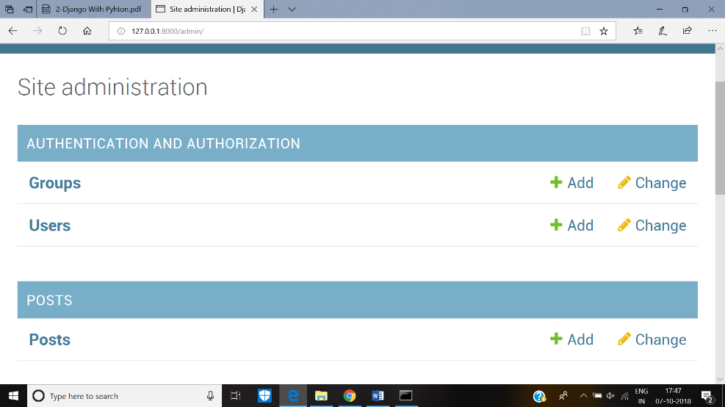

//Click on the post and add different posts

//To modify the model add str method in **posts/models.py**

from django.db import models

class Post(models.Model):

text = models.TextField()

def __str__(self):

return self.text[:50]

//check Django using **python manage.py runserver**

//To display database content to our homepage code views.py and create template

//now create templates directory using command prompt

**mkdir templates**

**type NUL > home.html**

//add with following code

<h1>Message Board Homepage</h1>

<ul>

{% for post in object_list %}

<li>{{post}}</li>

{%endfor%}

</ul>

// In **nb_project/settings.py** update DIRS Field for templates folder

**cd ../nb_project**

**settings.py**

TEMPLATES = [

{

'BACKEND': 'django.template.backends.django.DjangoTemplates',

'DIRS': [os.path.join(BASE_DIR,'templates')],

'APP_DIRS': True,

'OPTIONS': {

---

--- },

// add this code in **posts/views.py**

**cd ../posts**

**views.py**

from django.shortcuts import render

from django.views.generic import ListView

from .models import Post

class HomePageView(ListView):

model=Post

template_name = 'home.html'

context_object_name = 'all_posts_list'

// Create a new app url file inside posts folder **posts/urls.py** and insert the following code

**type NUL > urls.py**

**urls.py**

from django.conf.urls import url

from .views import HomePageView

urlpatterns = [

url('', HomePageView.as_view(),name='home'),

]

// include url in your project urls file i.e **nb_project/urls.py**

**cd ../nb_project**

**urls.py**

from django.contrib import admin

from django.urls import path

from django.conf.urls import include,url

urlpatterns = [

url('admin/', admin.site.urls),

url('',include('posts.urls')),

]

**python manage.py runserver**

**<http://127.0.0.1:8000/>**

## Output

