Optimization of Pyramidal Reaction Wheel Configuration for Minimizing Angular Momentum

Raghav Mahajan
Department of Mechanical Engineering
Vellore Institure of Technology
Vellore, India
raghav.mahajan2023@vitstudent.ac.in

Vedant Singh
Deparment of Mechancial Engineering Vellore Institute of Technology
Vellore, India
vedant.singh2023b@vitstudent.ac.in

Pranav Subhash
Deparment of Mechancial Engineering Vellore Institute of Technology
Vellore, India
pranav.subhash2023@vitstudent.ac.in

Abstract— many spacecraft using more than 3 reaction wheels for both redundancy and extra maneuverability capabilities. Actuators configuration plays an effective role in the performance of the attitude control system. This paper deals with the management of 4 reaction wheels used simultaneously in the pyramidal configuration. Due to the saturation phenomenon, it is very important to minimizing the angular momentum in the case of using momentum exchange devices. Therefore this paper investigates the best tilt-angle of wheels in pyramidal configuration to perform the maneuver with minimum angular momentum.
Index Terms— Attitude control system, Momentum management, Over actuated spacecraft, Reaction wheel configuration,
- Introduction
Reaction wheels are cost-effective actuators commonly used in attitude control systems of spacecraft to perform high- precision, high-accuracy, and agility. At least three reaction wheels (RWs) are needed for 3-axis attitude control of the spacecraft [1]. Nevertheless, despite all the well-known advantages of RWs they suffer from momentum saturation and bearing failure [2]. If one RW becomes damaged, then the satellite's attitude can no longer be adequately controlled. Obviously, replacing any hardware in space is very risky and expensive, if not impossible [3]. Thus, the principles of product assurance and reliability are of utmost importance in the space industry. The most practical solution to deal with reaction wheel failure is using an extra wheel as the hardware redundancy. Accordingly, Many spacecraft employ more than three wheels, both for (i) redundancy and for the (ii) additional maneuvering capability of the extra wheels [4]. Among all the configuration of 4 reaction wheels, pyramidal configuration is more practical case, which also attracted huge attention. Figure 1 shows 4 RWs in the pyramidal configuration.
Shirazi investigated the optimal RWs tilt-angle in the pyramidal configuration in a minimum power consumption point of view [5] Jin focused on fault-tolerant control method

ss
based on dynamics inversion and time-delay control approach for satellites with four reaction wheels in pyramidal configuration [6]. Reynolds stated that Spacecraft reaction wheel maneuvers are limited by the maximum torque and/or angular momentum which the wheels can provide in each direction. He analyzed 4 RWs momentum envelope (workspace) specifications in different configurations [7].
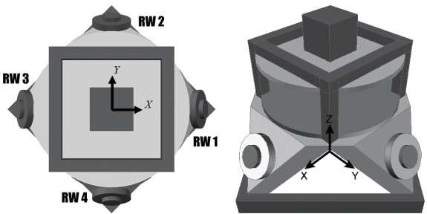
Figure 1. Pyramidal configuration of 4 RWs
Lebedev and Hogan designed a control strategy to obtain perfect tracking attitude control with continuous momentum dumping based on 4-RWs [8, 9]. Kron studied several ways for optimal and simultaneous use of 4-RWs to achieve high pointing-accuracy in the presence of torque and angular velocity constraints [10]. Zhang designed a controller based on sliding mode observer to eliminate RWs misalignment and installation deviation in pyramidal configuration [11]. Several configurations based on four reaction wheels are investigated in order to identify the most suitable configuration that provides maximum pointing accuracy by Ismail [12]. Schaub developed a power-optimal RW torque distribution strategy that minimizes the instantaneous electrical power requirements [13]. He claimed that the proposed control strategy is able to reduce the amount of mechanical power and energy required by about 10– 20%, while only marginally increasing the average required torque. Blenden developed an analytical instantaneous power-

optimal attitude control for a spacecraft using an integrated RW array system allowing for energy storage and return [14]. He showed that in the case of over actuated attitude control system it is possible to regenerate electrical power in RWs slowing down phase.
In the case of using reaction wheel array, minimization of the wheels' angular momentum is a matter of great concern in order to prevent frequent saturation and control performance degradation. However, no discussion is made about the 4-RWs angular-momentum-minimization strategy in pyramidal configuration so far, despite being of great theoretical and practical interest. Therefore, the question of which tilt-angle of RWs performs maneuver with minimum angular momentum
1
𝑞˙₂ = 2 (𝑞₃𝜔_{𝑥} − 𝑞₄𝜔_{𝑦} − 𝑞₁𝜔_{𝑧})
1
𝑞˙₃ = 2 (−𝑞₂𝜔_{𝑥} + 𝑞₁𝜔_{𝑦} + 𝑞₄𝜔_{𝑧})
1
𝑞˙₄ = 2 (−𝑞₁𝜔_{𝑥} − 𝑞₂𝜔_{𝑦} − 𝑞₃𝜔_{𝑧})
Quaternion parameters are less intuitive, so the simulation results will be transferred to the Euler angles according to the Eq. (3), at the end.
2(𝑞₁𝑞₂ + 𝑞₃𝑞₄)
∅ = 𝑎𝑟𝑐𝑡𝑎𝑛 ( )
2 2 2 2
𝑞1 − 𝑞2 − 𝑞3 + 𝑞4

has remained unanswered. The main goal of this paper is to find the optimum RWs tilt-angle in pyramidal configuration to
perform the maneuver with minimum angular momentum.
𝜃 = −arcsin(2(𝑞₂𝑞₄ − 𝑞₁𝑞₃))
2(𝑞₁𝑞₄ + 𝑞₂𝑞₃)
3 = arctan( )
2 2 2 2
𝑞 + 𝑞 − 𝑞 − 𝑞
(3)

1 2 3 4

This paper is organized as follows: the rigid spacecraft attitude dynamics and kinematic equations are presented in section 2. The conventional PD-based "quaternion-error" controller is proposed in the 3rd section. simulation-based optimization of the RWs tilt-angle and angular momentum minimization strategy are presented in chapter 4. Finally, the conclusions are summarized in Section 5.
- EQUATION OF MOTION
Rigid spacecraft dynamic and kinematic will be modeled in this section
- Dynamic Modeling
The dynamic equation of a rigid spacecraft equipped with reaction wheels can be found in many references. We used the dynamic equation presented in [4] by Sidi because of familiar notations.
𝑇_{𝑥} = ℎ˙𝑥 + ℎ˙w𝑥 + (𝜔_{𝑦}ℎ_{𝑧} + 𝜔_{𝑧}ℎ_{𝑦}) + (𝜔_{𝑦}ℎ_{w𝑧} + 𝜔_{𝑧}ℎ_{w𝑦})
C. Reaction Wheels Control Strategy
Reaction wheels configuration plays an important role in the performance and character of the attitude control system. In comparison with other configurations of 4 RWs, the Pyramidal configuration has some advantages in the implementation phase. RWs tilt-angle (𝛽) can be optimized to achieve a special goal such as minimum power consumption, minimum tracking error, or heist agility. In this paper, we will optimize 𝛽 to perform the maneuver with minimum angular momentum. Wheels tilt-angle in the pyramidal configuration is shown in figure 2.

𝑇_{𝑦} = ℎ˙𝑦 + ℎ˙w𝑦 + (𝜔_{𝑧}ℎ_{𝑥} + 𝜔_{𝑥}ℎ_{𝑧}) + (𝜔_{𝑧}ℎ_{w𝑥} + 𝜔_{𝑥}ℎ_{w𝑧})
𝑇_{𝑧} = ℎ˙𝑧 + ℎ˙w𝑧 + (𝜔_{𝑥}ℎ_{𝑦} + 𝜔_{𝑦}ℎ_{𝑥}) + (𝜔_{𝑥}ℎ_{w𝑦} + 𝜔_{𝑦}ℎ_{w𝑥})
(1)

where 𝑇 = [𝑇 , 𝑇 , 𝑇 ]𝑇є ³ represents total torque (control
𝑥 𝑦 𝑧
and disturbance torque) applied to the body frame. ℎ_{w} =
𝑇
[ℎ_{w𝑥}, ℎ_{w𝑦}, ℎ_{w𝑧}] є ³ is RWs angular momentum. ℎ =
[ℎ , ℎ , ℎ ]𝑇є ³ is spacecraft body angular momentum. 𝜔 =
𝑥 𝑦 𝑧
[𝜔 , 𝜔 , 𝜔 ]𝑇є ³ denotes body angular velocity with respect to
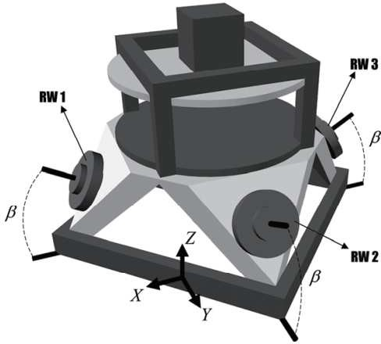
𝑥 𝑦 𝑧

the inertia frame.
- Kinematic modeling
The quaternion parameters 𝑸 = [𝑞₄, q^{𝑇}]^{𝑇}є × ³ are used to define the spacecraft's attitude orientation between the body- fixed frame and the inertial frame due to their non-singularity.
Figure 2. Tilt-angle of RWs in a pyramidal configuration
The torques delivered by the wheels are called 𝑇_{𝑖} = [𝑇₁, 𝑇₂, 𝑇₃, 𝑇₄]^{𝑇}є ⁴ and should be converted to the control torques along the three body axes. Thus we have the following relations:

The kinematic equations of a spacecraft are given in Eq. (2) [4].
𝑇_{𝐶}𝑥
𝑐𝛽
0 −𝑐𝛽 0
𝑇₁

𝑞˙
= 1 (𝑞 𝜔

− 𝑞 𝜔

+ 𝑞 𝜔 ) (2)
[𝑇𝐶𝑦] = [ 0
𝑐𝛽
0 −𝑐𝛽 𝑇2 (4)
3
] [𝑇 ]

1 2 4 𝑥
3 𝑦
2 𝑧
𝑇_{𝐶}𝑧
𝑠𝛽
𝑠𝛽
𝑠𝛽
𝑠𝛽
𝑇₄

Where 𝑠𝛽 = sin(𝛽) and 𝑐𝛽 = cos(𝛽). The control torque vector is computed by the quaternion error approach described in Section III. We can calculate the components 𝑇_{𝑖}, which are the control torques to be applied by each one of the four wheels as follows:
𝑇_{𝑖} = 𝐴∗𝑇_{𝐶} (5)
Where 𝐴∗ is the pseudo inverse of the coefficient matrix.
- Controller design
Here we used the standard PD-type controller called "quaternion error" introduced in [4]. In this control approach, the control torques are formulated as follows:
𝑇𝐶𝑥 = −2𝐾𝑝𝑥q𝐸1q𝐸4 − 𝐾𝑑𝑥𝝎𝑒x
- RWs Incidence Angle Optimization
Optimization will be done based on simulation results in this section. Because the RWs power consumption, angular momentum and saturation time are deeply dependent to the maneuver type (high-angle maneuver, agile maneuver, slow maneuver and etc.), we considered the following maneuver types to ensure our achievements based on simulation results. Shirazi considered only one maneuver ([𝜙_{𝑐𝑜𝑚}, 𝜃_{𝑐𝑜𝑚}, 3_{𝑐𝑜𝑚}] = [30,20, −40]𝑑𝑒𝑔) to find the optimal tilt-angle which minimizes the power consumption[5]. As shown in table I, We are considered a maneuver envelope, including all the possible rest- to-rest maneuvers similar to what was selected in reference [5].
TABLE I. Maneuver Envelope
Maneuver Maneuver
Number [3𝑐𝑜𝑚, 𝜃𝑐𝑜𝑚, 𝜙𝑐𝑜𝑚] Number [3𝑐𝑜𝑚, 𝜃𝑐𝑜𝑚, 𝜙𝑐𝑜𝑚]

𝑇𝐶𝑦 = −2𝐾𝑝𝑦q𝐸2q𝐸4 − 𝐾𝑑𝑦𝝎𝑒𝑦
𝑇𝐶𝑧 = −2𝐾𝑝𝑧q𝐸3q𝐸4 − 𝐾𝑑𝑧𝝎𝑒𝑧
(6)

1 [30,20, −40]𝑑𝑒𝑔 4 [20, −40,30]𝑑𝑒𝑔

where
𝑇
[𝑇_{𝑐}𝑥, 𝑇_{𝑐}𝑦, 𝑇_{𝑐}𝑧]
є ³
denotes the control torque, q_{𝐸}є ×
2 [20,30, −40]𝑑𝑒𝑔 5 [−40,30,20]𝑑𝑒𝑔
3 [30, −40,20]𝑑𝑒𝑔 6 [−40,20,30]𝑑𝑒𝑔

³ is the attitude error quaternion between (i) current and (ii) desired attitude quaternions, as presented in Eq. (7), and

𝑇
𝝎_{𝑒} = [𝜔_{𝑒}𝑥, 𝜔_{𝑒}𝑦, 𝜔_{𝑒}𝑧]
є ³
is the angular velocity error vector, as
The dynamic, kinematic, and controller have been simulated
in Simulink. Specifications of the spacecraft and orbital

𝑇
presented in Eq. (8). [𝐾_{𝑝}𝑥, 𝐾_{𝑝}𝑦, 𝐾_{𝑝}𝑧]
𝑇
and [𝐾_{𝑑}𝑥, 𝐾_{𝑑}𝑦, 𝐾_{𝑑}𝑧]
are
elements are presented in table II.

proportional and derivative gains, respectively.
TABLE II. Simulation Data

𝑞𝑇1 𝑞𝑇2 𝑞𝑇3 𝑞𝑇4 𝑞S1
Parameter | Data
Spacecraft Specification
Spacecraft Category Mini Satellite
Mission Earth Observation
4.2 0 0
Moments of inertia matrix 𝐼 = [ 0 4.4 0 ] [kg𝑚²]
0 0 4.2
Mass 100 kg
Initial attitude [𝜙₀, 𝜃₀, 3₀] = [0,0,0] 𝑑𝑒𝑔
Initial angular body rate [𝑝₀, 𝑞₀, 𝑟₀] = [0,0,0] rad/sec
Orbital Elements
Orbit Type Circular
Altitude 540 km
Orbital frequency 0.0011 rad/sec
Period 7.6317e+03 s
Inclination 85 deg
Actuator Specification
Actuator Type 4 Reaction Wheels in Pyramidal Config.
Maximum Torque 0.05 Nm
Maximum Rate 5000 RPM
Moment of Inertia 4.2e-4
Controller Parameters
𝐾_{𝑝}𝑥 = 1.05 𝐾_{𝑝}𝑦 = 1.1 𝐾_{𝑝}𝑧 = 1.05
𝐾_{𝑑}𝑥 = 4.2 𝐾_{𝑑}𝑦 = 4.4 𝐾_{𝑑}𝑧 = 4.2

1 −𝑞𝑇2 𝑞𝑇1 𝑞𝑇4 −𝑞𝑇3] [𝑞S2
(7)

q𝐸 = 2 [−𝑞𝑇3 −𝑞𝑇4 𝑞𝑇1 𝑞𝑇2
−𝑞𝑇4 𝑞𝑇3 −𝑞𝑇2 𝑞𝑇1
𝑞S3]
𝑞S4

where q_{𝐸}, 𝑞_{𝑇𝑖} and 𝑞_{𝑆𝑖}, (i=1,2,3,4) are the attitude error quaternions, desired attitude quaternions, and the satellite's current attitude quaternions, respectively.
𝝎_{𝑒} = 𝝎 − 𝝎_{𝑑} (8)
Where 𝝎 denotes the satellite's current body angular velocity

vector, and
𝑇
𝝎_{𝑑} = [𝜔_{𝑑}𝑥, 𝜔_{𝑑}𝑦, 𝜔_{𝑑}𝑧]
є ³
denotes desired angular

velocity vector.
Appropriate proportional and derivative gains to generate sufficient control torques can be calculated as following[4].

X channel 𝑘_{𝑝}𝑥
= 𝜔²𝐼

𝑘_{𝑑}𝑥
= 2𝜉𝜔_{𝑛}𝐼_{𝑥}

Y channel 𝑘𝑝𝑦
𝑛 𝑥
𝑛 𝑦
𝑛 𝑧
= 𝜔²𝐼
𝑘_{𝑑}𝑦
= 2𝜉𝜔_{𝑛}𝐼_{𝑦}
(9)

Z channel 𝑘_{𝑝}𝑧
= 𝜔²𝐼
𝑘_{𝑑}𝑧 = 2𝜉𝜔_{𝑛}𝐼_{𝑧}

where 𝐼 refers to the moment of inertia of each channel. 𝜔_{𝑛} denotes closed-loop system natural frequency and 𝜉 is the closed-loop damping ratio. In fact, 𝜔_{𝑛} and 𝜉 determine the behavior of satellite controlled motion. We selected 𝜔_{𝑛} = 0.5 and 𝜉 = 1 to achieve the fastest and smooth (Non-oscillating) response[4].


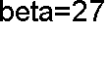
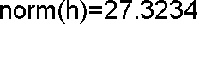
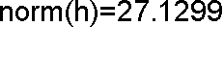
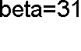
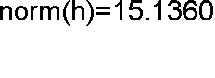
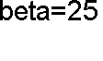
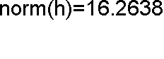
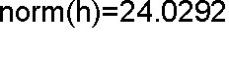
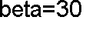
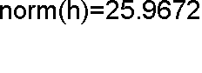
Figure 3 shows the block diagram of the attitude control system simulation.
Optimal Tilt-angle (deg)

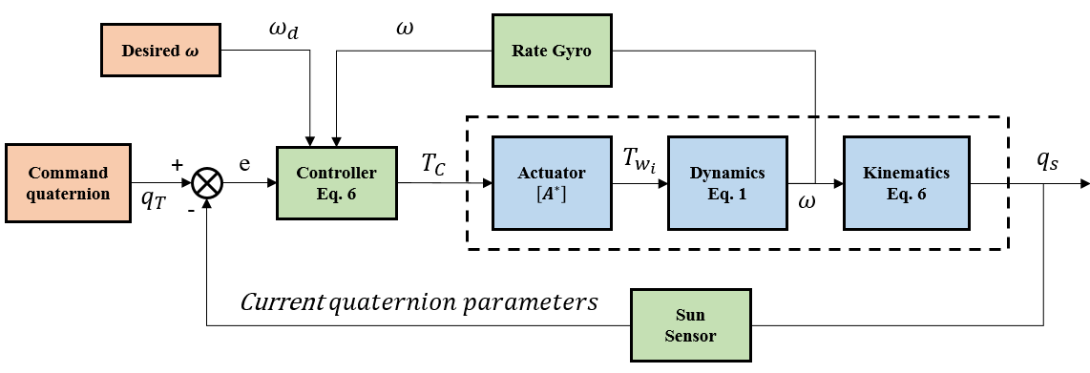
Figure 3. Block diagram of the attitude control system
Variation of RWs array angular velocity with respect to the tilt- angle is depicted in Figure 4.










Figure 4. Block diagram of the attitude control system
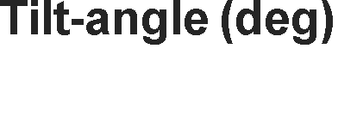









According to the figure 4 it can be claimed that minimum RWs array angular momentum achieves in almost 𝛽 = 25° 𝑡𝑜 33° for most of the maneuvers.
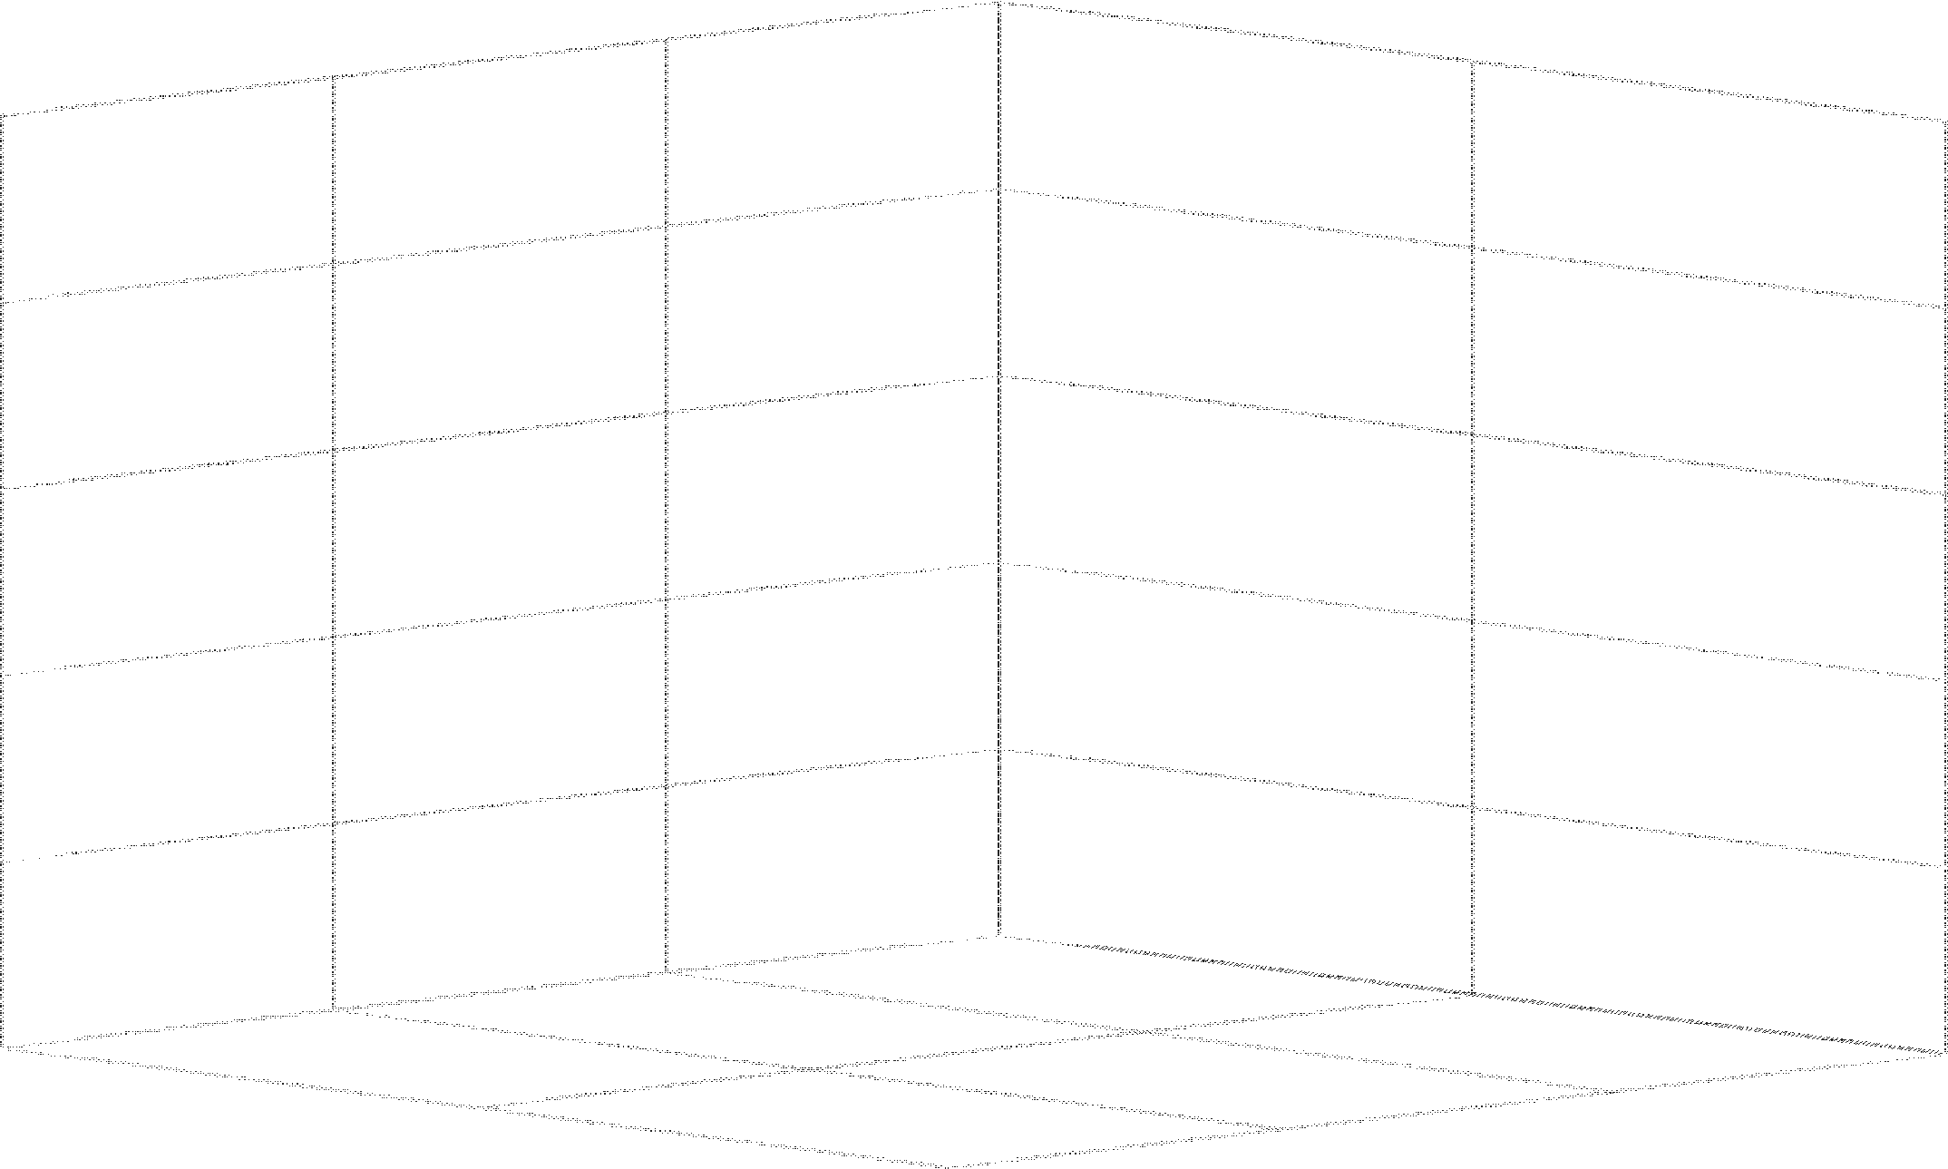
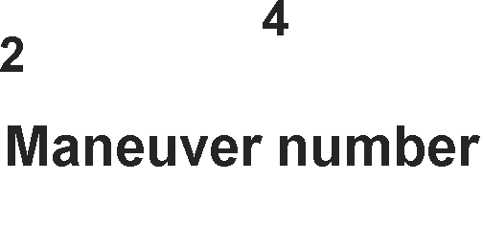


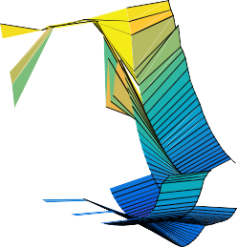

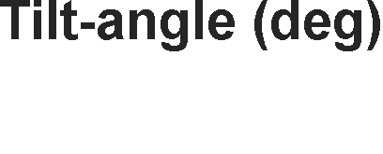







The following figure shows a 3D plot (3D view of figure 4), which is useful to find out the behavior of tilt-angle and wheels array angular momentum with respect to the maneuver type.

Figure 5. RWs array angular momentum as a function of wheels tilt-angle based on maneuver type.
We tried to surmise the useful data of Figures 4 and 5 by presenting figure 6. Figure 6 shows the minimum angular momentum norm of the wheels array and their corresponding tilt-angle for each maneuver.
Figure 6. The exact amount of optimal tilt-angle and angular momentum of wheels array.
Attitude pointing accuracy is one of the most important problems for almost all space missions. We cannot ignore the attitude control system's accuracy in wheels array configuration design. Table III presents the norm of steady-state error attitude response, which was obtained in the case of using optimum tilt- angles were introduced in figure 6.
TABLE III. Comprehensive Data of attitude control system's performance
No. | ‖ℎ_{w}‖_{𝑚𝑖𝑛} [Nms] | Tilt-angle [deg] | 𝑒_{𝑠𝑠} [rad]
1 | 27.3234 | 27 | 1.0281e-11
2 | 27.1299 | 27 | 9.04e-11
3 | 15.1360 | 31 | 1.0064e-13
4 | 16.2638 | 25 | 2.5265e-14
5 | 24.0292 | 31 | 7.9838e-11
6 | 25.9672 | 30 | 1.0067e-10

According to table III it can be claimed that 𝛽 = 28.5° is the average of optimal tilt-angles and can be the best option to perform maneuver envelope presented in table I with minimum angular momentum and acceptable pointing error.

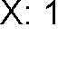
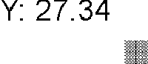
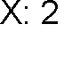
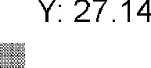
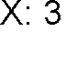
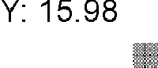
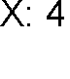
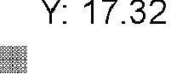
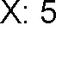
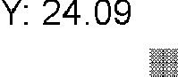
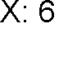
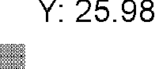
Therefore we defined 𝛽 = 28.5° as the optimal tilt-angle for performing maneuver envelope with minimum wheels angular momentum. Thus, we now need to evaluate the attitude control system's performance in 𝛽 = 28.5°. The following figure shows the norm of wheels angular momentum in different maneuvers based on 𝛽 = 28.5°.

Figure 7. RWs array angular momentum norm based on 𝛽 = 28.5°
norm(hw)

Steady-state pointing error norm in different maneuvers based on 𝛽 = 28.5° is depicted in figure 8.

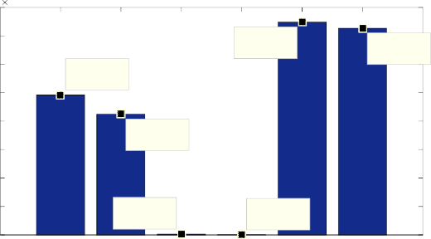
8
10-9
X: 4
Y: 2.914e-12
X: 3
Y: 3.285e-11
X: 2
Y: 4.248e-09
X: 1
Y: 4.923e-09
X: 6
Y: 7.274e-09
X: 5
Y: 7.487e-09

7
steady-state error norm (deg)

6

5

4

3
Figure 10 shows the 3D plot of the ouler angles time history.

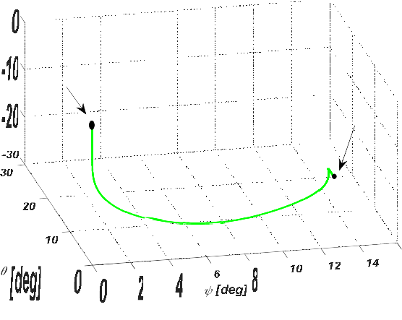

2
start
stop
Figure 10. Euler angles 3D time response
[deg]

1

0
1 2 3 4 5 6
Maneuver Number
Figure 8. Attitude pointing error norm based on 𝛽 = 28.5°

According to figure 7 and 8 we are allowed to choose 𝛽 = 28.5° the optimal tilt-angle for both (i)minimizing the wheels array angular momentum and (ii)achieving suitable pointing-accuracy as a tradeoff.
Following figures show the time-history of output in 50 seconds. It should be noted that the simulation condition is considered as table IV.

Figure 11 presents the norm of RWs array angular momentum.

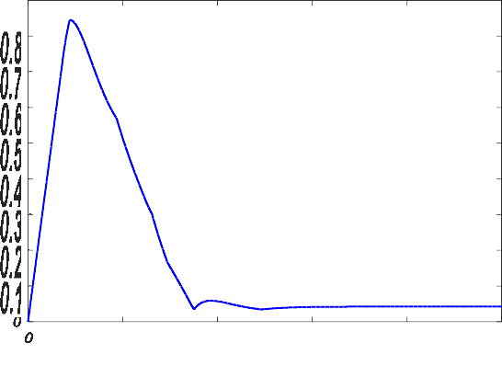
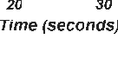



- Simulation data

Figure 11. Norm of the RWs angular momentum
RWs angular momentum norm
Statement | Emount
Initial condition | [𝜙₀, 𝜃₀, 3₀] = [0,0,0] 𝑑𝑒𝑔
RWs incidence angle | 𝛽 = 28.5°
Desired attitude | [𝜙_{𝑑}, 𝜃_{𝑑}, 3_{𝑑}] = [−30,20,15] 𝑑𝑒𝑔
Gravity gradient distrubance | 𝑇 = 3𝜇 (𝐼 − 𝐼 ) sin(2𝜙) 𝑐𝑜𝑠²(𝜃)  𝑑𝑥 2𝑟3 𝑧 𝑦  0  𝑇 = 3𝜇 (𝐼 − 𝐼 ) sin(2𝜃) cos(𝜙)  𝑑𝑦 2𝑟3 𝑧 𝑥  0  𝑇 = 3𝜇 (𝐼 − 𝐼 ) sin(2𝜃) sin(𝜙)  𝑑𝑧 2𝑟3 𝑥 𝑦  0

Euler angles of the satellite during maneuver is presented in figure 9.

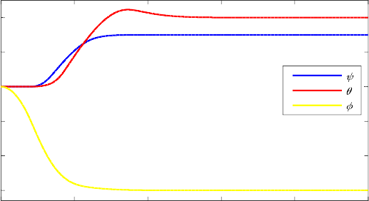
20


10

0

-10

-20

-30
0 10 20 30 40 50
Time [sec]
Figure 9. Euler angles time response
- Conclusion
Reaction wheels configuration plays an important role in the character and performance of the attitude control system. The location and tilt-angle of the wheels can be optimized to achieve any specific purpose (minimum pointing error, minimum power consumption, minimum control effort or maximum agility). In this paper, the authors investigated the optimum tilt-angle of 4 reaction wheels located in pyramidal configuration to perform a preselected maneuver envelope with minimum angular momentum. Based on simulation results, it can be claimed that
𝛽 = 28.5° is the optimal tilt-angle from the wheels array angular momentum point of view.
References
- Nudehi SS, Farooq U, Alasty A, et al., editors. Satellite attitude control using three reaction wheels. 2008 American Control Conference; 2008: IEEE.
- Wertz JR. Spacecraft attitude determination and control. Vol. 73. Springer Science & Business Media; 2012.

- Chaurais JR, Ferreira HC, Ishihara JY, et al. Attitude control of an underactuated satellite using two reaction wheels. 2015;38(10):2010- 2018.
- Sidi MJ. Spacecraft dynamics and control: a practical engineering approach. Vol. 7. Cambridge university press; 1997.
- Shirazi A, Mirshams MJIJoA, Sciences S. Pyramidal reaction wheel arrangement optimization of satellite attitude control subsystem for minimizing power consumption. 2014;15(2):190-198.
- Jin J, Ko S, Ryoo C-KJCEP. Fault tolerant control for satellites with four reaction wheels. 2008;16(10):1250-1258.
- Reynolds R, Markley FL. Maximum Torque and Momentum Envelopes for Reaction Wheel Arrays. 2001.
- Hogan EA, Schaub HJJoG, Control,, Dynamics. Three-axis attitude control using redundant reaction wheels with continuous momentum dumping. 2015;38(10):1865-1871.
- Lebedev DJJoC, International SS. Momentum unloading excessive reaction-wheel system of a spacecraft. 2008;47(4):613-620.
- Kron A, St-Amour A, de Lafontaine JJIPV. Four reaction wheels management: Algorithms trade-off and tuning drivers for the proba-3 mission. 2014;47(3):9685-9690.
- Zhang A, Ni J, Karimi HRJMPiE. Reaction wheel installation deviation compensation for overactuated spacecraft with finite-time attitude control. 2013;2013.
- Ismail Z, Varatharajoo RJAiSR. A study of reaction wheel configurations for a 3-axis satellite attitude control. 2010;45(6):750-759.
- Schaub H, Lappas VJJJog, control,, dynamics. Redundant reaction wheel torque distribution yielding instantaneous l2 power-optimal spacecraft attitude control. 2009;32(4):1269-1276.
- Blenden R, Schaub HJJog, control,, dynamics. Regenerative power- optimal reaction wheel attitude control. 2012;35(4):1208-1217.

