AutoSongSegmentLabel

User Manual

1. Introduction
AutoSongSegmentLabel is a program to segment zebra finch songs into its constituent syllables and organize the resulting syllables with appropriate labels.

Zebra finch song basically consists of a sequence of vocalizations. Individual sound units are called syllables and the short silent periods between consecutive syllables are called gaps. Most syllables are produced during expiration and the gaps correspond to short inhalations. Except for the very early stages of vocalization in juvenile birds, all other stages are characterized by syllables with well-defined acoustic characteristics. These acoustic characteristics can be visualized using a spectrogram – a representation of the time-frequency characteristics of the sound produced.

To start the program, change directory to the directory with all the songfiles that have to be segmented and labeled and type
>> AutoSongSegmentLabel
in the command window.
You will see a window like the one shown below. Each of the panel groups, the associated buttons and functions are described in detail below.

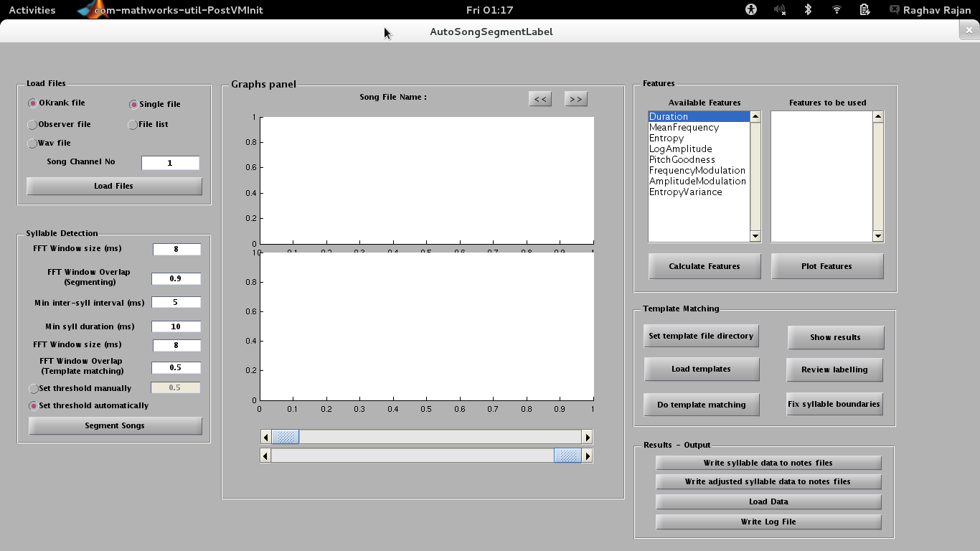

2. Load Files panel:

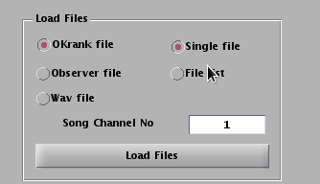
This panel is present at the top left corner has all the functions required to load data files.
- First you have to specify the file type by choosing one of 3 choice buttons on the left side. “Okrank file” is the default choice. To change this to either “Observer file” or “Wav file”, click on the appropriate button.
- Second you have to choose the format for the list of files to be analyzed. If you have only one file, then choose “Single file”. This is the default choice. If you have multiple files that need to be analyzed, make a text file that lists the names of all of the files to be analyzed. The text file should have only one file name in each row. It is important to make sure this file is a plain-text file and not a Word .doc file or any other word processor file. Such plain text files can be generated using matlab itself. Type
>> edit FileName.txt
where “FileName.txt” can be replaced with whatever name you choose to give the file. The name should be a good description of the files being analyzed. For eg. if you are analyzing songs produced by the bird, y10y95 (yellow 10 yellow 95 – these correspond to the bands on the legs of the bird. These bands are used to identify individual birds with the colour of the band and the numbers on the band) on 13th July 2013 in the undirected condition, name the text file “y10y95.13Jul2013.UnDir.SongFiles.txt”. It is important to be consistent with naming not only to ensure uniformity across all data sets, but also to make it easy to automate further stages of analysis. You can then use Matlab's editor window to enter the names of each of the files that have to be analyzed. Note, that there can only be one file name on each row. Once you have finished entering all the file names, save the file and close it.
The text file with the list of files has to be in the same directory as the data files. The program also needs to be run from within this directory. The text file has to be a plain text file with a .txt extension.

- Next, type the song channel number in the window next to “Song channel no”. If the data files only contain sound recordings from the microphone then type 1. If the data files have sound recordings combined with other types of recordings like neural recordings, type the number of the channel that contains sound recordings. You should know this if you had recorded the data. If you don't know it, then try different numbers from 1 to 32 and then look at the resulting spectrograms to see which one looks like sound recordings.
- Finally, after you've done all of this, click on the “Load Files” button. If you had chosen “Single file”, then clicking on the “Load Files” button will produce a pop-up that looks like this:
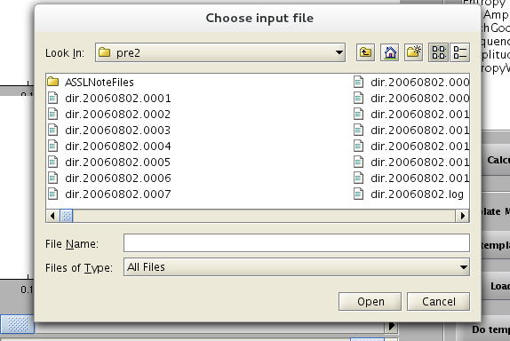
Choose the file that needs to be analyzed and click “Open” to continue.

If you have chosen to load a “File list”, then clicking on “Load Files” will produce a pop-up that looks like this:
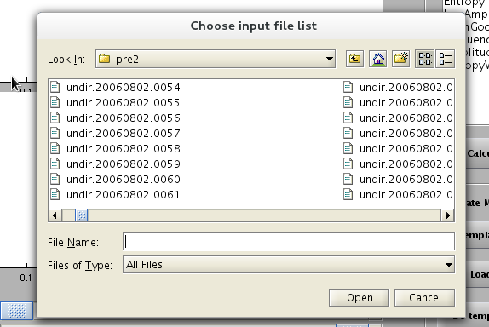
Choose the appropriate file list and then click on “Open”.

Once you click on “Open”, the program will load the names of all of the files to be analyzed. It will also display a spectrogram and the amplitude waveform of the first file (only file, if you chose to analyze only a single file) in the top and bottom axes windows of the Graphs panel. The main program window will now look like this.

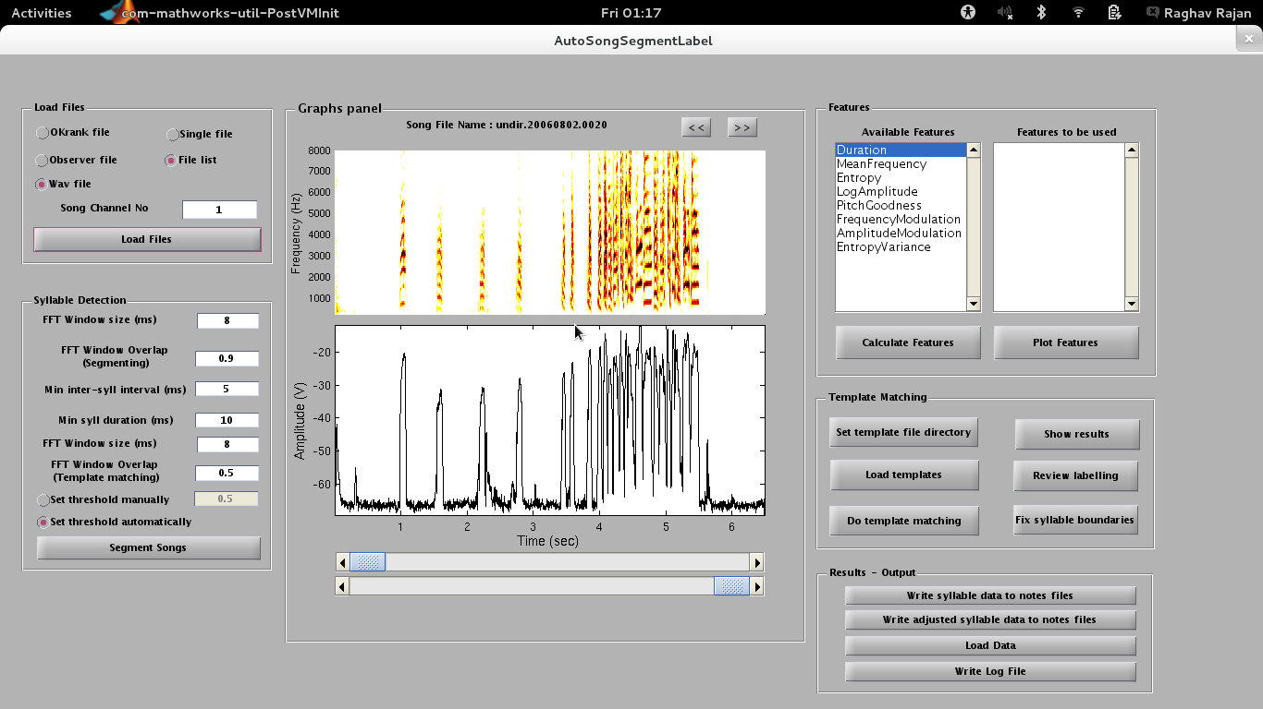

3. Graphs panel:
The top and the bottom plot display the spectrogram and the corresponding log amplitude waveform respectively for one file. The name of the file being displayed is shown on top of the spectrogram plot. The “<<” and “>>” buttons can be used to display different files in the list. Clicking the “<<” button will display the spectrogram and log amplitude waveform of the previous file in the list, while clicking the “>>” button will display the spectrogram and log amplitude waveform of the next file in the list.

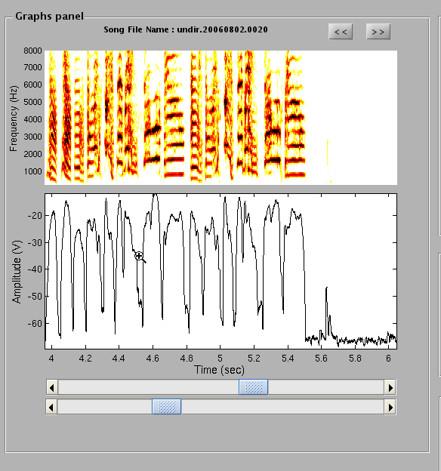
The two sliders below the amplitude waveform plot can be used to adjust the start time and the plot duration for the two plots. For eg. to look at the period from time t=4 to time t=6 sec. in greater detail, the sliders could be adjusted and the resulting plots and slider positions would like this:

4. Syllable detection panel:
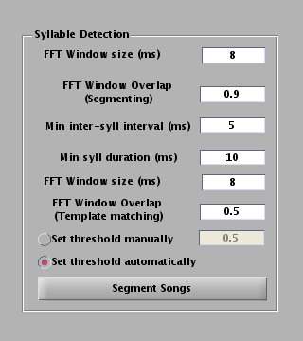
This panel contains all the parameters used for calculating the log amplitude waveform that is displayed in the bottom plot of the Graphs panel.

Click on “Segment Songs” to divide the file into syllables and gaps. The resulting syllables and gaps will be displayed both in the spectrogram window and the log amplitude waveform window as blue rectangles along with the spectrograms and the log amplitude waveforms. Again, these displays are only for one file. You can use the “<<” and the “>>” buttons to look at the segmenting results for the other files. The number of syllables detected for each file will also be displayed in the main command window.

The Graphs panel will look this now.

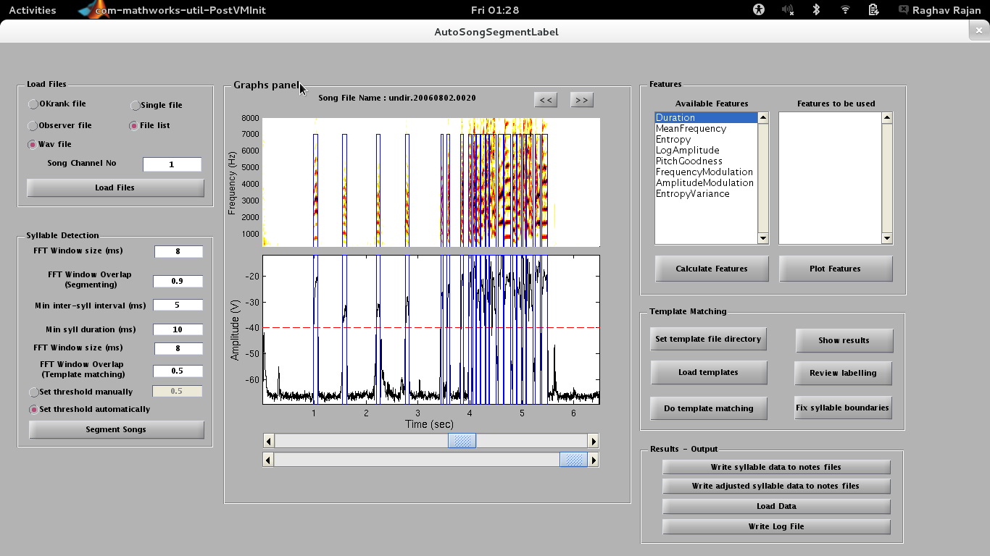
Note: the threshold used to detect syllables is shown as a red “dashed” line in the log amplitude plot window.
5. Features panel:

6. Template Matching panel:
Clicking on the “Review labelling” button brings up a window that can be used to review the results of template matching. This window and associated buttons, graphs, etc. are discussed in detail in section 6.2.
6.2 Review labelling window

The review labelling window can be used to examine the results of template matching. After template matching, each syllable identified is assigned a character label. This label is assigned using the following procedure:
- Each syllable is compared to one of the template syllables and a number (similarity value) measuring the similarity of the syllable and the template syllable is calculated.
- This process is repeated for each of the template syllables.
- All the resulting similarity values are compared and the syllable is assigned the character label corresponding to the template syllable with the highest similarity value.
- If the highest similarity value is less than 1, then the syllable is assigned '0' as the character label indicating that it is not similar to any of the template syllables. Similarity values below 1 can occur randomly, but this has to be refined in future to use a better way to decide on the cut-off.
- This process is repeated until all the syllables have been assigned a character label.

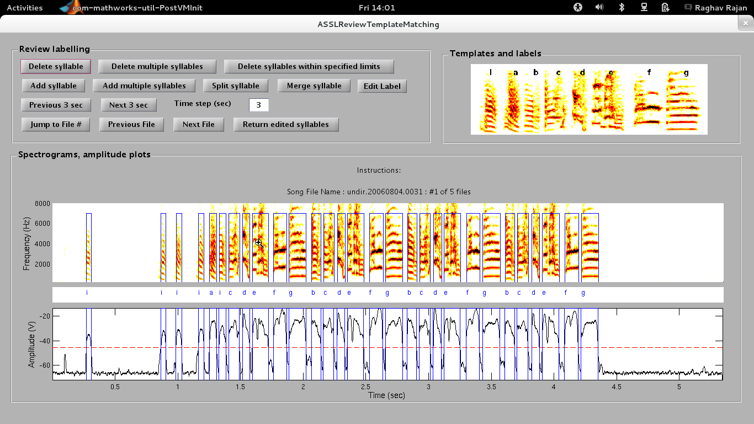

The assignment of labels is an automatic process designed to help increase the speed of song labeling. The above window helps to manually recheck the assigned labels and correct any errors if present. The error-rate has not been quantified as yet – something to be done.

The “Template Matching Review” window by default opens up with the spectrogram, log amplitude plot and assigned labels for all syllables in the first file. The window has the following panels:

    - Review labelling panel:
This panel has all the buttons required for reviewing and editing the syllable boundaries and labels. It also has a button for returning all the edited boundaries and labels to the main program window, so that all of the changes can be written to file.

It is very important to return all of the changes that you have made to the main program by clicking on the “return edited syllables” button. Then you have to write all of the data to files using buttons in the “results – output” panel in the main window. If you close the “Template matching review” window without returning the edited syllables, depending on the number of files that you are analyzing, you may need to go get yourself a few cups of coffee/tea and start again, as you will have to do it all again!!

For all the buttons that are used for editing syllable boundaries or editing syllable labels, instructions are also provided in the Spectrograms, amplitude plots panel after you click on the button.
After clicking on any of the buttons in this panel, you w
a) Delete syllable: This button is used to delete entire syllables. If there is a single syllable that you want to delete, click on this button and then click within the syllable that needs to be deleted.
b) Delete multiple syllables: If you need to delete multiple syllables that are not

    - Templates and labels panel:
    - Spectrograms, amplitude plots panel:

7. Results – Output panel:

