IILM UNIVERSITY, GREATER NOIDA
School of Computer Science and Engineering
INDUSTRIAL / SUMMER INTERNSHIP REPORT
on
C++ PROGRAMMING AND CONSOLE APPLICATION DEVELOPMENT
One-Month Remote Internship Programme
Submitted in partial fulfilment of the requirements for the award of the degree of
BACHELOR OF TECHNOLOGY in COMPUTER SCIENCE AND ENGINEERING
Name of Student | RAGHAV RATHI
Class / Section | 2CSE23
Year | 2nd Year
Semester | 3rd Semester
Host Organisation | VirtualWorks Lab (an educational initiative by Noivrn)
Internship Domain | C++ Programming
Duration | 09 September 2026 – 09 October 2026 (30 Days)
Academic Session 2026–27

Candidate's Declaration
I, RAGHAV RATHI, a student of B.Tech. (Computer Science and Engineering), 2nd Year, 3rd Semester, Class 2CSE23, IILM University, Greater Noida, hereby declare that this report titled “C++ Programming and Console Application Development” is a genuine record of the one-month remote internship undertaken by me with VirtualWorks Lab (an educational initiative by Noivrn) between 09 September 2026 and 09 October 2026.
I further declare that the console-based applications discussed in this report — the Number Guessing Game, the Hotel Management System, the Tic-Tac-Toe Game, and the Contact Management System — were designed and coded by me as the deliverables of this internship, and that this document has been compiled independently by me for academic submission.
Signature: ____________________________
Name: RAGHAV RATHI
Class / Section: 2CSE23

Acknowledgement
I would like to place on record my sincere thanks to VirtualWorks Lab and the Noivrn team for the opportunity to work on a structured, project-based C++ internship over the past month. The assignments pushed me to move past textbook exercises and build applications that a user could actually run, break, and expect to keep working correctly.
I am especially grateful for the mentorship and feedback provided during the programme, which helped me improve not just my code but also my approach to planning, testing, and documenting a small project from start to finish.
I also thank the School of Computer Science and Engineering, IILM University, Greater Noida, for encouraging students to pursue industry-style internships alongside coursework, and my family for their constant support through the duration of this programme.
Signature: ____________________________
Name: RAGHAV RATHI

Internship Offer Letter
The offer letter issued by VirtualWorks Lab confirming the internship placement is reproduced below.
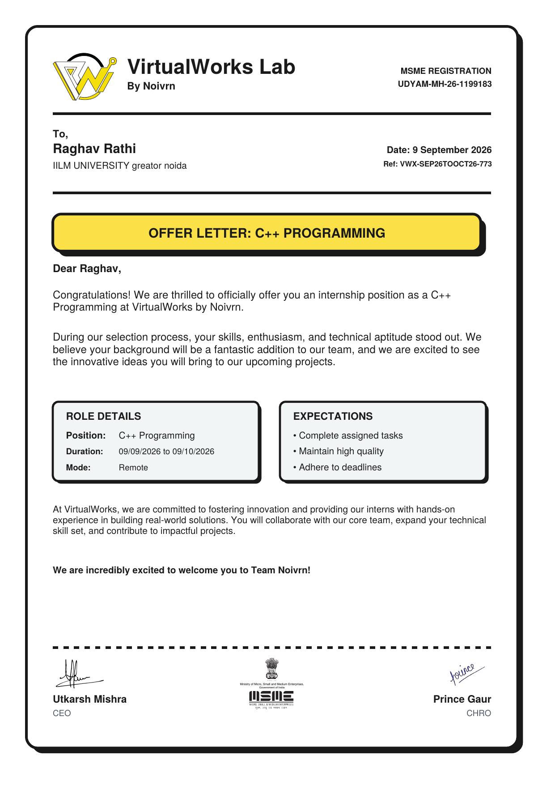

Certificate of Completion
The certificate of completion issued by VirtualWorks Lab on conclusion of the internship is reproduced below, along with the accompanying performance evaluation report.
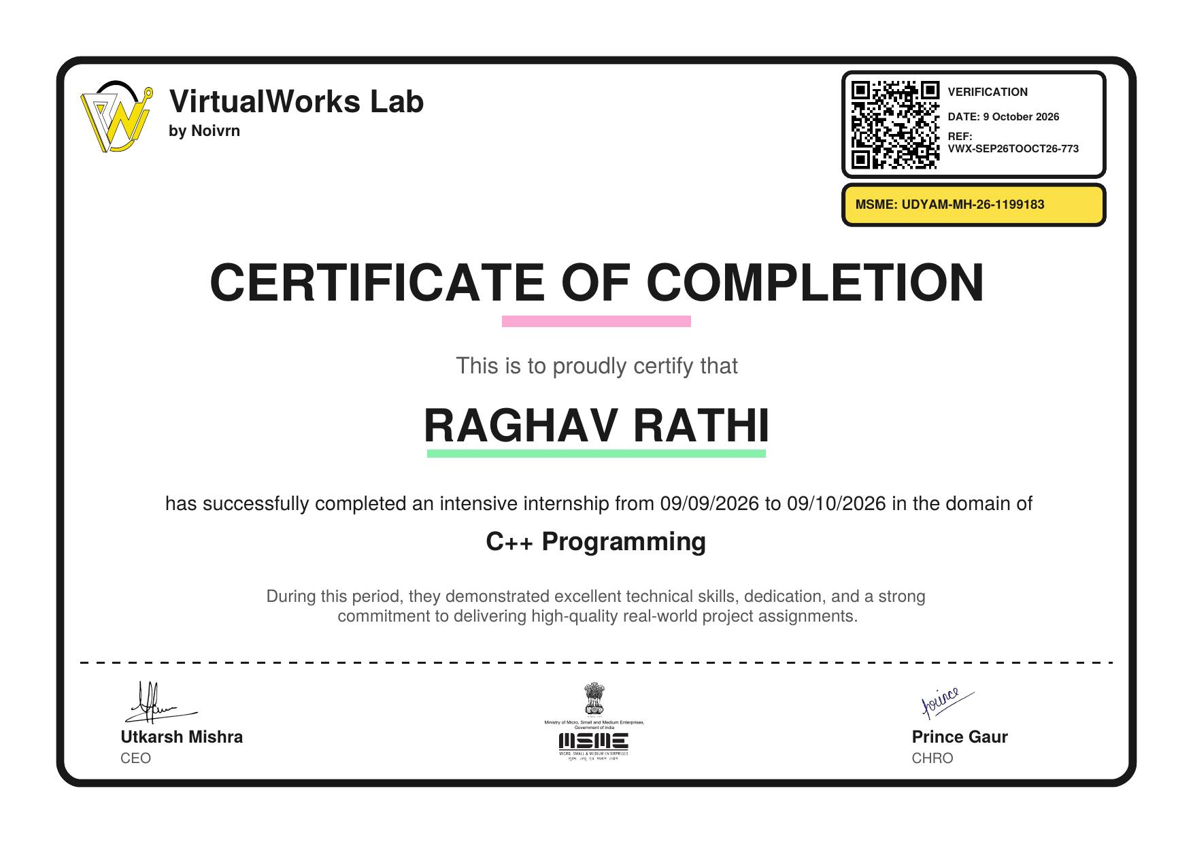
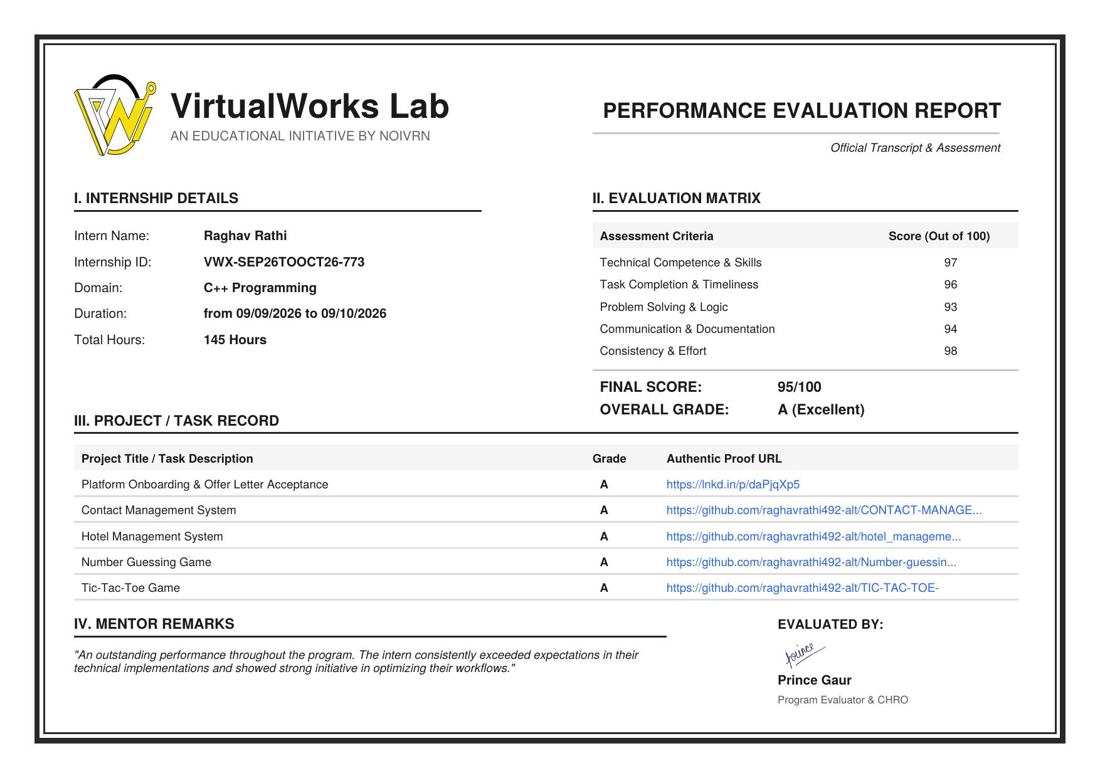

Table of Contents
Candidate's Declaration i
Acknowledgement ii
Internship Offer Letter iii
Certificate of Completion iv
Chapter 1: Introduction 1
Chapter 2: About the Host Organisation 2
Chapter 3: Objectives and Scope 3
Chapter 4: Tools and Technologies 4
Chapter 5: Working Method 5
Chapter 6: Project Work 6
6.1 Number Guessing Game 6
6.2 Hotel Management System 7
6.3 Tic-Tac-Toe Game 8
6.4 Contact Management System 9
6.5 Summary of Deliverables 10
Chapter 7: Testing Approach 10
Chapter 8: Outcomes and Reflection 11
Chapter 9: Possible Extensions 11
Chapter 10: References 12

Chapter 1: Introduction
This report documents a one-month remote internship in C++ programming completed with VirtualWorks Lab, an educational initiative run by Noivrn. The internship was structured around building four self-contained console applications, each targeting a different set of core programming concepts — from randomised logic and iterative interaction to structured records with file-based persistence.
Rather than treating each task as an isolated exercise, every assignment was expected to behave like a small real application: it needed to accept realistic input, handle mistakes gracefully, and produce output a non-programmer could read and trust. This report walks through the organisation, the objectives, the tools used, and each of the four projects, before closing with the outcomes and possible extensions of the work.

Chapter 2: About the Host Organisation
VirtualWorks Lab is an educational internship initiative operated by Noivrn, registered under the Ministry of Micro, Small and Medium Enterprises (MSME) as Udyam registration UDYAM-MH-26-1199183. It runs short, remote, project-based internship programmes aimed at early-stage engineering students, with an emphasis on producing working code rather than passive lecture-style content.
The programme assigns interns a small sequence of increasingly involved tasks, tracks task-wise completion against a public code repository, and closes with a documented performance evaluation and certificate. This report's internship reference number, VWX-SEP26TOOCT26-773, and the accompanying offer letter and certificate are included in the preceding section.

Chapter 3: Objectives and Scope

3.1 Objectives
- Reinforce core C++ syntax — loops, conditionals, functions, arrays, and strings — through complete, working programs rather than isolated snippets.
- Practise designing menu-driven, console-based user interaction.
- Use randomisation to build an interactive, replayable game.
- Model a two-dimensional game board and implement win/draw detection logic.
- Use C++ file streams to persist structured records (customers, bookings, contacts) between runs of a program.
- Build the habit of testing a program against normal, boundary, and invalid inputs before considering a task complete.

3.2 Scope
The work covered in this internship is limited to beginner-to-intermediate, single-user, console-based C++ applications intended for learning rather than production deployment. Persistence, where implemented, uses plain text files rather than a database; there is no authentication, concurrency handling, or graphical interface. Sections 4.10 and later applications' 'possible extensions' notes describe how each project could be taken further.

Chapter 4: Tools and Technologies
Tool / Concept | Role in the Internship
C++ (Standard Library) | Primary language for all four applications
iostream | Console menus, prompts, and result output
fstream | Reading and writing persistent records for the hotel and contact systems
cstdlib rand() / srand() | Random target-number generation for the guessing game
Arrays & 2D arrays | In-memory board representation for Tic-Tac-Toe; record buffers elsewhere
Functions & modular design | Splitting each program into input, validation, logic, and display units
Git & GitHub | Version control and submission of each completed task

Chapter 5: Working Method
Each task in the internship was approached the same way, regardless of size:
- Read the task brief and note the required inputs, outputs, and edge cases.
- Sketch the program's flow on paper — which functions exist, what each one needs, and what it returns.
- Implement the core logic first with minimal formatting, then add input validation and console formatting once the logic worked.
- Test with valid input, then deliberately try to break the program with blank, out-of-range, or malformed input.
- Push the finished, tested version to a dedicated GitHub repository as the submission artefact for that task.
TASK BRIEF → DESIGN SKETCH → CORE LOGIC → VALIDATION & POLISH → TESTING → SUBMISSION

Chapter 6: Project Work

6.1 Number Guessing Game
The first coding task was an interactive number-guessing game. The program privately generates a random target value within a fixed range using rand(), seeded once via srand(time(0)), and then repeatedly reads the user's guesses until the target is found.

Key features
- Random target generation within a configurable numeric range.
- Feedback of “too high” or “too low” after every incorrect guess.
- An attempt counter that reports how many guesses were needed once the player wins.
- Input guarding against non-numeric entries so the loop cannot be broken by bad input.

What it reinforced
This task was the simplest of the four but was still useful for practising a clean read-compare-respond loop, and for thinking about how a program should recover from unexpected input rather than crashing on it.
SEED RANDOM TARGET → READ GUESS → COMPARE → HIGH / LOW / CORRECT → REPEAT OR END

6.2 Hotel Management System
The Hotel Management System was the most structurally demanding of the four tasks. It manages a small set of rooms, lets a user check availability, book a room against guest details, view current bookings, and generate a basic bill — all backed by a text file so that bookings survive between separate runs of the program.

Key features
- A room-status view showing which rooms are currently free or occupied.
- A booking flow that captures guest name, contact number, and stay duration, and writes the record to file.
- A billing routine that calculates a total based on the room rate and number of nights.
- A checkout option that frees the room and removes the corresponding record.

What it reinforced
This project connected file handling with everyday record-keeping: writing a new line for each booking, reading the whole file back in to display current bookings, and rewriting the file (excluding the removed entry) on checkout, since C++ file streams have no built-in “delete this record” operation.
MENU → CHECK AVAILABILITY / BOOK / BILL / CHECKOUT → READ-WRITE ROOM FILE → DISPLAY RESULT

6.3 Tic-Tac-Toe Game
This task implemented a two-player Tic-Tac-Toe game on a 3×3 grid stored as a two-dimensional character array. After every move, the board is checked for a win across all rows, columns, and both diagonals, and separately for a draw once the board fills without a winner.

Key features
- A redrawn board after every move so both players can see the current state clearly.
- Move validation that rejects out-of-range positions and cells that are already taken.
- Win detection checked along eight possible lines (three rows, three columns, two diagonals).
- Automatic turn-switching between the two players and a clear end-of-game message.

What it reinforced
The main challenge here was less about syntax and more about state: making sure the board, the current player, and the win/draw checks always agreed with each other, especially around edge cases like a winning move on the final open cell.
INITIALISE BOARD → PLAYER MOVE → VALIDATE → UPDATE → CHECK WIN/DRAW → SWITCH TURN

6.4 Contact Management System
The final task extended the file-handling ideas from the Hotel Management System into a dedicated contact book: adding a new contact, listing all saved contacts, searching by name or phone number, and deleting a contact while keeping the rest of the file intact.

Key features
- Structured storage of name, phone number, and email per contact in a delimited text file.
- A linear search routine matching on name or phone number.
- A rebuild-on-delete approach: the file is read in full, the target record is skipped, and the remainder is written to a fresh file that replaces the original.
- Basic duplicate-entry and empty-field checks on adding a new contact.

What it reinforced
This task made the earlier file-handling lessons concrete through a workflow most users recognise — an address book — and reinforced why “read everything, filter, rewrite” is the standard pattern for deleting from a flat file.
MENU → ADD / VIEW / SEARCH / DELETE → FILE READ-FILTER-WRITE → UPDATED CONTACT LIST

6.5 Summary of Deliverables
Project | Core Concepts | Persistence
Number Guessing Game | Randomisation, loops, comparisons | None (in-memory only)
Hotel Management System | Structured records, menus, billing logic | Text file (bookings)
Tic-Tac-Toe Game | 2D arrays, state checks, turn logic | None (in-memory only)
Contact Management System | Search, add/view/delete, file rewrite | Text file (contacts)

Chapter 7: Testing Approach
Every task was tested along the same four lines before being treated as complete:
- Normal-case testing: typical, well-formed input for the given task.
- Boundary testing: smallest/largest valid values, first and last board cells, single-room or single-contact edge cases.
- Invalid-input testing: out-of-range menu choices, occupied Tic-Tac-Toe cells, non-numeric entries where a number was expected.
- Persistence testing (for the two file-based projects): closing and reopening the program to confirm saved records were still present and correct.

Chapter 8: Outcomes and Reflection
Across the four tasks, the internship moved from a purely logical, memory-only program (the guessing game) to programs that had to manage real state over time (the hotel and contact systems), with the Tic-Tac-Toe task sitting in between as a pure state-and-logic problem with no persistence. Working through that progression was more useful than any single task in isolation, since it forced the same core C++ tools — loops, functions, arrays, and file streams — to be reapplied in different combinations.
- More confidence writing menu-driven programs that don't break on bad input.
- A working understanding of when and how to reach for file streams for persistence.
- Practical experience with 2D array-based state and multi-condition win checking.
- A habit of testing against edge cases as part of finishing a task, not as an afterthought.
- First-hand experience of submitting completed work through a public Git repository.

Chapter 9: Possible Extensions
Each of the four applications was deliberately kept simple enough to finish within the internship timeline, but each has an obvious next step:
- Number Guessing Game: difficulty levels, a best-score tracker, and a limited number of attempts.
- Hotel Management System: multiple room categories, date-range-aware availability checks, and a proper receipt format.
- Tic-Tac-Toe: a single-player mode against a simple computer opponent, and support for larger board sizes.
- Contact Management System: an edit/update option, contact grouping, and replacing the flat text file with a lightweight database.

Chapter 10: References
- C++ Language and Standard Library reference — https://en.cppreference.com/
- IILM University, Greater Noida — https://iilm.edu/greater-noida/
- VirtualWorks Lab internship offer letter and certificate of completion, Ref. VWX-SEP26TOOCT26-773 (reproduced earlier in this report).
- Task-wise submission repositories maintained on GitHub under the intern's account, as listed in the performance evaluation report.

