Requirements Gathering:

Data Requirements:

San Francisco food data:

Business.csv

Violations.csv

Inspection_plus.csv

Load data into staging and create four dim table and finally create a fact table by combining the measures and key values for answering the BI questions using SSIS

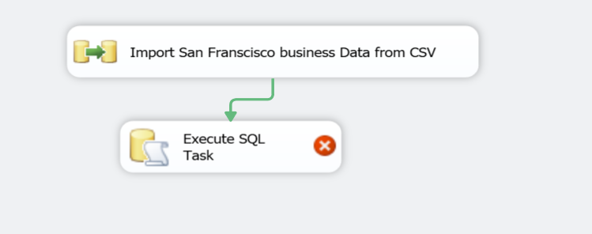

Data Flow component:

