# Gradient Squad

Team:

* Raghav Sharma
* Aishwarya Lodhi
* Srinishaa Prabhakaran
* Rishabh Gupta

# Homework 7

* Nice printing etc, see slides in Slack [edited to list details below]

Print it out on the console so you can read and assist in evaluating the outcome of the transposition.   
Is the transposed poem a good poem?

* T S Elliot:

|  | Poem 1 | Poem 2 |
| --- | --- | --- |
| Original | O Rose, thou art sick!  The invisible worm  That flies in the night,  In the howling storm,  Has found out thy bed  Of crimson joy:  And his dark secret love  Does thy life destroy. | Never seek to tell thy love,  Love that never told can be;  For the gentle wind does move  Silently, invisibly.  I told my love, I told my love,  I told her all my heart;  Trembling, cold, in ghastly fears,  Ah! she did depart!  Soon as she was gone from me,  A traveller came by,  Silently, invisibly  He took her with a sigh. |
| Transpose | o rose, thou art sick!  the unknown worm  that flies in the dark,  in the howling storms,  has find out thy bed  of crimson happiness:  and his darkest secret lovers  do thy life destroy. | lovers that never tell can be;  for the gentle wind does moves  silently, invisibly.  i tell my lovers, i tell my lovers,  i tell her all my heart;  trembling, winter, in ghastly fright,  ah! she did went!  soon as she was went from me,  a traveler comes by,  silently, invisibly  he taking her with a sigh. |

* Charles Bukowski:

|  | Poem 1 | Poem 2 |
| --- | --- | --- |
| Original | Some say the world will end in fire,  Some say in ice.  From what I've tasted of desire  I hold with those who favor fire.  But if it had to perish twice,  I think I know enough of hate  To know that for destruction ice  Is also great  And would suffice. | some said the world will done in fiery,  some said in snow.  from what i've tasted of desires  i clasp with those who favor fiery.  but if it have to hurt twsnow,  i thought i known such of wrath  to known that for destroyor snow  is also good  and would suffsnow. |
| Transpose | Her hardest hue to hold.  Her early leaf's a flower;  But only so an hour.  Then leaf subsides to leaf.  So Eden sank to grief,  So dawn goes down to day.  Nothing gold can stay. | nature's first green is gems,  her strongest hue to clasp.  her early leaves's a flowers;  but only so an hour.  then leaves subsides to leaves.  so eden sank to tears,  so morning went down to morning.  nothing gems can keeps. |

Does it make sense?   
Was the semantic similarity a good enough way of finding a suitable substitution?

* + 1. Do I need more poems and more POS?
* The substitution in the 20 poems we scraped seems to be good enough.
  1. **Do I have to run the notebook again even though I have run it before and have produced results?** If so, write defensive code to avoid re-running the parts of the notebook.
* No, we don’t need to run the notebook again, but we do need to restart the runtime after the installation.
  1. When I want to substitute/transpose the POS, Which POS should I use from the other poet?

1. start with a poem from poet A
2. find POS for poet A
3. pick the POS from poet B's list of POS that is **closest** to poet A's POS in this poem
4. transpose it
5. do this for all poems for poet A, then do this for all poems

* Here are all the files that contains the POS of poems from both the poets:

<https://drive.google.com/drive/folders/1zQeL1ObbZkJCz8_hSY_CFJwMUZnECVjO?usp=sharing>

* 1. Print and Analyze the similarity of poems

1. as-is between poets
2. similarity when you swap nouns
3. similarity when you swap verbs
4. similarity when you swap adjectives
5. similarity when you swap adverbs
6. similarity when you swap all

The following is the output for all similarities:

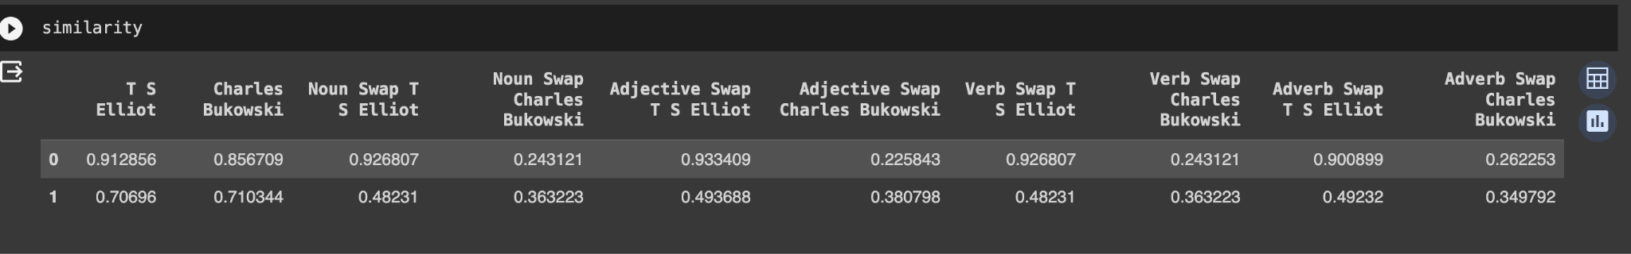

* 1. Perform Summarization
* Write to file: <https://drive.google.com/drive/folders/1zQeL1ObbZkJCz8_hSY_CFJwMUZnECVjO?usp=sharing>
* Is the summary close to the poem itself? Yes
  1. Perform Topic Modeling
* Write major topics to file.
* LDA:

Below graph shows major 2 topics out of 10 and relevant terms to file:

Topic 0:

Topic 1:

BERTopic:

Below is the result of BERTopic model

* 1. Create a table of stats, how many POS of what kind, how many poems, etc:
  2. Side by side table if the original POS and the transposed suggested POS from the second poet:

How many poems?POS, original word, the semantically similar word

9. What happens when you change the cosine similarity criterion?

* 1. Or when you change the similarity function

We can see that by modifying cs_threshold before swapping the similarity of the poems changes.

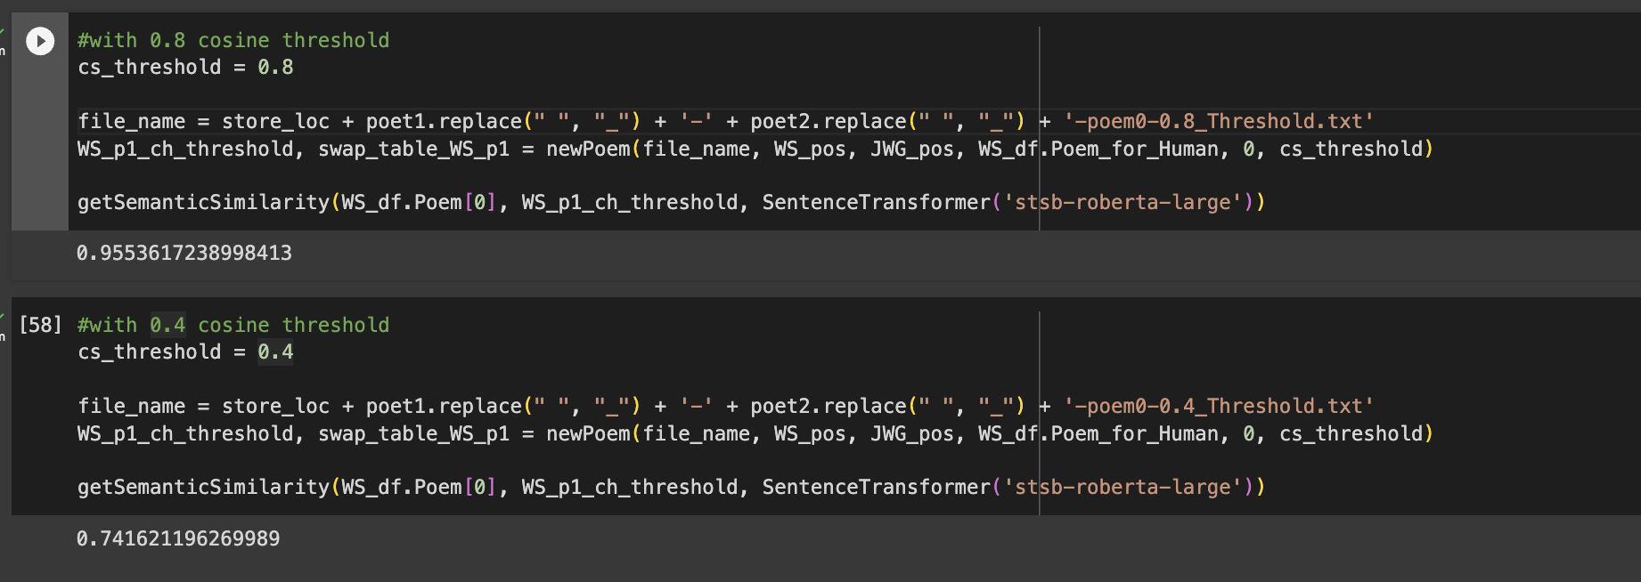

10. Try to modify the numbers for cosine similarity and the algorithm from diff libraries, test at least two of each please.

The first cell shows the similarity using cosine_similarity from ‘sklearn.metrics.pairwise’ library. The second method uses cosine from ‘scipy.spatial.distance’ library.

Both these methods give the same similarity score

