

Project no. – Tic Tac game

Section – K18AW

Submitted by-

* Agrima Agnihotri(11902957)
* Raghav Sharma(11813297)
* Aakarshit Shukla(11801782)

Submitted to-

* Ishan kumar Sir

ACKNOWLEDGEMENT

In our project, we had to take help and guidelines from some of the most valuable teachers, who deserve our most respected gratitude. The completion of our project gives us much pleasure. We would like to show our gratitude to Ishan Kumar Sir for giving us the opportunity to make this project and for his continuous support and guidance.

In addition to this we would also give our special thanks to our classmates and friends for their suggestion and tips to make this project a success.

INTRODUCTION

Python is a versatile language. Python is widely used general purpose , high level programming language. It was initially designed by Guido van Rossum in 1991 and developed by python software foundation. It was mainly developed for emphasis on code readability, and its syntax allows programmers to express the concept in fewer lines of code. It can be used as GUI for various basic shapes and for making some small animations.

This project, we are designing a tic tac game on AI based in which we are showing the concept of the game in tabular form.

REQUIREMENTS

* Software requirement
* Python IDE like Spyder or pyCharm
* Basic library files
* OS-Windows XP
* Hardware requirement
* Processor i3
* Minimum 1gb graphics
* RAM 4gb

OBJECTIVES

Our project name is tic tac toe game. This game is very popular and is fairly simple by itself. It is actually two player game. In this game, there is a board with n x n squares. In our game, it is 3x3 squares. The goal of tic tac toe is to be one of the players to get three same symbol in a row – horizontally, vertically or diagonally- on a 3 x 3 grid.

OVERVIEW

This game can be played in a 3 x 3 grid. The game can be played by two players. There are two options for players:

1. Human (b) Computer

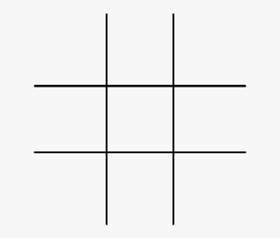

BIBLIOGRAPHY

* Most of the project was completed by going through the YouTube tutorials of python.
* We took reference by different books like Core Python Programming by Dr. R. Nageswara Rao, Python Programming for Beginners by Rayan Turner.
* We took help from google and geeksofgeeks.