Student Name: Raghav Sharma
Student ID: 11813297
Email Address: rash.hdr@gmail.com
GitHub Link: git@github.com:raghavsharma804/OSproject.git
https://github.com/raghavsharma804/OSproject
Code: Attached in the report.

Operating System Simulation Based Assignment

BACHELOR OF TECHNOLOGY
in
COMPUTER SCIENCE AND ENGINEERING

Raghav Sharma
Registration number: 11813297
Roll No: A16
Section: K18AW

School of Computer Science and Engineering
Lovely Professional University
Phagwara, Punjab (India)

Task:
- Write a multithreaded program in C that outputs prime numbers. This program should work as follows: The user will run the program and will enter a number on the command line. The program will then create a separate thread that outputs all the prime numbers less than or equal to the number entered by the user.
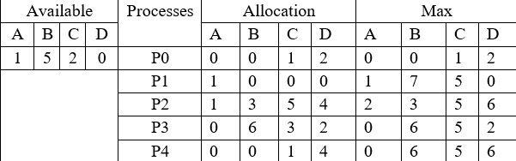
- Consider following and Generate a solution in C to find whether the system is in safe state or not?

Description:
- The creation of program for prime number uses two threads in C. First thread will prompt the user to enter the number upto which he wishes to get the prime number for.
The second thread will refer to the input taken by thread 1 and use that to calculate the prime number to that number starting from 1.

It will basically use the concept to multithreading. Advantage of thread here is that system will be able to process two requests from the user at the same time without having individual copy of code in the background.

The code is written in C language and executed in UBUNTU LTS for WINDOWS using -lpthread

Boundary condition :
Number entered by the user must be greater than zero.
Functional requirements:
Inputs:
1.The user must enter the number upto which the prime numbers need to be entered
Constraint :
1.There must be 2 threads in the program.
2.Prompt user for input for number.
3.Threads must wait for each other to finish and must now run together.

- Ques 24
To find out whether the system is in safe state or not , we use bankers’ algorithm to calculate the need of each process.

Banker’s Algorithm:
It is used in deadlock avoidance, such that it tells the system whether a particular system is in safe state or not; whether it will have a deadlock.
- It is used when there are many instances of resource.
- If a process wish to request a resource , it must wait for it be vacant.
- When a process gets all its resource, it will have to terminate and return all the resources back to the system.

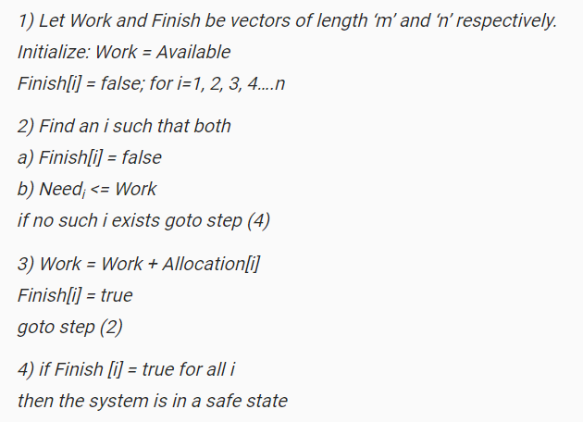
Basically Bankers’s algorithm uses Safety algorithm to find out safety of the system

Overview:
The allocation table and the maximum table is given. Along with the AVAILABLE TABLE.
Need table is calculated using the formula : Need=Maximum- Allocation.
- For each process allocation is the resources allocated to it.
- For each process maximum is the largest number of resources that can be given.
- For each process, need is the remaining need of resources by the process.
Conditions: Need must be less than the available then only it will be allotted
- After the need is fulfilled, the allocated resources of that particular process is added to ALLOCATED.
Boundary conditions:
1.User must enter all the details of the allocation and maximum table.
2. User must enter the available resources.
3. If need is negative then, it will be counted as zero.

Functional requirements:
Input:
- Number of resources.
- Number of process.
- Allocation table data
- Maximum table data
- Available resources data

Contraint:
- If need>available for all processes, exit the program and return message “unsafe”
- If need<0 then it must be taken as 0
- Sequence must be printed at the end.

INPUT/OUTPUT (Multithreading in C; Find out the number of prime numbers within the range of entered digit QUES 3.)

Test case 1:
Entered number is 45
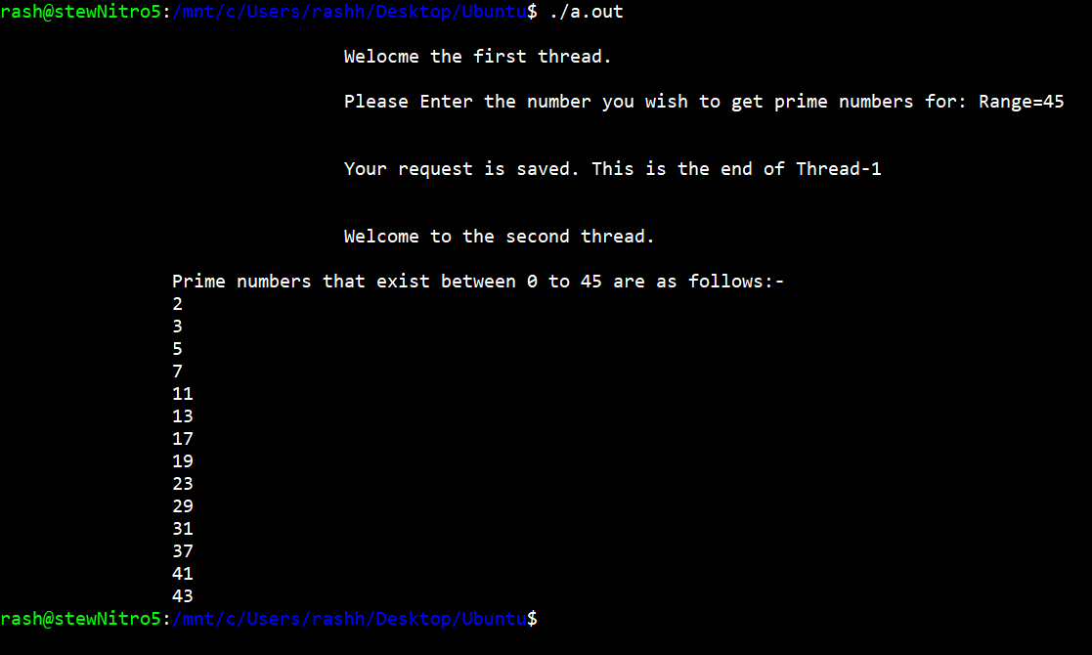

Test case 2:
Entered number is 0 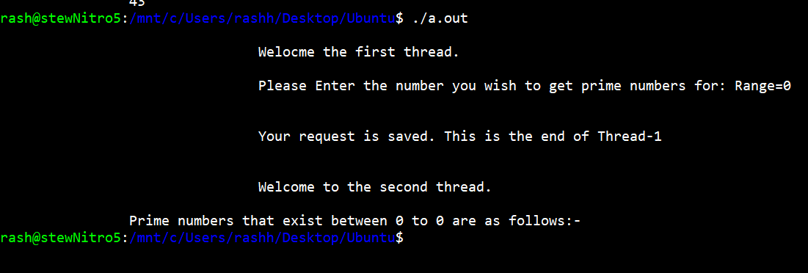

Test case 3:
Entered number is 10,000.

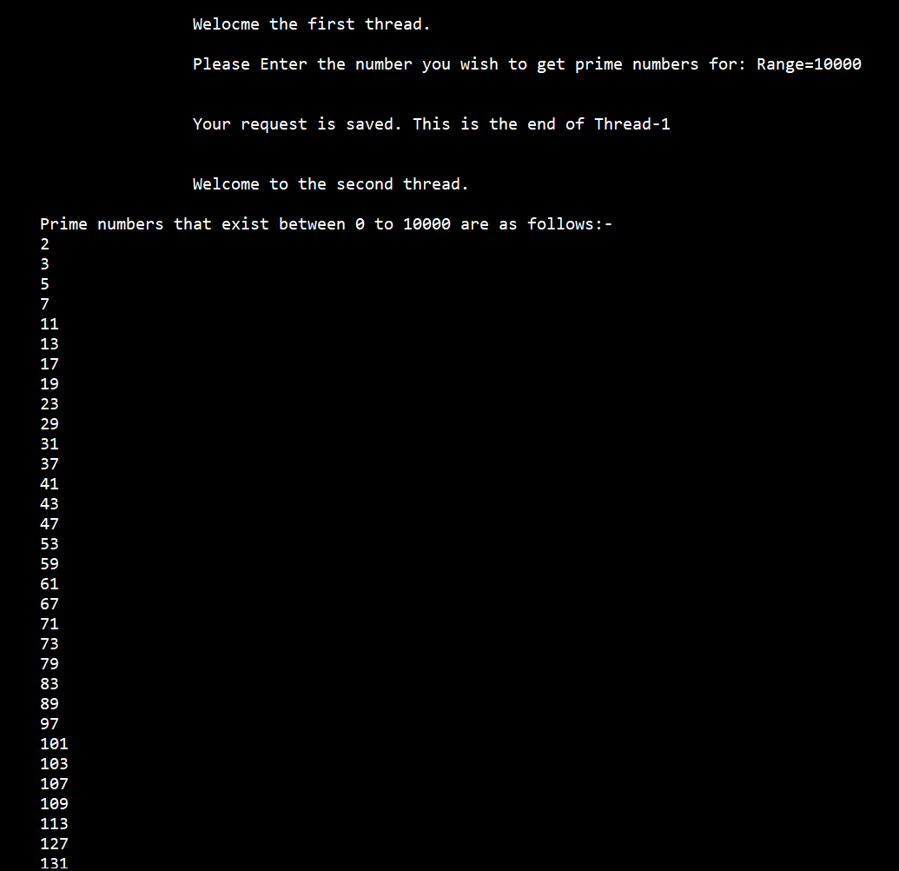
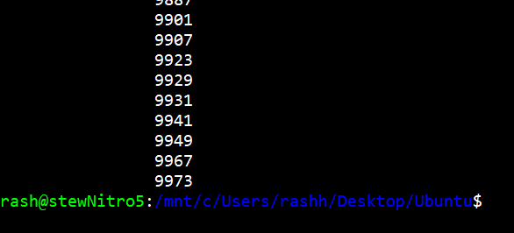

Code for multithreading ques 1: (code snippets at the end)
//code written by RAGHAV SHARMA K18AW
#include<stdio.h>
#include<unistd.h>
#include<pthread.h> //contains all the libraries required of threads in C
int range; //global variable range declared
void *getrange(void *value) //start of the first thread
{

printf("\n\t\t\t\tWelocme the first thread.\n\n\t\t\t\tPlease Enter the number you wish to get prime numbers for: Range="); //asks the user for entering the range
scanf("%d",&range); //scans the range integer and saves

printf("\n\n\t\t\t\tYour request is saved. This is the end of Thread-1"); //end of thread-1 message
return NULL;
} //end of thread-1
void *prime(void *disp) //start of thread 2
{
int i; //for interating of loop
printf("\n\n\n\t\t\t\tWelcome to the second thread.");
printf("\n\n\t\tPrime numbers that exist between 0 to %d are as follows:-\n",range);
for(i=2;i<=range;i++) //start of for loop for checking prime numbers.
{
int c=0;
for(int j=1;j<=i;j++)
{
if(i%j==0)
{
c++;
}
}
if(c==2)
{
printf("\t\t%d\n",i);
}
}
return NULL;
}

int main()
{
pthread_t threadone; //declaration of Thread-1
pthread_t threadtwo; //declaration of Thread-2
pthread_create(&threadone,NULL,getrange,NULL); //creation of Thread-1:
pthread_join(threadone,NULL);
pthread_create(&threadtwo,NULL,prime,NULL);
pthread_exit(NULL);
} //code written by RAGHAV SHARMA K18AW

INPUT/OUTPUT (for Banker’s Algorithm ques 24):
Test case 1:
Input used for the test case is:

PID ALLOCATION MAXIMUM AVAILABLE
A B C A B C A B C

P1 0 1 1 7 5 3 3 3 2
P2 2 0 0 3 2 2
P3 3 0 2 9 0 2
P4 2 1 1 4 2 2
P5 0 0 2 5 3 3

After calulation, the need table comes out to be
NEED AVAILABLE
7 4 3 3 3 2
1 2 2 5 3 2
6 0 0 7 4 3
2 1 1 7 4 5
5 3 1 7 5 5
10 5 7
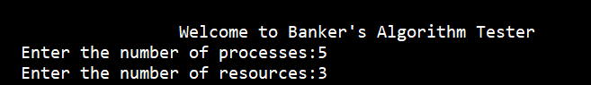
The system is in safe state.
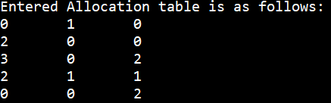
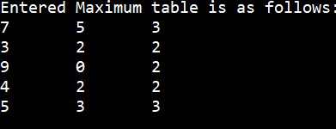

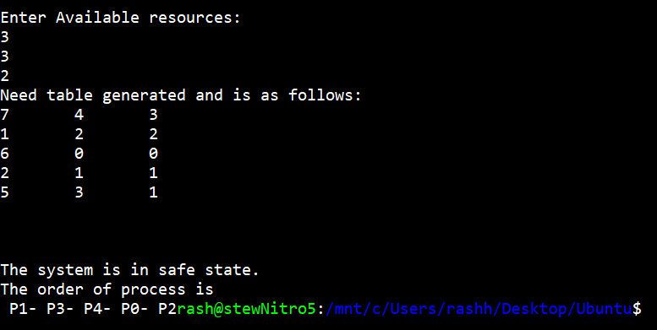

Test case 2:
Input used for the test case is:

PID ALLOCATION MAXIMUM AVAILABLE
A B C D A B C D A B C D

P1 0 0 1 2 0 0 1 2 1 5 2 0
P2 1 0 0 0 1 7 5 0
P3 1 3 5 4 2 3 5 6
P4 0 6 3 2 0 6 5 2
P5 0 0 1 4 0 6 5 6

Output Sceen:
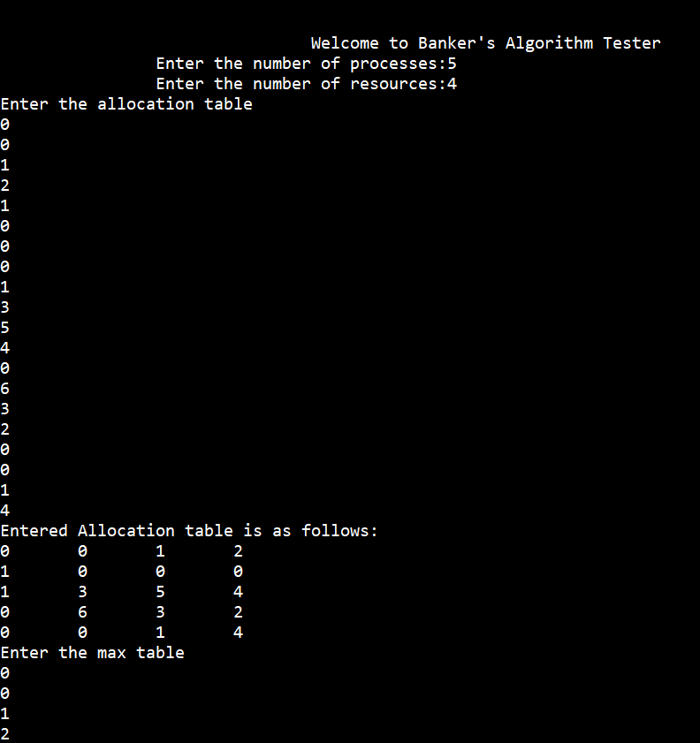

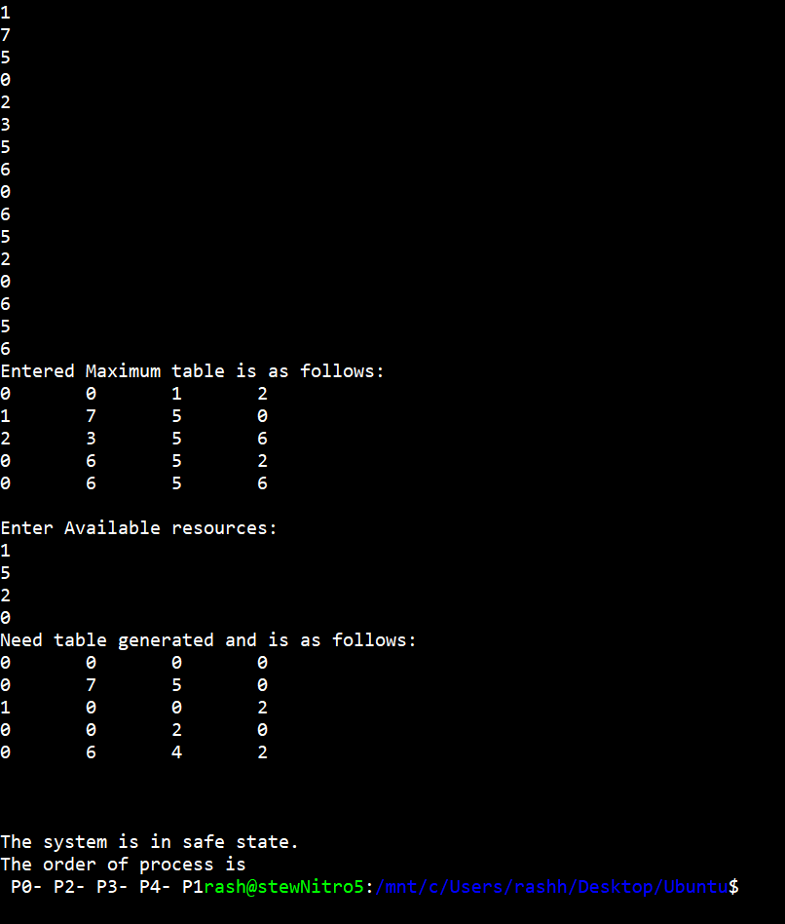

Code for Banker’s Algorithm(Ques 24): (code snippets at the end)
//code Written by Raghav Sharma
#include <stdio.h>
#include<unistd.h>
int main()
{
printf("\n\n\n\t\t\t\tWelcome to Banker's Algorithm Tester\n");
int i, j, k;
int pr,res;
int count=0;
printf("\t\tEnter the number of processes:");
scanf("%d",&pr);
printf("\t\tEnter the number of resources:");
scanf("%d",&res);
int allocation[pr][res];
int maximum[pr][res];
int need[pr][res];
int avail[4];
printf("Enter the allocation table\n");
for(int x=0;x<pr;x++)
{
for(int v=0;v<res;v++)
{
scanf("%d",&allocation[x][v]);
}
}
printf("Entered Allocation table is as follows:\n");
for(int x=0;x<pr;x++)
{
for(int v=0;v<res;v++)
{
printf("%d \t",allocation[x][v]);
}
printf("\n");
}
printf("Enter the max table\n");
for(int x=0;x<pr;x++)
{
for(int v=0;v<res;v++)
{
scanf("%d",&maximum[x][v]);
}

}
printf("Entered Maximum table is as follows:\n");
for(int x=0;x<pr;x++)
{
for(int v=0;v<res;v++)
{
printf("%d \t",maximum[x][v]);
}
printf("\n");
}
printf("\nEnter Available resources:\n");
for(int z=0;z<res;z++)
scanf("%d",&avail[z]); // Available Resources

int f[pr], ans[pr], ind = 0;
for (k = 0; k < pr; k++) {
f[k] = 0;
}
//NEED TABLE ENTRY
for (i = 0; i < pr; i++)
{
for (j = 0; j < res; j++)
{
need[i][j] = maximum[i][j] - allocation[i][j]; //calculation of need table
if(need[i][j]<0) //if need is negetive than it will be counted as zero rather than negetive
need[i][j]=0;
}
}
printf("Need table generated and is as follows:\n");
for(int x=0;x<pr;x++)
{
for(int v=0;v<res;v++)
{
printf("%d \t",need[x][v]);
}
printf("\n");
}
int y = 0;
for (k = 0; k < 5; k++)
{
for (i = 0; i < pr; i++)
{
if (f[i] == 0)
{
int flag = 0; //flag set to 0
for (j = 0; j < res; j++) {
if (need[i][j] > avail[j])
//check if need is greater than available
//if yes then skip this process
{
flag = 1;
count=count+1;
if(count>pr)
//if all the needs are greater than the available resources then the counter will move to label x that will terminate the program.
goto x;
else
break;
}
}

if (flag == 0)
{
ans[ind++] = i;
for (y = 0; y < res; y++)
avail[y] += allocation[i][y];
f[i] = 1;
}
}
}
}
printf("\n\n\nThe system is in safe state.\nThe order of process is\n");
for (i = 0; i < pr - 1; i++)
printf(" P%d-", ans[i]);
printf(" P%d", ans[pr - 1]);
return (0);
x: //label x
printf("\n\n\t\t\t\tA deadlock has occured and It is unsafe state!!!\n");
return(0);
}
//code Written by Raghav Sharma

Code snippets:
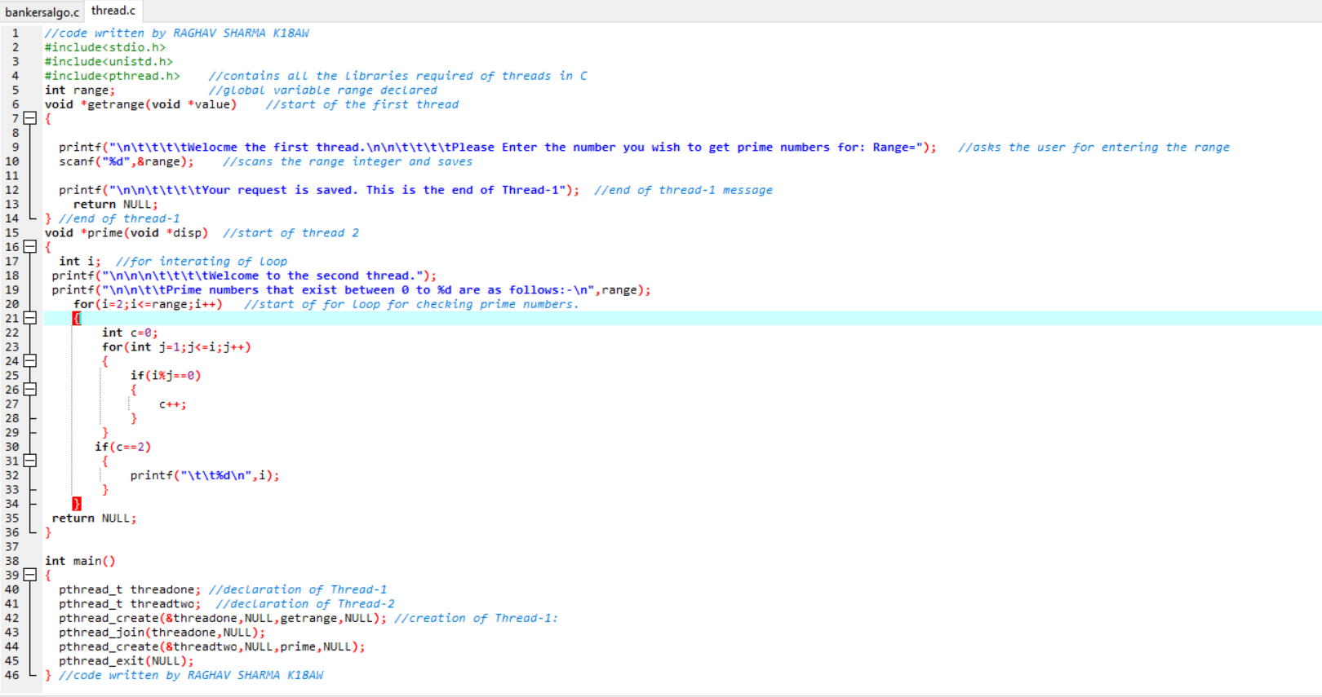
- Multithreading

- Banker’s Algorithm
