MODERN DATA ENGINEERING - FINAL GROUP ASSIGNMENT
Suzlon Energy
End-to-End Data Engineering Implementation on Databricks
Group Members
Aditya Bakhale (27PGAI0125)
Gundeep Singh (27PGAI0054)
Raghavendra Prasad Shetti (27PGAI0052)
Jio Institute | 2026

1. Objective and Business Context
The objective of this project is to implement the analytical design prepared in Assignment 1 for Suzlon Energy on the Databricks platform. The solution generates realistic synthetic business data, builds a Bronze-Silver-Gold medallion architecture, creates curated KPI tables and dashboard visualizations, and registers an ML-ready feature table for turbine failure-risk analysis.
The project focuses on four business areas: order booking, O&M contract renewal, turbine generation and availability, and service downtime. All data used in this implementation are synthetic and are not intended to represent Suzlon Energy's actual confidential operational or financial data.
2. Synthetic Data Generation
A scenario-driven Python generator was used instead of directly generating CSV rows through an AI tool. The generator creates related customers, sites, turbines, orders, contracts, daily generation records and service events while maintaining business relationships across tables. A fixed random seed supports reproducibility, and the date range and major data volumes are controlled through a configuration file.
2.1 Main business assumptions
- Customer segments include C&I, IPP, PSU and Retail, with different synthetic renewal probabilities.
- Wind-zone quality, turbine capacity, availability, turbine age and seasonality influence daily generation.
- Order value depends on turbine capacity, quantity and customer segment.
- Corrective and emergency service events carry higher synthetic downtime and severity than routine events.
- Generation is created at one row per turbine per day, preserving consistent relationships with turbine, site and date dimensions.
2.2 Generated data volume
Table | Rows
dim_model | 15
dim_customer | 5,000
dim_site | 300
dim_date | 365
dim_turbine | 1,000
dim_technician | 250
fact_order | 20,000
fact_contract | 6,000
fact_generation | 365,000
fact_service | 30,000
The largest fact table contains 365,000 daily turbine-generation rows covering 1 January 2025 to 31 December 2025. This provides sufficient scale for trend, ranking, aggregation and window-function analysis.
3. Databricks Medallion Architecture
The generated CSV files were uploaded to a Databricks managed volume and processed through logical Bronze, Silver and Gold layers. Delta tables were used for the engineered layers to provide a reliable tabular storage format and efficient SQL access.
Stage | Implementation | Purpose
Landing | /Volumes/workspace/default/suzlon_landing | Stores generated CSV files before ingestion.
Bronze | bronze_* Delta tables | Preserves the incoming data as received; fields are initially read as strings.
Silver | silver_* Delta tables | Applies explicit schemas, correct data types, cleaning, validation and business-range checks.
Gold | gold_* curated tables | Stores monthly aggregates, rollups and KPI-ready datasets for dashboards and analysis.
Feature Store | feature_turbine_failure | Stores ML-ready turbine-level features registered in Unity Catalog.
3.1 Data-quality and storage decisions
- Bronze preserves raw values and avoids silent type conversion during ingestion.
- Silver converts identifiers to integers, dates to DATE, monetary fields to DECIMAL and operational measures to appropriate numeric types.
- Primary-key and core business-range checks are performed before Gold processing.
- The generation fact is the largest table. Because the project uses a moderate synthetic dataset, the Silver layer is kept physically simple; date-based analysis is handled through the date dimension and smaller Gold monthly aggregates rather than creating many small partitions.

4. Gold Layer and Analytical Processing
The Gold layer contains business-facing aggregates at the correct analytical grain. It supports the dashboard and demonstrates the aggregation and window operations required by the assignment.
Technique / Gold table | Business use
Monthly generation mart | Site-by-month generation and availability.
ROLLUP | Monthly, site/state and overall hierarchical totals.
GROUPING SETS | Selected customer-segment and time-period summaries.
RANK() with PARTITION BY | Ranks turbines within each site by total generation.
3-month moving average | Smooths short-term variation to show the underlying trend.
LAG() | Compares each month with the previous month.
4.1 Dashboard-ready Gold tables
Dedicated Gold tables were created for monthly orders, monthly availability, monthly generation, contract renewal by customer segment, and service downtime by ticket type. This avoids mixing fact tables at incompatible grains and keeps each KPI calculation traceable to a specific curated source.

5. Databricks KPI Dashboard
The dashboard was created using Databricks Dashboards only. Six visuals were selected to show trends, comparisons and rankings rather than only single-number summaries.
Dashboard visual | Business question
Monthly Order Booking Value | How does order-booking value change month by month?
Contract Renewal by Segment | Which customer segments show stronger O&M renewal performance?
Monthly Fleet Availability | Is fleet availability stable, improving or deteriorating over time?
Top 10 Sites by Energy Generation | Which wind sites generate the most energy?
Service Downtime by Ticket Type | Which service categories contribute the most downtime?
Energy Generation Moving Average | What is the underlying generation trend after smoothing short-term variation?

5.1 Dashboard snapshots
Dashboard 1 - Monthly Order Booking Value
Line chart showing the monthly order-booking trend across 2025.

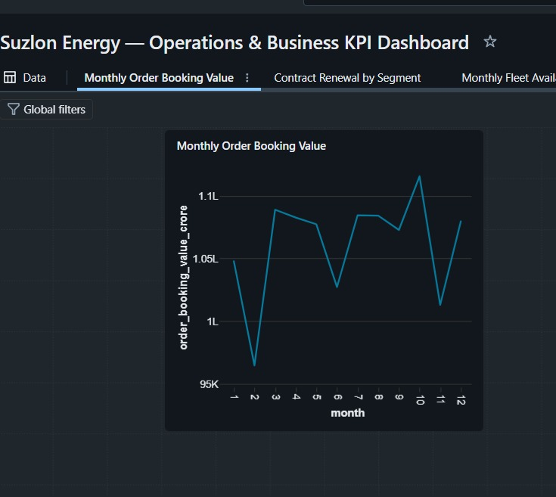
Dashboard 2 - Contract Renewal by Segment
Bar chart comparing renewal rates across C&I, IPP, PSU and Retail customer segments.
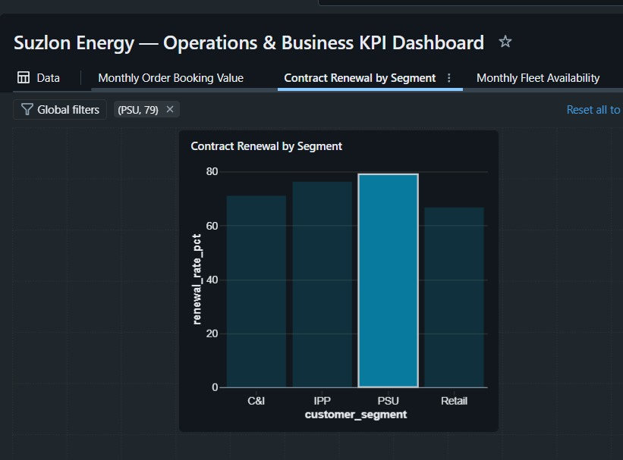

Dashboard 3 - Monthly Fleet Availability
Line chart showing monthly fleet availability during 2025.
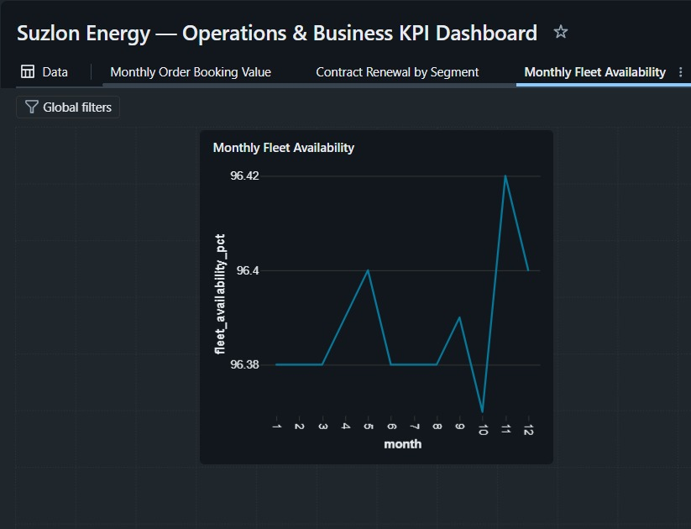
Dashboard 4 - Top 10 Sites by Energy Generation
Bar chart ranking the ten highest-generating wind sites.
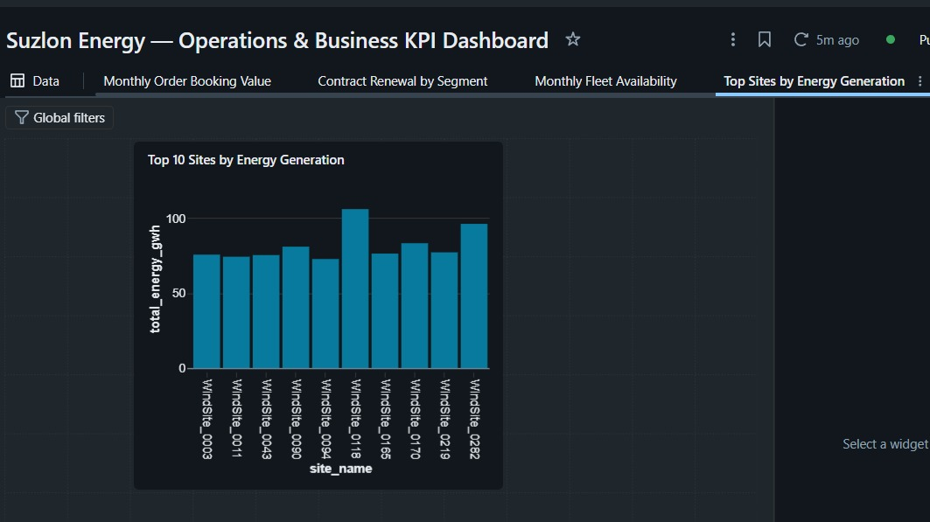

Dashboard 5 - Service Downtime by Ticket Type
Bar chart comparing total downtime for Corrective, Emergency, Inspection and Preventive service events.
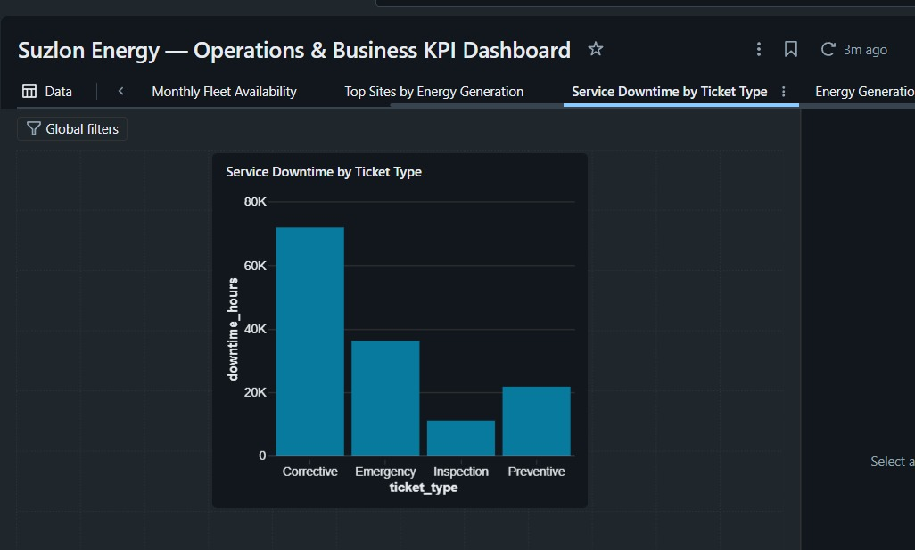
Dashboard 6 - Energy Generation Moving Average
Two-line chart comparing monthly energy generation with the 3-month moving average.
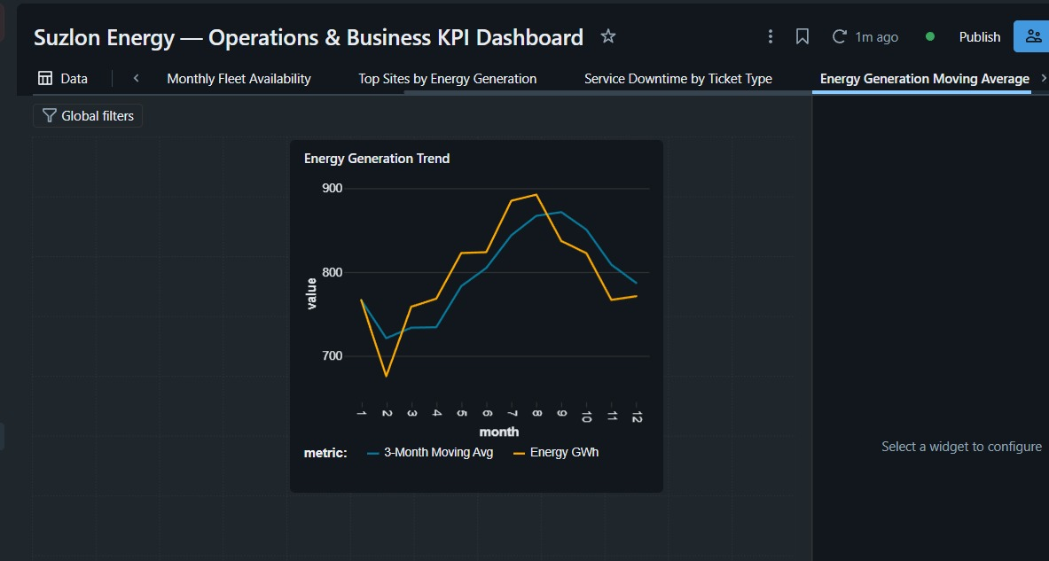

6. Feature Store
The ML use case selected from Assignment 1 is turbine/component failure prediction. Because the approved final schema does not contain raw SCADA variables such as vibration or gearbox temperature, the implementation uses operational proxies that are available in the generated data. Features are calculated over the latest 90-day window ending on 31 December 2025.
Feature | Meaning and predictive relevance
avg_availability_pct | Average turbine availability over 90 days; repeated loss of availability may indicate reliability deterioration.
total_downtime_hours_90d | Total downtime over 90 days; higher downtime indicates operational instability.
service_ticket_count_90d | Number of service interventions over 90 days; repeated events may signal elevated failure risk.
avg_energy_kwh_90d | Average daily energy over 90 days; persistent output decline may indicate deteriorating performance.
The feature dataset contains one row per turbine. Quality checks confirmed unique non-null turbine identifiers, valid availability ranges and non-negative operational measures for 1,000 turbines. The table was registered in Unity Catalog as workspace.default.feature_turbine_failure, with turbine_id as the primary key and feature_date as the snapshot date.
7. Key Business Insights
- Monthly order booking remains within a relatively consistent range but shows visible peaks and dips, supporting month-level demand monitoring.
- PSU customers show the strongest synthetic contract-renewal rate, while Retail is comparatively lower, indicating where retention attention may be most useful.
- Fleet availability remains consistently high and stable across the year, with only small month-to-month changes.
- Energy generation differs across sites, supporting direct comparison of top-performing locations.
- Corrective maintenance contributes the largest share of service downtime in the synthetic dataset, followed by emergency events.
- The moving-average view shows a mid-year rise in generation followed by moderation later in the year.
8. Conclusion
The project implements the Assignment 1 analytical design as an end-to-end Databricks workflow. Configurable Python scripts generate the synthetic data; Bronze and Silver layers ingest and clean it; Gold tables support rollups, window functions and six dashboard KPIs; and a registered feature table supports future turbine failure-risk modelling. The implementation therefore connects business intelligence and ML feature engineering within one governed pipeline.

