Time Series Analysis
Forecasting Air Quality in Beijing
What a short-range PM2.5 forecast is worth to the people who have to act on it
Group number: 04
S. No. | Name | Roll Number
1 | Nishkarsh Khandelwal | 27PGAI0051
2 | Jagath Ponnanna P M | 27PGAI0072
3 | Raghavendra Prasad Shetti | 27PGAI0052
4 | Chirag Parida | 27PGAI0055
Submitted as the group project for the Time Series Analysis course

1. Executive summary
We were asked to act as consultants and find a business forecasting problem worth solving. We chose air quality in Beijing, because the forecast has a decision attached to it: the city has to decide, a day or two in advance, whether to issue a health advisory, restrict traffic or close schools.
We built forecasts of daily PM2.5 using five years of hourly readings, and compared naive baselines, exponential smoothing, regression and Box-Jenkins models. The best model one day ahead is a seasonal ARMA, specified as (1,0,1) x (1,0,1) with a weekly period of seven days and a constant term, with a root mean squared error of 64.9 µg/m³ against the naive benchmark of 74.6, an improvement of about 13 per cent. Its prediction intervals are well calibrated: the 80 per cent interval contained 80.8 per cent of the actual values in the test year.
Three findings go beyond the model comparison, and they are what we would want a client to read first.
- The useful forecast horizon is short. At seven days ahead the seasonal ARMA model no longer beats simply forecasting the long run average, and although the calendar regression edges ahead of it on RMSE, that model identifies almost no severe episodes and so is of little practical use. Any advisory system built on this data should plan one to three days out, not a week.
- The emission controls around the APEC summit in November 2014 cut PM2.5 by about 32 µg/m³, a reduction of 36 per cent, after adjusting for the weather that actually occurred. This is close to the 30 per cent that Beijing’s own monitoring centre reported at the time, which is reassuring since our model knew nothing about that figure.
- The Spring Festival makes the air worse, not better, in all four years we tested, by an average of 19 µg/m³. We expected the opposite, because factories and construction shut down for the fortnight. Fireworks and domestic activity outweigh the industrial pause.
We also evaluated the models a second way, as alert systems rather than as number generators, and the two rankings disagree. The model with the best RMSE is not the model that catches the most pollution episodes. Our recommendation takes that seriously, because the client’s cost of missing a severe episode is not the same as the cost of a false alarm.

2. The client and the decision
We have framed this as advice to the Beijing municipal environmental authority. The authority publishes air quality advisories and can trigger temporary measures: restricting vehicles, halting construction, advising schools to cancel outdoor activity.
All of those need notice. A school told at 7 a.m. that today is unsafe has already let children travel in. So the forecast has to arrive at least a day before the episode, and it has to be specific enough to act on.
The costs of being wrong are not symmetric, and this matters for everything that follows. A false alarm costs the authority some disruption and a little credibility, and credibility is a real asset because an authority that cries wolf is ignored. A missed episode means children spend a day outdoors during a severe pollution episode. We treat a miss as the more expensive error, and we test how sensitive our recommendation is to that assumption rather than asserting a single exchange rate.
Our forecasting objective, stated precisely: predict the daily mean PM2.5 concentration one to seven days ahead, with an interval around each forecast, and report how far ahead the forecast remains useful enough to act on.

3. The data

3.1 Source
We used the Beijing PM2.5 dataset from the UCI Machine Learning Repository, which is one of the sources listed in the project guidelines. The file is PRSA_data_2010.1.1-2014.12.31.csv. It holds 43,824 hourly observations from 1 January 2010 to 31 December 2014 in 13 columns. PM2.5 was measured at the United States Embassy station in Beijing, and the meteorological columns come from Beijing Capital International Airport.
Citation: Chen, S. (2015). Beijing PM2.5 [Dataset]. UCI Machine Learning Repository. DOI 10.24432/C5JS49. Licensed CC BY 4.0.

3.2 What we found when we opened it
2,067 PM2.5 readings are missing, about 4.7 per cent of the file. That number alone is not very informative, so we looked at how the missing values are arranged. They fall into 214 separate gaps. The median gap is a single hour, but the longest runs 155 consecutive hours starting on 21 September 2010.
That distinction drove the cleaning rule. A one hour gap can be interpolated without much risk. A six day gap cannot, because filling it would be inventing data rather than repairing it. We interpolated gaps of six hours or less, which covered 158 of the 214 gaps and recovered 580 readings, and left the remaining 1,463 hours missing.

3.3 From hourly to daily
We model daily averages rather than hourly readings. The reason is practical: hourly data carries a daily cycle, a weekly cycle and an annual cycle all at once, and the methods taught in this course handle one seasonal period at a time. A daily series keeps the patterns that matter for a next-day advisory and drops the intra-day detail the client does not need.
A day only gets an average if at least 18 of its 24 hours have a valid reading. A daily mean built from six night time readings is not comparable to one built from a full day, and treating the two as equivalent would quietly corrupt every model downstream. 79 days of 1,825 failed that test and were set to missing. We kept them in the index as empty rows so that the series stays evenly spaced, which every method we use depends on.
The resulting series runs from 2 January 2010 to 31 December 2014, 1,825 days, of which 1,746 have a value.

4. Exploratory analysis
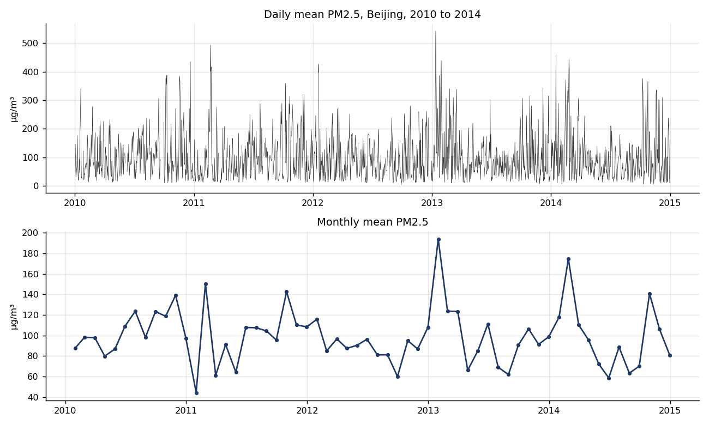
Figure 1: daily and monthly mean PM2.5. The winter peaks are obvious; a trend is not.
The series is dominated by seasonality rather than trend. Winters are consistently worse than summers, which is what you would expect from coal fired heating, but there is no visible long run improvement or deterioration across the five years.
The distribution is strongly right skewed: mean 98.6 µg/m³ against a median of 78.7, standard deviation 77.7, skewness 1.62, and a maximum daily mean of 542. Concentration cannot fall below zero but has no real ceiling, so the distribution has a long tail of severe episodes. This matters later for the choice of error measure.
An augmented Dickey-Fuller test returns a statistic of -15.46 with a p-value below 0.0001, so we reject a unit root and treat the daily series as stationary in levels. The Ljung-Box test is significant at lags 7, 14 and 30 with p-values below 0.001, confirming there is real structure to model rather than noise.
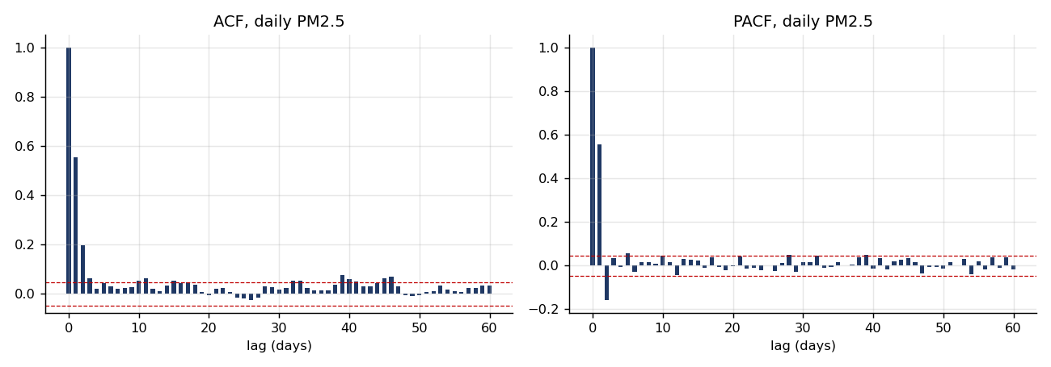
Figure 2: autocorrelation and partial autocorrelation. Strong short-lag dependence that decays within about a week.

4.1 A diagnostic we have not seen used elsewhere
The usual approach is to compute one set of seasonal indices for the whole series. We computed them separately for each year, using the same ratio to centred moving average method taught in the decomposition session, and then asked how much each month’s index moves from year to year.
The logic is simple. If a month’s index is stable across years, whatever drives it is tied to the solar calendar. If it jumps around, something is moving in and out of that month.
Month | Mean index | SD across years | Lowest | Highest
January | 1.180 | 0.607 | 0.439 | 1.923
February | 1.345 | 0.401 | 0.848 | 1.795
March | 0.995 | 0.273 | 0.614 | 1.234
June | 0.960 | 0.245 | 0.593 | 1.094
April | 0.869 | 0.149 | 0.650 | 0.984
December | 1.021 | 0.049 | 0.958 | 1.072
Table 1: seasonal index stability, selected months, ordered by variability.
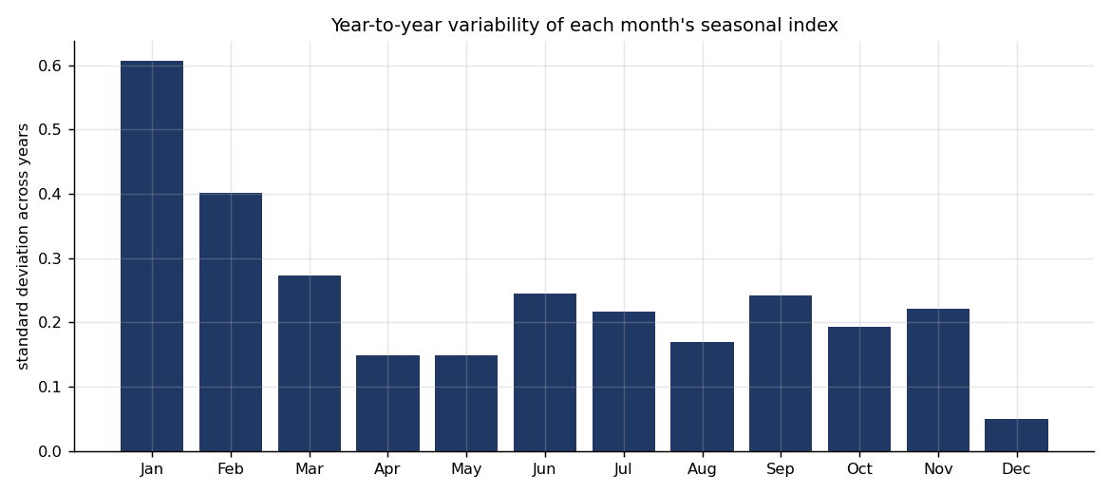
Figure 3: January and February are far less stable than any other month.
January’s index ranges from 0.44 in 2011 to 1.92 in 2013, a factor of more than four for the same calendar month. February is the second least stable. December, by contrast, has a standard deviation of 0.049, which is almost perfectly repeatable.
Our hypothesis was the Spring Festival, which moves between late January and mid February. But we have to be honest about an alternative explanation, and it is a strong one. January 2013 averaged 193.9 µg/m³ against January 2011’s 44.3. That month was the episode the international press called the airpocalypse, and it alone could account for January’s instability. The diagnostic flags the months but cannot attribute the cause, so we tested the festival properly in sections 6 and 8 rather than claiming the diagnostic had settled it.

4.2 The series in lunar coordinates
We gave every day a second coordinate: the number of days to or from the first day of the Spring Festival. In this coordinate system day zero is always the festival, whatever its Gregorian date.
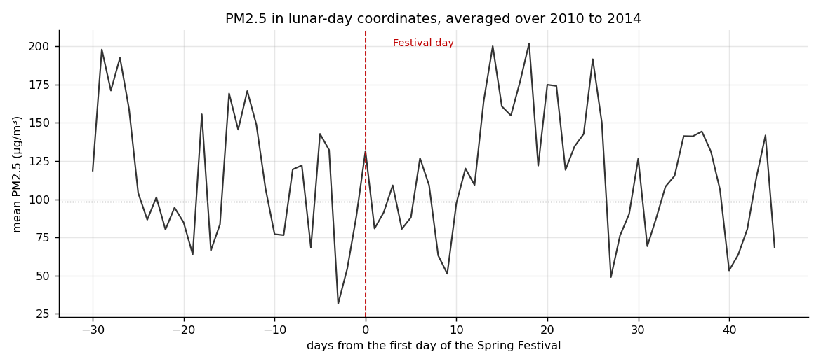
Figure 4: PM2.5 averaged by distance from the Spring Festival, 2010 to 2014.
Year | Festival date | Festival day | Prior fortnight | Ratio
2010 | 14 February | 132.0 | 65.1 | 2.0
2011 | 3 February | 100.9 | 42.3 | 2.4
2012 | 23 January | 199.9 | 109.1 | 1.8
2013 | 10 February | 60.5 | 197.1 | 0.3
2014 | 31 January | 164.3 | 145.6 | 1.1
Table 2: festival day against the average of the preceding fortnight, µg/m³.
In four of the five years the festival day is sharply above the preceding fortnight, roughly doubling in 2010, 2011 and 2012. 2013 is the exception and ran well below its baseline, but that baseline was 197 µg/m³ because of the airpocalypse, so the comparison for that year is not meaningful.

5. Forecasting models and how we tested them
We trained on 2010 to 2013 and tested on 2014, which holds a complete annual cycle. Every model produces a one day ahead and a seven day ahead forecast for each day of the test year, rolling forward one day at a time. Smoothing constants and model parameters were estimated once on the training data and then held fixed, so no model ever sees the test year when choosing its settings.
Two details about the missing days. The smoothing and ARIMA recursions cannot step over a hole, so the training series is interpolated for fitting. We never score a forecast against an interpolated value, so the accuracy tables use only days with a genuine reading.

5.1 Baselines and smoothing
The naive model, where tomorrow is forecast to equal today, is the benchmark everything else has to beat. We also fitted simple exponential smoothing, Holt and Winters.
The estimated smoothing constants are themselves informative. Alpha came out at 0.78 for simple exponential smoothing, meaning the model leans heavily on the most recent observation and has a short memory, which is what a noisy series demands. More interestingly, the optimiser chose beta equal to zero for Holt and gamma equal to zero for Winters. The training data says there is no trend and no weekly cycle worth modelling in daily PM2.5. We had expected a weekday effect from traffic and did not find one.
One day ahead, nothing beats the naive model: naive 74.61, simple exponential smoothing 74.62, Holt 74.76, Winters 79.73. Seven days ahead, every smoothing method loses to forecasting the overall mean.

5.2 Regression
We fitted three regressions on the same training period. Model A uses the Gregorian calendar only: a trend term, month dummies, day of week dummies and a heating season flag. Model B adds five Spring Festival variables. Model C adds the weather columns.
Model A and Model B explain almost nothing: adjusted R-squared of 0.013 and 0.016 respectively. The calendar on its own is a weak predictor of daily pollution. Model C, with weather, jumps to 0.481 and cuts holdout RMSE from 77.86 to 58.45.
We report Model C separately and do not treat it as a forecasting model, because it uses the same day’s weather. Using today’s wind speed to explain today’s pollution is fair; using it to forecast seven days ahead would mean assuming we already know next week’s weather. The honest conclusion is that daily pollution in Beijing is mostly a meteorology story, and that an operational forecasting system should be built on top of a weather forecast rather than pretending the weather is known.
All three regressions return a Durbin-Watson statistic near 0.93, well below the lower critical bound. The residuals are strongly positively autocorrelated, which means two things: the regression is leaving information unused, and its standard errors cannot be trusted. That is exactly the gap the Box-Jenkins stage fills.
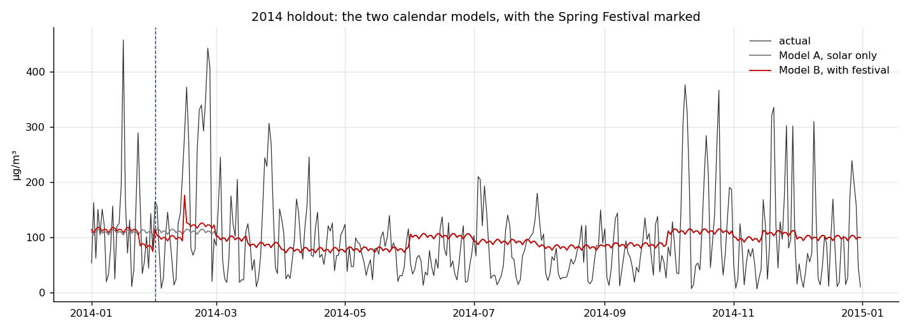
Figure 5: the two calendar models against actual values in 2014, with the Spring Festival marked.

5.3 Box-Jenkins
We compared seven specifications chosen from the ACF and PACF rather than by searching a large grid, and judged them on AIC together with a Ljung-Box test on the residuals.
Model | AIC | BIC | Ljung-Box p
ARMA(1,1) with weekly seasonal | 16076.9 | 16108.6 | 0.237
ARMA(2,2) | 16139.8 | 16171.5 | 0.235
ARMA(1,1) | 16146.9 | 16168.0 | 0.237
AR(2) | 16147.5 | 16168.6 | 0.172
ARIMA(1,1,1) | 16171.8 | 16187.7 | 0.0001
MA(1) | 16228.3 | 16244.2 | 0.000
Table 3: candidate models, fitted on 2010 to 2013.
The seasonal ARMA has the lowest AIC and residuals that pass as white noise. Stated precisely, the selected specification is ARMA(1,1) with a seasonal ARMA(1,1) at period seven and a constant term, with no differencing at either level, written SARIMAX(1,0,1) x (1,0,1,7). We call it the seasonal ARMA model below. Note that ARIMA(1,1,1) fails the residual test. That is a useful confirmation of the ADF result: the series is already stationary, so differencing it makes the model worse rather than better.
This model gives the best one day ahead forecast of anything we built, at RMSE 64.88 against the naive floor of 74.61.

5.4 A mistake we made, and what it taught us
Our first ARIMAX run returned festival coefficients of +92, +109 and +101, all strongly significant. They looked spectacular and they were wrong. Every coefficient sat close to the series mean of 98.6, which was the clue.
The state space implementation we used omits the constant term by default. With no constant and an undifferenced series, the model is pulled towards zero, and the exogenous variables quietly absorbed the mean instead of measuring the festival. This is the situation the regression session describes when it asks what happens if the intercept is forced to zero. Adding the constant fixed it, and improved the AIC of every undifferenced model as well. We mention it because the diagnostic that caught it, noticing that coefficients sat suspiciously near the series mean, is the kind of check worth building into any analysis.

6. Comparing the models
Model | Horizon | RMSE | MAD | Mean error
Seasonal ARMA(1,1) | 1 day | 64.88 | 47.04 | -0.45
ARIMAX with festival terms | 1 day | 65.63 | 47.35 | -0.49
Naive | 1 day | 74.61 | 52.56 | -0.11
Simple exponential smoothing | 1 day | 74.62 | 52.79 | -0.10
Holt | 1 day | 74.76 | 53.14 | +4.48
Winters (weekly) | 1 day | 79.73 | 58.10 | +1.55
Overall mean | 7 days | 81.40 | 59.56 | -1.65
Seasonal ARMA(1,1) | 7 days | 81.72 | 59.58 | -1.12
Calendar regression | 7 days | 78.29 | 57.34 | +2.66
Simple exponential smoothing | 7 days | 105.29 | 74.16 | +1.03
Naive | 7 days | 111.02 | 78.21 | +1.22
Table 4: holdout accuracy on 2014. All figures in µg/m³.

6.1 Why we select on RMSE
The course sets out five measures and we computed all five. Choosing between them is not a formality here, because they disagree.
MAPE and MPE behaved badly on this series and the reason is instructive. Dividing by an actual value of 3 or 5 µg/m³ on a clear day turns a small absolute error into an enormous percentage. Every model in our table shows an MPE between -43 and -108 per cent, which would suggest catastrophic over forecasting, while the plain mean error in µg/m³ is close to zero for most of them. The percentage measures are not wrong arithmetically; they are simply unsuitable for a series that spends part of the year near zero.
So we added mean error, in the original units, as the bias check, and selected on RMSE. RMSE squares the errors, which means it penalises large misses more heavily than small ones. For this client that is the right emphasis, because the days that matter are the severe episodes and a model that is comfortably accurate on clean days while missing every spike is of no use. MAD would treat a 10 µg/m³ error on a clean day as equivalent to a 10 µg/m³ error during an emergency.

6.2 Prediction intervals
A point forecast on its own understates what the client needs to know. We therefore report intervals, and we checked whether they can be believed by counting how often the actual value fell inside them during the test year.
Horizon | Nominal 80% | Nominal 95% | Average 95% width
1 day | 80.8% | 92.6% | 240 µg/m³
7 days | 89.4% | 93.0% | 298 µg/m³
Table 5: interval coverage in 2014 against the nominal level.
One day ahead the intervals are well calibrated: 80.8 per cent coverage against a nominal 80 per cent. Seven days ahead the 80 per cent interval over covers at 89.4 per cent, meaning it is wider than it needs to be. Either way the intervals are honest, which is what allows the decision rule in section 9 to use them.
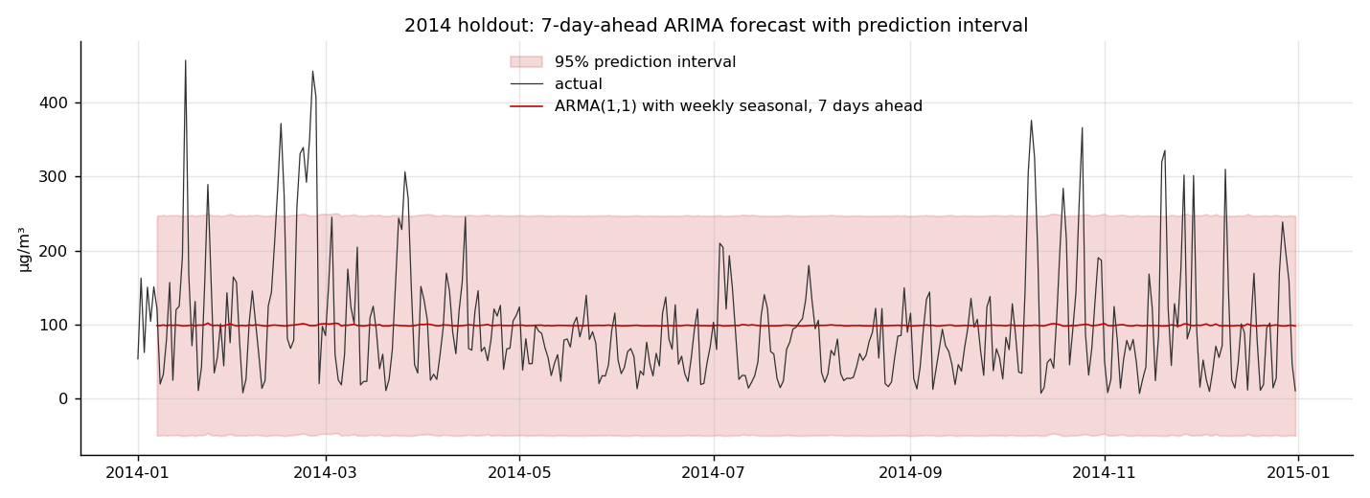
Figure 6: seven day ahead forecasts for 2014 with the 95 per cent prediction interval.

7. Does the lunar calendar earn its place?
This was our original hypothesis: that a model which knows about the Spring Festival should beat one that knows only the Gregorian calendar, because the festival moves and a month dummy therefore mis-times it.
We tested it twice. First in ordinary regression, where the joint F test on the five festival variables returned F = 1.592 with p = 0.159, so we could not reject the hypothesis that they are all zero. But the Durbin-Watson of 0.93 told us those standard errors were unreliable, so we ran the test again with the error term modelled as an ARMA process.
Variable | OLS coefficient | ARIMAX coefficient | ARIMAX p-value
New Year’s Eve | -33.81 | +99.18 | 0.0013
Festival day | +23.64 | +23.21 | 0.3316
Week before | -29.52 | +61.12 | 0.0002
Festival window | -22.95 | +13.00 | 0.4054
Lantern Festival | +76.72 | +41.85 | 0.0298
Table 6: festival coefficients, ordinary least squares against ARIMAX, µg/m³.
With the autocorrelation handled properly, three effects are clearly significant: New Year’s Eve at +99 µg/m³, the week before the festival at +61, and the Lantern Festival at +42. These are large effects, and the Lantern Festival result is particularly satisfying because it is the night the festival closes with a second round of fireworks.
And yet adding the festival block raises AIC from 16076.9 to 16088.5, and makes holdout RMSE slightly worse at both horizons.
The two results are not in conflict, and the resolution is the useful part. The festival genuinely moves pollution on specific days, by a large and measurable amount. It just does not improve a forecast evaluated over a year, because those are five or six days out of 365 and the annual average barely notices them. Our conclusion is that the festival variables belong in a report on what drives Beijing’s air, and do not belong in an operational forecasting model. We would not have predicted that split at the start.

8. Combining forecasts
The guidelines allow the selected model to be a combined one, so we tested a combination of the seasonal ARMA model, which knows about persistence, and the calendar regression, whose predictions do not degrade with horizon because next week’s calendar is already known. We followed the procedure from the combining forecasts session in order.
Step one, the bias check, passed. Neither forecast has a mean error significantly different from zero at either horizon, so combining them is legitimate.
Step two is where it broke. The correlation between the two models’ squared errors is 0.726 at one day ahead and 0.989 at seven days, both overwhelmingly significant. The worked example in the session had a correlation of -0.178 with p = 0.374, meaning genuinely independent errors.
The explanation is worth stating plainly, because it is a lesson about forecasting rather than about this dataset. Seven days out, both models are effectively predicting something close to the long run average, since neither has real information at that range. On a quiet day both are roughly right; on a spike day both miss by almost exactly the same amount. Their errors become the same number. The session’s requirement that each method must have unique information content is not satisfied, and a weighted average of two models that fail in the same places has nothing to recover.
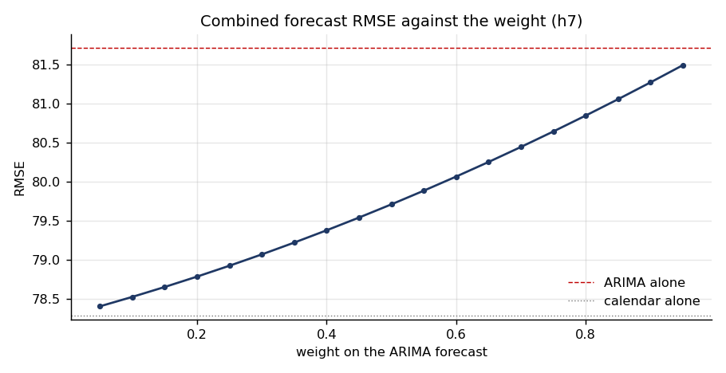
Figure 7: RMSE against the weight on the ARIMA forecast, seven days ahead.
The regression based weights confirm it. Seven days ahead the no intercept regression returns -0.93 on the ARIMA forecast and +2.00 on the calendar model. They sum to 1.07, which passes that check, but one weight is negative, and the session advises using the method only when both weights are positive.
We also repeated the exercise honestly, estimating the weights on the first half of 2014 and testing on the second half, because fitting weights on the same data used to evaluate them flatters the result. One day ahead the combination is worse than the ARIMA model alone, 62.82 against 62.53. Seven days ahead it beats the better single model by 0.16 per cent, which is noise.
We therefore do not recommend a combined model. Combining was worth testing, the procedure gave a clear answer, and the diagnostic explains why.

9. What the shutdowns actually bought
Our data contain two intervention periods that let us build counterfactual comparisons, and both speak to a question the client cares about: how much does a shutdown buy? We should say at the outset that these are suggestive comparisons rather than definitive causal estimates. We can measure the gap between what happened and what the model expected, and we can rule out the most obvious confounder, but we cannot control conditions the way a designed experiment would.
The method is the same in each case. Train the model on everything before the intervention, forecast through the window, and compare against what happened. The obvious objection is weather, so we ran each counterfactual twice: once with a model that knows only the history of the series, and once with a model that also sees the weather that actually occurred during the window. The second number is the part that cannot be explained away by a lucky fortnight of wind.

9.1 APEC, November 2014
Ahead of the APEC summit, controls ran from 3 to 12 November 2014. Factories and power plants were halted, construction stopped, odd and even number plate restrictions were imposed, the winter heating season was delayed by a week, and a public holiday was declared.
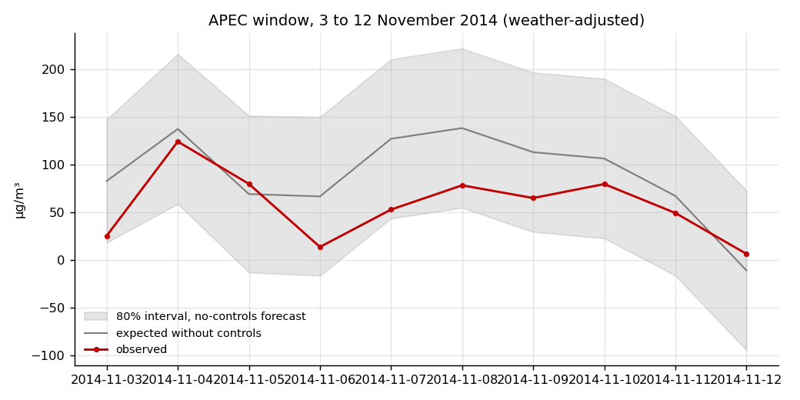
Figure 8: observed PM2.5 during the APEC window against what the model expected without controls.
Our weather adjusted model expected 89.8 µg/m³ across the window. The observed average was 57.5. The difference is 32.3 µg/m³, a reduction of 36 per cent. The history only version of the same exercise gives almost the same answer, 32.2 µg/m³.
For an external check: Beijing’s Environmental Monitoring Centre reported at the time that PM2.5 fell about 30 per cent over 1 to 12 November. Our estimate was produced from the data alone, with no knowledge of that figure, and lands in the same place.
One caveat we should not skip. No individual day during the window fell below the lower bound of the 80 per cent prediction interval. The effect is clear in the average across the window but not day by day, because the intervals are wide. We would describe the result as strong evidence of a large effect rather than as proof on any single date.

9.2 The Spring Festival, and where we were wrong
We expected the festival shutdown to produce a smaller version of the same effect. Factories close for roughly a fortnight, construction stops, and much of the migrant workforce leaves the city.
Spring Festival | Expected | Observed | Difference
2011 | 94.5 | 113.9 | +19.4
2012 | 67.4 | 77.0 | +9.6
2013 | 100.6 | 123.2 | +22.7
2014 | 85.8 | 109.5 | +23.7
Average | 87.1 | 105.9 | +18.8
Table 7: Spring Festival windows, day 0 to day 14, weather adjusted, µg/m³.
The air was worse than expected in all four years, by an average of 19 µg/m³. There is no year in which the shutdown produced cleaner air than the model predicted.
This agrees with the ARIMAX coefficients in section 7, where New Year’s Eve came in at +99 and the Lantern Festival at +42. Two different methods, applied independently, point the same way. The results suggest that fireworks and other festival activity more than offset the reduction associated with the industrial shutdown. We put that carefully on purpose: the dataset records pollution, not its sources, so we are inferring the mechanism from timing rather than measuring emissions.
The contrast with APEC is the interesting part, and it is what makes the pair of experiments worth doing together. APEC was a controlled shutdown with no compensating emissions, and the air got dramatically cleaner. The Spring Festival is a shutdown accompanied by two weeks of celebration, and the air got worse. The lesson for the client is that halting industry is effective, and that the benefit can be entirely cancelled by what the population does instead.

10. Judging the forecasts as decisions
RMSE treats every day in the year as equally important. The client does not. They either issue an advisory or they do not, and the two kinds of mistake cost different amounts.
So we scored every model a second way. We set an action threshold of 150 µg/m³ as the level at which a severe episode warrants an advisory, and asked how well each model calls the question. This is our decision threshold rather than an official regulatory boundary; another authority could set it higher or lower and the comparison below would still hold. 63 days of 2014 crossed that threshold, 17.3 per cent of the year.
Model | RMSE | Days judged | Hits | Misses | False alarms | Hit rate
Seasonal ARMA, 1 day | 64.9 | 365 | 27 | 36 | 15 | 43%
Naive, 1 day | 74.6 | 365 | 33 | 30 | 30 | 52%
Calendar regression | 77.9 | 365 | 1 | 62 | 0 | 2%
Seasonal ARMA, 7 days | 81.7 | 359 | 0 | 60 | 0 | 0%
Upper 80% bound rule, 1 day | 102.3 | 365 | 59 | 4 | 191 | 94%
Upper 95% bound rule, 1 day | 137.0 | 365 | 63 | 0 | 299 | 100%
Table 8: each model as an alert system, 2014. The seven day model is judged on 359 days rather than 365, because the first six days of the test year have no seven day ahead forecast available; 60 of those 359 days crossed the threshold, against 63 of the full 365.
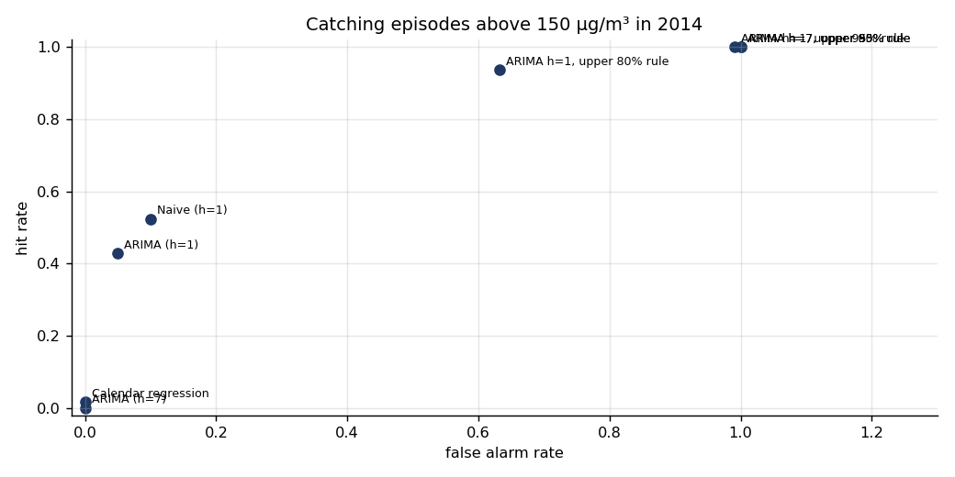
Figure 9: hit rate against false alarm rate for each decision rule.
The two rankings disagree, and the disagreement is the most important result in this report.
The seasonal ARMA model has the best RMSE of anything we built, and it catches 27 of the 63 episodes. The naive model, which is worse on RMSE by a wide margin, catches 33 of them. On the accuracy table the ARMA model wins; as an alert system the naive model warns the city about six more dangerous days.
The seven day ahead ARMA model is the sharpest illustration. Its RMSE of 81.7 is perfectly respectable and sits mid table. It catches zero episodes out of sixty. Because it reverts to the mean, it never crosses the threshold, so it never issues an advisory at all. By the standard accuracy table it looks like a usable model. As a public health instrument it is worthless.
Model | Miss costs 2x | Miss costs 5x | Miss costs 10x
Seasonal ARMA, 1 day | 87 | 195 | 375
Naive, 1 day | 90 | 180 | 330
Seasonal ARMA, 7 days | 120 | 300 | 600
Upper 80% bound rule, 1 day | 199 | 211 | 231
Upper 95% bound rule, 1 day | 299 | 299 | 299
Table 9: expected cost under three assumptions about how much worse a miss is than a false alarm.
Which model is best depends on the exchange rate between the two errors. If a miss costs twice a false alarm, the seasonal ARMA model wins. At five times, the naive model wins. At ten times, the rule based on the upper bound of the 80 per cent interval wins.
That 80 per cent rule deserves a closer look, because it is the one we end up recommending. It catches 59 of the 63 episodes, a hit rate of 94 per cent, at the cost of 191 false alarms across the year. The 95 per cent version catches all 63 but raises the false alarms to 299, which means issuing a warning on four days out of five. An authority that does that will be ignored within a season, and that cost appears nowhere in our arithmetic. The 80 per cent rule sits at a far more usable point on the trade off, and it is cheapest under the cost ratio we think is closest to the truth.
Note also that the interval rules have poor RMSE by construction, because an upper bound is not meant to be an unbiased estimate of the value. That is the clearest demonstration in this report that the two ways of judging a forecast are measuring different things.

11. Recommendation

11.1 The model
For a one to three day advisory, use the seasonal ARMA model, SARIMAX(1,0,1) x (1,0,1,7) with a constant, published with its 80 per cent prediction interval rather than as a single number. It is the most accurate model we tested at that range, its intervals are well calibrated, and it requires nothing beyond the pollution history itself.
Do not include the festival variables in the operational model. They are statistically significant and substantively interesting, but they make the forecast slightly worse across a full year.
Do not use a combined model. We tested it properly and it adds nothing here.

11.2 The alert rule
Separate the forecast from the decision rule. Rather than issuing an advisory when the point forecast crosses 150 µg/m³, issue it when the upper bound of the 80 per cent interval does. On 2014 that rule catches 59 of the 63 episodes against the point forecast rule’s 27, at the cost of 191 false alarms rather than 15. We tested the 95 per cent version too and do not recommend it: it catches the remaining four episodes but pushes false alarms to 299, which is a warning on four days in five.
We recommend the authority agree an explicit exchange rate between a missed episode and a false alarm before fixing the rule, because as Table 9 shows, that single judgement changes which model is preferred. This is a policy decision, not a statistical one, and it should be made deliberately rather than inherited by accident from a choice of error measure.
The broader point, and the one we would want remembered, is that the forecasting model and the alert rule are two separate decisions. Picking the model is a statistical question and we have answered it. Picking the interval level is a policy question about how much false alarm the authority will tolerate to avoid a miss, and it should be decided deliberately rather than inherited by accident from whichever error measure happened to be used.

11.3 Strategy
Three things follow from our results.
- Stop promising week ahead forecasts. Beyond about three days the model carries no information the long run average does not already contain, and an advisory system that pretends otherwise will lose credibility. Publishing an honest three day horizon is better than an unreliable seven day one.
- Invest in weather inputs, not in more pollution history. Adding meteorological variables raised adjusted R-squared from 0.016 to 0.481, roughly a thirtyfold increase in explained variation. The single most valuable improvement available to this forecasting system is a reliable local weather forecast feeding into it. Nothing else we tested comes close.
- Plan the Spring Festival as a pollution event, not a holiday. The air is reliably worse, by around 19 µg/m³ across the fortnight and far more on the key nights. The APEC result shows that industrial controls work when they are not offset, which suggests that the lever available during the festival is fireworks policy rather than factory policy.

12. Limitations
Five years is not much when the effect you are testing happens once a year. Four Spring Festivals in the training window is too few to estimate five coefficients precisely, and that imprecision is the main reason the regression test in section 7 was inconclusive while the counterfactuals in section 9 were not.
The PM2.5 readings come from one monitoring station. Beijing is large, and pollution is not uniform across it. A multi-station dataset would allow us to check whether the patterns we found hold across the city.
Our counterfactuals assume the model trained before an intervention would have remained valid through it. That is reasonable over ten or fifteen days and would not be over a season.
The cost ratios in section 10 are assumptions, not measurements. We showed the sensitivity rather than hiding it, but an authority using this would need its own figures.
Interpolating gaps of up to six hours is a judgement. We chose six because the median gap is one hour and most gaps are short, but a different threshold would produce slightly different daily averages. The threshold sits at the top of our preparation script so it can be changed and the analysis rerun.

13. What we would do differently
We would go after weather forecasts from the start. We spent most of our effort on calendar effects, and adding meteorological variables turned out to raise adjusted R-squared from 0.016 to 0.481. The calendar work produced our most interesting findings, but if the goal had been purely to forecast well, weather was where the value was and we found that out late.
We would also set up the decision evaluation earlier. We built it last, almost as an extra, and it turned out to change the conclusion. Had we known in week one that the seven day model catches zero episodes, we would have spent less time improving its RMSE.
Finally, we would test the interpolation and minimum hours thresholds systematically rather than fixing them once. We believe our choices are reasonable but we did not quantify how much they matter.
Looking back at the whole project, we set out to ask whether Beijing’s two calendars could improve a pollution forecast. The data gave a broader answer than the question deserved. Short term dependence is what makes a forecast work at all; meteorology explains most of the variation; the festival effects are real but too concentrated in a handful of days to improve a forecast judged across a year; and accuracy on its own is not sufficient grounds for a public health decision. We would rather report that than the tidier story we expected to find.

14. References
Chen, S. (2015). Beijing PM2.5 [Dataset]. UCI Machine Learning Repository. https://doi.org/10.24432/C5JS49. Licensed under CC BY 4.0.
Beijing Environmental Monitoring Centre, as reported in South China Morning Post, 18 November 2014, on air pollutant levels during 1 to 12 November 2014.
Course material: Session 1 Introduction, Session 2A Timeseries Data, Session 2B Smoothing Methods, Session 3 Cyclical Component, Session 4 Forecasting with Regression, Sessions 6 and 7 ARIMA Models, Session 10A Combining Forecasts.

Appendix: files submitted
- PRSA_data_2010.1.1-2014.12.31.csv, the original dataset exactly as downloaded, before any processing.
- final_dataset_daily.csv, the processed daily series with calendar variables, used for all analysis.
- data_quality_log.txt, a record of what the preparation script found and what it did.
- 01_prepare_data.py through 07_counterfactual_and_decisions.py, the analysis code, which runs in order.
- figures and tables directories, containing every figure and numerical table referenced above.
- README.md, instructions for reproducing the analysis from the raw file.

