WEEK 7 HANDS ON
Submitted by:Simran Raghav(6362006)

REACT JS
Exercise 1: Create a React App-cricketapp
Code:
1)IndianPlayers.js
import React from 'react';

const IndianPlayers = () => {
const oddTeam = ['Sachin1', 'Virat3', 'Yuvaraj5'];
const evenTeam = ['Dhoni2', 'Rohit4', 'Raina6'];
const [odd1, odd2, odd3] = oddTeam;
const [even1, even2, even3] = evenTeam;
const T20Players = ['Mr. First Player', 'Mr. Second Player', 'Mr. Third Player'];
const RanjiTrophyPlayers = ['Mr. Fourth Player', 'Mr. Fifth Player', 'Mr. Sixth Player'];
const allPlayers = [...T20Players, ...RanjiTrophyPlayers];
return (
<div>
<h2>Odd Team Player</h2>
<ul>
<li>First: {odd1}</li>
<li>Third: {odd2}</li>
<li>Fifth: {odd3}</li>
</ul>
<h2>Even Team Player</h2>
<ul>
<li>Second: {even1}</li>
<li>Fourth: {even2}</li>
<li>Sixth: {even3}</li>
</ul>
<h2>List of Indian Players Merged</h2>
<ul>
{allPlayers.map((player, index) => (
<li key={index}>{player}</li>
))}
</ul>
</div>
);
};
export default IndianPlayers;

- ListofPlayers.js
import React from 'react';

const ListofPlayers = () => {
const players = [
{ name: 'Mr. Jack', score: 50 },
{ name: 'Mr. Michael', score: 70 },
{ name: 'Mr. John', score: 40 },
{ name: 'Mr. Ann', score: 61 },
{ name: 'Mr. Elisabeth', score: 61 },
{ name: 'Mr. Sachin', score: 95 },
{ name: 'Mr. Dhoni', score: 100 },
{ name: 'Mr. Virat', score: 84 },
{ name: 'Mr. Jadeja', score: 64 },
{ name: 'Mr. Raina', score: 75 },
{ name: 'Mr. Rohit', score: 80 },
];

const lowScorers = players.filter(player => player.score < 70);
return (
<div>
<h2>List of Players</h2>
<ul>
{players.map((player, index) => (
<li key={index}>{player.name} {player.score}</li>
))}
</ul>
<h2>List of Players having Scores Below 70</h2>
<ul>
{lowScorers.map((player, index) => (
<li key={index}>{player.name} {player.score}</li>
))}
</ul>
</div>
);
};
export default ListofPlayers;

- App.js
import React from 'react';
import ListofPlayers from './components/ListofPlayers';
import IndianPlayers from './components/IndianPlayers';

function App() {
const flag = true; // change this to false to toggle
return (
<div className="App">
<h1>Welcome to Cricket App</h1>
{flag ? <ListofPlayers /> : <IndianPlayers />}
</div>
);
}
export default App;

Ouput:
Case1:when flag=true
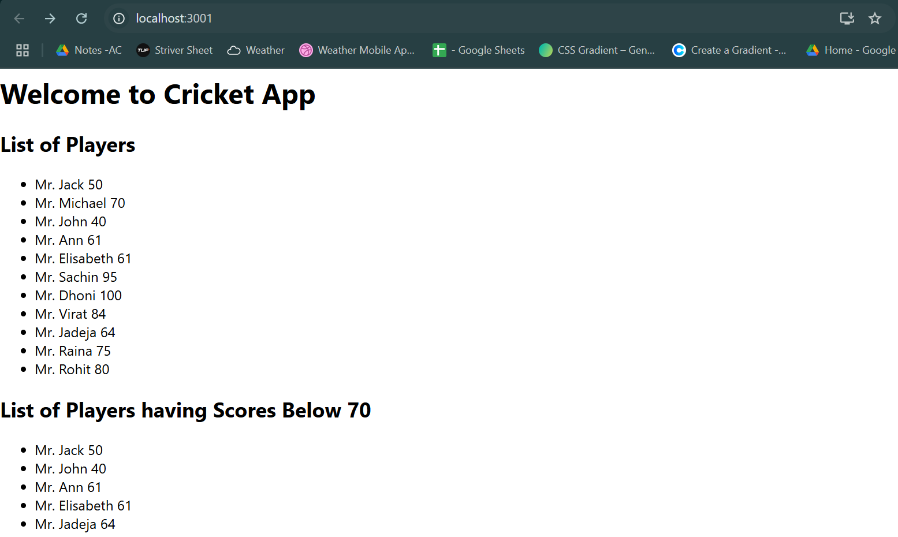

Case2:when flag=false
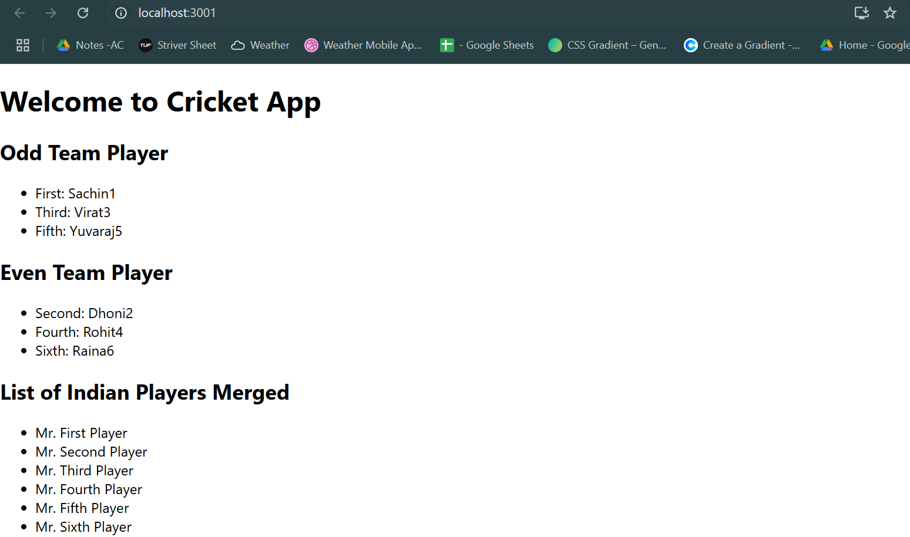

Exercise 2: Create a React App-officespacerentalapp
Code:
import React from 'react';
import officeImage from './assets/officeSpace.jpeg';

function App() {
const office = {
name: 'The Hive Workspaces',
rent: 75000,
address: '5th Floor, Tower B, Global Tech Park, Bengaluru'
};
const officeList = [
{
name: 'Innov8 Coworking',
rent: 55000,
address: 'Connaught Place, New Delhi'
},
{
name: '91Springboard',
rent: 65000,
address: 'Indiranagar, Bengaluru'
},
{
name: 'WeWork',
rent: 85000,
address: 'Cyber City, Gurugram'
},
];
const getRentStyle = (rent) => {
return {
color: rent > 60000 ? 'green' : 'red',
fontWeight: 'bold'
};
};
return (
<div style={{ padding: '20px', fontFamily: 'Arial' }}>
<h1>Office Space Rental App</h1>
<img
src={officeImage}
alt="Office Space"
style={{ width: '20%', maxWidth: '500px', marginBottom: '20px' }}
/>
<h2>{office.name}</h2>
<p>Address: {office.address}</p>
<p style={getRentStyle(office.rent)}>Rent: ₹{office.rent}</p>
<hr />
<h2>Other Available Spaces:</h2>
{officeList.map((off, index) => (
<div key={index} style={{ marginBottom: '15px' }}>
<h3>{off.name}</h3>
<p>Address: {off.address}</p>
<p style={getRentStyle(off.rent)}>Rent: ₹{off.rent}</p>
</div>
))}
</div>
);
}
export default App;

Output:
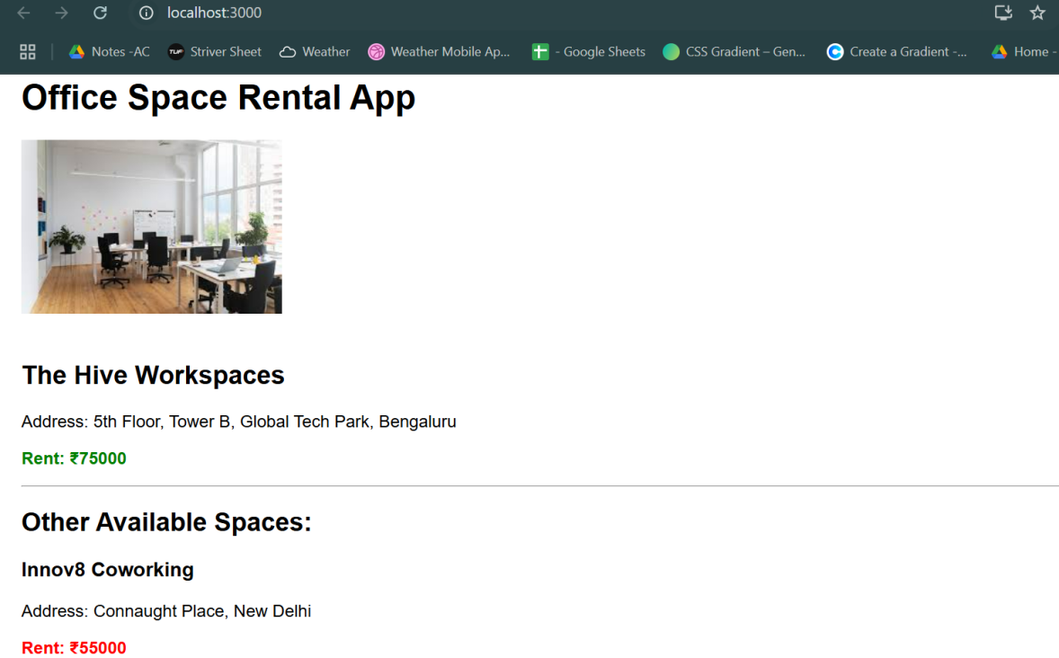

Exercise 3: Create a React App-eventexamplesapp
Code:
CurrencyConvertor.js
import React, { Component } from 'react';

class CurrencyConvertor extends Component {
constructor(props) {
super(props);
this.state = {
rupees: '',
euros: ''
};
this.handleSubmit = this.handleSubmit.bind(this);
this.handleChange = this.handleChange.bind(this);
}
handleChange(event) {
this.setState({ rupees: event.target.value });
}
handleSubmit(event) {
event.preventDefault();
const euroRate = 0.011; // 1 INR ≈ 0.011 Euro (adjust as needed)
const euros = (this.state.rupees * euroRate).toFixed(2);
this.setState({ euros });
}
render() {
return (
<div>
<h2>Currency Converter</h2>
<form onSubmit={this.handleSubmit}>
<input
type="number"
placeholder="Enter amount in ₹"
value={this.state.rupees}
onChange={this.handleChange}
/>
<button type="submit">Convert</button>
</form>
{this.state.euros && (
<p>Amount in Euro: €{this.state.euros}</p>
)}
</div>
);
}
}
export default CurrencyConvertor;

App.js
import React, { Component } from 'react';
import CurrencyConvertor from './components/CurrencyConvertor';

class App extends Component {
constructor(props) {
super(props);
this.state = {
count: 0,
};

this.increment = this.increment.bind(this);
this.sayHello = this.sayHello.bind(this);
this.increase = this.increase.bind(this);
this.sayWelcome = this.sayWelcome.bind(this);
this.handleClick = this.handleClick.bind(this);
}
increment() {
this.setState({ count: this.state.count + 1 });
}
sayHello() {
alert("Hello! This is a static message.");
}
increase() {
this.increment();
this.sayHello();
}
decrement = () => {
this.setState({ count: this.state.count - 1 });
};
sayWelcome(message) {
alert(message);
}
handleClick(event) {
alert("I was clicked");
}
render() {
return (
<div style={{ padding: '20px' }}>
<h1>React Events Example</h1>
<h2>Counter: {this.state.count}</h2>
<button onClick={this.increase}>Increase</button>
<button onClick={this.decrement}>Decrease</button>
<br /><br />
<button onClick={() => this.sayWelcome("Welcome to React Events!")}>
Say Welcome
</button>
<br /><br />
<button onClick={this.handleClick}>Synthetic OnPress</button>
<br /><br />
<CurrencyConvertor />
</div>
);
}
}
export default App;

Output:
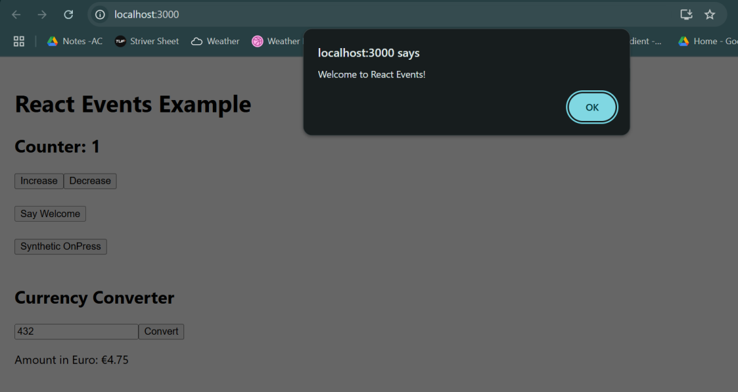

Exercise 4: Create a React App-ticketbookingapp
Code:
App.js
import React, { Component } from 'react';
import GuestPage from './components/GuestPage';
import UserPage from './components/UserPage';

class App extends Component {
constructor(props) {
super(props);
this.state = {
isLoggedIn: false
};
}
toggleLogin = () => {
this.setState(prevState => ({
isLoggedIn: !prevState.isLoggedIn
}));
};
render() {
const { isLoggedIn } = this.state;
// Element variable for conditional rendering
let pageContent;
if (isLoggedIn) {
pageContent = <UserPage />;
} else {
pageContent = <GuestPage />;
}
return (
<div style={{ padding: '20px', fontFamily: 'Arial' }}>
<h1>Ticket Booking App</h1>
<button onClick={this.toggleLogin}>
{isLoggedIn ? 'Logout' : 'Login'}
</button>
<hr />
{pageContent}
</div>
);
}
}
export default App;

GuestPage.js
import React from 'react';

const GuestPage = () => {
return (
<div>
<h2>Welcome, Guest!</h2>
<p>You can view available flights, but you need to log in to book tickets.</p>
<ul>
<li>✈️ Flight A - 10:00 AM</li>
<li>✈️ Flight B - 2:00 PM</li>
<li>✈️ Flight C - 6:00 PM</li>
</ul>
</div>
);
};
export default GuestPage;
UsrPage.js
import React from 'react';

const UserPage = () => {
return (
<div>
<h2>Welcome, User!</h2>
<p>You are now logged in. You can book flights below:</p>
<button>Book Flight A</button>
<button>Book Flight B</button>
<button>Book Flight C</button>
</div>
);
};
export default UserPage;

Output:
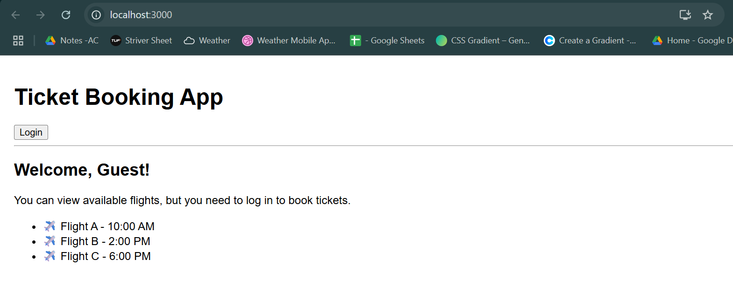
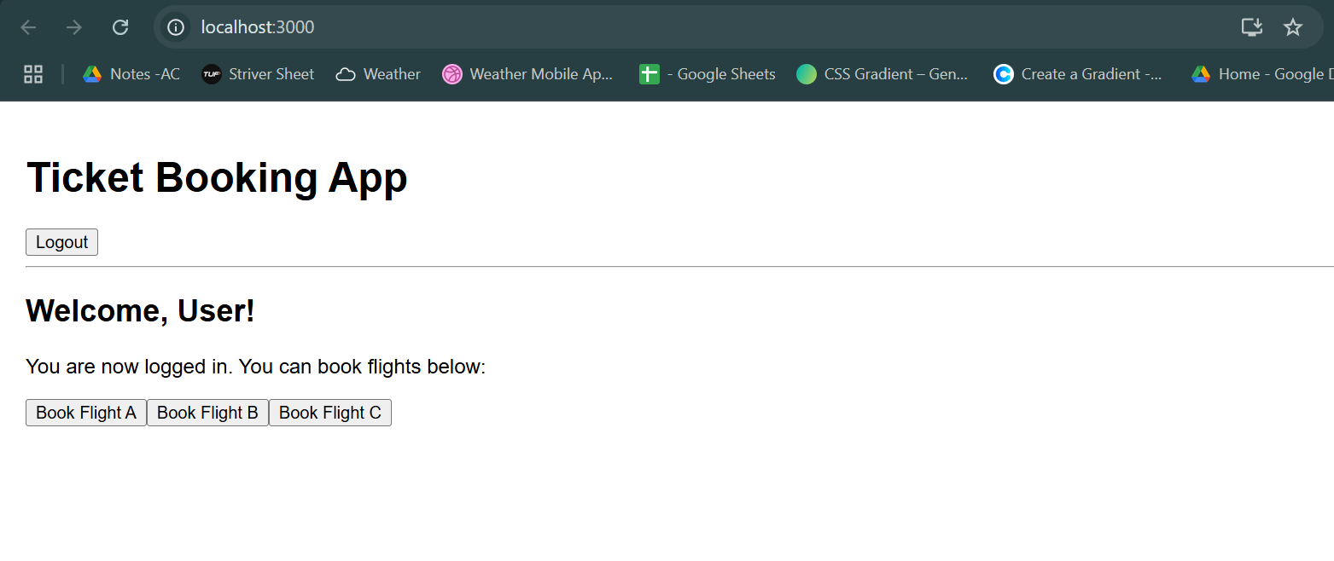

Exercise 5: Create a React App-bloggerapp
Code:
App.js
import React, { Component } from 'react';
import BookDetails from './components/BookDetails';
import BlogDetails from './components/BlogDetails';
import CourseDetails from './components/CourseDetails';

class App extends Component {
constructor(props) {
super(props);
this.state = {
view: 'books', // books | blogs | courses
};
}
switchView = (view) => {
this.setState({ view });
};
render() {
const { view } = this.state;
const books = [
{ title: 'React Explained', author: 'Zac Gordon' },
{ title: 'Learning JavaScript', author: 'Ethan Brown' },
];
const blogs = [
{ title: 'Getting Started with React', writer: 'Simran R' },
{ title: 'Hooks vs Classes', writer: 'John D' },
];
const courses = [
{ name: 'React Basics', duration: '3 weeks' },
{ name: 'Advanced React', duration: '4 weeks' },
];
let content;
if (view === 'books') {
content = <BookDetails books={books} />;
} else if (view === 'blogs') {
content = <BlogDetails blogs={blogs} />;
} else {
content = <CourseDetails courses={courses} />;
}
return (
<div style={{ padding: '20px' }}>
<h1>📘 Blogger App</h1>
{/* Conditional buttons */}
<button onClick={() => this.switchView('books')}>Show Books</button>
<button onClick={() => this.switchView('blogs')}>Show Blogs</button>
<button onClick={() => this.switchView('courses')}>Show Courses</button>
<hr />
{/* Conditional rendering using variable */}
{content}
{/* Also demo short-circuit rendering */}
{view === 'books' && <p>📌 You’re viewing Books section</p>}
{view === 'blogs' && <p>📌 You’re viewing Blogs section</p>}
{view === 'courses' && <p>📌 You’re viewing Courses section</p>}
{/* Conditional using ternary (for demo) */}
<p>
{view === 'books'
? 'Use the BookDetails component for list rendering with keys'
: view === 'blogs'
? 'This is showing BlogDetails with .map()'
: 'This is showing CourseDetails using props'}
</p>
</div>
);
}
}
export default App;

BookDetails.js
import React from 'react';

const BookDetails = ({ books }) => {
return (
<div>
<h2>📚 Book Details</h2>
<ul>
{books.map((book, index) => (
<li key={index}>{book.title} — {book.author}</li>
))}
</ul>
</div>
);
};
export default BookDetails;

BlogDetails.js
import React from 'react';

const BlogDetails = ({ blogs }) => {
return (
<div>
<h2>📝 Blog Details</h2>
<ul>
{blogs.map((blog, index) => (
<li key={index}>{blog.title} by {blog.writer}</li>
))}
</ul>
</div>
);
};
export default BlogDetails;

CourseDetails.js
import React from 'react';

const CourseDetails = ({ courses }) => {
return (
<div>
<h2>🎓 Course Details</h2>
<ul>
{courses.map((course, index) => (
<li key={index}>{course.name} ({course.duration})</li>
))}
</ul>
</div>
);
};
export default CourseDetails;
Output:
