**WEEK 6 HANDS ON**

Submitted by:Simran Raghav(6362006)

**REACT JS**

**Exercise 1: Create a React App-myfirstreact**

CODE:

**#installed create-react-app and created project**

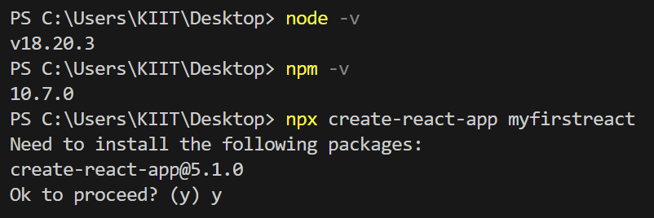

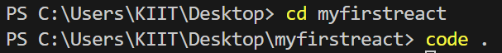

**#modified App.js file**

import React from 'react';

function App() {

  return(

   <div><h>Welcome to the first session of React</h></div>

  );

}

export default App;

**#ran the application (git bash)**

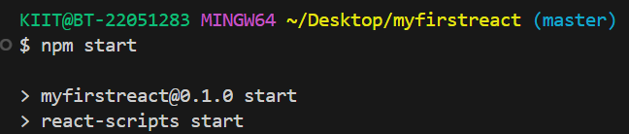

OUTPUT:

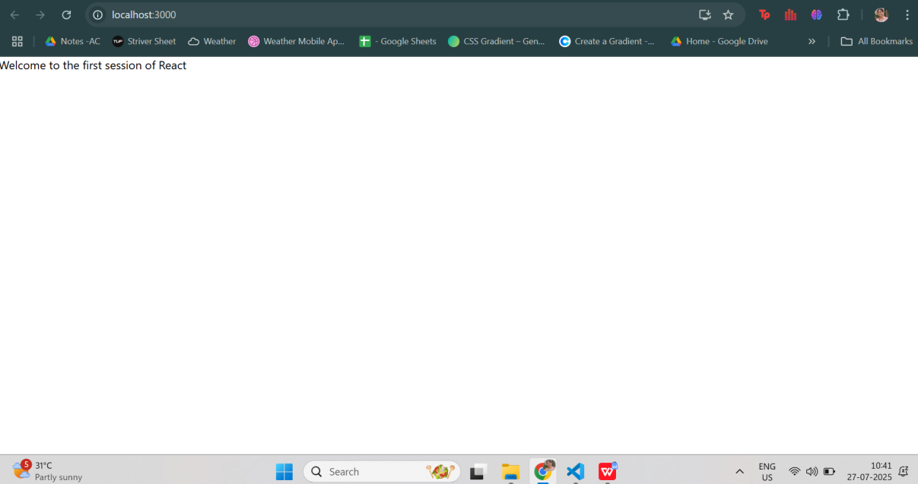

**Exercise 2: Create a React App-StudentApp**

CODE:

**#added Components to the folder structure(/src)**

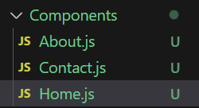

1. About.js

import React from 'react';

function About() {

  return (

    <div>

      <h3>Welcome to the About page of the Student Management Portal</h3>

    </div>

  );

}

export default About;

1. Contact.js

import React from 'react';

function Contact() {

  return (

    <div>

      <h3>Welcome to the Contact page of the Student Management Portal</h3>

    </div>

  );

}

export default Contact;

3)Home.js

import React from 'react';

 function Home()

 {

    return(

        <div><h3>Welcome to the Home page of Student Management Portal</h3></div>

    );

 }

 export default Home;

**#modified App.js**

import React from 'react';

import Home from './Components/Home';

import About from './Components/About';

import Contact from './Components/Contact';

function App() {

  return (

    <div>

             <Home/>

             <About/>

             <Contact/>

    </div>

  );

}

export default App;

OUTPUT:

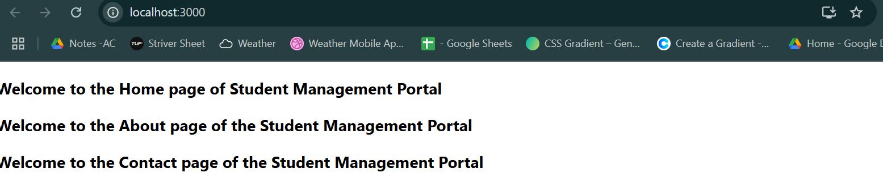

**Exercise 3: Create a React App-scorecalculatorapp**

CODE:

**#added Component and Stylesheets to the folder structure(/src)**

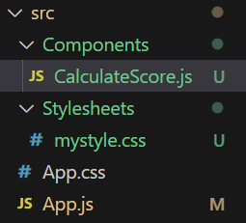

1. CalculatorScore.js

import '../Stylesheets/mystyle.css';

const percentToDecimal = (decimal) => {

  return decimal.toFixed(2) + '%';

}

const calcScore = (total, goal) => {

  return percentToDecimal((total / goal) * 100);

}

export const CalculateScore = ({ Name, School, total, goal }) => (

  <div className="formatstyle">

    <h1><font color="Brown">Student Details:</font></h1>

    <div className="Name">

      <b><span> Name: </span></b>

      <span>{Name}</span>

    </div>

    <div className="School">

      <b><span> School: </span></b>

      <span>{School}</span>

    </div>

    <div className="Total">

      <b><span>Total: </span></b>

      <span>{total}</span>

      <span> Marks</span>

    </div>

    <div className="Score">

      <b>Score:</b>

      <span>{calcScore(total, goal)}</span>

    </div>

  </div>

);

1. mystyle.css

.Name {

  font-weight: 300;

  color: blue;

}

.School {

  color: crimson;

}

.Total {

  color: darkmagenta;

}

.formatstyle {

  text-align: center;

  font-size: large;

}

.Score {

  color: forestgreen;

}

**#modified App.js**

import React from 'react';

import { CalculateScore } from './Components/CalculateScore';

function App() {

  return (

    <div>

      <CalculateScore Name="Simran" School="KIIT" total={480} goal={500} />

    </div>

  );

}

export default App;

OUTPUT:

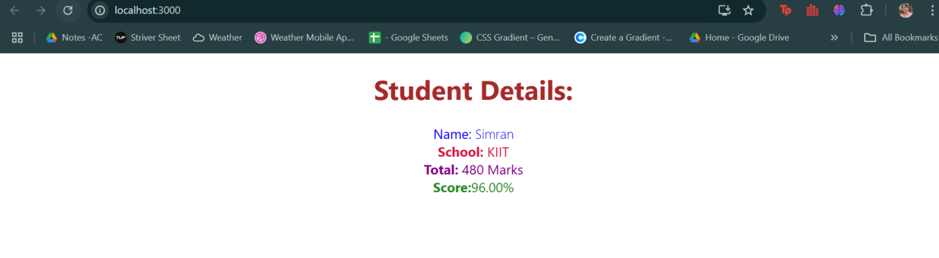

**Exercise 4: Create a React App-blogapp**

CODE:

**# added files to /src**

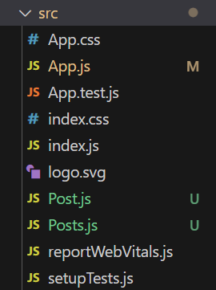

1. Post.js

import React from 'react';

class Post extends React.Component {

  render() {

    const { title, body } = this.props;

    return (

      <div style={{ border: '1px solid #ccc', padding: '10px', marginBottom: '15px' }}>

        <h3>{title}</h3>

        <p>{body}</p>

      </div>

    );

  }

}

export default Post;

1. Posts.js

import React from 'react';

import Post from './Post';

class Posts extends React.Component {

  constructor(props) {

    super(props);

    this.state = {

      posts: [],

      hasError: false

    };

  }

  componentDidMount() {

    this.loadPosts();

  }

  loadPosts() {

    fetch('https://jsonplaceholder.typicode.com/posts')

      .then(response => response.json())

      .then(data => {

        this.setState({ posts: data });

      })

      .catch(error => {

        console.error('Error fetching posts:', error);

        this.setState({ hasError: true });

      });

  }

  componentDidCatch(error, info) {

    alert('An unexpected error occurred in the component.');

    console.error('Caught error:', error, info);

    this.setState({ hasError: true });

  }

  render() {

    if (this.state.hasError) {

      return <h2>Something went wrong while loading posts.</h2>;

    }

    return (

      <div>

        <h2>Blog Posts</h2>

        {this.state.posts.slice(0, 5).map(post => (

          <Post key={post.id} title={post.title} body={post.body} />

        ))}

      </div>

    );

  }

}

export default Posts;

**#modified App.js**

import React from 'react';

import Posts from './Posts';

function App() {

  return (

    <div className="App">

      <Posts />

    </div>

  );

}

export default App;

OUTPUT:

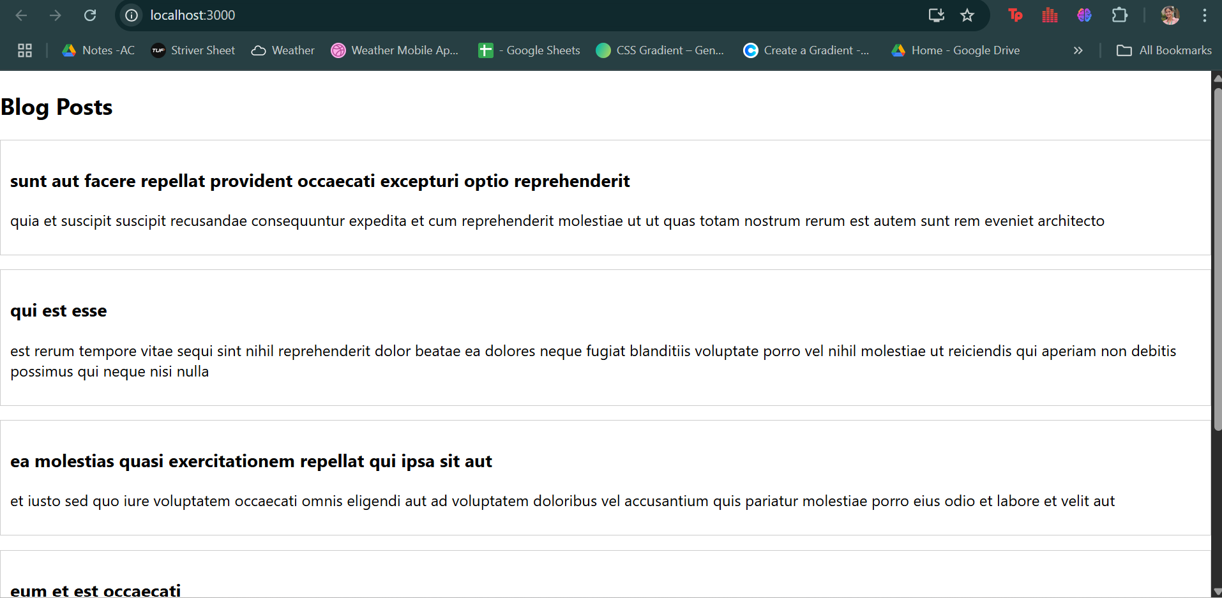

**Exercise 5: Create a Cohort Dashboard**

CODE:

**# modified folder structure(/src)**

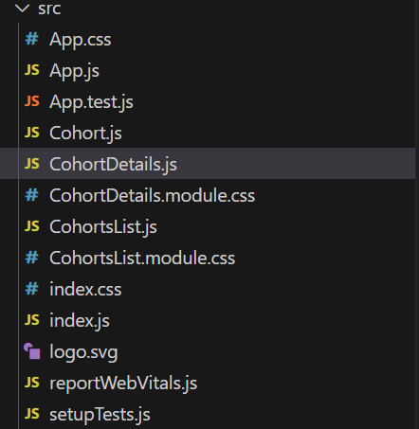

1)CohortDetails.js

import React from 'react';

import styles from './CohortDetails.module.css';

const getTitleColor = (tech) => {

  if (tech === '.NET FSD') return 'blue';

  if (tech === 'Java FSD') return 'green';

  return '#333';

};

const CohortDetails = ({ cohort }) => {

  return (

    <div className={styles.box}>

      <h3 style={{ color: getTitleColor(cohort.technology) }}>

        {cohort.cohortCode} - {cohort.technology}

      </h3>

      <dl>

        <dt>Start Date:</dt>

        <dd>{cohort.startDate}</dd>

        <dt>Trainer:</dt>

        <dd>{cohort.trainerName}</dd>

        <dt>Coach:</dt>

        <dd>{cohort.coachName}</dd>

        <dt>Status:</dt>

        <dd>{cohort.currentStatus}</dd>

      </dl>

    </div>

  );

};

export default CohortDetails;

2)CohortDetails.module.js

.box {

  width: 300px;

  margin: 10px;

  padding: 20px;

  border: 1px solid #ccc;

  border-radius: 10px;

  background: #fff;

  box-shadow: 0 2px 8px rgba(0,0,0,0.05);

  display: flex;

  flex-direction: column;

}

dt {

  font-weight: 500;

  margin-top: 8px;

}

dd {

  margin-left: 0;

  margin-bottom: 4px;

}

1. CohortsList.js

import React from 'react';

import { CohortsData } from './Cohort';

import CohortDetails from './CohortDetails';

import styles from './CohortsList.module.css';

const CohortsList = () => (

  <div>

    <h1 style={{ marginLeft: '10px' }}>Cohorts Details</h1>

    <div className={styles.container}>

      {CohortsData.map((cohort, idx) => (

        <CohortDetails key={idx} cohort={cohort} />

      ))}

    </div>

  </div>

);

export default CohortsList;

1. CohortsList.module.css

.container {

  display: flex;

  flex-wrap: wrap;

  gap: 20px;

  margin-top: 20px;

}

**#modified App.js**

import React from 'react';

import CohortsList from './CohortsList';

function App() {

  return <CohortsList />;

}

export default App;

OUTPUT:

