Project Report ( ISE Project Energy Efficient Systems)

INTRODUCTION:-
This report outlines the development and features of a Flask-based web application designed for testing and training purposes, integrating terminal functionality seamlessly. Additionally, the application incorporates PyJoules to measure system energy consumption during testing and training activities.

OBJECTIVE:-
The primary goal of this project is to create a web-based platform that facilitates testing and training tasks while providing users with the ability to open a terminal directly from the interface. Furthermore, the integration of PyJoules enables the measurement of system energy consumption, enhancing the understanding of resource utilization during testing and training processes.

TECHNOLOGIES USED:-

Flask Framework: Utilized for building the web application due to its simplicity and flexibility.
HTML/CSS: Employed for designing the user interface and ensuring a visually appealing experience.
GNOME Terminal: Integrated with the application to provide terminal access.
PyJoules: Integrated to measure system energy consumption during testing and training activities.
Implementation:

IMPLEMENTATION:-

Flask App Setup:
The Flask application is initialized with the necessary configurations, including a static folder for storing static assets.

Routes:
Index Page: Users are presented with a homepage containing relevant information and navigation links.

Testing Page: Users can perform testing tasks, and upon form submission, a new terminal window opens using the GNOME Terminal.

Training Page: Similar to the testing page, users engage in training activities, and a terminal window opens upon form submission.

Terminal Integration:
The open_terminal() function spawns a new GNOME Terminal process when triggered by form submissions on the testing and training pages.
This integration facilitates a seamless transition between the web interface and terminal environment for executing commands or scripts.

Energy Measurement with PyJoules:
PyJoules is integrated into the application to measure system energy consumption during testing and training tasks.
By monitoring energy usage, users gain insights into the resource utilization of their activities, contributing to better optimization and efficiency.

User Interface:
HTML templates and CSS stylesheets are utilized for rendering the user interface, ensuring a visually appealing and intuitive experience.

Error Handling:
The application runs in debug mode to provide detailed error messages and automatic server reloading during development.
Proper error handling mechanisms are implemented to ensure the reliability and robustness of the application.

SCREENSHOTS:-
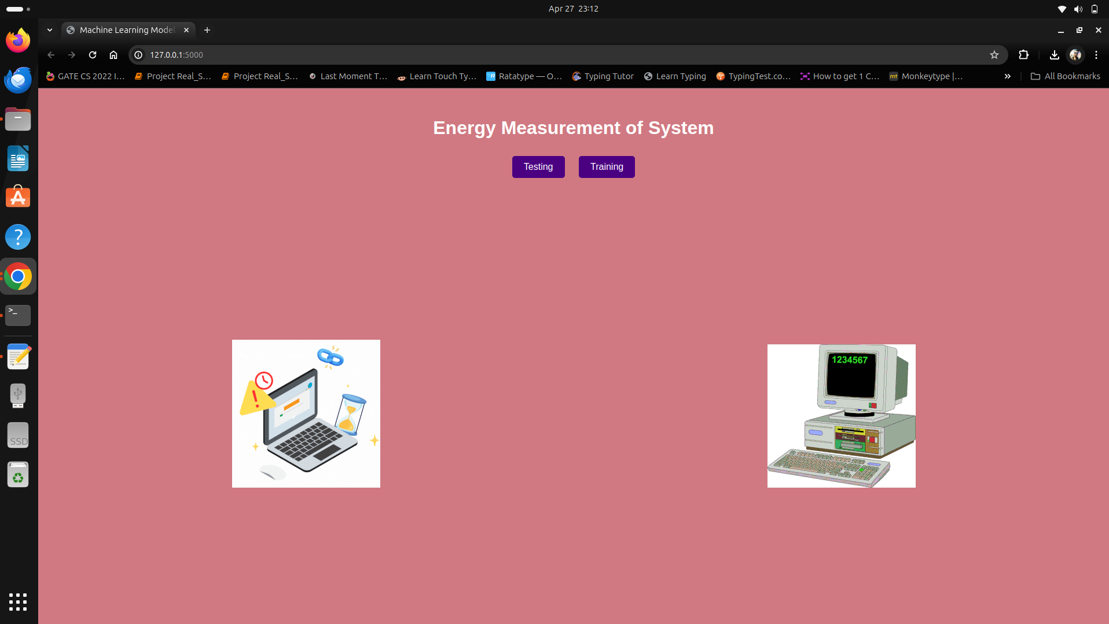
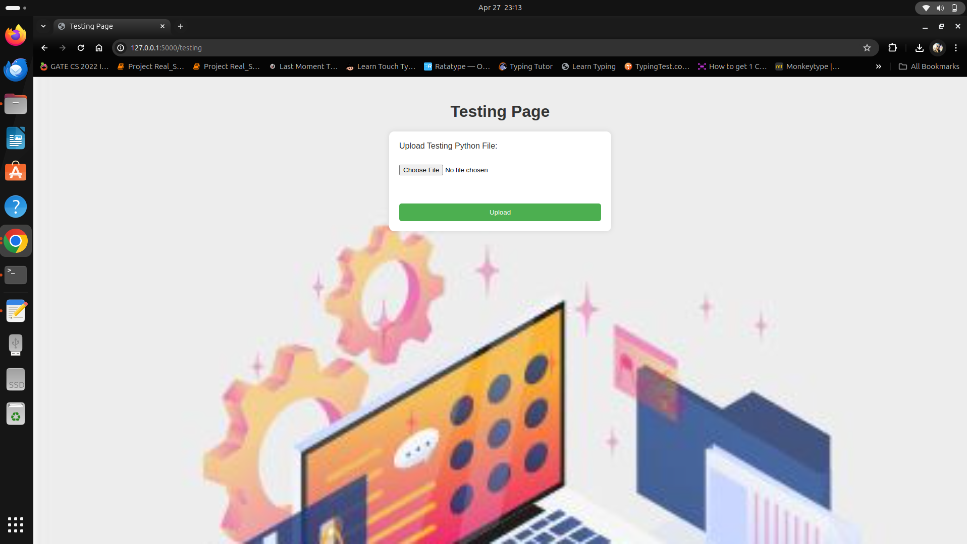

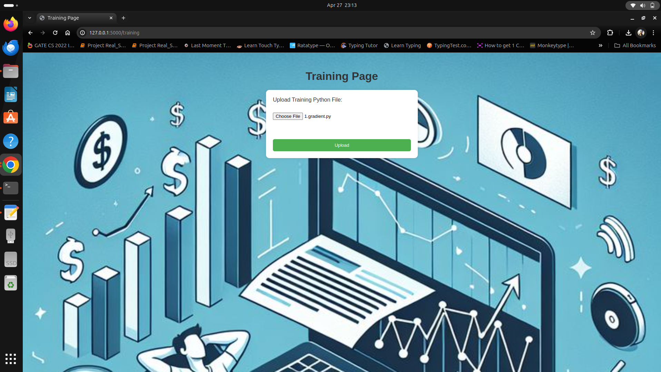

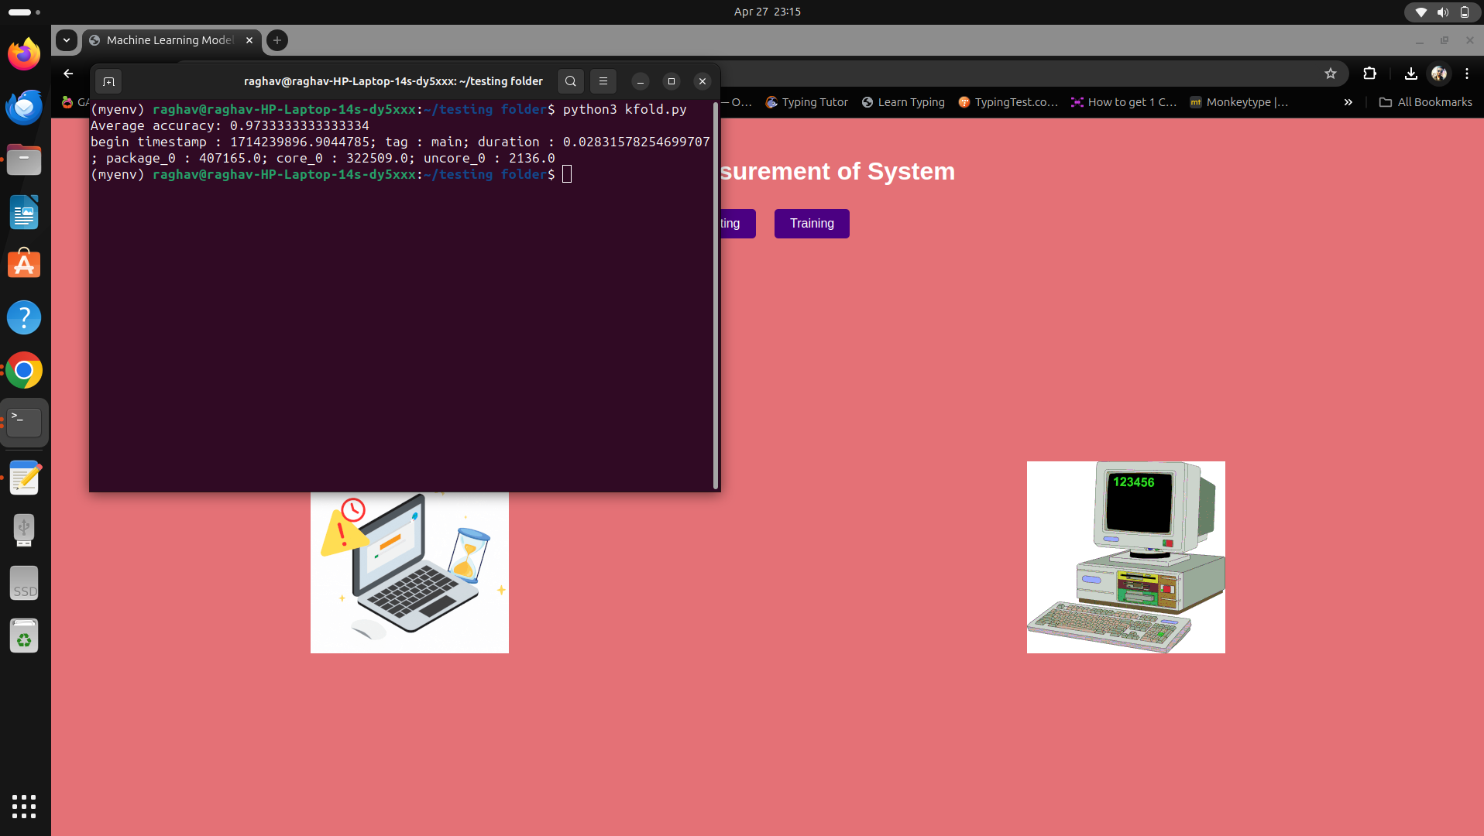

After working on front-end and back-end of our project we have addressed certain possible solutions to the frequently asked questions :
How we are reducing the energy consumption of the system ?
Reducing the energy consumption of a system further often involves optimizing various aspects of hardware and software. Here are some strategies to consider:
- Optimize Code Efficiency: Improve the efficiency of our application's code by identifying and eliminating unnecessary computations, reducing memory usage, and minimizing I/O operations. Writing efficient algorithms and data structures can significantly reduce energy consumption.
- Use Energy-Efficient Libraries and Frameworks: Choosing libraries and frameworks that are optimized for energy efficiency. For example, certain machine learning frameworks offer optimizations for running inference tasks with lower energy consumption.
- Reduce Resource Usage: Minimize the use of CPU, GPU, memory, and other resources when they are not needed. Utilize power-saving modes and techniques provided by the operating system and hardware.
- Optimize Data Processing: Batch processing and optimizing data transfer operations can reduce energy consumption by minimizing the time the system spends in active states.
Is there a way to reduce the effect of other applications and just focus on one application while measuring using PyJoules?
Regarding focusing on one application while measuring energy consumption using PyJoules, PyJoules primarily measures energy consumption at the system level rather than at the application level. However, you can isolate the impact of your application by minimizing the influence of other applications and system processes. Here's how you can do it:
- Run the Application in Isolation: Close unnecessary applications and services running on the system to reduce interference with your application's energy measurements.
- Monitor Energy Consumption Before and After Application Execution: Take baseline measurements of system energy consumption before running your application. Then, monitor energy consumption during application execution to isolate the impact of your application.
- Repeat Measurements: Conduct multiple measurements and average the results to mitigate the effects of background processes and system variability.
- pyRAPL (Python Running Average Power Limit) is an alternative to PyJoules for energy consumption measurement and analysis, specifically on Intel processors that support the RAPL (Running Average Power Limit) interface. While both PyJoules and pyRAPL serve similar purposes,
They have different underlying mechanisms:
- PyJoules: PyJoules is a Python library designed to measure and analyze the energy consumption of Python code. It primarily focuses on providing energy consumption metrics at the software level, allowing developers to profile and optimize the energy efficiency of their Python applications. It does not specifically rely on RAPL for measurements but rather provides a higher-level interface for energy analysis.
- pyRAPL: PyRAPL, on the other hand, directly interacts with the RAPL interface provided by Intel processors. It allows users to monitor and control the power consumption of various hardware components, such as the CPU package, cores, and memory controller, in real-time. PyRAPL provides a lower-level interface compared to PyJoules and is more tailored towards hardware-level energy measurement and analysis.

OBSERVATIONS:-
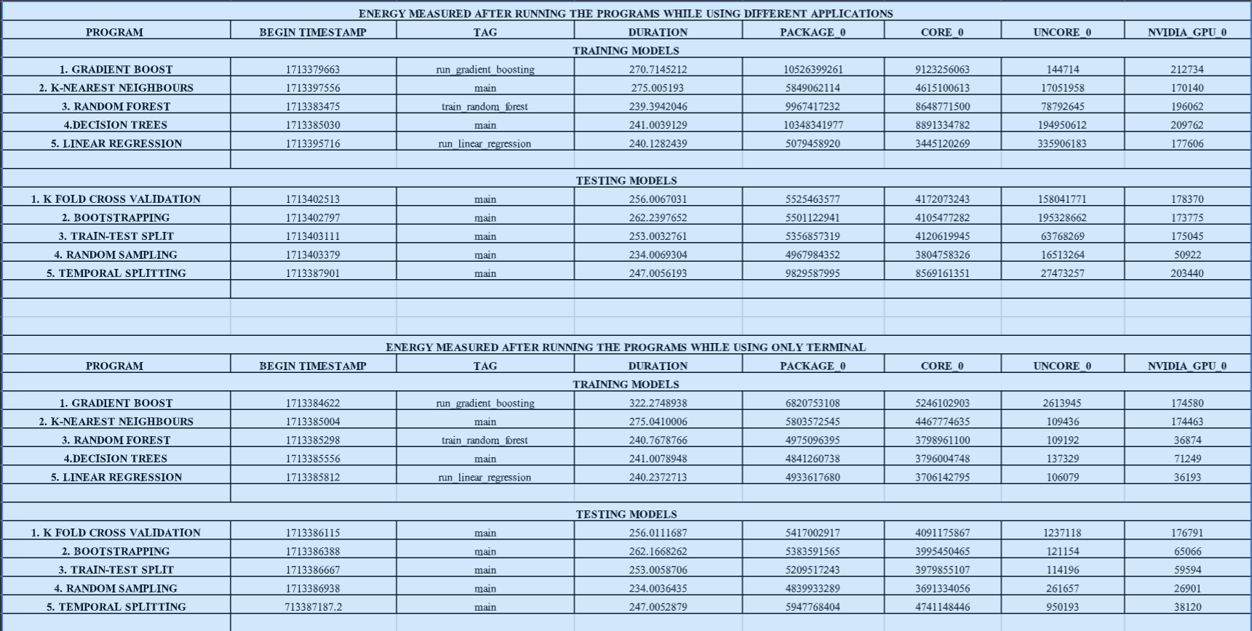

- Begin Timestamp: This is a timestamp indicating when the event (likely the beginning of a process) occurred. It represents the number of seconds that have passed since the Unix epoch (January 1, 1970, 00:00:00 UTC).
- Tag: This is a label or identifier for the event or process being logged.
- Duration: This is the duration of the event or process, measured in seconds. It indicates how long it took for the process labeled to complete.
- Package_0: This value represents energy consumption (in Micro joules ) by the first package (CPU package) during the event or process.
- Core_0: This value represents energy consumption (again, likely in joules or watt-seconds) by the first CPU core during the event or process.
- Uncore_0: This value represents energy consumption ( in Micro joules) by the first uncore component (part of the CPU that is not a core, such as the memory controller) during the event or process.
- Nvidia_gpu_0: This value represents energy consumption ( in Micro joules ) by the first NVIDIA GPU during the event or process.
Overall, this log entry provides information about the timing, duration, and energy consumption of an event or process. It specifically details energy consumption by various components such as the CPU package, CPU cores, uncore components, and NVIDIA GPU during the event.
From the table we have observed that:
- The time taken to run testing and training models in terminal while some other applications are running parallelly is more than that taken to run the models on terminal without the presence of other applications.
- So we can say that when we measure the energy of a python program using pyjoules library
If any application is running parallelly with the program on the system then pyjoules also measures the energy used by that application
We also faced an error in running the program at first but it was resolved using the following command:-
- sudo chmod -R a+r /sys/class/powercap/intel-rapl (or)
- sudo chown -R energy /sys/class/powercap/intel-rapl

CONCLUSION:-
In conclusion, the developed Flask web application provides a user-friendly platform for testing and training tasks, complemented by seamless integration with the GNOME Terminal and energy measurement capabilities through PyJoules. The project successfully achieves its objectives of delivering a functional and intuitive web-based environment with enhanced terminal and energy monitoring functionalities.

