Predicting Airfoil Lift Coefficient using Neural Networks
Raghav Sood, Siddharth Ghiya, Rahul Sharma
Department of Mechanical Engineering, Carnegie Mellon University, Pittsburgh, PA,15213

Abstract

The project aims at creating a Neural Network that can g predict lift coefficient of an airfoil within no time and requires user to have no specific knowledge of CFD Softwares to achieve the stated task. Adaptability of a Fully Connected Neural Network (FC) and a Convolutional Neural Network (CNN) are tested for learning underlying non-linearities of Navier-Stokes Equation. NACA 4-digit Airfoil profiles are obtained from UIUC airfoil database and lift data is generated using JavaFoil. Data Augmentation is done by choosing a range of Angle of Attack and Reynolds Number. The results for FC network are compared to CNN and is found that CNN can give more accurate predictions and can be easily scaled to profiles other than NACA 4-digit.

Introduction
Conventional CFD software take considerable amount of time and computation to solve for flow around an airfoil to calculate its performance parameters and rely on an underlying physics model which has high dimensional non-linearities. Furthermore, using CFD software requires user to have good knowledge of that underlying physics model to generate actual good results. Due to the advancement in computational power and Machine Learning (ML) algorithms, a new approach can be used to approximate these complicated physics models that can produce results as good as these physics based CFD models.

Different models for different scopes can be generated using a data driven approach. In today’s world there is no dearth of data. Humongous amount of data is being generated everyday by simulations and actual experiments. This data if properly prepared can be used to train numerous models that can also model the scenarios that are too complex to be modeled in the physics of CFD models.

Most of the early interdisciplinary work in the field of fluids and ML was done employing only Fully Connected Neural Networks. But the problem with the FC networks was that they didn’t preserve the spatial identity of the input. But with the advent of CNN and Generative Networks, a lot of research in the field of fluids using Machine Learning has gained attention of researchers. A very recent paper in 2018 [1] showed very promising results by using Generative Networks for parametrized fluids simulations. They were able to reconstruct velocity fields 700X faster than a traditional CPU solver while achieving compression rates over 1300X.

The unique feature of the CNN’s is that they can capture the high and low level spatial and temporal features of an input which are big requirement in the field of fluids as the geometry and the environmental conditions play a big role in Fluid Dynamics.

In this project we use both the FC Network and CNN to predict lift coefficients of airfoils. The FC network can’t preserve the spatial identity of inputs therefore is provided with the 4-digits of NACA airfoil and angle of attack as geometrical input features. Whereas to demonstrate how a CNN can easily and more efficiently learn the spatial features such as geometry and orientation of the airfoil it is just provided with the image of the airfoil at various angles of attack as an input with a layer of Reynolds Number appended to one channel of the image (can be interpreted as coloring the image according to Reynolds Number).

Data Generation

Dataset
28 NACA 4-digit airfoils were chosen from the UIUC Airfoil Database [2]. The raw data was in the form of x and y coordinates of the airfoils.

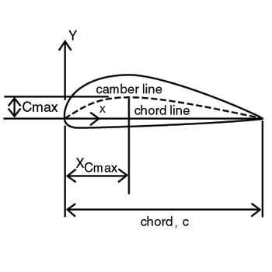
Figure 1 Airfoil Geometry Terminology
The digits in NACA's four-digit numbering system [3] are defined as follows:
- The first digit denotes the maximum camber, C_{max}, as a percent of the chord.
- The second digit denotes the chordwise position of the maximum camber, X_{Cmax}, in tenths of the chord.
- The last two digits denotes the maximum thickness of the airfoil section, t, as a percent of the chord.

Lift Data Generation using JavaFoil
Lift data for the airfoils is needed for training the network. As there is no database available that could provide us with the lift coefficients of the chosen airfoils, it is decided to generate data ourselves.

An airfoil analysis applet JavaFoil [4] is chosen to estimate the lift coefficients of the airfoils. One of the major constraints in training a Neural Network is availability of enough data. Therefore, we decided to augment the data we have by running the simulations on the chosen airfoils for a range of Reynolds Number and Angle (AoA) of Attack. The range of AoA is chosen to be from -20⁰ to +20⁰ and the range of Reynolds Number is chosen to be from 30,000 to 6,430,000. The step for angle of attack is chosen to be 1⁰ and for angle of attack to be 400,000. Every airfoil is simulated for the above range of parameters and this data augmentation results in the dataset of 19516 configurations. 15000 instances of this data are taken as train data and rest is left as test data.

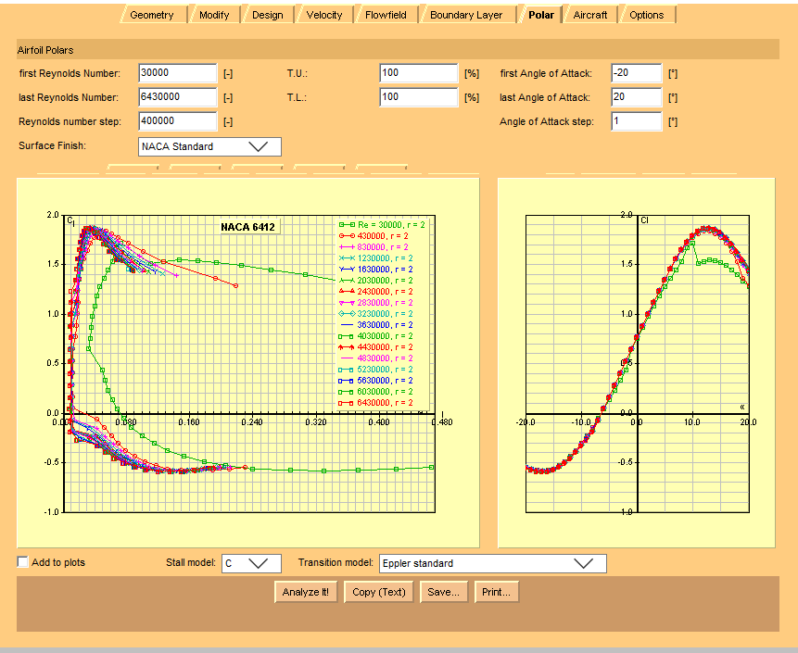
Figure 2 JavaFoil Simulations for Data Generation

Results from JavaFoil simulations are saved to txt files.

2.3 Data Preprocessing

To be able to use the data stored in txt files as an input to a Neural Network, considerable data preprocessing is required. As two different type of networks are implemented in this project, both need different data preprocessing. All data preprocessing is done by writing Python scripts.

2.3.1 Data Preprocessing for Fully Connected Network

The input for the FC network is decided to be the 4-digits from the airfoil name, Angle of Attack and Reynolds Number.

A Python script is written to parse the txt files generated by JavaFoil which saves the airfoil name, AoA, Reynolds Number and the Lift Coefficient in a data array.

The input data to the network is required to be in the form of a one hot vector. The digits are converted in one-hot vectors of dimension 10X1 and are appended together and AoA and Reynolds Number are appended at the last rows, thus resulting in an input vector of 42X1 for each airfoil configuration. The data was further divided into batches. The batch size was chosen to be 50. Therefore, the final processed input data for FC network had a dimension of 50X42X1.

2.3.2 Data Preprocessing for Convolution Neural Network

The input for the CNN is a 64X64 image of the airfoil configuration with the Reynold number appended at the second channel of the image.

A Python script is written that first multiplies the coordinate matrix with a rotation matrix that rotates the data about the origin by a specified angle. The range of angles for each airfoil profile varies from -20⁰ to +20⁰ with a 1⁰ step. Then the script plots the rotated x and y coordinate data for the airfoils and fills in color to the airfoil to make geometry as a more prominent feature. The plot is saved as 64X64 grayscale png image.


Figure 3 Saved 64X64 plot of a rotated NACA airfoil

The data is again divided into batches of size 50 and just before inputting the image into the network the Reynold Number is read from the earlier saved data for FC network for the same configuration and is appended to the second channel of the image as a 64X64 array. Therefore, the final size of he input to the network is 50X2X64X64.

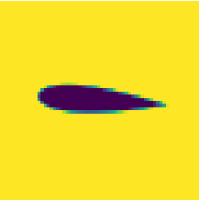

Figure 4 Airfoil image with Reynold Number as 2nd channel

The ruler
The LATEX style defines a printed ruler which should be present in the version submitted for review. The ruler is provided in order that reviewers may comment on particular lines in the paper without circumlocution. If you are preparing a document using a non-LATEX document preparation system, please arrange for an equivalent ruler to appear on the final output pages. The presence or absence of the ruler should not change the appearance of any other content on the page. The camera ready copy should not contain a ruler. (LATEX users may uncomment the \cvprfinalcopy command in the document preamble.) Reviewers: note that the ruler measurements do not align well with lines in the paper—this turns out to be very difficult to do well when the paper contains many figures and equations, and, when done, looks ugly. Just use fractional references (e.g. this line is 189.5), although in most cases one would expect that the approximate location will be adequate.

Mathematics
Please number all of your sections and displayed equations. It is important for readers to be able to refer to any particular equation. Just because you didn’t refer to it in the text doesn’t mean some future reader might not need to refer to it. It is cumbersome to have to use circumlocutions like “the equation second from the top of page 3 column 1”. (Note that the ruler will not be present in the final copy, so is not an alternative to equation numbers). All authors will benefit from reading Mermin’s description of how to write mathematics: http://www.pamitc.org/documents/mermin.pdf. Every equation should be numbered, even if you don't refer to it!

Blind review
Many authors misunderstand the concept of anonymizing for blind review. Blind review does not mean that one must remove citations to one’s own work—in fact it is often impossible to review a paper unless the previous citations are known and available.
Blind review means that you do not use the words “my” or “our” when citing previous work. That is all. (But see below for techreports)
Saying “this builds on the work of Lucy Smith [1]” does not say that you are Lucy Smith, it says that you are building on her work. If you are Smith and Jones, do not say “as we show in [7]”, say “as Smith and Jones show in [7]” and at the end of the paper, include reference 7 as you would any other cited work.
An example of a bad paper:

An analysis of the frobnicatable foo filter.
In this paper we present a performance analysis
of our previous paper [1], and show it to be inferior
to all previously known methods. Why the
previous paper was accepted without this analysis
is beyond me.
[1] Removed for blind review

An example of an excellent paper:

An analysis of the frobnicatable foo filter.
In this paper we present a performance analysis of
the paper of Smith et al. [1], and show it to be
inferior to all previously known methods. Why the
previous paper was accepted without this analysis
is beyond me.
[1] Smith, L and Jones, C. “The frobnicatable
foo filter, a fundamental contribution to human
knowledge”. Nature 381(12), 1-213.

If you are making a submission to another conference at the same time, which covers similar or overlapping material, you may need to refer to that submission in order to explain the differences, just as you would if you had previously published related work. In such cases, include the anonymized parallel submission [4] as additional material and cite it as
[1] Authors. “The frobnicatable foo filter”, Face and Gesture 2014 submission ID 324, Supplied as additional material efg324.pdf.
Finally, you may feel you need to tell the reader that more details can be found elsewhere, and refer them to a technical report. For conference submissions, the paper must stand on its own, and not require the reviewer to go to a techreport for further details. Thus, you may say in the body of the paper “further details may be found in [5]”. Then submit the techreport as additional material. Again, you may not assume the reviewers will read this material.
Sometimes your paper is about a problem which you tested using a tool which is widely known to be restricted to a single institution. For example, let’s say it’s 1969, you have solved a key problem on the Apollo lander, and you believe that the CVPR70 audience would like to hear about your solution. The work is a development of your celebrated 1968 paper entitled ”Zero-g frobnication: How being the only people in the world with access to the Apollo lander source code makes us a wow at parties”, by Zeus et al.
You can handle this paper like any other. Don’t write “We show how to improve our previous work [Anonymous, 1968]. This time we tested the algorithm on a lunar lander [name of lander removed for blind review]”. That would be silly, and would immediately identify the authors. Instead write the following:
We describe a system for zero-g frobnication. This system is new because it handles the following cases: A, B. Previous systems [Zeus et al. 1968] didn’t handle case B properly. Ours handles it by including a foo term in the bar integral.
...
The proposed system was integrated with the Apollo lunar lander, and went all the way to the moon, don’t you know. It displayed the following behaviours which show how well we solved cases A and B: ...
As you can see, the above text follows standard scientific convention, reads better than the first version, and does not explicitly name you as the authors. A reviewer might think it likely that the new paper was written by Zeus et al, but cannot make any decision based on that guess. He or she would have to be sure that no other authors could have been contracted to solve problem B.

Miscellaneous
When citing a multi-author paper, you may save space by using “et alia”, shortened to “et al.” (not “et. al.” as “et” is a complete word.) However, use it only when there are three or more authors. Thus, the following is correct:
“Frobnication has been trendy lately. It was introduced
by Alpher [3], and subsequently developed by Alpher and Fotheringham-Smythe [1], and Alpher et al. [2].”
This is incorrect: “... subsequently developed by Alpher et al. [1] ...” because reference [1] has just two authors. If you use the \etal macro provided, then you need not worry about double periods when used at the end of a sentence as in Alpher et al.
For this citation style, keep multiple citations in numerical (not chronological) order, so prefer [1, 3, 4] to [3, 1, 4].

Formatting your paper
All text must be in a two-column format. The total allowable width of the text area is 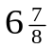inches (17.5 cm) wide by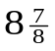inches (22.54 cm) high. Columns are to be 31/4 inches (8.25 cm) wide, with a 5/16 inch (0.8 cm) space between them. The main title (on the first page) should begin 1.0 inch (2.54 cm) from the top edge of the page. The second and following pages should begin 1.0 inch (2.54 cm) from the top edge. On all pages, the bottom margin should be 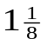inches (2.86 cm) from the bottom edge of the page for 8.5 × 11-inch paper; for A4 paper, approximately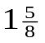inches (4.13 cm) from the bottom edge of the page.

Margins and page numbering
Figure 2: Short captions should be centred.
All printed material, including text, illustrations, and charts, must be kept within a print area inches (17.5 cm) wide by inches (22.54 cm) high. Page numbers should be in footer with page numbers, centered and .75 inches from the bottom of the page and make it start at the correct page number rather than the 4321 in the example (how to do that depends on your version of word or open office. Failure to use the correct page number, or place it properly, could result in the paper not being included in Xplore, (even if it passes PDF express (which does not check page number)

Type-style and fonts
Wherever Times is specified, Times Roman may also be used. If neither is available on your word processor, please use the font closest in appearance to Times to which you have access.
MAIN TITLE. Center the title 1-3/8 inches (3.49 cm) from the top edge of the first page. The title should be in Times 14-point, boldface type. Capitalize the first letter of nouns, pronouns, verbs, adjectives, and adverbs; do not capitalize articles, coordinate conjunctions, or prepositions (unless the title begins with such a word). Leave two blank lines after the title.
AUTHOR NAME(s) and AFFILIATION(s) are to be centered beneath the title and printed in Times 12-point, non-boldface type. This information is to be followed by two blank lines.
The ABSTRACT and MAIN TEXT are to be in a twocolumn format.
MAIN TEXT. Type main text in 10-point Times, singlespaced. Do NOT use double-spacing. All paragraphs should be indented 1 pica (approx. 1/6 inch or 0.422 cm). Make sure your text is fully justified—that is, flush left and flush right. Please do not place any additional blank lines between paragraphs.
Figure and table captions should be 9-point Roman type as in Figures 1 and 2. Short captions should be centred. Callouts should be 9-point Helvetica, non-boldface type. Initially capitalize only the first word of section titles and first-, second-, and third-order headings.
FIRST-ORDER HEADINGS. (For example, 1. Introduction) should be Times 12-point boldface, initially capitalized, flush left, with one blank line before, and one blank line after.
SECOND-ORDER HEADINGS. Should be Times 11-point boldface, initially capitalized, flush left, with one blank line before, and one after. If you require a third-order heading (we discourage it), use 10-point Times, boldface, initially capitalized, flush left, preceded by one blank line, followed by a period and your text on the same line.

Footnotes
Please use footnotes sparingly. Indeed, try to avoid footnotes altogether and include necessary peripheral observations in the text (within parentheses, if you prefer, as in this sentence). If you wish to use a footnote, place it at the bottom of the column on the page on which it is referenced. Use Times 8-point type, single-spaced.

References
List and number all bibliographical references in 9-point Times, single-spaced, at the end of your paper. When referenced in the text, enclose the citation number in square brackets, for example [4]. Where appropriate, include the name(s) of editors of referenced books.

Illustrations, graphs, and photographs
All graphics should be centered. Please ensure that any point you wish to make is resolvable in a printed copy of the paper. Resize fonts in figures to match the font in the body text, and choose line widths which render effectively in print. Many readers (and reviewers), even of an electronic copy, will choose to print your paper in order to read it.
You cannot insist that they do otherwise, and therefore must not assume that they can zoom in to see tiny details on a graphic. When placing figures in LATEX, it’s almost always best to use \includegraphics, and to specify the figure width as a multiple of the line width as in the example below

\usepackage[dvips]{graphicx} ...
\includegraphics[width=0.8\linewidth]
{myfile.eps}

Color
Please refer to the author guidelines on the CVPR 2015 web page for a discussion of the use of color in your document.

Final copy
You must include your signed IEEE copyright release form when you submit your finished paper. We MUST have this form before your paper can be published in the proceedings. Please direct any questions to the production editor in charge of these proceedings at the IEEE Computer Society Press: Phone (714) 821-8380, or Fax (714) 761-1784.

References
- A. Alpher, , and J. P. N. Fotheringham-Smythe. Frobnication revisited. Journal of Foo, 13(1):234–778, 2003.
- A. Alpher, , J. P. N. Fotheringham-Smythe, and G. Gamow. Can a machine frobnicate? Journal of Foo, 14(1):234–778, 2004.
- A. Alpher. Frobnication. Journal of Foo, 12(1):234–778, 2002.
- Actual Author Name. The frobnicatable foo filter, 2014. Face and Gesture (to appear ID 324).
- Actual Author Name. Frobnication tutorial, 2014. Some URL al tr.pdf.

This is what a footnote looks like. It often distracts the reader from the main flow of the argument.

