When you open the interface, it looks like this :

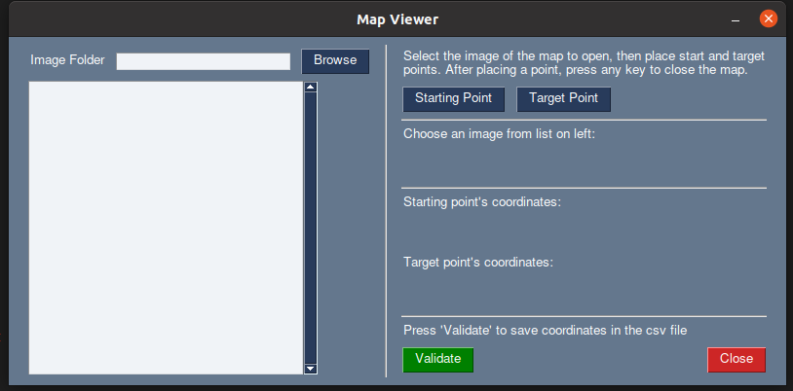

First, click on the “Browse” button and select a folder. All the png and jpg files will appear on the list under the “Image Folder”. Then select a file from the list.

Then you can choose to place the starting point and the target point. Press any of the button to open the selected file. If the image is to small, it will be resized for the display (only for the display, the file is unchanged). Click on the image to place the point. Here is an example of how it looks like :

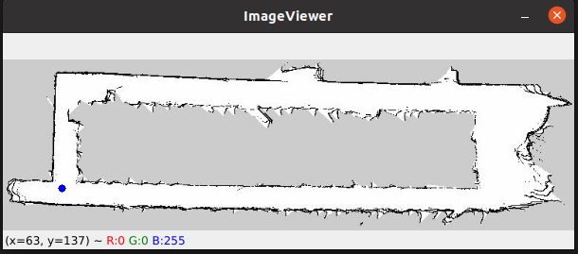

The blue point is the selected point. If no point appear when you click, it’s because the interface consider the selected point as a wall. You can place as many point as you want on the image, but only the last one will be saved. Once you have selected a point you can close the image by pressing any key. When you close the image, the coordinates on the interface are updated for either the starting or the target point, depending on which one you choose. You can reopen the image and replace the points as many time as you want. If the image have been resized, the coordinates displayed on the “ImageViewer” window won’t be the same as the in the interface. Those of the interface correspond to the original image, without resizing.

Once you have selected both starting and target points, you can press the “Validate” button to save the coordinates in a csv file named “coordinates.csv”. A message appear at the right of the button to confirm that the csv file have been updated. At this point, the window should look like this :

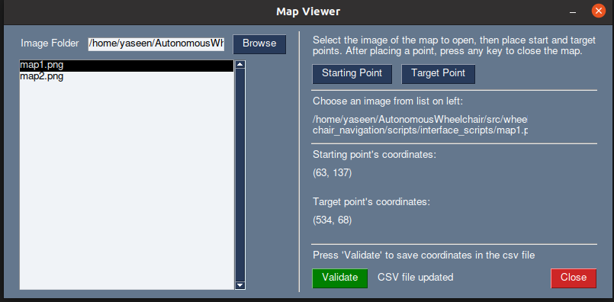

You can close the window by clicking on the “Close” button or the top right button. The coordinates are saved in two column in the csv file.

