Software Requirements Specification: Nexus Store Platform
Version 3.0 - Approved baseline - Prepared by the Nexus platform team

Revision History
Version | Date | Change
2.0 | 2026-03-01 | Payments chapter
3.0 | 2026-10-01 | Security workflows as UML

Table of Contents
1 Introduction ........ 2
2 Overall Description ........ 3
3 Specific Requirements ........ 4

1 Introduction

1.1 Purpose
This SRS specifies the externally visible behaviour of the Nexus Store API. Every API change is reviewed against it before merge.

1.2 Definitions, Acronyms and Abbreviations
Term | Definition
OTP | One-time password
2FA | Two-factor authentication

2 Overall Description
Shoppers use the web and mobile apps; the Nexus Store API talks to the payment gateway.
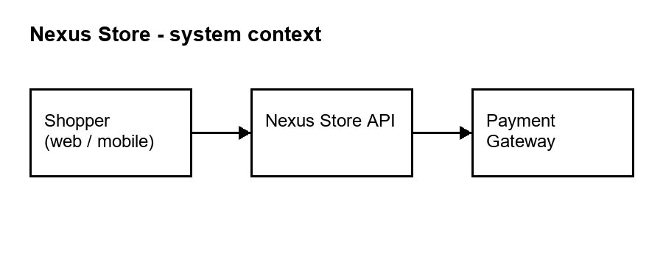
Figure 1: System context diagram

3 Specific Requirements

3.1 Core Functional Requirements
Req ID | Title | Description | Priority
REQ-01 | User Authentication & Session Management | The system must provide a secure user authentication mechanism that validates credentials against stored hashed passwords and issues a signed JWT access token with a configurable expiry time. All authenticated sessions must be uniquely identifiable via a session_id field returned in the authentication response, enabling session revocation and audit trail generation. | High
REQ-02 | Product Catalogue Retrieval | The system must expose a paginated endpoint to retrieve the full product catalogue, supporting filtering by keyword, category, and price range. Each product record in the response must include the product_id, name, description, category, price, stock_quantity, and at least one associated image_url. The endpoint must accept pagination parameters (page and page_size) to control result volume. | High
REQ-03 | Shopping Cart Management | The system must allow authenticated users to add, update quantity, and remove individual items from a persistent shopping cart. Every cart state response must include the full list of cart items with their item_id, product_id, quantity, unit_price, and a server-computed subtotal reflecting the current cart total. Cart state must persist across user sessions. | High
REQ-04 | Refund Transaction Integrity | All refund transactions must include a unique, client-provided transaction_id field in the request body to enable idempotent processing and financial audit compliance. This transaction_id must also appear in the refund receipt returned in the API response, ensuring end-to-end traceability of every refund operation initiated by the client system. | High
REQ-05 | Checkout & Order Placement | The checkout endpoint must accept a complete order payload including the user's cart contents, a validated shipping_address object, a selected delivery_method, and a payment_method_token. Upon successful order placement, the API must return a unique order_id and an estimated_delivery_date. The endpoint must reject incomplete payloads with a structured validation error response. | High
REQ-06 | Payment Method Support | The system must support multiple payment methods including credit and debit card payments (via card_token), digital wallet payments through Apple Pay (via apple_pay_token) and Google Pay (via google_pay_token), and previously stored payment instruments (via saved_payment_id). The payment_type field must be explicitly declared in every payment processing request to identify the method being used. | High

3.2 Account and Order Features

REQ-07 Order Status Tracking
The system must provide an authenticated endpoint that accepts an order_id and returns the real-time fulfilment status of that order. The status response must include a status_label field and an array of timeline_events, each with a stage name (order_placed, processing, dispatched, out_for_delivery, delivered) and its corresponding ISO 8601 timestamp. Orders that do not belong to the authenticated user must return a 403 Forbidden response.

REQ-08 User Profile Management
Authenticated users must be able to retrieve and update their profile information via dedicated GET and PUT endpoints. Updatable fields must include display_name, email, shipping_addresses (an array), and notification_preferences. Any request to change the email field must set an email_verification_pending flag in the response, indicating that a re-verification workflow has been triggered.

REQ-10 Notification Subscription Management
The system must allow authenticated users to retrieve and modify their notification preferences via dedicated endpoints. Subscribable notification categories must include order_updates, promotional_offers, and security_alerts. Preference changes must be persisted immediately and honoured by all downstream messaging services. The response must confirm the updated preference state for each category.

3.3 Security Workflows
High-value operations follow the workflow modelled in Figure 2.
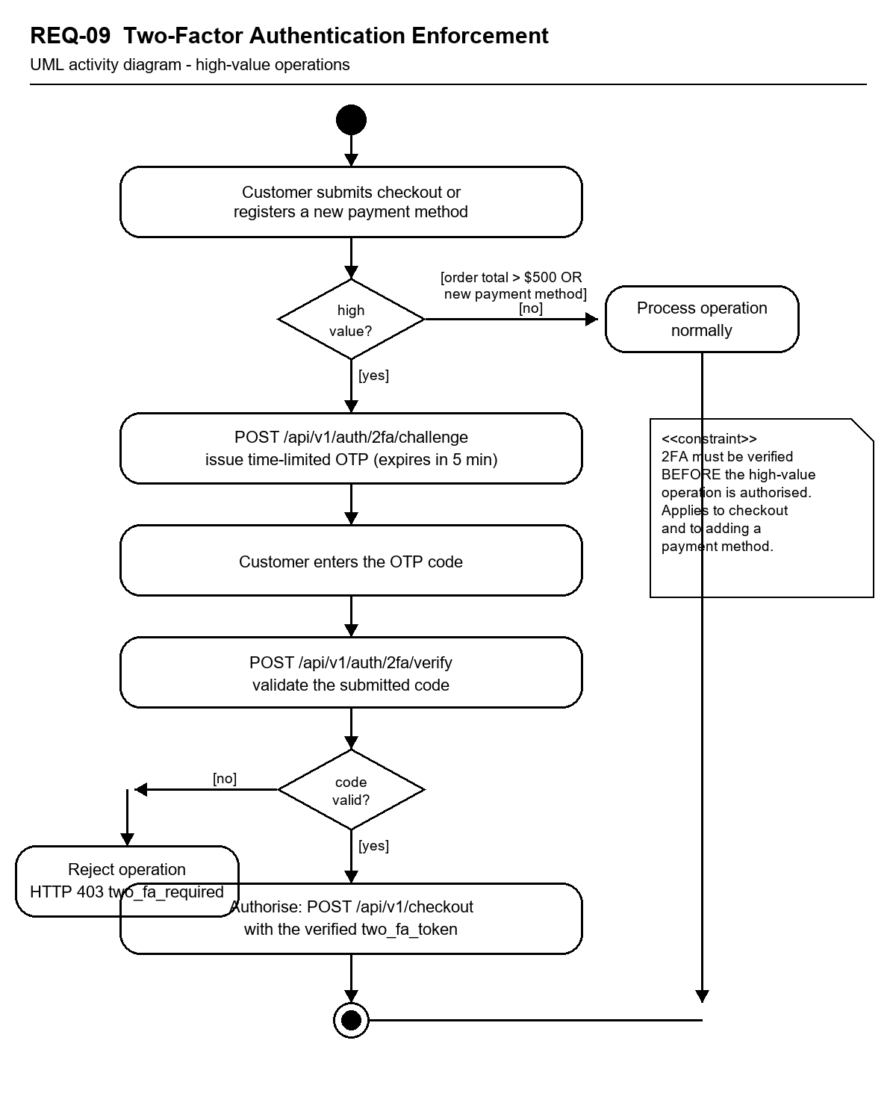
Figure 2: REQ-09 Two-Factor Authentication Enforcement - activity diagram

Appendix A: UI Mock-ups
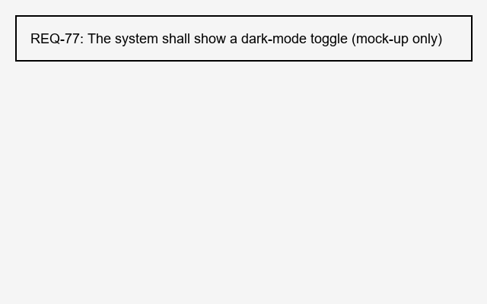
Figure 3: Settings screen mock-up

