[UNIVERSITY OF ARIZONA](http://www.university.com/)

**Application of Logistic Regression in Automatic Reading Comprehension and Detection of Grammatical Structures Based on Difficulty**

*Author:*

[Ragheb AL-GHEZI](http://www.johnsmith.com/)

*Supervisor:*

[Dr. Robert HENDERSON](http://www.jamessmith.com/)

*A report submitted in fulfillment of the requirements for the degree of Masters of Science*

*in the*

[Human Language Technology](http://researchgroup.university.com/) [Department of Linguistics](http://department.university.com/)

March 12, 2019

[UNIVERSITY OF ARIZONA](http://WWW.UNIVERSITY.COM/)

## Abstract

[Faculty Name](http://faculty.university.com/) [Department of Linguistics](http://department.university.com/)

Masters of Science

##### Application of Logistic Regression in Automatic Reading Comprehension and Detection of Grammatical Structures Based on Difficulty

by Ragheb AL-GHEZI

In this study we examine the use of a probabilistic classification algorithm called Logistic Regression on two novel Natural Language Processing (NLP) tasks: Automatic Reading Comprehension and Detection of Grammatical Difficulty in English Sentences. Logistic Regression has been used extensively in machine learning and NLP research over the past decades, but it gains popularity as it is considered the building block of Artificial Neural Network (ANN). Both tasks studied in this report show a unique use to multinomial logistic. In automatic reading comprehension task, given a reading pas- sage and a question, the goal is to extract an answer from the passage to the question if there exists one, or abstain from answering if the passage does not have an answer. For this purpose, a multinomial logistic regressor is used on two stages: a) find the sentence that most likely contains the answer (null-answer is treated as a sentence at this stage). b) within the best candidate sentence, another logistic regressor is used to extract the constituent that most likely represent the answer. The experiment results show that using simply designed features a logistic regressor score 0.71 F1 score and 0.40 F1 in stage 1 and 2 respectively, making it as a potential competitor to other state-of-the-art advanced neural network architectures. In the second task, detection of grammatical difficulty, a multinomial logistic regressor is applied in a semi-supervised manner on a low-resourced data to categorize the difficulty of English grammatical structures ac- cording to Common European Framework Reference (CEFR) guidelines. The method used shows a significant improvement from 0.67 F1 to 0.79 F1.

## Acknowledgements

The acknowledgments and the people to thank go here, don’t forget to include your project advisor. . .

# Contents

Abstract iii

Acknowledgements v

1. Introduction 1
   1. Background 1
   2. Goals 1
   3. Outline 2
2. Theory 3
   1. Introduction 3
   2. Classification as a Machine Learning Task 3
   3. Feature Extraction 4
      1. Frequency-based Methods 4
      2. Dimensionality reduction 7
      3. Distributional Method 8
   4. Logistic Regression 8
      1. Classification Functions 9
      2. Objective Functions 10
      3. Optimization 11
   5. Evaluation Metrics 11
      1. Confusion Matrix 11
      2. Precision, Recall and F-Score 11
   6. Conclusion 12
3. The Use of Semi-supervised Learning in Classification of English Grammati-

cal Structures 15

* 1. Introduction 15
  2. Related Works 17
  3. Method 17
     1. Dataset: English Grammar Profile 17
     2. Multinomial Logistic Regression 18
     3. Feature Design 19
  4. Experimental Results 19
     1. First Phase 19
     2. Second Phase 21
  5. Conclusion 21

1. Two-stage Classification Method for Automatic Reading Comprehension 23

viii

* 1. Introduction 23
  2. Related Work 24
  3. Stage One: Selecting Best Candidate Sentence 25
     1. Feature Extraction 25
     2. Training and Result 27
  4. Stage Two: Predicting the Answer Span 29
  5. Experiment and Error Analysis 29
  6. Future Studies and Recommendation 30
  7. Conclusion 31

1. Conclusion 33
   1. Summary of Contributions 34
   2. Recommendations and Future Work 34
2. Auxiliary Functions for Codes in Ch3&4 35
3. Complete Code for Grammatical Detection System 37
4. Complete Code for Automatic Reading Comprehension 39

Bibliography 41

**List of Figures**

* 1. Figure Showing Workflow of Machine Learning 4
  2. Confusion Mtrix Example 12
  3. 2d projection of the three classes A, B and C using K-means Clustering

and PCA 18

* 1. Confusion matrix illustrating the performance of LR-BoW-Word model

with class weight to deal with data imbalance 20

* 1. Confusion matrix illustrating the performance of LR-BoW-Word model

after augmentation 22

* 1. Flowchart illustrating the two-stage classification approach 26
  2. Confusion matrix shows which classes were predicted correctly 28

# List of Tables

2.1 Bag-of-words feature example 5

* 1. An excerpt of English sentences and their corresponding CEFR difficulty levels 16
  2. Comparison of Precision-Recall - Phase One 20

4.1 This table shows the results of running a multinomial regularized logis- tic regression. The class column represents the index of sentences within the paragraph, and -1 represents the unanswerable question case. Unpre-

dicted classes are removed. 27

*For/Dedicated to/To my.. .*

**Chapter 1**

**Introduction**

### Background

Lum is a company developing customized machine reading technology using machine learning and natural language processing. Their technology is served to a variety of medical, agricultural and educational domains and sectors. During the internship, the researcher was assigned two main NLP tasks that contribute to solving problems in teaching foreign languages using online distance learning. The two NLP tasks are auto- matic reading comprehension and detecting grammatical difficulty of English sentences according to CEFR. The goal of the first task is to design and implement a system that, given a reading passage and a set of questions, can automatically find answers to those questions from within the reading passage. The motivation for such a system is that it can help human language instructors create automatically graded assignment and quiz activities in virtual learning environments. The purpose of the second task is to create a system that can automatically categorize a given English text into three levels of gram- matical difficulty: Elementary (A), Intermediate (B), and Advanced (C). In this report, the researcher investigates the possibility to use NLP and ML algorithms to solve these two problems. The report also covers the entire process: data description and analysis, literature survey, feature design, and engineering and evaluating the performance of the algorithm.

### Goals

One goal of this internship report is to examine the suitability of using a machine learn- ing linear classification algorithm called logistic regression on two novel educational tasks: automatic reading comprehension and detection of grammatical difficulty. An- other goal is to explore and compare different methods of feature extraction and feature engineering to each of these tasks. Furthermore, examine the use of logistic regression in a semi-supervised fashion to bootstrap the scarcity of training data and improve the overall quality of generalization.

1. *Chapter 1. Introduction*

### 1.3 Outline

The first chapter gives a general background about the internship that the researcher undertakes as well as the goals intended to achieve through this internship report.

The second chapter is dedicated to reviewing the theory of machine learning in the context of natural language processing. It also defines classification as a supervised ma- chine learning task and logistic regression as one popular linear classification algorithm. The chapter also includes the conventional methods of computational representation of human languages such as bag-of-words, term-frequency-inverse-document-frequency, and word embeddings. Finally, it concludes by showing the metrics used to evaluate classification systems.

The third chapter introduces the task of detecting grammatical errors in English sentence as a classification problem and explains the use of multinomial logistic regression in a semi-supervised fashion to solve it. The chapter also briefly surveys the most important studies in the literature that tackled similar textual classification tasks. Finally, it shows the experiments, the results of applying the algorithm of the data collected as well as the conclusions.

The fourth chapter introduces the task of automatic reading comprehension and the data set used for this purpose. It also discusses the common approaches tackling these tasks in the literature. Next, the chapter uses the different feature engineering used to create a numerical representation of text. Finally, the chapter is concluded with the result and evaluation as well as sections dedicated to error analysis and future work respectively.

The fifth chapter contains the overall conclusion of the internship report.

**Chapter 2**

**Theory**

### Introduction

In this chapter, we explain the fundamentals of machine learning theory, with emphasis on supervised classification task. We start by describing the three primary stages of the machine learning process: feature extraction, classifier training, and testing and evaluation. We also discuss two types of feature engineering methods: frequency-based and distributional in addition to dimensionality reduction methods. Next, we introduce a linear classification technique called logistic regression and explain its mathematical foundations. Finally, we discuss the metrics used to evaluate the performance of super- vised classification tasks.

### Classification as a Machine Learning Task

Generally, there are two types of supervised learning tasks according to the data type of the predicted output: regression and classification. When the predicted output is a continuous value such as predicting the price of a house or the temperature, the task is called regression. A classification task, on the other hand, is when the predicted output is a discrete value such as predicting the sentiment of a document (negative or positive) or predicting the whether state (rainy, sunny, cloudy).

The goal of classification task is to select a correct class for a given input, or more generally a task of “ assigning objects from a universe to two or more classes or categories ” (Manning, Manning, and Schütze, 1999). A classifier is an algorithm that quantitatively models the relationship between a set of inputs and their associated outputs such that it learns to label new data. In the task of spam filtering, for instance, input data are texts and the output are binary labels (0 or 1) representing whether or not a document is spam.

Any classification task has two main phases: training and prediction **??**. During training, a feature extractor is used to convert each input into a set of features. These features are designed to capture the basic information about each input. Pairs of feature sets and their corresponding labels are, then, fed into the machine learning algorithm to generate a model. In the prediction phase, the trained model is used on unseen data to predict the labels.

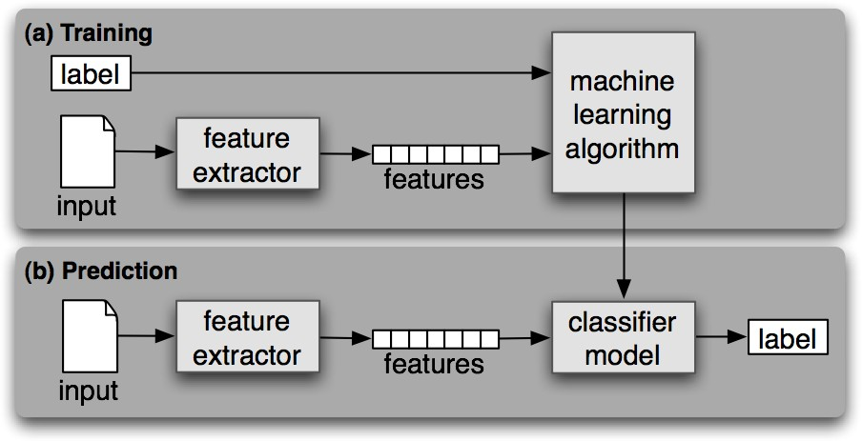

FIGURE 2.1: Figure Showing Workflow of Machine Learning

### Feature Extraction

The first step in any machine learning task is feature extraction in which a text input is transformed into a set of attributes that characterize it. An example of a feature of a negative sentiment document may be the presence of the word *terrible*. Choosing what features to use when representing a text or a document not only has a major impact on the entire classification process, but it is also arguably the most difficult phase in any natural language processing task. The reasons go to several fundamental questions on how to represent language computationally. For example, on what level should we represent a text: *character-wise*, *word-wise* or *sentence-wise*, or even more specifically morphologically, etymologically or phonologically? Do we treat a word e.g. *try* and all its morphological variations e.g. *tries*, *trying*, *tried* similarly or differently? How to rep- resent and model the semantics of human language computationally? Questions like these and many others are the core of natural language processing. Nevertheless, several automatic feature extraction methods have developed over the past decades that can be categorized into frequency-based or distributional, and we briefly explore some of the most common ones.

#### Frequency-based Methods

Frequency-based methods such as Bag-of-Words (BOW) and tfidf rely on number of occurrence of tokens in the text. They have been used extensively in a wide range of NLP applications, and each of them has advantages and disadvantages.

##### Bag-of-Words Representation

The bag-of-words (BOW) representation is the most straightforward and most intuitive representation. It represents each document by a vector whose component corresponds

TABLE 2.1: Bag-of-words feature example

|  |  |  |  |  |  |  |  |  |
| --- | --- | --- | --- | --- | --- | --- | --- | --- |
|  | the | apple | is | better | than | orange | summar | winter |
| Vector 1 | 2 | 1 | 1 | 1 | 1 | 1 | 0 | 0 |
| Vector 1 | 0 | 1 | 1 | 1 | 0 | 1 | 1 | 1 |

to the number of occurrences of a word in the document. To illustrate, the BOW vector representations of a data set of two documents (1) and (2) are shown in table 2.1:

1. The apple is better than the orange.
2. The summer is better than winter.

Despite the simplicity of BOW method, it has two main disadvantages. One major dis- advantage is that BOW method pays no respect to the order of tokens in the document, and this can give similar representations to semantically different documents. For in- stance, the sentences *the wolf eats the goat* and *the goat eats the wolf* have similar vector representation as they have exact same words. Another downside to BOW is that features with high frequency are more important than those of less frequency. We can see in 2.1 that the component corresponding to the first dimension (the) of vector 1 is bigger than in that of vector 2 because document 1 has two occurrence of the word *the* while the document 2 has only one occurrence.

To address the problem of order, several studies have attempted to count the occurrence of sentences instead of words (Fuhr and Buckley, 1991) (Tzeras and Hartmann, 1993). Although the sentences offer the advantage of better preserving the semantic relation- ship of the words, their use as features failed in practice. According to Lewis (Lewis, 1992), this representation is penalized by a large number of possible combinations which leads to low and too random frequencies. A more practical approach is representation by n-grams. It consists of breaking the text into moving sequences of *n* consecutive tokens. For example, the trigram segmentation of the word "language" gives the follow- ing 3-grams: lan, ang, ngu, gua, uag, age. The notion of n-grams was introduced by (Shannon, 1948); who was interested in predicting the appearance of certain characters according to the other characters. Since then, n-grams have been used in many areas such as speech recognition and information retrieval. Using n-gram on a character-level or word-level gives a contextual representation of the text.A modification to BOW to overcome the bias of high frequency tokens result in devising a method called Term Frequency Inverse Term Frequency (tfidf).

##### TFIDF Representation

TFIDF has two main parts. Term Frequency is proportional to the frequency of the term in the document (local weighting). It can be used as is or in several variations (Singhal, Mitra, and Buckley, 1997) (Sable and Church, 2001).

*t fij* = *f* (*ti*, *dj*)

*t fij* = 1 + log ( *f* (*ti*, *dj*))

*f t* , *d*

( )*i jt f* = 0.5 + 0.5*ij*

*maxti∈dj f* (*ti*, *dj*)

where *f* (*ti*, *dj*) is the term frequency of document *j*. Variations include logarithmic scaling of frequency counting or normalization.

Inverse Document Frequency measures the importance of a term throughout the collection (overall weighting). A term that often appears in the document base should not have the same impact as a less frequent term. Indeed, the terms that appear in the majority of documents do not have any discriminating power to distinguish documents from each other and must, therefore, have low weightings. The IDF weighting is inversely proportional to the number of documents containing the term to be weighted. Thus, the more the term appears in several documents, the less it is discriminating and is assigned a low weighting. The IDF weighting is generally expressed as follows:

*id f t* = log *N*

( )( )*i*

*d f* (*ti*)

where *d f* (*ti*) is the term frequency of feature *i* and *N* is the number of documents in the corpus.

The TFIDF weighting combines the two weightings TF and IDF in order to provide a better approximation of the importance of a term in a document. According to this weighting, for a term to be important in a document, it must frequently appear in the document and rarely in other documents. This weighting is given by the product of the local weighting of the term in the document by its overall weighting in all the documents of the corpus.

*t f id f* (*ti*, *dj*) = *t fij ×* log ( *N* )

*d f* (*ti*)

Frequency-based text representation methods explored so far, despite their usefulness in a variety of tasks in natural language processing, share sparsity as one problem in common. The number of features generated using these methods can easily exceed the tens of thousands, and that does not only negatively influence the categorization process, but it is also very computationally expensive in terms of hardware resources. In addition, the higher the dimensions of the features are, the weaker the features become. This problem is known as the *curse of dimensionality* (Bellman, 2015). To remedy this issue, techniques, borrowed from the field of information theory and linear algebra, have been developed to reduce the feature space dimensionality without losing much information.

#### Dimensionality reduction

There are number of linguistic and non-linguistic ways to reduce the number of features in text data. Depending on the task, we can aggregate words of certain linguistic relation in concepts. For example, we replace co-hyponyms *dog* and *wolf* with their hypernym *canine*; or *vehicle* and *car* with *automobile*. Concepts, defined as units of knowledge, can be used as features to solve the ambiguity problem as well as the problem of synonymy. Indeed, each concept represents a unique meaning that can be expressed by several synonymous words. Similarly, a word with many meanings (senses) is found mapped to several concepts. Thus, a document containing the word *vehicle* may be indexed by other words such as car or automobile. The transition from a word representation to a concept representation requires the use of semantic resources external to the content of documents such as semantic networks, thesauri, and ontologies. As a result, the performance of such a representation crucially depends on the semantic richness of the resources used in terms of the number of concepts and relationships between these concepts.

In some cases, we may need to treat morphologically variants words similarly. For ex- ample, words such as play, player, players, plays, and played will be replaced by *play*. Lemmatization and stemming are the two techniques used to find the canonical form of a word. Lemmatization uses a knowledge base containing the different inflected forms corresponding to the different possible lemmas. Thus, the singular masculine form will replace the inflected forms of noun while the infinitive form will replace the different inflected forms of a verb. Lemmatization requires the use of a dictionary of inflected forms of language as well as a grammar labeler. Stemming uses a knowledge base of syntactic and morphological rules and to transform words into their roots. One of the most well known stemming algorithms for the English language is Porter’s algorithm (Porter, 1980). Lemmatization is more complicated to implement since it de- pends on the grammatical labelers. In addition, it is more sensitive to misspellings than stemming.

LISTING 2.1: An example of simple Stemmer Written in Python

**def** stem ( word ) :

S u f f i x _ l i s t = [ " ing " , " ly " , " ed " , " ious " ,\

" i e s " , " ive " , " es " , " s " , " ment" ]

**for** s u f f i x **in** S u f f i x _ l i s t :

**i f** word . endswith ( s u f f i x ) :

**return** word[: **len** ( s u f f i x ) ]

*−*

**return** word

Dimensionality reduction can also be done using probabilistic and linear algebraic techniques such as principal component analysis (PCA) and linear discriminant analysis (LDA) that aim to project highly dimensional data into lower dimension space. But we limit the discussion to only two methods: clustering and Latent Semantic Allocation.

Clustering (Baker and McCallum, 1998) (Sable and Church, 2001) (Slonim and Tishby, 2001) can be used to reduce dimensionality. It consists of representing the documents in a new representation space other than the original one — each dimension of the new

representation space groups terms that share the same meaning. Thus, the documents will no longer be represented by terms but rather by groupings of terms representing semantic concepts. This new space of representation offers the advantage of managing the synonymy since the synonymous terms will appear in the same groupings. Like- wise, the fact that a term can be included in several groupings also makes it possible to manage the polysemy. Another exciting method to reduce dimensionality, proposed by (Deerwester et al., 1990) is Latent Semantic Allocation (LSA). It uses singular value decomposition of the document *x* term matrix to change the representation by keeping only the *k* axes of strongest singular values. However, LSA is very expensive in terms of calculation time during learning as it relies on a matrix factorization method called Singular Value Decomposition (SVD) which runs computationally in cubic size. Likewise, with each new document, it is necessary to redo the whole grouping process.

#### Distributional Method

An alternative approach for text representation in natural language of processing is the distributional similarity. The basic idea of the distribution of similarity is to represent the meaning of a word using words that co-occur in the same context. "You shall know a word by the company it keeps" (Firth, 1957). For example, the words ’dog’ and ’cat’ have the same meaning in the following two sentences: I have a cat, I have a dog. While this idea might not be adequate to capture or account for the complexity or the sophistication of human language, it has succeeded tremendously in a variety of lexicalized NLP tasks. It has become the de facto representation method of text. The need for such a method does not only come from the need for more accurate numerical representation, but its density compared to other methods makes it less computation- ally expensive. Word2Vec (Mikolov et al., 2013) and GloVe (Pennington, Socher, and Manning, 2014) are two famous algorithms for creating word embedding.

The intuition of word2vec is to train a classifier on a binary prediction task: “Is word *w* likely to show up near X?” where *X* is the word to which we want to find embeddings. Then, we use the weights learned by the classifier as embeddings. Skip-gram algorithm (Mikolov et al., 2013), first, initializes embeddings randomly. Then, it iteratively up- dates the embeddings of each word *w* to be equal to the words they occur within the same context. Finally, it injects *k* number non-neighbor words as negative examples.

### Logistic Regression

Logistic regression is a machine learning classifier that is used in a variety of learning tasks in natural language processing and computer vision. It belongs to a group of probabilistic classifiers called discriminative models which, unlike its generative counterparts like Naive Bayes classifiers, tries to distinguish the classes rather than learn to generate them. More formally, given a document *x* and a class *y* , logistic regressions computes the conditional probability of a class *yi* given its input *xi P*(*y x*). There are two types of logistic regression classifier: binary and multinomial. The binary logistic regression is used when there are two classes of inputs to be predicted such as spam or

*|*

* 1. *Logistic Regression* 9

not spam; positive or negative; malignant or benign. Multinomial or multi-class logistic regression is used when the number of predicted classes is more than two such postive, neutral or negative.

According to (Jurafsky and Martin, 2014), classification using logistic regression, like any other supervised classification algorithm, has four main components:

* + - A feature extractor: to numerically represent language data (characters, words and sentences, etc) input **X** as feature vector [*x*1, *x*2, . . . , *xn*]*T* where *n* represents the number of features in the input data.

A classification function to compute an estimation to class *y*ˆ via *p*(*y x*). The use of classification function determines whether the classifier is binary or multinomial.

* *|*

An objective function to minimize the error predicted label *y*ˆ and actual label *y* in training examples (cross entropy)

*•*

An optimizer to help find the minimum of the objective function (stochastic gra- dient descent).

*•*

Given a dataset of *m* number of observations *x* and classes *y D* = {(***x***(*i*), *y*(*i*) }*m* ,

*i*=1

the goal is to learn the set of optimal weights *w*ˆ that maximizes the log probability of predicting a class *y* given an observation *x*

*w*ˆ argmax *m*

=

∑

1=*i*

*w*

log *P* (*y*(*i*) *x*(*i*) (2.1)

The distribution type of *P y*(*i*)*|x*(*i*) determines whether the type of learning is binary or multiclass. The probability distribution of binary output is Bernoulli, while the probability distribution of multiclass output is multinomial.

(

*|*

#### Classification Functions

What we have discussed so far gives us a method to numerically translate language from a form that is uniquely comprehensible to humans into a representation that a computer can understand, and can somehow capture the characteristics of human language. However, in order for the logistic regression to learn to classify, a classification function should be utilized. Depending on whether the classification task is binary or multinomial, there are two main functions used: Sigmoid and Softmax. Sigmoid function, used for binary classification, outputs 1 if an observation input (feature vector) is a member of a particular class e.g. (spam), and 0 otherwise. In other words, it calculates *P*(*y* = 1 *x*) for spam text and *P*(*y* = 0 *x*) for non-spam text. The mathematical form of the Sigmoid function or (logistic function, hence comes the name of the classifier) is as follow:

*| |*

*Sig*(*x*) = 1

1 + *e−*(*w·x*+*b*)

where *x* represent the input vector, *w* is the learned weights, and *b* is the bias term or the intercept of the linear equation. One mathematical property of the Sigmoid function is that it maps any input between 0 and 1, and to make it as probability we need to make the sum of *P*(*y* = 1) and *P*(*y* = 0) equals to 1.

*P*(*y* = 1) = *σ*(*w · x* + *b*) *P*(*y* = 0) = 1 *− σ*(*w · x* + *b*)

Now to make a decision, the classifier declares an observation input as *Yes* (if it is a member of class spam) if the probability is greater than a certain threshold, say 0.5, and declares an observation input as *No* otherwise.

ˆ 1 if *P*(*y* = 1 *x*) *>* 0.5

*|y* =

0 otherwise

In the case of multinomial classification, the logic remains the same except for the classification function where Softmax is used rather than Sigmoid. Softmax works on normalizing the prediction of an observation by the values of all other classes in order to produce valid probability distribution.

*p*(*y* = *i|x*) = ∑*k*

*ewi ·x*+*bi*

*ewj·x*+*bj*

*j*=1

#### Objective Functions

During the learning process, we need to answer the question of *how correct is the estimated output of y*ˆ *of classifier from the true output y?*. Thus our objective *function* is to minimize the difference between the estimated output and the true one such that the weights learned during this minimization process are, hopefully, generalizable enough to correctly label observations unseen in the training phase. So we can imagine an objective function to be a difference between the *y*ˆ and *y* i.e. *y*ˆ *y* , but for mathematical convenience we need a non-convex objective function (or also commonly referred to as loss function) that can be easily optimized. Thus, we use maximum likelihood estimation.

*| − |*

Binary classification can be seen as Bernoulli distribution since the outcome is either 0 or 1. More formally, the probability of predicting class *y* given input x *is* p (*y x*) =

*|*

*y*ˆ*y*(1 *y*ˆ)1*−y*. Minimizing the probability is the same as maximizing the negative log

*−*

Likelihood:

*LCE*(*y*ˆ, *y*) = *−* log *p*(*y|x*) = *−*[*y* log *y*ˆ + (1 *− y*) log(1 *− y*ˆ)]

* 1. *Evaluation Metrics* 11

Finally, by plugging in the value of *y*ˆ we get:

*L w*, *b*

*CE* (

1 *m*

*y*(*i*) log

(*w x*(*i*)

*b* (1

*y*(*i*) log (1

(*w x*(*i*)

*b*

, where *m* is the number of training examples.

*−m*

) = ∑

*i*=1

*σ*

*·*

+

+

*−*

*− σ*

*·*

+

On the other hand, multinomial classification uses the same process except that it uses a different classification function *Softmax* and hence has different (multinomial) distribution. So the loss function for a single example *x* is the sum of the logs of the *K* output classes:

*L* ˆ *K ewk·x*+*bk*

*CE* (*y*, *y*) = *−* ∑ 1*{y* = *k}* log ∑*K*

*ewj·x*+*bj*

*k*=1 *j*=1

#### Optimization

The objective functions derived in the previous section are optimized using numerical methods. Several algorithms are used for this purpose such as Stochastic Gradient De- scent, that uses first derivative (gradient) information to find a minimum of a function; Newton-Raphson algorithm uses Second derivative information to find a minimum of a function. Discussing the details of how these algorithms work and the mathematical derivation of gradients is beyond the scope of this work. Interested readers are referred to (Jurafsky and Martin, 2014) for more details on the derivation of Stochastic Gradient Descent.

### Evaluation Metrics

#### Confusion Matrix

A confusion matrix is a method to visualize the results of a classification algorithm. For the binary classification, the algorithm can be used to predict whether a test sample is either 0, or 1. As a way to measure how well the algorithm performs, we can count four different metrics, here 1 defined as positive and 0 defined as negative:

* + - 1. True positive (TP), the algorithm classifies 1 where the correct class is 1.
      2. False positive (FP), the algorithm classifies 1 where the correct class is 0.
      3. True negative (TN), the algorithm classifies 0 where the correct class is 0.
      4. False negative (FN), the algorithm classifies 0 where the correct class is 1.

#### Precision, Recall and F-Score

Precision and Recall are two popular measurements to evaluate the performance of supervised classification methods. Precision is defined as:

FIGURE 2.2: Confusion Matrix Example

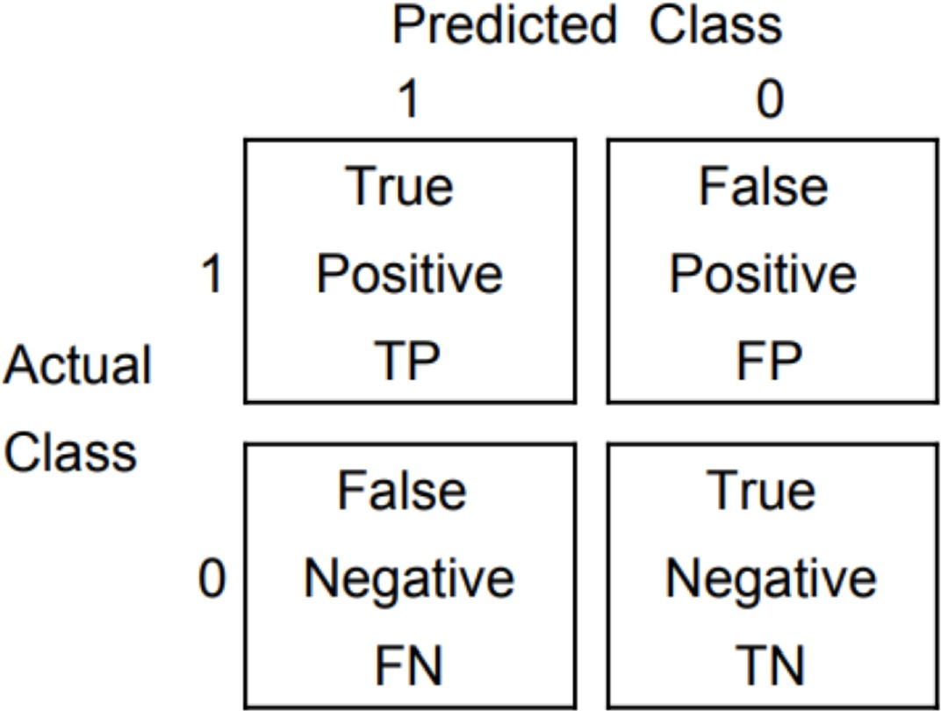

, Recall defined as:

Precision = *TruePostive*

*TruePostive* + *FalsePositive*

Recall = *TruePostive TruePostive* + *FalseNegative*

and F-score is the harmonic mean of both precision and recall:

*F* = 2 precision *·* recall

*·*1

precision + recall

A classifier with high precision means it classifies almost no inputs as positive unless they are positive. A classifier with high recall, on the other hand, would mean that it misses almost no positive values.

### 2.6 Conclusion

In this chapter, we briefly introduced some fundamental topics of Machine Learning theory required for natural language processing supervised classification tasks. We discussed two commonly used numerical methods to represent text computationally and their variants, Frequency-based methods: Bag-of word models (BoW) and Term Frequency - Inverse Document Frequency (tfidf), and Distributional similarity methods. Besides, we reviewed some techniques to reduce the dimensionality of feature space

* 1. *Conclusion* 13

to reduce the complexity of the training and save computational resources. Finally, we covered how logistic regression as a probabilistic algorithm can be used for binary or multinomial classification along with the evaluation metrics used to gauge its performance. In the next two chapters, we show the use of multinomial logistic regression classifier on two novel tasks in natural language processing: grammatical difficulty categorization of English sentences and automatic reading comprehension. We also explore how logistic regression can be used in a semi-supervised manner to work on tasks with limited data.

15

**Chapter 3**

**The Use of Semi-supervised Learning in Classification of English Grammatical Structures**

### Introduction

The need to assess the difficulty of written texts is crucial in foreign language learning and teaching. Language instructors need a text difficulty metric that conforms to the guidelines of foreign language learning and teaching to find reading materials that match the proficiency level of their learners. Similarly, curricula designers and textbook publishers need such a metric to provide reliable and consistent learning resources and activities. Existing text evaluation metrics (Kincaid et al., 1975, Stenner et al., 2006, Lan- dauer, Kireyev, and Panaccione, 2011, Graesser, McNamara, and Kulikowich, 2011) ei- ther do not conform to educational guidelines or they are too broad to be useful for lan- guage learning and teaching purposes. Perhaps, the most popular text evaluation tools designed for educators is ETS’s TextEvaluator (Napolitano, Sheehan, and Mundkowsky, 2015). It evaluates a written text based on a number of criteria that include coherence, cohesion, lexical density and syntactic difficulty (Textevaluator.ets.org. ,2019). How- ever, their syntactic difficulty feature still does not accommodate the need of teachers. For example, if a teacher wants to provide their intermediate-level learners with a reading passage that feature the language of cause and effect, or if-conditionals, a tool like ETS’s TextEvaluator does not help much, considering the categorization features they use such as average sentence length, average number of modifiers per noun phrase, average number of dependent clauses per sentence (Ibid, 2019). So in this chapter we design and implement a system that classifies a written text into three level of grammatical difficulty. The grammatical difficulty is aligned with Common European Framework Reference (CEFR) (Education Committee. Modern Languages Division, 2001) language learning standards.

Common European Framework Reference (CERF) is a standard for describing language achievement on a six-point scale, from A1 for beginners, up to C2 for proficient user

TABLE 3.1: An excerpt of English sentences and their corresponding CEFR difficulty levels

Sentence

I go there every year with my friends

I think swimming is good for my body. Tomorrow I’m expecting a delivery of our latest catalogues.

Do not hesitate to contact me should you need further information.

Living in Greece, I have had a chance

to realise how much tourism can affect one’s life.

There were no photographs of him in Ann ’s mother’s albums.

Level A1 A2

B1 B2 C1

C2

ability on the four primary skills reading, writing, listening, speaking, and the two secondary skills: vocabulary and grammar. The latter two skills are considered the back- bone for the four primary skills in terms of difficulty. For example, a frequently uncommon lexical item like sagacious makes the sentence in which it appears more difficult to an English learner than a sentence with a more frequent lexical item like wise. Similarly, grammatical structures also play a vital role in the overall difficulty of a sentence. For instance, the word *should* conveys a different meaning in *I should study for my final exams* than in *this is your mission should you accept it*. The latter is considered more difficult to an English learner because the use of should as a conditional is less frequent than its use as a modal auxiliary expressing necessity according to CEFR.

The English Grammar Profile (EGP) (O’Keeffe and Mark, 2017) is a finite list of (1222) grammar features compiled from the Cambridge Learner Corpus which comprises over 250,000 scripts from Cambridge English Exams at all levels. The purpose of EGP is to "establish which grammatical features characterizes learners’ output at each level of CEFR."(EPG, Information Booklet) The list contains structural features, their corresponding CEFR levels and example sentences (Figure 3.1)

Our goal in this chapter is to train a multinomial logistic regression classifier on the example sentences derived from EPG to predict the CEFR difficulty level. Due to the limited number of examples (around 3000 example sentences), we combine each two levels into one class, so we end up with three super-levels: A, B, and C where they indicate the levels elementary, intermediate and advanced respectively. We also improve the performance of the classification by applying a bootstrapping technique (Yarowsky, 1995) to fetch data from external source to supplement the training data. Finally, we evaluate the performance of the classification before and after the bootstrapping against a random classifier.

*3.2. Related Works* 17

### Related Works

Sentence classification is the most common task in natural language processing. A considerable number of studies conducted on lexicalized tasks like sentiment analysis, spam filtering, news categorization, etc. Rarely do we see work on classification sentences based on their syntactic structures. Thus, to the best of our knowledge, no work has ever tackled the task of classifying the grammatical difficulty of English sentences according to CEFR guidelines. Therefore, we will briefly survey techniques used to solve general sentence classification problems.

Proximity-based Algorithms such as Rocchio’s algorithm (Rocchio, 1971) and K-nearest neighbor (Tam, Santoso, and Setiono, 2002) build vector for each class using a training set of a document by measuring the similarity, such as Euclidean distance or cosine similarity, between the documents. Some studies (Bang, Yang, and Yang, 2006) incorporated dictionary-based methods to construct a conceptual similarity with KNN classifier, while (Chang and Poon, 2009) combine two KNN classifier with a Naive Bayes one using TF-IDF over phrases to categorize large collections of emails. While proximity- based methods perform well on document classification, yet using them on a large training set is not feasible as computing similarities across documents is computation- ally and resource-wise expensive. Another disadvantage is that noise, and irrelevant data can severely degrade the performance of the classification.

Another family of classifiers that work well in text categories tasks is decision trees. Classification using this method is done through automatic creating of "if-then" rules. Their use in tasks like spam filtering is widespread even with the advent of deep neural network methods (Wu, 2009). Another common powerful classifier is Naive Bayes that based on Bayes’ rule. It perform surprisingly well for many real-world classification applications under some specific conditions (“A Comparison of Event Models for Naive Bayes Text Classication”) (Rish, Hellerstein, and Thathachar, 2001). While Naive Bayes does not often outperform discriminative classifiers like Support-Vector Machine, it has the advantage of functioning well with small training data. (Kim et al., 2006) and (Isa et al., 2008) show good results by selecting Naive Bayes with SVM for text classification and clustering the documents. Using a Poisson Naive Bayes for text classification model also yield excellent results (Isa et al., 2008).

The SVM classification method and logistic regression have shown outstanding results when used in text classification tasks (Yang and Liu, 1999) (Brücher, Knolmayer, and Mittermayer, 2002) perhaps because of their capacity of handling high-dimensional sparse data well. However, they can be relatively complex in training and require high time and resource consumption.

### Method

#### Dataset: English Grammar Profile

The dataset used for this study, provided by English Grammar Profile, exhibits typical grammar profile for each level. It consists of 3615 examples and 1215 rules, divided as

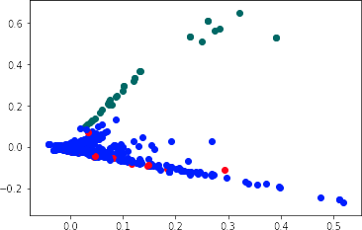

FIGURE 3.1: 2d projection of the three classes A, B and C using K-means Clustering and PCA

follows: class A has 1194 supporting examples; class B has 1775 examples, and class C has 646 supporting examples. We merged each the six levels into three super-categories in order to provide more data within each category.

* + - * **Rule**: Can use ’and’ to join a limited range of common adjectives.
      * **Example**: The teachers are very nice and friendly.
      * **Level**: A1

As we can see, the dataset provides some guidance of what characterizes each example. These rules are prepared to be used by human teachers, and they are not very computationally friendly. On the other hand, the small number of examples in the dataset is not enough to build a reliable probabilistic classifier to learn to distinguish the various properties of the classes. Therefore, in order to improve the performance, we are using a semi-supervised data augmentation technique similar to Yarawsky’s bootstrapping approach (Yarowsky, 1995).

#### Multinomial Logistic Regression

Suppose that **x** is the vectorized sentence in either of its two forms: BoW or TfIDF, *y Y* is the class label, **w***k* and *bk* are network parameters associated with class *y*. Then the probability of **x** belonging to the class *y* can be defined by the Softmax function:

*∈*

*p*(*y|***x**) = 1 exp(**w***T* **x** + *by*) , (3.1)

*z*(**x**) *y*

where *z*(**x**) = ∑*K* exp(**w***T***x** + *bj*).

*j*=1

*j*

* 1. *Experimental Results* 19

Let the log-likelihood function be

*N*

*L*(*β*) = ∑ log *pgi* (*xi*; *β*)

*i*=1

.

*N T*

( *K−*1

*βT x*

= ∑

*i*=1

*βgi xi −* log

1 + ∑ *e l i*

*l*=1

To apply the Newton-Raphson method, we need the second derivative of the log-likelihood function

*∂*2 *L*(*β*) *N*

*∂βkj∂βmn* = *−* ∑ *xijxin pk* (*xi*; *β*) [*l*(*k* = *m*) *− pm* (*xi*; *β*)]

*i*=1

The formula for updating *βnew* for multiclass is:

*β* new = *β* old + (**X**˜ *T* **WX**˜ *−*1 **X**˜ *T* (**y** *−* **p**)

where *y* is the concatenated indicator vector of dimension *N ×* (*K −* 1), *p* is the concatenated vector of fitted probabilities of dimension *N ×* (*K −* 1), *X*˜ is an *N*(*K −* 1) *×* (*p* + 1)(*K −* 1) matrix; and Matrix *W* is an *N*(*K −* 1) *× N*(*K −* 1) square matrix.

#### Feature Design

For this task, we are comparing two standard methods of feature generation in natural language processing and information retrieval: bag-of-word model and term-frequency inverse-document frequency (TFIDF)

### Experimental Results

In this section, we evaluate several variations of our method against a random model as our baseline model. In the following experiments, all methods are done using Python

* 1. and Scikit Learn Library tested on MacBook Pro laptop with Core i5 processor and 8 GB of RAM.

#### First Phase

In the first phase of our experiment, we train a logistic regression classifier, optimized by the Newton-Raphson method, on English Grammar Profile dataset. We also introduce a feature design method to mask word categories with their part-of-speech tags in order

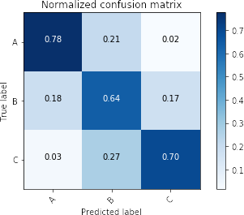

FIGURE 3.2: Confusion matrix illustrating the performance of LR-BoW- Word model with class weight to deal with data imbalance

TABLE 3.2: Comparison of Precision-Recall - Phase One

|  |  |  |  |
| --- | --- | --- | --- |
| Model | Precision (%) | Recall (%) | F1 (%) |
| Random-Baseline | 39 (%) | 39 (%) | 39 (%) |
| **BoW-LR-Words** | 70 (%) | **69** (%) | **69** (%) |
| BoW-LR-Masked | 66 (%) | 62 (%) | 63 (%) |
| Tfidf-LR-Words | **75** (%) | 66 (%) | 60 (%) |
| Tfidf-LR-Masked | 66 (%) | 64 (%) | 61 (%) |

to preserve grammatical information and avoid the lexical influence of the word. We use a combination of feature design methods such as:

**BoW**: Apply unigram, bigram and trigram bag-of-words model with both word tokens, and masked tokens.

*•*

**Tf-idf**: Apply unigram, bigram and trigram tf-idf model with both word tokens, and masked tokens.

*•*

From table 2, we compare the performance of 4 variations of our method against the baseline, which is a random model. Surprisingly, we notice that our bag-of-words model with word tokens (BoW-LR-Words) outperform the one with the masked sequence in terms of precision and recall respectively. Besides, BoW-LR-Words also out- performs (tfidf-LR-words) model in terms of recall only, while the latter has higher re- call. From the confusion matrix (fig. 2), we see that (BoW-LR-Words) model predicts

* 1. *Conclusion* 21

most of the testing data correctly even though the number of training data is not equal among the classes, especially for class C. Therefore, we needed to assign specific weights to each class during the training in order to avoid this imbalance in the data.

#### Second Phase

The results shown in Table 2 does indicate that the linear model has learned the associations between sentences and their corresponding grammatical class reasonably well. However, both of our feature design techniques, namely bag-of-words and tfidf have their disadvantages. The first assigns similarity based on occurrence, size and mutual words. For example, the BoW model learns that longer sentences tend to be the most difficult, while shorter ones are less difficult. Similarly, while tfidf treats the drawbacks of BoW model, it still ignores the usefulness of what-so-called *Stop Words* due to their commonality. In other words, it is very hard to trust these results with this amount of training data. Therefore, we propose a non-synthetic data augmentation method to provide more training examples, and thereby improve the overall performance of the model.

Using a text-only version of the brown corpus (**citeulike: 13797746**), we use our BoW- LR-Words model to predict the grammatical difficulty labels of its sentences. Then, we collect the sentences predicted with high certainty (above 0.9 probability) to be fed to the original dataset. It is crucial to set a higher probability threshold as the new data examples will serve as seed points for our prediction in the future, and we do not want the classifier to *drift* from the original trajectory. This technique is reminiscent of Yarawsky’s Bootstrapping (Yarowsky, 1995)(semi-supervised) algorithm, but with one difference is that unlike in Yarawsky’s method, we apply this step only once.

Out of 38400 sentences in the unlabeled corpus, only 1428 sentences have been detected with certainty above 90%. We also removed any sentence that is longer than 30 words in order to lessen the undesirable effect of BoW technique. We apply our best model from phase one to the augmented dataset of 5043 examples under the same training conditions to get a precision of **0.80**, recall of **0.79**, and F1 score of **0.79**.

### Conclusion

In this chapter, we have presented a classification method based on simple multinomial logistic regression and bag-of-words model augmented with semi-supervised (boot- strapping) method to classify English sentences based on their level difficulty, A=Beginner, B=intermediate, C=Advanced according to CEFR. We have also compared several common feature design techniques to encode the sentences along with a proposed masking BoW method that replaces lexical items with their grammatical category. Finally, the model achieves an overall F1 score of 0.69, and 0.79 after augmenting it with example sentences from an unlabeled corpus.

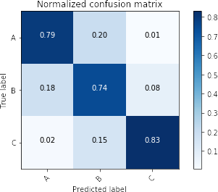

FIGURE 3.3: Confusion matrix illustrating the performance of LR-BoW- Word model after augmentation

23

**Chapter 4**

**Two-stage Classification Method for Automatic Reading Comprehension**

### Introduction

Teaching reading comprehension in an online learning environment is very challenging to the instructors as they need to provide the learners with reading material that is authentic, thematically diverse and appropriate to learners’ reading level. The system we developed in the previous chapter help language instructors detect the grammatical difficulty of reading materials the find online, but it still does not help eliminate the efforts they need to expend on developing practice exercises and quizzes. In order for second and foreign language learners to master a difficult skill like reading comprehension, they need a lot of practice, which means more training exercises need to be prepared. So in this chapter we design and implement a system that automatically answers comprehension questions given a reading text. While such system still does not fully solve the problem raised, it can significantly aid in the automatic creation of reading comprehension practice activities in online learning enviroments

Automatic Reading Comprehension is the task of automatically answering comprehension questions based on information derived from short texts. Recently, it has received a special attention from NLP community because of the second release of Stanford Question Answering Dataset (SQuAD 2.0) (Rajpurkar, Jia, and Liang, 2018). The dataset consists of 150K questions posed by crowd workers on a set of Wikipedia articles. The answers to these questions lie within the reading passages, though some questions are unanswerable from within the reading passage. What sets SQUAD 2.0 from other data sets is that 50k of its questions are unanswerable, and this requires the learning models not only to find answers, but also to abstain from answering when necessary.

The strategy we will use for this task is on two stages **(Figure 4.1)**. In the first stage, we break the reading passages into sentences, and train a multinomial logistic regression classifier to find the sentence most likely contains the answer. We also train the classifier to give a null-answer if an answer does not exist. Next, we divide the best candidate sentence from stage one into its constituent phrases, and train another a multinomial logistic regression classifier to find the constituent phrase that most likely to be the answer to the

question. This dual stage method has advantages over other competing models when it comes to speed and consumption of computational resources.

### Related Work

There have been a large number of studies that tackle traditional Machine Comprehension tasks, where answers exist within the passage. The difficulty of SQUAD 2.0 task, though, lies in abstaining from answers when no answer span exists in the passage. Thus, in this section we review that models that address this constraint. It worth mentioning that all of the systems described in this section are complicated neural network architectures, and discussing its details is beyond the limitation of this report.

(Seo et al., 2016) introduced bi-directional attention flow (BiDAF) that uses a recurrent neural network to encode contextual information in both question and passage along with an attention mechanism to align parts of the question to the sentence containing the answer and vise versa. The model offers context representation at multilevel of granularity: character-level, word-level, and contextual embedding. What sets this work from others is that it does not represent the context paragraph into a fixed-length vector. Instead, it dynamically computes vectors at each time step, combines it with the one from the previous layer and allow *flow* through to the next layers. The model outputs confidence scores of start and end index of all potential answers. One problem with this model is that it is not designed to handle unanswerable questions. (Levy et al., 2017) extends the work by assigning a probability to null-answers to account for the questions whose answers do not exist in the corresponding paragraph. It achieves 59.2% EM score and 62.1% F1 score.

(Hu et al., 2018) propose a read-then-verify system that can abstain from answering when a question has no answer given the passage. They introduce two auxiliary losses to help the neural reader network focus on answer extraction and no-answer detection respectively, and then utilize an answer verifier to validate the legitimacy of the predicted answer. One essential contribution is answer-verification. The model incorporates a multi-layer transformer decoder to recognize the textual entailment that sup- ports the answer in and passage. This model achieves an ExactMatch EM score of 71.6% and 74.23% F1 on SQuAD 2.0.

(Wang, Yan, and Wu, 2018) proposes a new hierarchical attention network that mimics the human process of answering reading comprehension tests. It gradually focuses attention on the part of the passage containing the answer to the question. The modal comprises of three layers. a) **encoder layer**: builds representations to both the question and the passage using a concatenation of word-embedding representation (Penning- ton, Socher, and Manning, 2014) and a pre-trained neural language modal (Peters et al., 2018) b) **Attention layer**: its function is to capture the relationship between the question and the passage at multiple levels using self-attention mechanisms. c) **Matching layer**: given refined representation for both question and passage, a bi-linear matching layer

detects the best answer span for the question. This method achieves state-of-the-art results as of September 2018. Their single model achieves 79.2% EM and 86.6% F1 score, while their ensemble model achieves 82.4% EM and 88.6% F1 Score.

Current models that have shown significant improvement on Machine Comprehension tasks and other similar ones owe their success to a new neural architecture called trans- former networks (Vaswani et al., 2017). It has become the *de facto* in recent sequential learning tasks, eschewing recurrence. This architecture creates global dependencies be- tween input and output using only attention mechanisms. An even more successful model is Bidirectional Encoder Representations from Transformers BERT (Devlin et al., 2018). It is a task-independent pre-trained language model that uses a deep transformer network to create rich and context-specific vector representation. Using a method called Masked Language Model, the goal is to randomly mask tokens from the input and predict the vocabulary id of the masked word based only on its context. BERT has shown significant improvement on several tasks, one of which is SQUAD.

While these models achieve astonishing results, they are very difficult to implement, and very resource-intensive. We argue that the simplifying linguistic assumptions we followed in our proposed strategy can greatly eliminate the need to such complexity of design, and yield good results.

### Stage One: Selecting Best Candidate Sentence

At this level, the classification task is to predict the sentence, in the paragraph, containing the right answer, or declaring that the question is unanswerable. So we train a multiclass logistic regression classifier that takes a question and a reading passage as inputs and outputs the index of the passage sentence that is most likely contain the answer. The classifier is trained with L2 regularization and optimized using Newton- Raphson method. The best candidate sentence has the following three criteria. First, it shares more words with the question than other sentences. Second, it has high cosine similarity with the question than other sentences. Finally, it shares a syntactic similarity with the question. We are using these criteria as features for the classifier.

#### Feature Extraction

**Cosine Similarity**: for every sentence in the paragraph as well as the question a word vector representation is created via InferSent (Conneau et al, 2017), which is a pre-trained sentence embeddings method that provides semantic representations for English sentences. InferSent is an encoder based on a bi-directional LSTM architecture with max pooling, trained on the Stanford Natural Language Inference (SNLI) dataset. Cosine distance score is calculated for each sentence- question pair.

*•*

**Word Overlap**: calculates the Jaccard score between each sentence-question pair. Jaccard index is a method of computing the explicit similarity between two sets as

*•*



Data Preprocessing



Input



Has an Answer

True

Output

Logistic Regression Classiﬁer Predict C

Logistic Regression Classiﬁer

Predict S with the right answer

False

FIGURE 4.1: Flowchart illustrating the two-stage classification approach

|  |  |  |  |
| --- | --- | --- | --- |
| height**class** | **precision** | **recall** | **F1-score** |
| -1 | 1 | 0.99 | 0.99 |
| 0 | 0.47 | 0.68 | 0.56 |
| 1 | 0.63 | 0.54 | 0.58 |
| 2 | 0.62 | 0.55 | 0.58 |
| 3 | 0.62 | 0.53 | 0.57 |
| 4 | 0.58 | 0.47 | 0.52 |
| 5 | 0.57 | 0.48 | 0.52 |
| 6 | 0.57 | 0.49 | 0.53 |
| 7 | 0.46 | 0.33 | 0.38 |
| 8 | 0.56 | 0.38 | 0.45 |
| 9 | 0.46 | 0.37 | 0.41 |
| 10 | 0.48 | 0.32 | 0.39 |
| 11 | 0.35 | 0.21 | 0.26 |
| avg / total | 0.72 | 0.71 | 0.71 |

TABLE 4.1: This table shows the results of running a multinomial regularized logistic regression. The class column represents the index of sentences within the paragraph, and -1 represents the unanswerable question case. Unpredicted classes are removed.

follows:

*J*(*Q*, *S*) = *|Q ∩ S|*

*|Q ∪ S|*

where Q and S are sets of words in question and sentence respectively.

**POS Overlap**: computes the Jaccard score over the part-of-speech-tag representation of sentences. In other words, instead of the word tokens, it checks similarity over POS tokens. We use the default POS-tagger in the SpaCy library of Python programming language to obtain the POS representation for the sentences and questions alike.

*•*

Using the three features above every question-sentence pair will have three scores and an additional binary feature indicating whether or not the question is answerable.

#### Training and Result

We get the results shown in **??**. Numbers in class column represents the index of the sentence in the paragraph containing the answer, and -1 indicates that the question has no answer in the paragraph. We also limit the number of sentences to 10. The results show that with simple features we get an F1 score of 0.71.

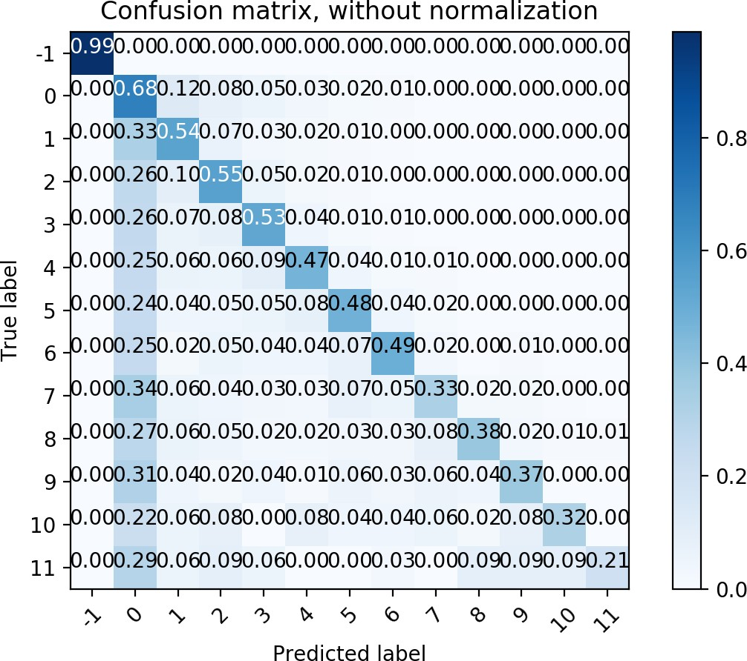

FIGURE 4.2: Confusion matrix shows which classes were predicted correctly

*4.4. Stage Two: Predicting the Answer Span* 29

### Stage Two: Predicting the Answer Span

Stage Two: Selecting the Answer Span To select the most plausible answer span from the candidate sentence, we design a number of features, some of which are based on constituent analysis. A constituency parser is used to analyze a sentence into its constituent phrases. For example, the sentence "the quick brown fox jumps over the lazy dog" has the following syntactic (constituency) tree:

The intuition is an answer span is one of constituents of the best candidate sentence. So we are using a constituency parser (Kitaev and Klein, 2018), we obtain all constituents in a candidate sentence. These constituents will be the classes from which we pick the right span. More generally, we design the following features for this stage:

**Contextual Overlap**: Constituents sharing context with the original question are potential candidates to be the correct answers. So we measure the cosine similarity between each constituent and the question:

*•*

∑*n* 1 *C|w| Qi*

✓

*similarity* =

* ∑*n*

*i*=

*C*2 ∑*n Q*2

*i*=1

*|w|*

*i*=1

*i*

where w is the number of slide window around the candidate constituent. For our purposes features of size 2 and 3 are used.

**Constituent Label**: Constituency parse tree label of the span combined with wh- word. For example, for a question "who designed the iPhone prototype?" and its answer "Steve Jobs designed the first prototype for the iPhone.", a constituent label feature is who-NP, who-V, who-VP, who-PP, etc.

*•*

**Distributional Distance**: We measure the distributional cosine similarity between the sum of all words in the contextual window and the question using Glove (Pennington, 2012).

*•*

*Matching Word Frequencies*: Sum of the TF-IDF of the words that occur in both the question and the sentence containing the candidate answer.

*•*

* + *Lengths*: Number of words to the left and the right of the span.

### Experiment and Error Analysis

In this stage, we have done three different attempts. In the first attempt, we used only two features "contextual overlap" and "constituent label". We also limited the number of classes (constituents) to 30. Using the same training settings and configurations from stage one, the logistic regression achieves a 0.25 F1 score. The confusion matrix shows a clear case of data imbalance. Classes at the beginning have more supporting points, and therefore have less error than others. However, our analysis to the errors indicates the wrong answers are partially correct most of the times. Class 2 has been identified as class 1 34%. For example, the answer of *At what age did Beyonce meet LaTavia Robertson?*

is predicted as *At age eight* when the correct answer is *age eight*. Similarly, class 12 is predicted as class eleven 16%. The answer to the question *Who supervised the design and implementation of the iPod user interface?* is *Steve Jobs*, but it is predicted as *Of Steve Jobs*. Clearly, the predicted answers are not very far from the true ones. A harsher assumption such as keeping only Noun Phrase constituents could have resolved some of these issues, but we will leave this for future studies.

Other types of errors are due to literal word matching between the questions and phrases. For example, the answer for *How much was public expenditure on the island in 2001-2002?* is predicted to be *Public expenditure* when the true answer is *£10 million*. In this case, the phrase *public expenditure* appears in the question, which makes it a stronger candidate given the features designed. Another example, answer to *what roles were women recruited for in the 1950s?* is *in medicine, communication*, but it is predicted as *logistics, and administration*. Given the features we have designed, it is very difficult for the classifier to recognize this settle difference between the classes. In the second attempt, we have added the 3 remaining features: Distributional Distance, Matching Word Frequencies, and length, while keeping the same parameters of the first attempt. We get a 0.35 F1 score. Looking at the confusion matrix, it is apparent that the new features do significantly improve the performance.

In our last experiment, we replaced logistic regression classifier in second attempt with a 3-layer feed-forward neural network of 128, 64 and 32 nodes respectively, optimized by Adam optimizer on a 100 epochs. The neural network achieves F1 score of 0.42. Using a neural network does indeed increase the performance, but its use is not very practical given its configuration. Each node in this neural network is equivalent to one logistic regression classifier, so using a feed-forward neural network with total nodes of 224 is equal in computational power to 224 logistic regression.

### Future Studies and Recommendation

Looking at errors produced during the three attempts, we can improve the performance by injecting more linguistic information from Named Entity Recognizers, Semantic Role Labelers and Dependency Parsers. A Named Entity Recognizer can help answer questions about locations, persons or entities (Where, Who and Which questions). Information derived from a dependency parser and a semantic role labeler can, for example, help resolve cases when the answers are the subjects or the objects of the sentences. An- other thing to investigate is to eliminate PP and VP constituent phrases, and only keep NP phrases. This idea comes from the assumption that the majority of answers to Wh- questions in SQUAD 2.0 dataset can be Noun Phrases. This assumption can help reduce the number of classes to be predicted, and there will be no need to limit the number of outputs to certain number as we did.

*4.7. Conclusion* 31

### Conclusion

We introduced a two-step classification method for automatic reading comprehension via SQUAD 2.0 dataset. Our stage 1 classifier managed to find whether or not a question is answerable within a given passage and find the sentence containing the right answer with F1 score of 0.71. Our stage 2 classifier manages to detect the exact span with F1 score of 0.35 even though the predicted answer is not distant from the exact answer. In order to improve the performance of our approach, future studies should investigate the usefulness of features generated from Named Entity Recognition, Semantic Role Labeling and Dependency Parsing processes, which are expected to be potential solutions to the problems we faced in this work

**Chapter 5**

**Conclusion**

Applications of Machine Learning in education are ubiquitous, from learning analytics to machine translation to summarization. One field of education that can be greatly benefited from the applications of natural language processing is distance education. Teaching foreign languages by means of distance learning requires tremendous efforts from instructors and course developer to prepare online materials, learning activities and resources. This report examines the applicability of supervised classification technique called logistic regression in two educational scenarios: detection of grammatical difficulty and automatic reading comprehension. The simplicity and practicality of the proposed solutions to each of these problems make them uniquely useful in onsite and online teaching environments.

As we pointed out in chapter 2, representing a written text is a crucial step in the ma- chine learning pipeline, and to do so, we have explored some of the most common methods such as bag-of-word, TF-IDF, and word embeddings. We have also noticed the advantages and disadvantages of each method in addition to techniques of dimensionality reduction such as clustering, latent semantic allocation, and stemming and lemmatization. Moreover, we have explained the workflow of classification as a supervised machine learning, starting from feature extraction through classification to evaluation of performance.

In chapter 3, we examine the use of multinomial logistic regression classifier to classify a written text according to how difficult a foreign language learner of English sees it using educational standards of Common European Framework Reference (CEFR). We also showed how logistic regression classifier could fit within a semi-supervised framework such as bootstrapping to work on low resources data.

In Chapter 4, we have investigated another use for logistic regression classification in method on a novel educational task, automatic reading comprehension. We have demonstrated that using logistic regression on two stages can compete with relatively advanced and complex neural network architecture commonly used for this purpose. The main catalyst for this success comes from using a set of linguistically rich features such as constituency parser and sentential embeddings. The performance of the model, the analysis of error made as well as the simplicity and efficiency of the model make it feasible to be applied in onsite or virtual learning environments.

34 *Chapter 5. Conclusion*

### Summary of Contributions

There are three main contributions to this work. First, we are, to the best of our knowledge, the first to propose an automated solution to classify a written English text by following pedagogic standards (CEFR). Second, we have *cautiously* applied a bootstrap- ping technique to supplement the training data from unlabeled corpora, and that led to 10% F1 increase in performance. Finally, we created a novel two-stage system based on multinomial logistic regression that not only answers comprehension questions given reading passages but it also able to abstain from answering if a question is unanswerable within the reading passage.

### Recommendations and Future Work

We have seen that each of the tasks we tackled in this report can help solve a particular educational scenario a foreign language instructor may encounter in a face-to-face or on- line learning settings. However, there still exist a few challenges that need the attention of NLP researchers. The solution proposed in chapter 4 find answers to comprehension questions, but it still requires the questions as input. This means, teachers and material developers still have to create the questions. Thus, future studies are to investigate the process of automatically creating different types of comprehension questions given reading passages. Such a system complemented by the system we proposed, can make an automatic tool of learning activity creation that is ready to deploy in Learning Management Systems (LMS) or Courseware Platforms. As for improving the performance of the current automatic reading comprehension system, we recommend incorporating more linguistic features such as information derived from Named Entity Recognition, Dependency Parsing and Semantic Role Labeling.

Due to the shortage of training examples on each of six classes in the grammatical detection task, we merged every two classes into one super-class to be the output. However, to provide more specificity to error detection, we recommend applying more iterations of cautious bootstrapping to obtain more training examples on each of the six classes (A1, A2, B1, B2, C1, C3). More training examples can also reduce the state of data imbalance we had in this task, and therefore could eliminate the need for adjusting the class weights. The features we used are based on bag-of-words and TFIDF, and we recommend using word embeddings or the sentence embeddings technique we have used for automatic reading comprehension task in chapter 4. Another recommendation is to use easy-to-interpret classification algorithms like decision trees. This brings the advantage of providing "if-then" classification rules that humans can read and understand. Furthermore, as the task involves grammatical structures, we recommend designing features using constituency and dependency parsers. Finally, we encourage future studies to investigate how close will be the rules generated from the last two recommendations to the ones CEFR experts devised (can-do statements).