Raghe Mahamud
D605 Task 3

Part A
A: Optimization Problem Program
This submission includes the program used to run this optimization in Python.

A1: Demonstrate Solver Solution
Here is the solution given by the program:
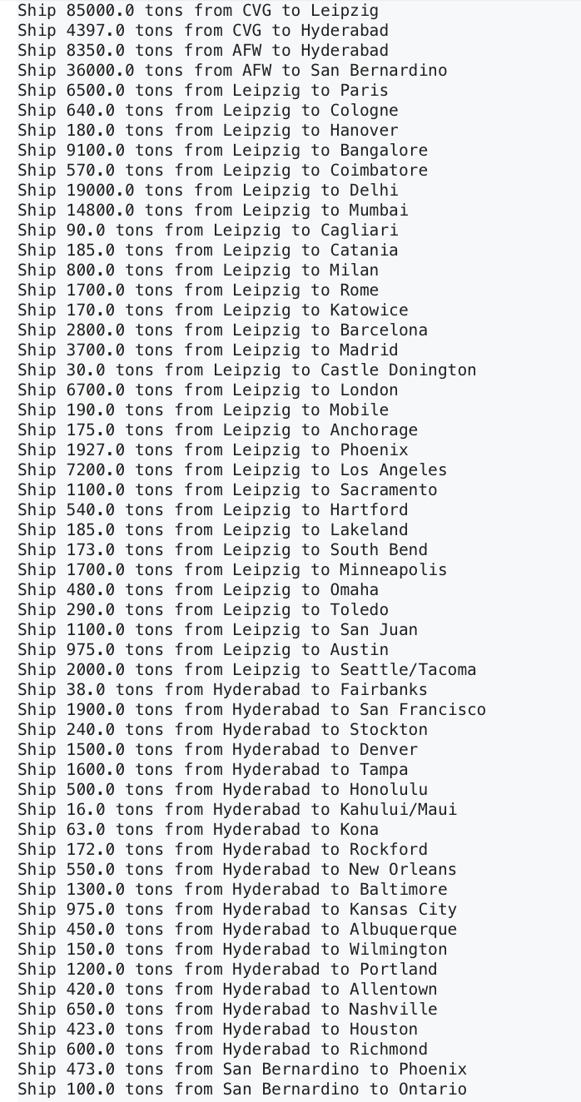
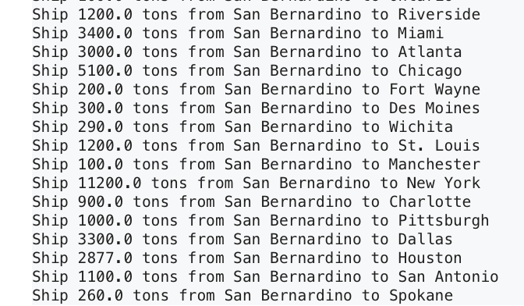

Part B

B: Output Analysis
The above output gives 71 shipping directives to optimize the shipping routes and amounts. Each hub has a specific number of tons it should ship to each of its corresponding cities, ranging from just 16 tons to over 7,000 tons.
B1: Satisfying Optimization Problem Constraints
In the code, four constraints were checked after the optimization:

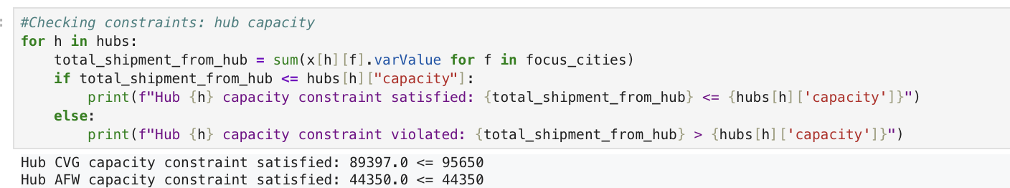

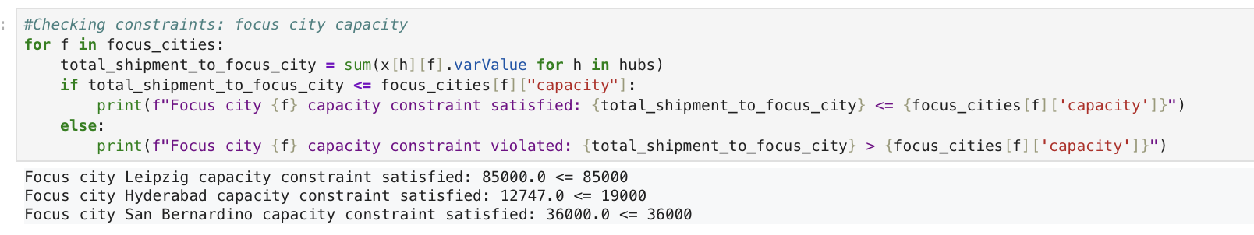

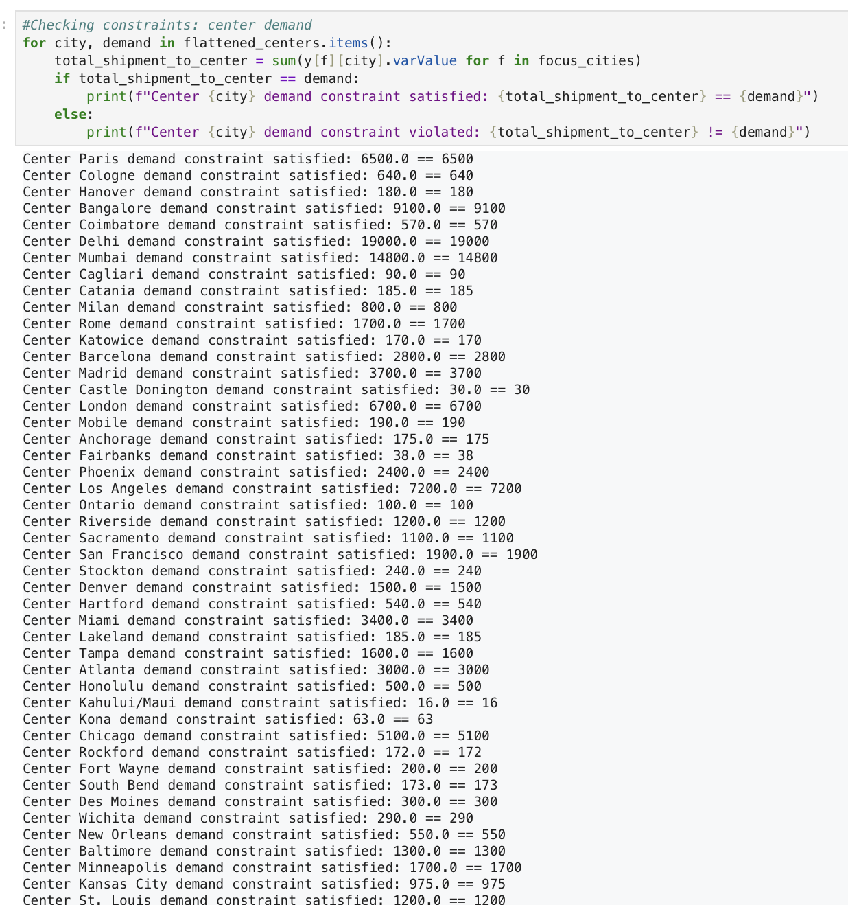
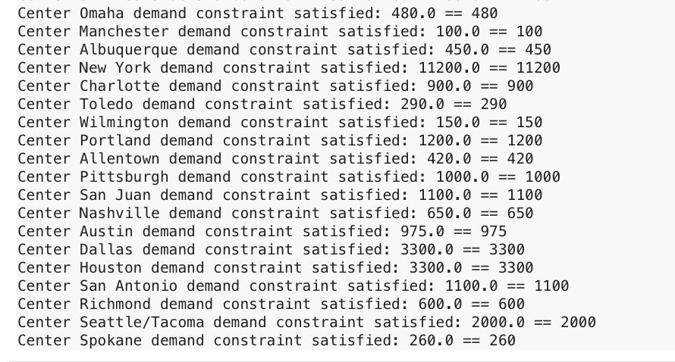

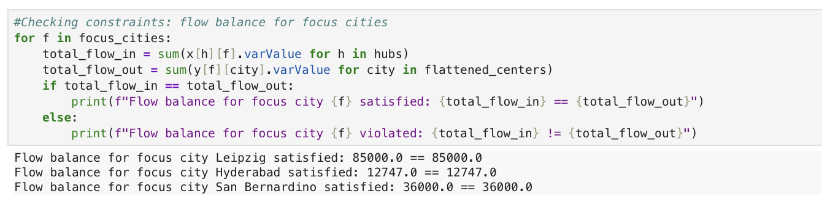

Note that all four of the above constraints were returned as satisfied, and the calculation for each was provided.
B2: Decision Variables, Constraints, and Objective Function
Here is my code defining the decision variables, the constraints, and the objective function:

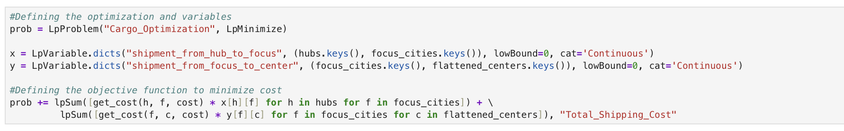

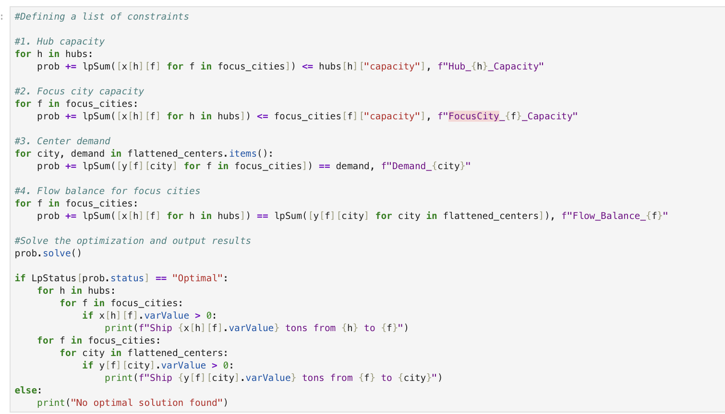

As referenced in task 2, the constraints are hub capacity, focus city capacity, flow conservation,
and center demand. The decision variables were the quantities in and out of focus cities. Lastly, here is the objective function, just as it is defined above:
$$min\left(\sum_{i=1}^{2}{\sum_{j=1}^{3}{c_{ij}x_{ij}+}}\sum_{i=1}^{2}{\sum_{k=1}^{65}{c_{ik}y_{ik}+}}\sum_{j=1}^{3}{\sum_{k=1}^{65}{c_{jk}z_{jk}}}\right)$$
Where:
$c_{ij}$ is the cost per unit of shipping from hub I to focus city j
$c_{ik}$ Cost per unit of shipping from hub i to center k
$c_{jk}$ Cost per unit of shipping from focus city j to center k

B3: Expected Output Solution
Because the decision variables were the shipping amounts between cities, this is the expected
output. The output of the optimization, as shown above, consists of shipping routes and the
amount of tonnage that is to be sent. After testing the constraints, we can confirm that each
center will be at or under capacity and that each center will fill its demand.

Part C

C: Reflection
When I first approached this problem, I had already defined the decision variables, constraints, and the objective function, and I assumed the optimization calculations would be pretty straightforward. However, I quickly ran into problems with inputting the data. The data was contained in a Word document, and when I copied it to a CSV file, I encountered problems. The disorganization of the data and the lack of a clean dataset were the most significant problems I had to overcome. However, the data in this project was surprisingly limited and not nearly as big as in past assignments. As a workaround, I was able to define the data in the program rather than import it, which fixed the problem. I also encountered issues with N/A values in the data. Therefore, as the optimizer wouldn’t allow them to be processed, I had to replace those values with large values to prevent the optimizer from assuming unavailable shipping routes were feasible. Essentially, my approach developed and changed over time, and I had to adjust my expectations of the program's process as I went. It was a balance between finding ways to get the code to work with the original plan for the project.

Sources

No external sources were used, except for the WGU official course materials.

